Preliminary ESP regressions

Abigail Tyrell

13 Jul 2021

# Black sea bass

Stock region: Mid

EPU: MAB, All, all, NE

# 1 Introduction

These are preliminary regressions that compare Mid Black sea bass catch, abundance, recruitment, and F to various indicators in the MAB, All, all, NE Environmental Protection Units (EPUs) taken from the ecodata package. The indicators are lagged by 0 years.

# 2 Regression analysis

All regressions are simple linear correlations assessed at the p < 0.5 level. Please note, due to the large number of indicators tested, a certain amount of statistically significant results are expected even if there are no underlying mechanistic connections. These correlations do not necessarily imply causation.

## 2.1 Trends with time

##### Figures

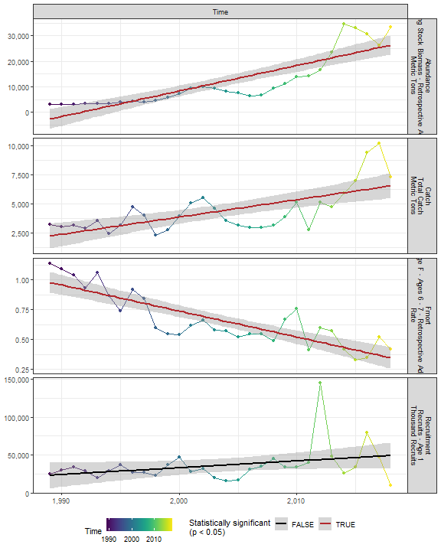

##### Regression statistics

Table 2.1: Catch vs Time

|  |  |  |  |  |
| --- | --- | --- | --- | --- |
|  | Estimate | Std. Error | t value | Pr(>|t|) |
| (Intercept) | -292860.65 | 62334.28 | -4.70 | 0 |
| Val | 148.36 | 31.11 | 4.77 | 0 |

|  |  |
| --- | --- |
| Name | Value |
| F-statistic | 22.74 |
| df | 1, 28 |
| R2 | 0.45 |
| R2-adj | 0.43 |

Table 2.1: Fmort vs Time

|  |  |  |  |  |
| --- | --- | --- | --- | --- |
|  | Estimate | Std. Error | t value | Pr(>|t|) |
| (Intercept) | 44.35 | 5.16 | 8.60 | 0 |
| Val | -0.02 | 0.00 | -8.47 | 0 |

|  |  |
| --- | --- |
| Name | Value |
| F-statistic | 71.72 |
| df | 1, 28 |
| R2 | 0.72 |
| R2-adj | 0.71 |

Table 2.1: Abundance vs Time

|  |  |  |  |  |
| --- | --- | --- | --- | --- |
|  | Estimate | Std. Error | t value | Pr(>|t|) |
| (Intercept) | -1986351.82 | 221985.0 | -8.95 | 0 |
| Val | 997.37 | 110.8 | 9.00 | 0 |

|  |  |
| --- | --- |
| Name | Value |
| F-statistic | 81.03 |
| df | 1, 28 |
| R2 | 0.74 |
| R2-adj | 0.73 |

## 2.2 Physical indicators

### 2.2.1 Temperature-related

#### 2.2.1.1 Cold pool index

##### Figures

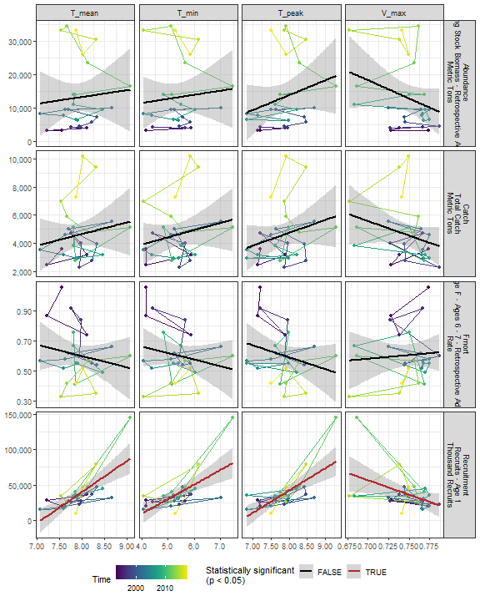

##### Regression statistics

Table 2.2: Recruitment vs T_mean

|  |  |  |  |  |
| --- | --- | --- | --- | --- |
|  | Estimate | Std. Error | t value | Pr(>|t|) |
| (Intercept) | -309857.00 | 68345.19 | -4.53 | 0 |
| Val | 43797.57 | 8613.65 | 5.08 | 0 |

|  |  |
| --- | --- |
| Name | Value |
| F-statistic | 25.85 |
| df | 1, 24 |
| R2 | 0.52 |
| R2-adj | 0.5 |

Table 2.2: Recruitment vs T_min

|  |  |  |  |  |
| --- | --- | --- | --- | --- |
|  | Estimate | Std. Error | t value | Pr(>|t|) |
| (Intercept) | -72267.28 | 24998.89 | -2.89 | 0.01 |
| Val | 20519.51 | 4631.38 | 4.43 | 0.00 |

|  |  |
| --- | --- |
| Name | Value |
| F-statistic | 19.63 |
| df | 1, 24 |
| R2 | 0.45 |
| R2-adj | 0.43 |

Table 2.2: Recruitment vs T_peak

|  |  |  |  |  |
| --- | --- | --- | --- | --- |
|  | Estimate | Std. Error | t value | Pr(>|t|) |
| (Intercept) | -208762.84 | 50062.90 | -4.17 | 0 |
| Val | 31410.13 | 6376.78 | 4.93 | 0 |

|  |  |
| --- | --- |
| Name | Value |
| F-statistic | 24.26 |
| df | 1, 24 |
| R2 | 0.5 |
| R2-adj | 0.48 |

Table 2.2: Recruitment vs V_max

|  |  |  |  |  |
| --- | --- | --- | --- | --- |
|  | Estimate | Std. Error | t value | Pr(>|t|) |
| (Intercept) | 343163.9 | 122104.1 | 2.81 | 0.01 |
| Val | -409413.3 | 163258.6 | -2.51 | 0.02 |

|  |  |
| --- | --- |
| Name | Value |
| F-statistic | 6.29 |
| df | 1, 24 |
| R2 | 0.21 |
| R2-adj | 0.17 |

#### 2.2.1.2 Warm core rings

##### Figures

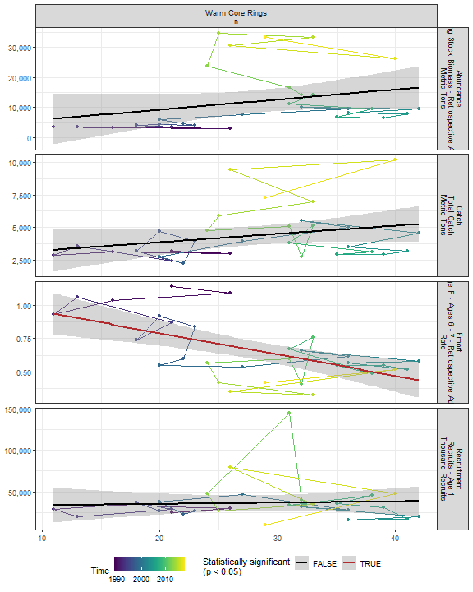

##### Regression statistics

Table 2.3: Fmort vs Warm Core Rings n

|  |  |  |  |  |
| --- | --- | --- | --- | --- |
|  | Estimate | Std. Error | t value | Pr(>|t|) |
| (Intercept) | 1.11 | 0.12 | 9.44 | 0 |
| Val | -0.02 | 0.00 | -3.97 | 0 |

|  |  |
| --- | --- |
| Name | Value |
| F-statistic | 15.8 |
| df | 1, 28 |
| R2 | 0.36 |
| R2-adj | 0.34 |

#### 2.2.1.3 Marine heatwave index

##### Figures

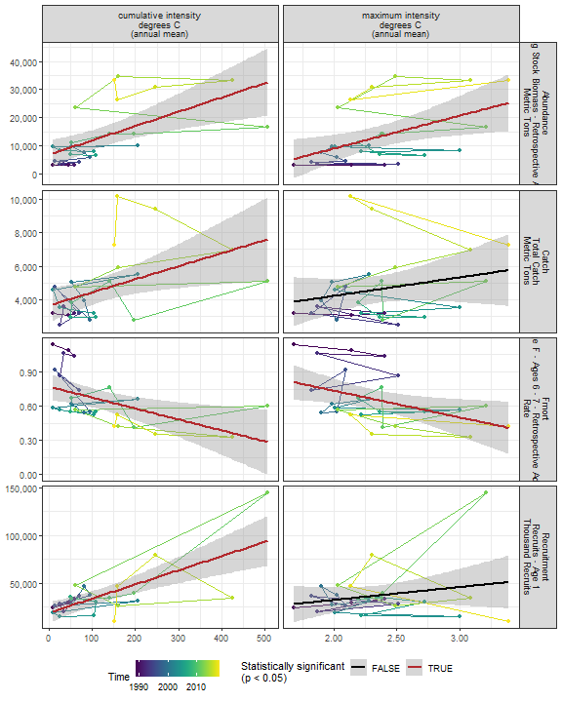

##### Regression statistics

Table 2.4: Catch vs cumulative intensity degrees C (annual mean)

|  |  |  |  |  |
| --- | --- | --- | --- | --- |
|  | Estimate | Std. Error | t value | Pr(>|t|) |
| (Intercept) | 3644.92 | 500.41 | 7.28 | 0.00 |
| Val | 7.82 | 2.97 | 2.63 | 0.01 |

|  |  |
| --- | --- |
| Name | Value |
| F-statistic | 6.93 |
| df | 1, 24 |
| R2 | 0.22 |
| R2-adj | 0.19 |

Table 2.4: Fmort vs cumulative intensity degrees C (annual mean)

|  |  |  |  |  |
| --- | --- | --- | --- | --- |
|  | Estimate | Std. Error | t value | Pr(>|t|) |
| (Intercept) | 0.77 | 0.06 | 13.57 | 0.00 |
| Val | 0.00 | 0.00 | -2.85 | 0.01 |

|  |  |
| --- | --- |
| Name | Value |
| F-statistic | 8.12 |
| df | 1, 24 |
| R2 | 0.25 |
| R2-adj | 0.22 |

Table 2.4: Fmort vs maximum intensity degrees C (annual mean)

|  |  |  |  |  |
| --- | --- | --- | --- | --- |
|  | Estimate | Std. Error | t value | Pr(>|t|) |
| (Intercept) | 1.20 | 0.23 | 5.22 | 0.00 |
| Val | -0.23 | 0.10 | -2.41 | 0.02 |

|  |  |
| --- | --- |
| Name | Value |
| F-statistic | 5.8 |
| df | 1, 24 |
| R2 | 0.19 |
| R2-adj | 0.16 |

Table 2.4: Recruitment vs cumulative intensity degrees C (annual mean)

|  |  |  |  |  |
| --- | --- | --- | --- | --- |
|  | Estimate | Std. Error | t value | Pr(>|t|) |
| (Intercept) | 19349.24 | 5217.65 | 3.71 | 0 |
| Val | 147.72 | 30.98 | 4.77 | 0 |

|  |  |
| --- | --- |
| Name | Value |
| F-statistic | 22.73 |
| df | 1, 24 |
| R2 | 0.49 |
| R2-adj | 0.46 |

Table 2.4: Abundance vs cumulative intensity degrees C (annual mean)

|  |  |  |  |  |
| --- | --- | --- | --- | --- |
|  | Estimate | Std. Error | t value | Pr(>|t|) |
| (Intercept) | 6796.69 | 2417.52 | 2.81 | 0.01 |
| Val | 51.04 | 14.36 | 3.56 | 0.00 |

|  |  |
| --- | --- |
| Name | Value |
| F-statistic | 12.64 |
| df | 1, 24 |
| R2 | 0.34 |
| R2-adj | 0.32 |

Table 2.4: Abundance vs maximum intensity degrees C (annual mean)

|  |  |  |  |  |
| --- | --- | --- | --- | --- |
|  | Estimate | Std. Error | t value | Pr(>|t|) |
| (Intercept) | -14400.68 | 10199.38 | -1.41 | 0.17 |
| Val | 11686.12 | 4299.27 | 2.72 | 0.01 |

|  |  |
| --- | --- |
| Name | Value |
| F-statistic | 7.39 |
| df | 1, 24 |
| R2 | 0.24 |
| R2-adj | 0.2 |

#### 2.2.1.4 Marine heatwave index in the stock region

##### Figures

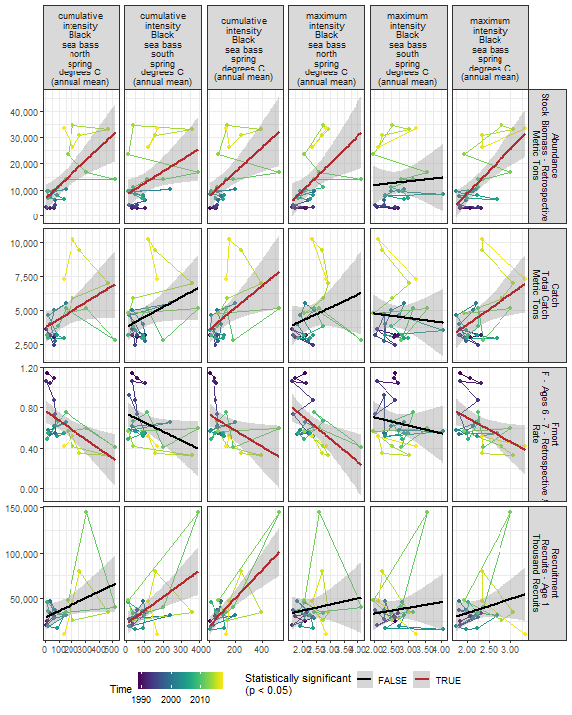

##### Regression statistics

Table 2.5: Catch vs cumulative intensity Black sea bass north spring degrees C (annual mean)

|  |  |  |  |  |
| --- | --- | --- | --- | --- |
|  | Estimate | Std. Error | t value | Pr(>|t|) |
| (Intercept) | 3728.87 | 552.81 | 6.75 | 0.00 |
| Val | 6.12 | 2.93 | 2.08 | 0.05 |

|  |  |
| --- | --- |
| Name | Value |
| F-statistic | 4.34 |
| df | 1, 23 |
| R2 | 0.16 |
| R2-adj | 0.12 |

Table 2.5: Catch vs cumulative intensity Black sea bass spring degrees C (annual mean)

|  |  |  |  |  |
| --- | --- | --- | --- | --- |
|  | Estimate | Std. Error | t value | Pr(>|t|) |
| (Intercept) | 3550.84 | 508.00 | 6.99 | 0.00 |
| Val | 8.10 | 3.04 | 2.66 | 0.01 |

|  |  |
| --- | --- |
| Name | Value |
| F-statistic | 7.09 |
| df | 1, 24 |
| R2 | 0.23 |
| R2-adj | 0.2 |

Table 2.5: Catch vs maximum intensity Black sea bass spring degrees C (annual mean)

|  |  |  |  |  |
| --- | --- | --- | --- | --- |
|  | Estimate | Std. Error | t value | Pr(>|t|) |
| (Intercept) | -562.62 | 2057.71 | -0.27 | 0.79 |
| Val | 2251.58 | 898.53 | 2.51 | 0.02 |

|  |  |
| --- | --- |
| Name | Value |
| F-statistic | 6.28 |
| df | 1, 24 |
| R2 | 0.21 |
| R2-adj | 0.17 |

Table 2.5: Fmort vs cumulative intensity Black sea bass north spring degrees C (annual mean)

|  |  |  |  |  |
| --- | --- | --- | --- | --- |
|  | Estimate | Std. Error | t value | Pr(>|t|) |
| (Intercept) | 0.77 | 0.06 | 13.48 | 0.00 |
| Val | 0.00 | 0.00 | -3.10 | 0.01 |

|  |  |
| --- | --- |
| Name | Value |
| F-statistic | 9.62 |
| df | 1, 23 |
| R2 | 0.29 |
| R2-adj | 0.26 |

Table 2.5: Fmort vs cumulative intensity Black sea bass spring degrees C (annual mean)

|  |  |  |  |  |
| --- | --- | --- | --- | --- |
|  | Estimate | Std. Error | t value | Pr(>|t|) |
| (Intercept) | 0.73 | 0.06 | 12.48 | 0.00 |
| Val | 0.00 | 0.00 | -2.28 | 0.03 |

|  |  |
| --- | --- |
| Name | Value |
| F-statistic | 5.19 |
| df | 1, 24 |
| R2 | 0.18 |
| R2-adj | 0.14 |

Table 2.5: Fmort vs maximum intensity Black sea bass spring degrees C (annual mean)

|  |  |  |  |  |
| --- | --- | --- | --- | --- |
|  | Estimate | Std. Error | t value | Pr(>|t|) |
| (Intercept) | 1.18 | 0.23 | 5.06 | 0.00 |
| Val | -0.24 | 0.10 | -2.36 | 0.03 |

|  |  |
| --- | --- |
| Name | Value |
| F-statistic | 5.57 |
| df | 1, 24 |
| R2 | 0.19 |
| R2-adj | 0.15 |

Table 2.5: Fmort vs maximum intensity Black sea bass north spring degrees C (annual mean)

|  |  |  |  |  |
| --- | --- | --- | --- | --- |
|  | Estimate | Std. Error | t value | Pr(>|t|) |
| (Intercept) | 1.17 | 0.19 | 6.30 | 0.00 |
| Val | -0.23 | 0.08 | -2.91 | 0.01 |

|  |  |
| --- | --- |
| Name | Value |
| F-statistic | 8.48 |
| df | 1, 23 |
| R2 | 0.27 |
| R2-adj | 0.24 |

Table 2.5: Recruitment vs cumulative intensity Black sea bass spring degrees C (annual mean)

|  |  |  |  |  |
| --- | --- | --- | --- | --- |
|  | Estimate | Std. Error | t value | Pr(>|t|) |
| (Intercept) | 19133.75 | 5054.96 | 3.79 | 0 |
| Val | 155.73 | 30.28 | 5.14 | 0 |

|  |  |
| --- | --- |
| Name | Value |
| F-statistic | 26.46 |
| df | 1, 24 |
| R2 | 0.52 |
| R2-adj | 0.5 |

Table 2.5: Recruitment vs cumulative intensity Black sea bass south spring degrees C (annual mean)

|  |  |  |  |  |
| --- | --- | --- | --- | --- |
|  | Estimate | Std. Error | t value | Pr(>|t|) |
| (Intercept) | 22225.03 | 5926.65 | 3.75 | 0 |
| Val | 145.80 | 41.82 | 3.49 | 0 |

|  |  |
| --- | --- |
| Name | Value |
| F-statistic | 12.16 |
| df | 1, 25 |
| R2 | 0.33 |
| R2-adj | 0.3 |

Table 2.5: Abundance vs cumulative intensity Black sea bass north spring degrees C (annual mean)

|  |  |  |  |  |
| --- | --- | --- | --- | --- |
|  | Estimate | Std. Error | t value | Pr(>|t|) |
| (Intercept) | 6731.31 | 2454.37 | 2.74 | 0.01 |
| Val | 48.42 | 13.03 | 3.72 | 0.00 |

|  |  |
| --- | --- |
| Name | Value |
| F-statistic | 13.81 |
| df | 1, 23 |
| R2 | 0.38 |
| R2-adj | 0.35 |

Table 2.5: Abundance vs cumulative intensity Black sea bass spring degrees C (annual mean)

|  |  |  |  |  |
| --- | --- | --- | --- | --- |
|  | Estimate | Std. Error | t value | Pr(>|t|) |
| (Intercept) | 7479.43 | 2509.01 | 2.98 | 0.01 |
| Val | 47.01 | 15.03 | 3.13 | 0.00 |

|  |  |
| --- | --- |
| Name | Value |
| F-statistic | 9.79 |
| df | 1, 24 |
| R2 | 0.29 |
| R2-adj | 0.26 |

Table 2.5: Abundance vs maximum intensity Black sea bass spring degrees C (annual mean)

|  |  |  |  |  |
| --- | --- | --- | --- | --- |
|  | Estimate | Std. Error | t value | Pr(>|t|) |
| (Intercept) | -25768.49 | 8761.91 | -2.94 | 0.01 |
| Val | 17225.19 | 3826.03 | 4.50 | 0.00 |

|  |  |
| --- | --- |
| Name | Value |
| F-statistic | 20.27 |
| df | 1, 24 |
| R2 | 0.46 |
| R2-adj | 0.44 |

Table 2.5: Abundance vs maximum intensity Black sea bass north spring degrees C (annual mean)

|  |  |  |  |  |
| --- | --- | --- | --- | --- |
|  | Estimate | Std. Error | t value | Pr(>|t|) |
| (Intercept) | -10938.27 | 8496.07 | -1.29 | 0.21 |
| Val | 10344.55 | 3544.96 | 2.92 | 0.01 |

|  |  |
| --- | --- |
| Name | Value |
| F-statistic | 8.52 |
| df | 1, 23 |
| R2 | 0.27 |
| R2-adj | 0.24 |

Table 2.5: Abundance vs cumulative intensity Black sea bass south spring degrees C (annual mean)

|  |  |  |  |  |
| --- | --- | --- | --- | --- |
|  | Estimate | Std. Error | t value | Pr(>|t|) |
| (Intercept) | 8251.23 | 2693.24 | 3.06 | 0.01 |
| Val | 43.63 | 19.00 | 2.30 | 0.03 |

|  |  |
| --- | --- |
| Name | Value |
| F-statistic | 5.27 |
| df | 1, 25 |
| R2 | 0.17 |
| R2-adj | 0.14 |

#### 2.2.1.5 GLORYS bottom temperature

##### Figures

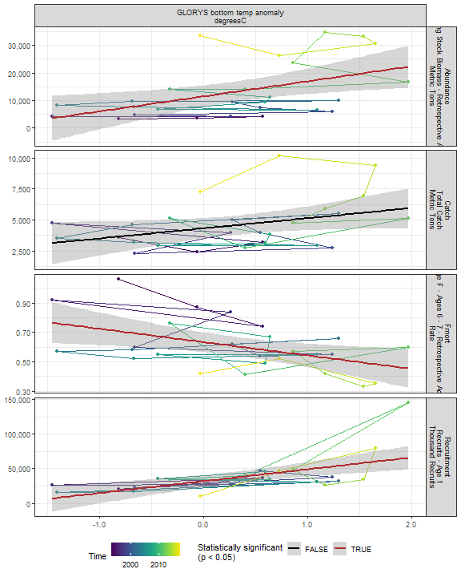

##### Regression statistics

Table 2.6: Fmort vs GLORYS bottom temp anomaly degreesC

|  |  |  |  |  |
| --- | --- | --- | --- | --- |
|  | Estimate | Std. Error | t value | Pr(>|t|) |
| (Intercept) | 0.63 | 0.03 | 19.34 | 0.00 |
| Val | -0.09 | 0.03 | -2.67 | 0.01 |

|  |  |
| --- | --- |
| Name | Value |
| F-statistic | 7.13 |
| df | 1, 24 |
| R2 | 0.23 |
| R2-adj | 0.2 |

Table 2.6: Recruitment vs GLORYS bottom temp anomaly degreesC

|  |  |  |  |  |
| --- | --- | --- | --- | --- |
|  | Estimate | Std. Error | t value | Pr(>|t|) |
| (Intercept) | 31705.22 | 4334.29 | 7.31 | 0 |
| Val | 17136.74 | 4496.85 | 3.81 | 0 |

|  |  |
| --- | --- |
| Name | Value |
| F-statistic | 14.52 |
| df | 1, 24 |
| R2 | 0.38 |
| R2-adj | 0.35 |

Table 2.6: Abundance vs GLORYS bottom temp anomaly degreesC

|  |  |  |  |  |
| --- | --- | --- | --- | --- |
|  | Estimate | Std. Error | t value | Pr(>|t|) |
| (Intercept) | 11467.48 | 1907.66 | 6.01 | 0.00 |
| Val | 5450.91 | 1979.21 | 2.75 | 0.01 |

|  |  |
| --- | --- |
| Name | Value |
| F-statistic | 7.59 |
| df | 1, 24 |
| R2 | 0.24 |
| R2-adj | 0.21 |

#### 2.2.1.6 Long-term sea surface temperature

##### Figures

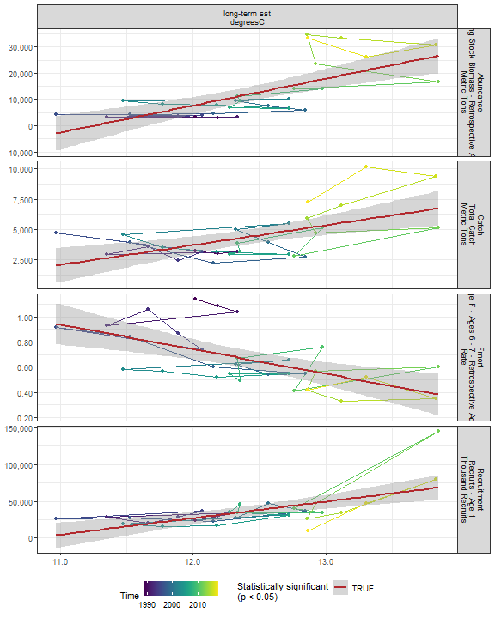

##### Regression statistics

Table 2.7: Catch vs long-term sst degreesC

|  |  |  |  |  |
| --- | --- | --- | --- | --- |
|  | Estimate | Std. Error | t value | Pr(>|t|) |
| (Intercept) | -15875.60 | 5495.74 | -2.89 | 0.01 |
| Val | 1632.12 | 442.31 | 3.69 | 0.00 |

|  |  |
| --- | --- |
| Name | Value |
| F-statistic | 13.62 |
| df | 1, 28 |
| R2 | 0.33 |
| R2-adj | 0.3 |

Table 2.7: Fmort vs long-term sst degreesC

|  |  |  |  |  |
| --- | --- | --- | --- | --- |
|  | Estimate | Std. Error | t value | Pr(>|t|) |
| (Intercept) | 3.09 | 0.63 | 4.92 | 0 |
| Val | -0.20 | 0.05 | -3.87 | 0 |

|  |  |
| --- | --- |
| Name | Value |
| F-statistic | 14.97 |
| df | 1, 28 |
| R2 | 0.35 |
| R2-adj | 0.33 |

Table 2.7: Recruitment vs long-term sst degreesC

|  |  |  |  |  |
| --- | --- | --- | --- | --- |
|  | Estimate | Std. Error | t value | Pr(>|t|) |
| (Intercept) | -242332.94 | 64356.61 | -3.77 | 0 |
| Val | 22443.81 | 5179.52 | 4.33 | 0 |

|  |  |
| --- | --- |
| Name | Value |
| F-statistic | 18.78 |
| df | 1, 28 |
| R2 | 0.4 |
| R2-adj | 0.38 |

Table 2.7: Abundance vs long-term sst degreesC

|  |  |  |  |  |
| --- | --- | --- | --- | --- |
|  | Estimate | Std. Error | t value | Pr(>|t|) |
| (Intercept) | -115373.65 | 25365.72 | -4.55 | 0 |
| Val | 10256.01 | 2041.47 | 5.02 | 0 |

|  |  |
| --- | --- |
| Name | Value |
| F-statistic | 25.24 |
| df | 1, 28 |
| R2 | 0.47 |
| R2-adj | 0.46 |

#### 2.2.1.7 Sea surface temperature anomaly in EPU

##### Figures

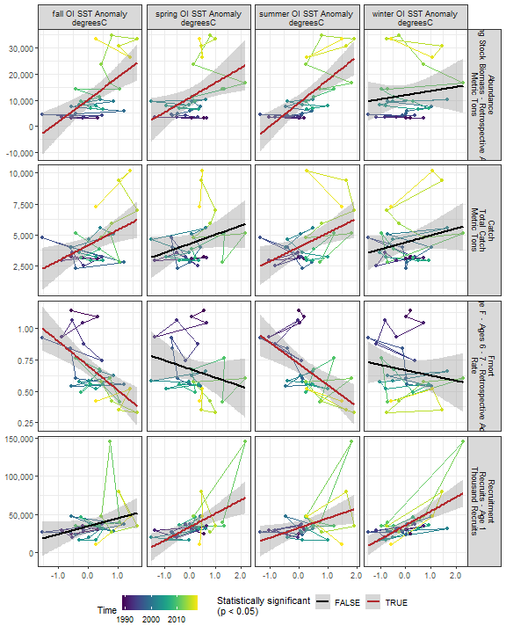

##### Regression statistics

Table 2.8: Catch vs summer OI SST Anomaly degreesC

|  |  |  |  |  |
| --- | --- | --- | --- | --- |
|  | Estimate | Std. Error | t value | Pr(>|t|) |
| (Intercept) | 3995.00 | 349.26 | 11.44 | 0.00 |
| Val | 1156.33 | 418.03 | 2.77 | 0.01 |

|  |  |
| --- | --- |
| Name | Value |
| F-statistic | 7.65 |
| df | 1, 28 |
| R2 | 0.21 |
| R2-adj | 0.19 |

Table 2.8: Catch vs fall OI SST Anomaly degreesC

|  |  |  |  |  |
| --- | --- | --- | --- | --- |
|  | Estimate | Std. Error | t value | Pr(>|t|) |
| (Intercept) | 4133.98 | 331.88 | 12.46 | 0.00 |
| Val | 1259.78 | 450.91 | 2.79 | 0.01 |

|  |  |
| --- | --- |
| Name | Value |
| F-statistic | 7.81 |
| df | 1, 28 |
| R2 | 0.22 |
| R2-adj | 0.19 |

Table 2.8: Fmort vs summer OI SST Anomaly degreesC

|  |  |  |  |  |
| --- | --- | --- | --- | --- |
|  | Estimate | Std. Error | t value | Pr(>|t|) |
| (Intercept) | 0.72 | 0.04 | 19.36 | 0 |
| Val | -0.17 | 0.04 | -3.80 | 0 |

|  |  |
| --- | --- |
| Name | Value |
| F-statistic | 14.42 |
| df | 1, 28 |
| R2 | 0.34 |
| R2-adj | 0.32 |

Table 2.8: Fmort vs fall OI SST Anomaly degreesC

|  |  |  |  |  |
| --- | --- | --- | --- | --- |
|  | Estimate | Std. Error | t value | Pr(>|t|) |
| (Intercept) | 0.7 | 0.03 | 20.59 | 0 |
| Val | -0.2 | 0.05 | -4.22 | 0 |

|  |  |
| --- | --- |
| Name | Value |
| F-statistic | 17.81 |
| df | 1, 28 |
| R2 | 0.39 |
| R2-adj | 0.37 |

Table 2.8: Recruitment vs summer OI SST Anomaly degreesC

|  |  |  |  |  |
| --- | --- | --- | --- | --- |
|  | Estimate | Std. Error | t value | Pr(>|t|) |
| (Intercept) | 31914.24 | 4452.19 | 7.17 | 0.00 |
| Val | 12852.17 | 5328.81 | 2.41 | 0.02 |

|  |  |
| --- | --- |
| Name | Value |
| F-statistic | 5.82 |
| df | 1, 28 |
| R2 | 0.17 |
| R2-adj | 0.14 |

Table 2.8: Recruitment vs winter OI SST Anomaly degreesC

|  |  |  |  |  |
| --- | --- | --- | --- | --- |
|  | Estimate | Std. Error | t value | Pr(>|t|) |
| (Intercept) | 35750.13 | 3271.20 | 10.93 | 0 |
| Val | 18263.95 | 3650.84 | 5.00 | 0 |

|  |  |
| --- | --- |
| Name | Value |
| F-statistic | 25.03 |
| df | 1, 28 |
| R2 | 0.47 |
| R2-adj | 0.45 |

Table 2.8: Recruitment vs spring OI SST Anomaly degreesC

|  |  |  |  |  |
| --- | --- | --- | --- | --- |
|  | Estimate | Std. Error | t value | Pr(>|t|) |
| (Intercept) | 33326.54 | 3758.16 | 8.87 | 0 |
| Val | 17714.73 | 4762.86 | 3.72 | 0 |

|  |  |
| --- | --- |
| Name | Value |
| F-statistic | 13.83 |
| df | 1, 28 |
| R2 | 0.33 |
| R2-adj | 0.31 |

Table 2.8: Abundance vs summer OI SST Anomaly degreesC

|  |  |  |  |  |
| --- | --- | --- | --- | --- |
|  | Estimate | Std. Error | t value | Pr(>|t|) |
| (Intercept) | 8968.13 | 1508.55 | 5.94 | 0 |
| Val | 8860.24 | 1805.58 | 4.91 | 0 |

|  |  |
| --- | --- |
| Name | Value |
| F-statistic | 24.08 |
| df | 1, 28 |
| R2 | 0.46 |
| R2-adj | 0.44 |

Table 2.8: Abundance vs fall OI SST Anomaly degreesC

|  |  |  |  |  |
| --- | --- | --- | --- | --- |
|  | Estimate | Std. Error | t value | Pr(>|t|) |
| (Intercept) | 10237.42 | 1553.75 | 6.59 | 0 |
| Val | 8580.32 | 2110.98 | 4.06 | 0 |

|  |  |
| --- | --- |
| Name | Value |
| F-statistic | 16.52 |
| df | 1, 28 |
| R2 | 0.37 |
| R2-adj | 0.35 |

Table 2.8: Abundance vs spring OI SST Anomaly degreesC

|  |  |  |  |  |
| --- | --- | --- | --- | --- |
|  | Estimate | Std. Error | t value | Pr(>|t|) |
| (Intercept) | 10974.53 | 1735.94 | 6.32 | 0.00 |
| Val | 5680.50 | 2200.03 | 2.58 | 0.02 |

|  |  |
| --- | --- |
| Name | Value |
| F-statistic | 6.67 |
| df | 1, 28 |
| R2 | 0.19 |
| R2-adj | 0.16 |

#### 2.2.1.8 Sea surface temperature anomaly in stock region

##### Figures

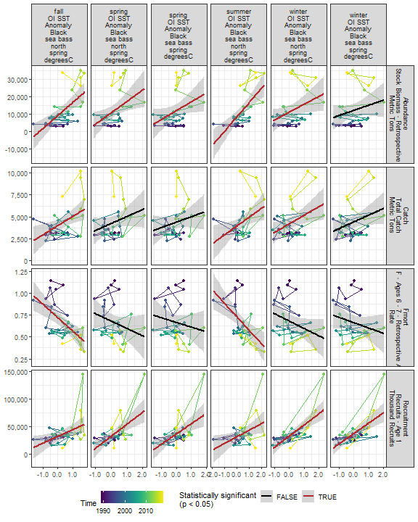

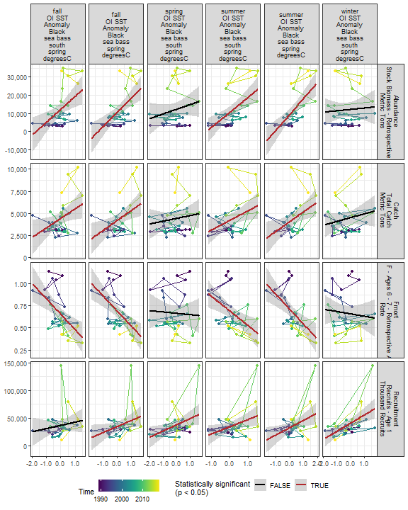

##### Regression statistics

Table 2.9: Catch vs winter OI SST Anomaly Black sea bass north spring degreesC

|  |  |  |  |  |
| --- | --- | --- | --- | --- |
|  | Estimate | Std. Error | t value | Pr(>|t|) |
| (Intercept) | 4202.55 | 334.21 | 12.57 | 0.00 |
| Val | 970.83 | 384.86 | 2.52 | 0.02 |

|  |  |
| --- | --- |
| Name | Value |
| F-statistic | 6.36 |
| df | 1, 28 |
| R2 | 0.19 |
| R2-adj | 0.16 |

Table 2.9: Catch vs summer OI SST Anomaly Black sea bass north spring degreesC

|  |  |  |  |  |
| --- | --- | --- | --- | --- |
|  | Estimate | Std. Error | t value | Pr(>|t|) |
| (Intercept) | 3946.43 | 365.94 | 10.78 | 0.00 |
| Val | 1001.75 | 389.36 | 2.57 | 0.02 |

|  |  |
| --- | --- |
| Name | Value |
| F-statistic | 6.62 |
| df | 1, 28 |
| R2 | 0.19 |
| R2-adj | 0.16 |

Table 2.9: Catch vs fall OI SST Anomaly Black sea bass north spring degreesC

|  |  |  |  |  |
| --- | --- | --- | --- | --- |
|  | Estimate | Std. Error | t value | Pr(>|t|) |
| (Intercept) | 3985.82 | 345.41 | 11.54 | 0.00 |
| Val | 1047.06 | 362.51 | 2.89 | 0.01 |

|  |  |
| --- | --- |
| Name | Value |
| F-statistic | 8.34 |
| df | 1, 28 |
| R2 | 0.23 |
| R2-adj | 0.2 |

Table 2.9: Catch vs summer OI SST Anomaly Black sea bass spring degreesC

|  |  |  |  |  |
| --- | --- | --- | --- | --- |
|  | Estimate | Std. Error | t value | Pr(>|t|) |
| (Intercept) | 4071.45 | 345.60 | 11.78 | 0.00 |
| Val | 1116.06 | 429.52 | 2.60 | 0.01 |

|  |  |
| --- | --- |
| Name | Value |
| F-statistic | 6.75 |
| df | 1, 28 |
| R2 | 0.19 |
| R2-adj | 0.17 |

Table 2.9: Catch vs fall OI SST Anomaly Black sea bass spring degreesC

|  |  |  |  |  |
| --- | --- | --- | --- | --- |
|  | Estimate | Std. Error | t value | Pr(>|t|) |
| (Intercept) | 4189.25 | 327.18 | 12.8 | 0.00 |
| Val | 1152.32 | 411.78 | 2.8 | 0.01 |

|  |  |
| --- | --- |
| Name | Value |
| F-statistic | 7.83 |
| df | 1, 28 |
| R2 | 0.22 |
| R2-adj | 0.19 |

Table 2.9: Catch vs summer OI SST Anomaly Black sea bass south spring degreesC

|  |  |  |  |  |
| --- | --- | --- | --- | --- |
|  | Estimate | Std. Error | t value | Pr(>|t|) |
| (Intercept) | 4197.84 | 340.16 | 12.34 | 0.00 |
| Val | 1080.79 | 463.11 | 2.33 | 0.03 |

|  |  |
| --- | --- |
| Name | Value |
| F-statistic | 5.45 |
| df | 1, 28 |
| R2 | 0.16 |
| R2-adj | 0.13 |

Table 2.9: Catch vs fall OI SST Anomaly Black sea bass south spring degreesC

|  |  |  |  |  |
| --- | --- | --- | --- | --- |
|  | Estimate | Std. Error | t value | Pr(>|t|) |
| (Intercept) | 4436.81 | 333.48 | 13.3 | 0.00 |
| Val | 1073.63 | 465.98 | 2.3 | 0.03 |

|  |  |
| --- | --- |
| Name | Value |
| F-statistic | 5.31 |
| df | 1, 28 |
| R2 | 0.16 |
| R2-adj | 0.13 |

Table 2.9: Fmort vs summer OI SST Anomaly Black sea bass north spring degreesC

|  |  |  |  |  |
| --- | --- | --- | --- | --- |
|  | Estimate | Std. Error | t value | Pr(>|t|) |
| (Intercept) | 0.73 | 0.04 | 18.89 | 0 |
| Val | -0.15 | 0.04 | -3.73 | 0 |

|  |  |
| --- | --- |
| Name | Value |
| F-statistic | 13.89 |
| df | 1, 28 |
| R2 | 0.33 |
| R2-adj | 0.31 |

Table 2.9: Fmort vs fall OI SST Anomaly Black sea bass north spring degreesC

|  |  |  |  |  |
| --- | --- | --- | --- | --- |
|  | Estimate | Std. Error | t value | Pr(>|t|) |
| (Intercept) | 0.72 | 0.04 | 19.79 | 0 |
| Val | -0.15 | 0.04 | -4.00 | 0 |

|  |  |
| --- | --- |
| Name | Value |
| F-statistic | 16.04 |
| df | 1, 28 |
| R2 | 0.36 |
| R2-adj | 0.34 |

Table 2.9: Fmort vs summer OI SST Anomaly Black sea bass spring degreesC

|  |  |  |  |  |
| --- | --- | --- | --- | --- |
|  | Estimate | Std. Error | t value | Pr(>|t|) |
| (Intercept) | 0.71 | 0.04 | 19.51 | 0 |
| Val | -0.17 | 0.05 | -3.77 | 0 |

|  |  |
| --- | --- |
| Name | Value |
| F-statistic | 14.2 |
| df | 1, 28 |
| R2 | 0.34 |
| R2-adj | 0.31 |

Table 2.9: Fmort vs fall OI SST Anomaly Black sea bass spring degreesC

|  |  |  |  |  |
| --- | --- | --- | --- | --- |
|  | Estimate | Std. Error | t value | Pr(>|t|) |
| (Intercept) | 0.69 | 0.03 | 20.33 | 0 |
| Val | -0.17 | 0.04 | -4.07 | 0 |

|  |  |
| --- | --- |
| Name | Value |
| F-statistic | 16.6 |
| df | 1, 28 |
| R2 | 0.37 |
| R2-adj | 0.35 |

Table 2.9: Fmort vs summer OI SST Anomaly Black sea bass south spring degreesC

|  |  |  |  |  |
| --- | --- | --- | --- | --- |
|  | Estimate | Std. Error | t value | Pr(>|t|) |
| (Intercept) | 0.69 | 0.04 | 18.88 | 0 |
| Val | -0.16 | 0.05 | -3.31 | 0 |

|  |  |
| --- | --- |
| Name | Value |
| F-statistic | 10.95 |
| df | 1, 28 |
| R2 | 0.28 |
| R2-adj | 0.26 |

Table 2.9: Fmort vs fall OI SST Anomaly Black sea bass south spring degreesC

|  |  |  |  |  |
| --- | --- | --- | --- | --- |
|  | Estimate | Std. Error | t value | Pr(>|t|) |
| (Intercept) | 0.65 | 0.04 | 18.67 | 0 |
| Val | -0.17 | 0.05 | -3.56 | 0 |

|  |  |
| --- | --- |
| Name | Value |
| F-statistic | 12.67 |
| df | 1, 28 |
| R2 | 0.31 |
| R2-adj | 0.29 |

Table 2.9: Recruitment vs winter OI SST Anomaly Black sea bass north spring degreesC

|  |  |  |  |  |
| --- | --- | --- | --- | --- |
|  | Estimate | Std. Error | t value | Pr(>|t|) |
| (Intercept) | 32552.41 | 3178.17 | 10.24 | 0 |
| Val | 20235.21 | 3659.78 | 5.53 | 0 |

|  |  |
| --- | --- |
| Name | Value |
| F-statistic | 30.57 |
| df | 1, 28 |
| R2 | 0.52 |
| R2-adj | 0.5 |

Table 2.9: Recruitment vs summer OI SST Anomaly Black sea bass north spring degreesC

|  |  |  |  |  |
| --- | --- | --- | --- | --- |
|  | Estimate | Std. Error | t value | Pr(>|t|) |
| (Intercept) | 31024.65 | 4583.89 | 6.77 | 0.00 |
| Val | 11953.24 | 4877.29 | 2.45 | 0.02 |

|  |  |
| --- | --- |
| Name | Value |
| F-statistic | 6.01 |
| df | 1, 28 |
| R2 | 0.18 |
| R2-adj | 0.15 |

Table 2.9: Recruitment vs fall OI SST Anomaly Black sea bass north spring degreesC

|  |  |  |  |  |
| --- | --- | --- | --- | --- |
|  | Estimate | Std. Error | t value | Pr(>|t|) |
| (Intercept) | 31554.50 | 4351.74 | 7.25 | 0.00 |
| Val | 12332.59 | 4567.15 | 2.70 | 0.01 |

|  |  |
| --- | --- |
| Name | Value |
| F-statistic | 7.29 |
| df | 1, 28 |
| R2 | 0.21 |
| R2-adj | 0.18 |

Table 2.9: Recruitment vs summer OI SST Anomaly Black sea bass spring degreesC

|  |  |  |  |  |
| --- | --- | --- | --- | --- |
|  | Estimate | Std. Error | t value | Pr(>|t|) |
| (Intercept) | 32501.53 | 4326.05 | 7.51 | 0.00 |
| Val | 13372.14 | 5376.47 | 2.49 | 0.02 |

|  |  |
| --- | --- |
| Name | Value |
| F-statistic | 6.19 |
| df | 1, 28 |
| R2 | 0.18 |
| R2-adj | 0.15 |

Table 2.9: Recruitment vs fall OI SST Anomaly Black sea bass spring degreesC

|  |  |  |  |  |
| --- | --- | --- | --- | --- |
|  | Estimate | Std. Error | t value | Pr(>|t|) |
| (Intercept) | 34333.50 | 4277.17 | 8.03 | 0.00 |
| Val | 11184.61 | 5383.01 | 2.08 | 0.05 |

|  |  |
| --- | --- |
| Name | Value |
| F-statistic | 4.32 |
| df | 1, 28 |
| R2 | 0.13 |
| R2-adj | 0.1 |

Table 2.9: Recruitment vs summer OI SST Anomaly Black sea bass south spring degreesC

|  |  |  |  |  |
| --- | --- | --- | --- | --- |
|  | Estimate | Std. Error | t value | Pr(>|t|) |
| (Intercept) | 34000.61 | 4245.71 | 8.01 | 0.00 |
| Val | 13043.51 | 5780.24 | 2.26 | 0.03 |

|  |  |
| --- | --- |
| Name | Value |
| F-statistic | 5.09 |
| df | 1, 28 |
| R2 | 0.15 |
| R2-adj | 0.12 |

Table 2.9: Recruitment vs spring OI SST Anomaly Black sea bass north spring degreesC

|  |  |  |  |  |
| --- | --- | --- | --- | --- |
|  | Estimate | Std. Error | t value | Pr(>|t|) |
| (Intercept) | 32100.66 | 3641.66 | 8.81 | 0 |
| Val | 21925.93 | 5182.48 | 4.23 | 0 |

|  |  |
| --- | --- |
| Name | Value |
| F-statistic | 17.9 |
| df | 1, 28 |
| R2 | 0.39 |
| R2-adj | 0.37 |

Table 2.9: Recruitment vs winter OI SST Anomaly Black sea bass spring degreesC

|  |  |  |  |  |
| --- | --- | --- | --- | --- |
|  | Estimate | Std. Error | t value | Pr(>|t|) |
| (Intercept) | 37223.24 | 3317.58 | 11.22 | 0 |
| Val | 18766.64 | 3849.64 | 4.87 | 0 |

|  |  |
| --- | --- |
| Name | Value |
| F-statistic | 23.76 |
| df | 1, 28 |
| R2 | 0.46 |
| R2-adj | 0.44 |

Table 2.9: Recruitment vs spring OI SST Anomaly Black sea bass spring degreesC

|  |  |  |  |  |
| --- | --- | --- | --- | --- |
|  | Estimate | Std. Error | t value | Pr(>|t|) |
| (Intercept) | 36131.85 | 3724.43 | 9.70 | 0 |
| Val | 18633.00 | 5191.00 | 3.59 | 0 |

|  |  |
| --- | --- |
| Name | Value |
| F-statistic | 12.88 |
| df | 1, 28 |
| R2 | 0.32 |
| R2-adj | 0.29 |

Table 2.9: Recruitment vs winter OI SST Anomaly Black sea bass south spring degreesC

|  |  |  |  |  |
| --- | --- | --- | --- | --- |
|  | Estimate | Std. Error | t value | Pr(>|t|) |
| (Intercept) | 40684.64 | 3871.34 | 10.51 | 0 |
| Val | 14742.57 | 3940.39 | 3.74 | 0 |

|  |  |
| --- | --- |
| Name | Value |
| F-statistic | 14 |
| df | 1, 28 |
| R2 | 0.33 |
| R2-adj | 0.31 |

Table 2.9: Recruitment vs spring OI SST Anomaly Black sea bass south spring degreesC

|  |  |  |  |  |
| --- | --- | --- | --- | --- |
|  | Estimate | Std. Error | t value | Pr(>|t|) |
| (Intercept) | 37618.28 | 4123.85 | 9.12 | 0.00 |
| Val | 11366.81 | 4609.60 | 2.47 | 0.02 |

|  |  |
| --- | --- |
| Name | Value |
| F-statistic | 6.08 |
| df | 1, 28 |
| R2 | 0.18 |
| R2-adj | 0.15 |

Table 2.9: Abundance vs winter OI SST Anomaly Black sea bass north spring degreesC

|  |  |  |  |  |
| --- | --- | --- | --- | --- |
|  | Estimate | Std. Error | t value | Pr(>|t|) |
| (Intercept) | 11086.85 | 1789.69 | 6.19 | 0.00 |
| Val | 4447.88 | 2060.89 | 2.16 | 0.04 |

|  |  |
| --- | --- |
| Name | Value |
| F-statistic | 4.66 |
| df | 1, 28 |
| R2 | 0.14 |
| R2-adj | 0.11 |

Table 2.9: Abundance vs summer OI SST Anomaly Black sea bass north spring degreesC

|  |  |  |  |  |
| --- | --- | --- | --- | --- |
|  | Estimate | Std. Error | t value | Pr(>|t|) |
| (Intercept) | 8409.60 | 1560.79 | 5.39 | 0 |
| Val | 8112.25 | 1660.69 | 4.88 | 0 |

|  |  |
| --- | --- |
| Name | Value |
| F-statistic | 23.86 |
| df | 1, 28 |
| R2 | 0.46 |
| R2-adj | 0.44 |

Table 2.9: Abundance vs fall OI SST Anomaly Black sea bass north spring degreesC

|  |  |  |  |  |
| --- | --- | --- | --- | --- |
|  | Estimate | Std. Error | t value | Pr(>|t|) |
| (Intercept) | 9117.50 | 1558.89 | 5.85 | 0 |
| Val | 7430.37 | 1636.06 | 4.54 | 0 |

|  |  |
| --- | --- |
| Name | Value |
| F-statistic | 20.63 |
| df | 1, 28 |
| R2 | 0.42 |
| R2-adj | 0.4 |

Table 2.9: Abundance vs summer OI SST Anomaly Black sea bass spring degreesC

|  |  |  |  |  |
| --- | --- | --- | --- | --- |
|  | Estimate | Std. Error | t value | Pr(>|t|) |
| (Intercept) | 9474.98 | 1494.00 | 6.34 | 0 |
| Val | 8842.62 | 1856.76 | 4.76 | 0 |

|  |  |
| --- | --- |
| Name | Value |
| F-statistic | 22.68 |
| df | 1, 28 |
| R2 | 0.45 |
| R2-adj | 0.43 |

Table 2.9: Abundance vs fall OI SST Anomaly Black sea bass spring degreesC

|  |  |  |  |  |
| --- | --- | --- | --- | --- |
|  | Estimate | Std. Error | t value | Pr(>|t|) |
| (Intercept) | 10588.98 | 1512.94 | 7.0 | 0 |
| Val | 8003.52 | 1904.11 | 4.2 | 0 |

|  |  |
| --- | --- |
| Name | Value |
| F-statistic | 17.67 |
| df | 1, 28 |
| R2 | 0.39 |
| R2-adj | 0.36 |

Table 2.9: Abundance vs summer OI SST Anomaly Black sea bass south spring degreesC

|  |  |  |  |  |
| --- | --- | --- | --- | --- |
|  | Estimate | Std. Error | t value | Pr(>|t|) |
| (Intercept) | 10530.87 | 1569.06 | 6.71 | 0 |
| Val | 8229.20 | 2136.17 | 3.85 | 0 |

|  |  |
| --- | --- |
| Name | Value |
| F-statistic | 14.84 |
| df | 1, 28 |
| R2 | 0.35 |
| R2-adj | 0.32 |

Table 2.9: Abundance vs fall OI SST Anomaly Black sea bass south spring degreesC

|  |  |  |  |  |
| --- | --- | --- | --- | --- |
|  | Estimate | Std. Error | t value | Pr(>|t|) |
| (Intercept) | 12288.98 | 1636.16 | 7.51 | 0 |
| Val | 7123.66 | 2286.26 | 3.12 | 0 |

|  |  |
| --- | --- |
| Name | Value |
| F-statistic | 9.71 |
| df | 1, 28 |
| R2 | 0.26 |
| R2-adj | 0.23 |

Table 2.9: Abundance vs spring OI SST Anomaly Black sea bass north spring degreesC

|  |  |  |  |  |
| --- | --- | --- | --- | --- |
|  | Estimate | Std. Error | t value | Pr(>|t|) |
| (Intercept) | 10677.03 | 1759.64 | 6.07 | 0.00 |
| Val | 6510.34 | 2504.16 | 2.60 | 0.01 |

|  |  |
| --- | --- |
| Name | Value |
| F-statistic | 6.76 |
| df | 1, 28 |
| R2 | 0.19 |
| R2-adj | 0.17 |

Table 2.9: Abundance vs spring OI SST Anomaly Black sea bass spring degreesC

|  |  |  |  |  |
| --- | --- | --- | --- | --- |
|  | Estimate | Std. Error | t value | Pr(>|t|) |
| (Intercept) | 11873.87 | 1764.71 | 6.73 | 0.00 |
| Val | 5040.02 | 2459.59 | 2.05 | 0.05 |

|  |  |
| --- | --- |
| Name | Value |
| F-statistic | 4.2 |
| df | 1, 28 |
| R2 | 0.13 |
| R2-adj | 0.1 |

### 2.2.2 Stratification

##### Figures

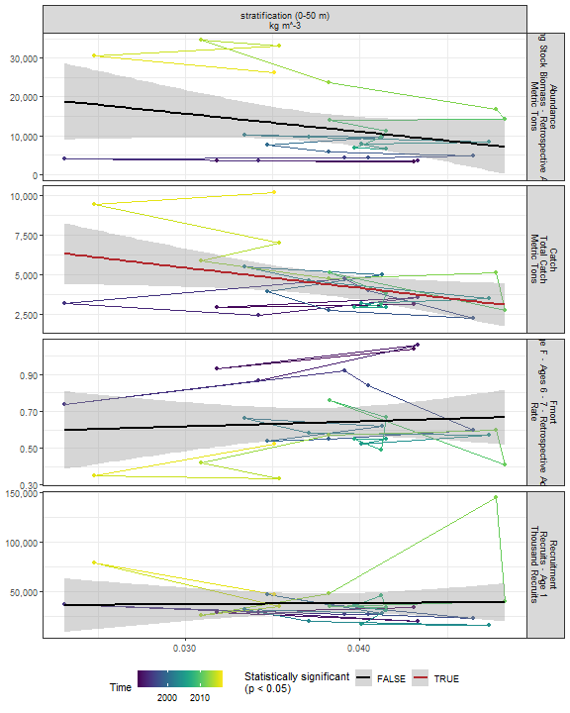

##### Regression statistics

Table 2.10: Catch vs stratification (0-50 m) kg m^-3

|  |  |  |  |  |
| --- | --- | --- | --- | --- |
|  | Estimate | Std. Error | t value | Pr(>|t|) |
| (Intercept) | 9270.54 | 2204.67 | 4.20 | 0.00 |
| Val | -127924.29 | 56707.01 | -2.26 | 0.03 |

|  |  |
| --- | --- |
| Name | Value |
| F-statistic | 5.09 |
| df | 1, 25 |
| R2 | 0.17 |
| R2-adj | 0.14 |

### 2.2.3 Wind

#### 2.2.3.1 Winter wind speed

##### Figures

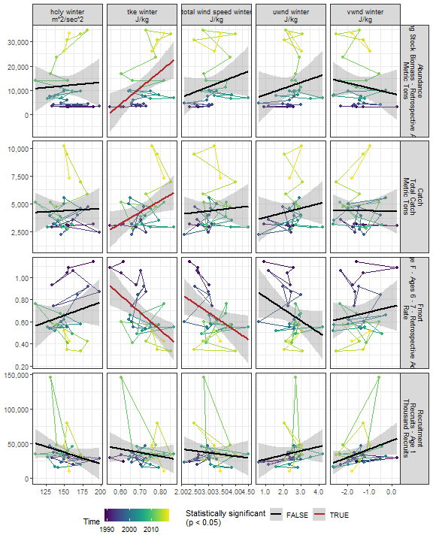

##### Regression statistics

Table 2.11: Catch vs tke winter J/kg

|  |  |  |  |  |
| --- | --- | --- | --- | --- |
|  | Estimate | Std. Error | t value | Pr(>|t|) |
| (Intercept) | -2908.65 | 3102.43 | -0.94 | 0.36 |
| Val | 10233.96 | 4334.77 | 2.36 | 0.03 |

|  |  |
| --- | --- |
| Name | Value |
| F-statistic | 5.57 |
| df | 1, 28 |
| R2 | 0.17 |
| R2-adj | 0.14 |

Table 2.11: Fmort vs tke winter J/kg

|  |  |  |  |  |
| --- | --- | --- | --- | --- |
|  | Estimate | Std. Error | t value | Pr(>|t|) |
| (Intercept) | 1.78 | 0.33 | 5.34 | 0 |
| Val | -1.56 | 0.46 | -3.36 | 0 |

|  |  |
| --- | --- |
| Name | Value |
| F-statistic | 11.31 |
| df | 1, 28 |
| R2 | 0.29 |
| R2-adj | 0.26 |

Table 2.11: Fmort vs total wind speed winter J/kg

|  |  |  |  |  |
| --- | --- | --- | --- | --- |
|  | Estimate | Std. Error | t value | Pr(>|t|) |
| (Intercept) | 1.17 | 0.22 | 5.22 | 0.00 |
| Val | -0.16 | 0.07 | -2.29 | 0.03 |

|  |  |
| --- | --- |
| Name | Value |
| F-statistic | 5.26 |
| df | 1, 28 |
| R2 | 0.16 |
| R2-adj | 0.13 |

Table 2.11: Abundance vs tke winter J/kg

|  |  |  |  |  |
| --- | --- | --- | --- | --- |
|  | Estimate | Std. Error | t value | Pr(>|t|) |
| (Intercept) | -35893.19 | 15234.91 | -2.36 | 0.03 |
| Val | 67122.49 | 21286.47 | 3.15 | 0.00 |

|  |  |
| --- | --- |
| Name | Value |
| F-statistic | 9.94 |
| df | 1, 28 |
| R2 | 0.26 |
| R2-adj | 0.24 |

#### 2.2.3.2 Spring wind speed

##### Figures

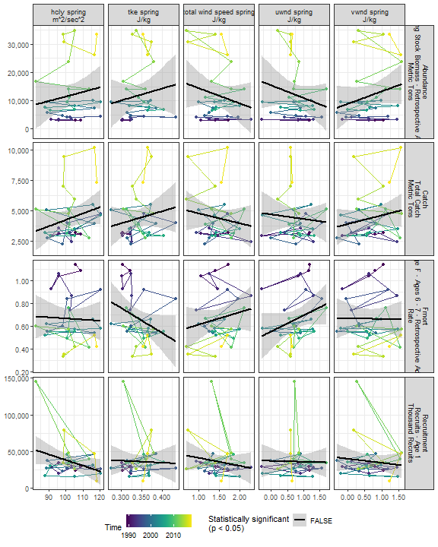

##### Regression statistics

[1] “No statistically significant data”

#### 2.2.3.3 Summer wind speed

##### Figures

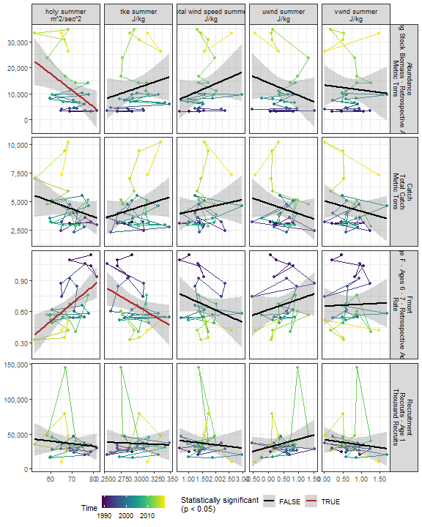

##### Regression statistics

Table 2.12: Fmort vs hcly summer m2/sec2

|  |  |  |  |  |
| --- | --- | --- | --- | --- |
|  | Estimate | Std. Error | t value | Pr(>|t|) |
| (Intercept) | -0.52 | 0.36 | -1.45 | 0.16 |
| Val | 0.02 | 0.01 | 3.32 | 0.00 |

|  |  |
| --- | --- |
| Name | Value |
| F-statistic | 11.04 |
| df | 1, 28 |
| R2 | 0.28 |
| R2-adj | 0.26 |

Table 2.12: Fmort vs tke summer J/kg

|  |  |  |  |  |
| --- | --- | --- | --- | --- |
|  | Estimate | Std. Error | t value | Pr(>|t|) |
| (Intercept) | 1.77 | 0.49 | 3.60 | 0.00 |
| Val | -3.72 | 1.65 | -2.25 | 0.03 |

|  |  |
| --- | --- |
| Name | Value |
| F-statistic | 5.07 |
| df | 1, 28 |
| R2 | 0.15 |
| R2-adj | 0.12 |

Table 2.12: Abundance vs hcly summer m2/sec2

|  |  |  |  |  |
| --- | --- | --- | --- | --- |
|  | Estimate | Std. Error | t value | Pr(>|t|) |
| (Intercept) | 55665.57 | 17073.09 | 3.26 | 0.00 |
| Val | -634.28 | 246.05 | -2.58 | 0.02 |

|  |  |
| --- | --- |
| Name | Value |
| F-statistic | 6.65 |
| df | 1, 28 |
| R2 | 0.19 |
| R2-adj | 0.16 |

#### 2.2.3.4 Fall wind speed

##### Figures

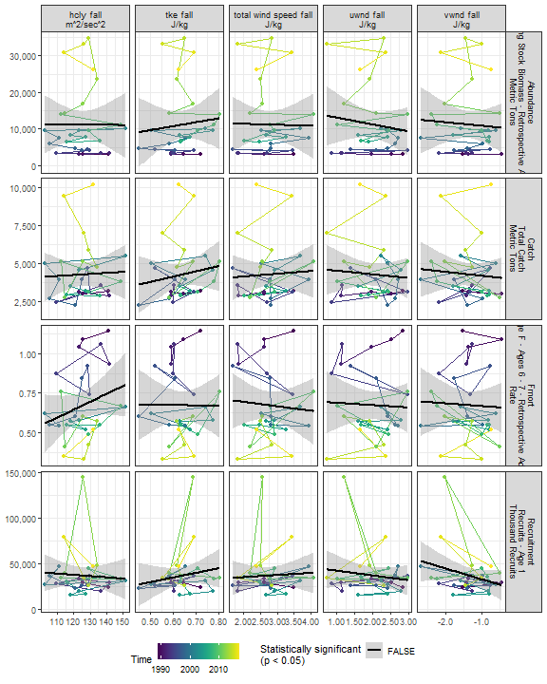

##### Regression statistics

[1] “No statistically significant data”

### 2.2.4 Gulf Stream Index

##### Figures

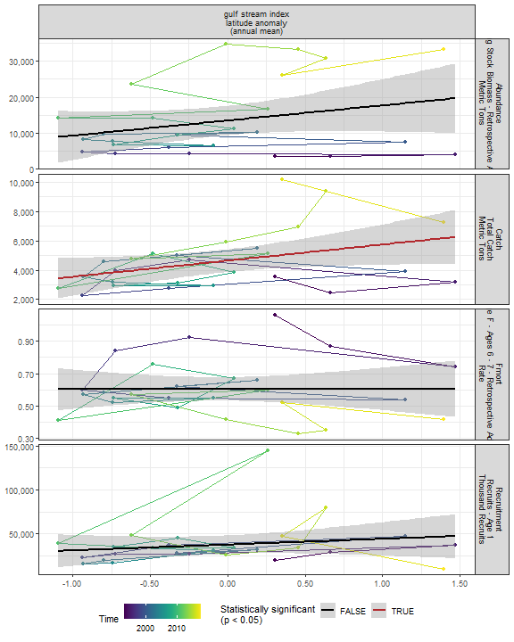

##### Regression statistics

Table 2.13: Catch vs gulf stream index latitude anomaly (annual mean)

|  |  |  |  |  |
| --- | --- | --- | --- | --- |
|  | Estimate | Std. Error | t value | Pr(>|t|) |
| (Intercept) | 4639.17 | 374.47 | 12.39 | 0.00 |
| Val | 1096.91 | 528.07 | 2.08 | 0.05 |

|  |  |
| --- | --- |
| Name | Value |
| F-statistic | 4.31 |
| df | 1, 24 |
| R2 | 0.15 |
| R2-adj | 0.12 |

### 2.2.5 North Atlantic Oscillation

##### Figures

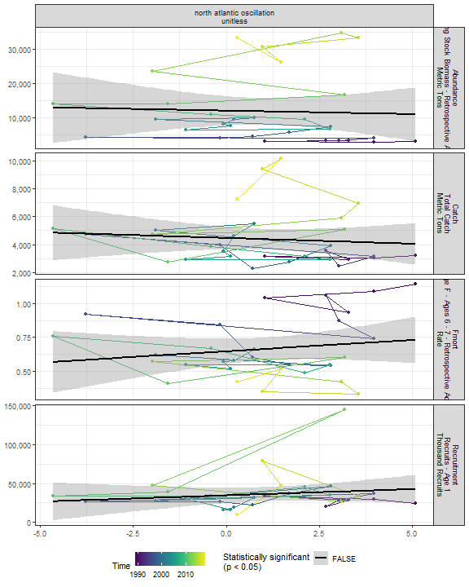

##### Regression statistics

[1] “No statistically significant data”

### 2.2.6 Species location

#### 2.2.6.1 Species distribution

##### Figures

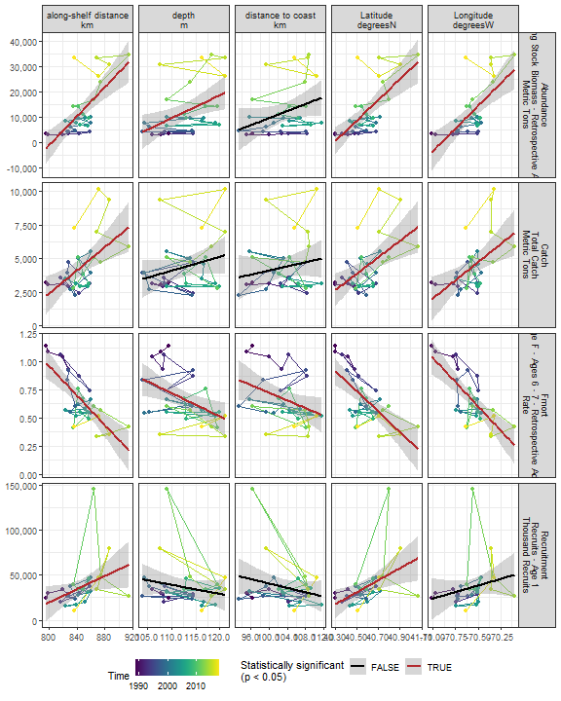

##### Regression statistics

Table 2.14: Catch vs Latitude degreesN

|  |  |  |  |  |
| --- | --- | --- | --- | --- |
|  | Estimate | Std. Error | t value | Pr(>|t|) |
| (Intercept) | -243694.99 | 73883.76 | -3.30 | 0 |
| Val | 6113.67 | 1820.85 | 3.36 | 0 |

|  |  |
| --- | --- |
| Name | Value |
| F-statistic | 11.27 |
| df | 1, 28 |
| R2 | 0.29 |
| R2-adj | 0.26 |

Table 2.14: Catch vs Longitude degreesW

|  |  |  |  |  |
| --- | --- | --- | --- | --- |
|  | Estimate | Std. Error | t value | Pr(>|t|) |
| (Intercept) | 383034.16 | 116496.27 | 3.29 | 0 |
| Val | 5365.62 | 1650.75 | 3.25 | 0 |

|  |  |
| --- | --- |
| Name | Value |
| F-statistic | 10.57 |
| df | 1, 28 |
| R2 | 0.27 |
| R2-adj | 0.25 |

Table 2.14: Catch vs along-shelf distance km

|  |  |  |  |  |
| --- | --- | --- | --- | --- |
|  | Estimate | Std. Error | t value | Pr(>|t|) |
| (Intercept) | -32440.24 | 10619.38 | -3.05 | 0 |
| Val | 43.55 | 12.56 | 3.47 | 0 |

|  |  |
| --- | --- |
| Name | Value |
| F-statistic | 12.03 |
| df | 1, 28 |
| R2 | 0.3 |
| R2-adj | 0.28 |

Table 2.14: Fmort vs Latitude degreesN

|  |  |  |  |  |
| --- | --- | --- | --- | --- |
|  | Estimate | Std. Error | t value | Pr(>|t|) |
| (Intercept) | 36.84 | 7.50 | 4.91 | 0 |
| Val | -0.89 | 0.18 | -4.82 | 0 |

|  |  |
| --- | --- |
| Name | Value |
| F-statistic | 23.23 |
| df | 1, 28 |
| R2 | 0.45 |
| R2-adj | 0.43 |

Table 2.14: Fmort vs Longitude degreesW

|  |  |  |  |  |
| --- | --- | --- | --- | --- |
|  | Estimate | Std. Error | t value | Pr(>|t|) |
| (Intercept) | -59.81 | 11.00 | -5.44 | 0 |
| Val | -0.86 | 0.16 | -5.50 | 0 |

|  |  |
| --- | --- |
| Name | Value |
| F-statistic | 30.24 |
| df | 1, 28 |
| R2 | 0.52 |
| R2-adj | 0.5 |

Table 2.14: Fmort vs along-shelf distance km

|  |  |  |  |  |
| --- | --- | --- | --- | --- |
|  | Estimate | Std. Error | t value | Pr(>|t|) |
| (Intercept) | 6.26 | 1.02 | 6.11 | 0 |
| Val | -0.01 | 0.00 | -5.46 | 0 |

|  |  |
| --- | --- |
| Name | Value |
| F-statistic | 29.86 |
| df | 1, 28 |
| R2 | 0.52 |
| R2-adj | 0.5 |

Table 2.14: Fmort vs depth m

|  |  |  |  |  |
| --- | --- | --- | --- | --- |
|  | Estimate | Std. Error | t value | Pr(>|t|) |
| (Intercept) | 3.00 | 0.81 | 3.69 | 0.00 |
| Val | -0.02 | 0.01 | -2.87 | 0.01 |

|  |  |
| --- | --- |
| Name | Value |
| F-statistic | 8.26 |
| df | 1, 28 |
| R2 | 0.23 |
| R2-adj | 0.2 |

Table 2.14: Fmort vs distance to coast km

|  |  |  |  |  |
| --- | --- | --- | --- | --- |
|  | Estimate | Std. Error | t value | Pr(>|t|) |
| (Intercept) | 2.43 | 0.82 | 2.96 | 0.01 |
| Val | -0.02 | 0.01 | -2.15 | 0.04 |

|  |  |
| --- | --- |
| Name | Value |
| F-statistic | 4.63 |
| df | 1, 28 |
| R2 | 0.14 |
| R2-adj | 0.11 |

Table 2.14: Recruitment vs Latitude degreesN

|  |  |  |  |  |
| --- | --- | --- | --- | --- |
|  | Estimate | Std. Error | t value | Pr(>|t|) |
| (Intercept) | -2652924.3 | 960154.03 | -2.76 | 0.01 |
| Val | 66271.8 | 23662.84 | 2.80 | 0.01 |

|  |  |
| --- | --- |
| Name | Value |
| F-statistic | 7.84 |
| df | 1, 28 |
| R2 | 0.22 |
| R2-adj | 0.19 |

Table 2.14: Recruitment vs along-shelf distance km

|  |  |  |  |  |
| --- | --- | --- | --- | --- |
|  | Estimate | Std. Error | t value | Pr(>|t|) |
| (Intercept) | -276515.83 | 146132.92 | -1.89 | 0.07 |
| Val | 369.82 | 172.79 | 2.14 | 0.04 |

|  |  |
| --- | --- |
| Name | Value |
| F-statistic | 4.58 |
| df | 1, 28 |
| R2 | 0.14 |
| R2-adj | 0.11 |

Table 2.14: Abundance vs Latitude degreesN

|  |  |  |  |  |
| --- | --- | --- | --- | --- |
|  | Estimate | Std. Error | t value | Pr(>|t|) |
| (Intercept) | -1648214.25 | 332019.98 | -4.96 | 0 |
| Val | 40912.92 | 8182.58 | 5.00 | 0 |

|  |  |
| --- | --- |
| Name | Value |
| F-statistic | 25 |
| df | 1, 28 |
| R2 | 0.47 |
| R2-adj | 0.45 |

Table 2.14: Abundance vs Longitude degreesW

|  |  |  |  |  |
| --- | --- | --- | --- | --- |
|  | Estimate | Std. Error | t value | Pr(>|t|) |
| (Intercept) | 2526922.83 | 532448.45 | 4.75 | 0 |
| Val | 35638.27 | 7544.77 | 4.72 | 0 |

|  |  |
| --- | --- |
| Name | Value |
| F-statistic | 22.31 |
| df | 1, 28 |
| R2 | 0.44 |
| R2-adj | 0.42 |

Table 2.14: Abundance vs along-shelf distance km

|  |  |  |  |  |
| --- | --- | --- | --- | --- |
|  | Estimate | Std. Error | t value | Pr(>|t|) |
| (Intercept) | -233747.67 | 47298.30 | -4.94 | 0 |
| Val | 290.54 | 55.93 | 5.20 | 0 |

|  |  |
| --- | --- |
| Name | Value |
| F-statistic | 26.99 |
| df | 1, 28 |
| R2 | 0.49 |
| R2-adj | 0.47 |

Table 2.14: Abundance vs depth m

|  |  |  |  |  |
| --- | --- | --- | --- | --- |
|  | Estimate | Std. Error | t value | Pr(>|t|) |
| (Intercept) | -89929.71 | 36852.43 | -2.44 | 0.02 |
| Val | 903.73 | 326.81 | 2.77 | 0.01 |

|  |  |
| --- | --- |
| Name | Value |
| F-statistic | 7.65 |
| df | 1, 28 |
| R2 | 0.21 |
| R2-adj | 0.19 |

#### 2.2.6.2 Northern range

Northernmost survey observation in each year.

##### Figures

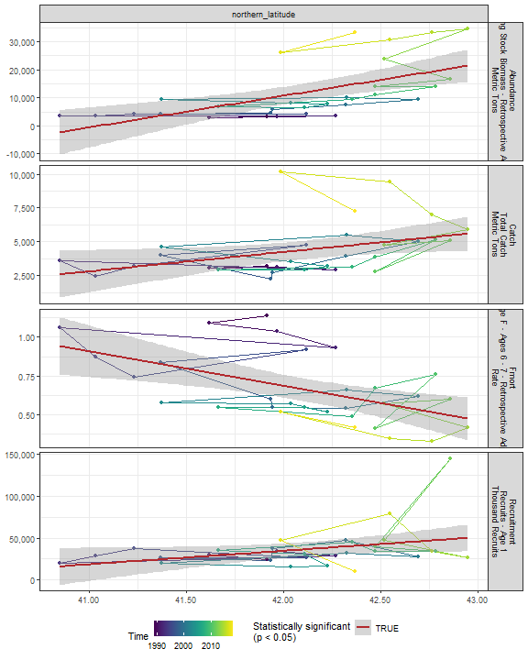

##### Regression statistics

Table 2.15: Catch vs northern_latitude

|  |  |  |  |  |
| --- | --- | --- | --- | --- |
|  | Estimate | Std. Error | t value | Pr(>|t|) |
| (Intercept) | -55715.69 | 26231.39 | -2.12 | 0.04 |
| Val | 1427.23 | 622.99 | 2.29 | 0.03 |

|  |  |
| --- | --- |
| Name | Value |
| F-statistic | 5.25 |
| df | 1, 28 |
| R2 | 0.16 |
| R2-adj | 0.13 |

Table 2.15: Fmort vs northern_latitude

|  |  |  |  |  |
| --- | --- | --- | --- | --- |
|  | Estimate | Std. Error | t value | Pr(>|t|) |
| (Intercept) | 10.07 | 2.80 | 3.60 | 0 |
| Val | -0.22 | 0.07 | -3.36 | 0 |

|  |  |
| --- | --- |
| Name | Value |
| F-statistic | 11.28 |
| df | 1, 28 |
| R2 | 0.29 |
| R2-adj | 0.26 |

Table 2.15: Recruitment vs northern_latitude

|  |  |  |  |  |
| --- | --- | --- | --- | --- |
|  | Estimate | Std. Error | t value | Pr(>|t|) |
| (Intercept) | -643401.13 | 330822.15 | -1.94 | 0.06 |
| Val | 16139.92 | 7856.94 | 2.05 | 0.05 |

|  |  |
| --- | --- |
| Name | Value |
| F-statistic | 4.22 |
| df | 1, 28 |
| R2 | 0.13 |
| R2-adj | 0.1 |

Table 2.15: Abundance vs northern_latitude

|  |  |  |  |  |
| --- | --- | --- | --- | --- |
|  | Estimate | Std. Error | t value | Pr(>|t|) |
| (Intercept) | -463707.94 | 119113.65 | -3.89 | 0 |
| Val | 11295.82 | 2828.92 | 3.99 | 0 |

|  |  |
| --- | --- |
| Name | Value |
| F-statistic | 15.94 |
| df | 1, 28 |
| R2 | 0.36 |
| R2-adj | 0.34 |

#### 2.2.6.3 Southern range

Southernmost survey observation in each year.

##### Figures

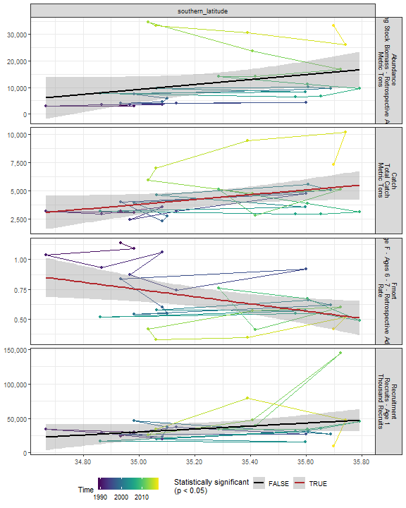

##### Regression statistics

Table 2.16: Catch vs southern_latitude

|  |  |  |  |  |
| --- | --- | --- | --- | --- |
|  | Estimate | Std. Error | t value | Pr(>|t|) |
| (Intercept) | -71418.84 | 36351.22 | -1.96 | 0.06 |
| Val | 2148.09 | 1030.20 | 2.09 | 0.05 |

|  |  |
| --- | --- |
| Name | Value |
| F-statistic | 4.35 |
| df | 1, 28 |
| R2 | 0.13 |
| R2-adj | 0.1 |

Table 2.16: Fmort vs southern_latitude

|  |  |  |  |  |
| --- | --- | --- | --- | --- |
|  | Estimate | Std. Error | t value | Pr(>|t|) |
| (Intercept) | 11.32 | 4.06 | 2.79 | 0.01 |
| Val | -0.30 | 0.12 | -2.62 | 0.01 |

|  |  |
| --- | --- |
| Name | Value |
| F-statistic | 6.88 |
| df | 1, 28 |
| R2 | 0.2 |
| R2-adj | 0.17 |

## 2.3 Trophic indicators

### 2.3.1 Chlorophyll

#### 2.3.1.1 Annual chlorophyll

##### Figures

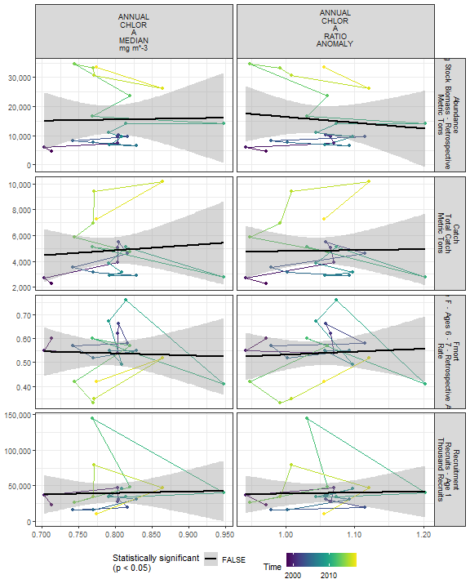

##### Regression statistics

[1] “No statistically significant data”

#### 2.3.1.2 Monthly chlorophyll

##### Figures

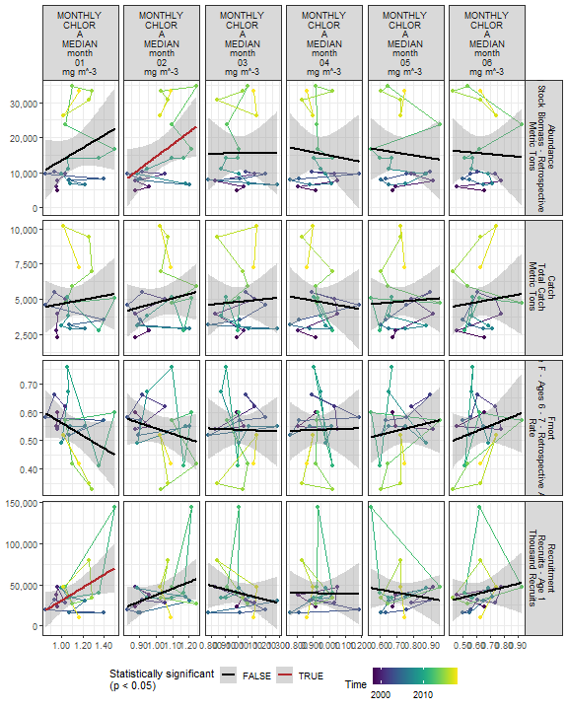

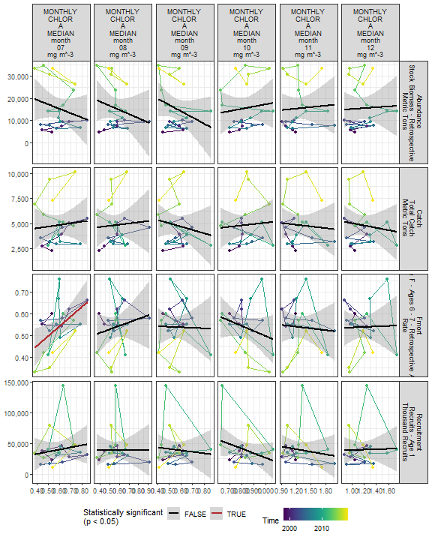

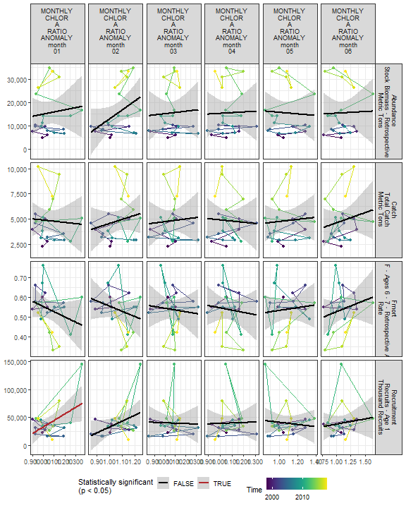

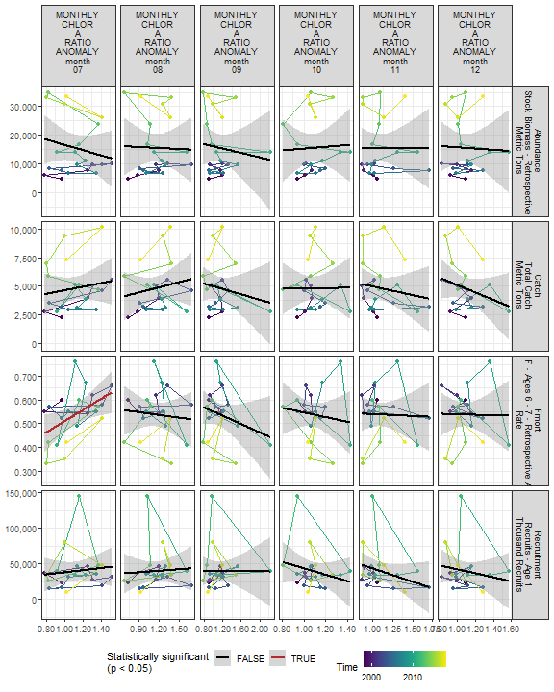

##### Regression statistics

Table 2.17: Fmort vs MONTHLY CHLOR A MEDIAN month 07 mg m^-3

|  |  |  |  |  |
| --- | --- | --- | --- | --- |
|  | Estimate | Std. Error | t value | Pr(>|t|) |
| (Intercept) | 0.27 | 0.11 | 2.57 | 0.02 |
| Val | 0.45 | 0.17 | 2.58 | 0.02 |

|  |  |
| --- | --- |
| Name | Value |
| F-statistic | 6.68 |
| df | 1, 19 |
| R2 | 0.26 |
| R2-adj | 0.22 |

Table 2.17: Fmort vs MONTHLY CHLOR A RATIO ANOMALY month 07

|  |  |  |  |  |
| --- | --- | --- | --- | --- |
|  | Estimate | Std. Error | t value | Pr(>|t|) |
| (Intercept) | 0.27 | 0.11 | 2.60 | 0.02 |
| Val | 0.24 | 0.09 | 2.53 | 0.02 |

|  |  |
| --- | --- |
| Name | Value |
| F-statistic | 6.38 |
| df | 1, 19 |
| R2 | 0.25 |
| R2-adj | 0.21 |

Table 2.17: Recruitment vs MONTHLY CHLOR A MEDIAN month 01 mg m^-3

|  |  |  |  |  |
| --- | --- | --- | --- | --- |
|  | Estimate | Std. Error | t value | Pr(>|t|) |
| (Intercept) | -49196.86 | 38135.28 | -1.29 | 0.21 |
| Val | 79831.89 | 33988.41 | 2.35 | 0.03 |

|  |  |
| --- | --- |
| Name | Value |
| F-statistic | 5.52 |
| df | 1, 19 |
| R2 | 0.23 |
| R2-adj | 0.18 |

Table 2.17: Recruitment vs MONTHLY CHLOR A RATIO ANOMALY month 01

|  |  |  |  |  |
| --- | --- | --- | --- | --- |
|  | Estimate | Std. Error | t value | Pr(>|t|) |
| (Intercept) | -83810.09 | 50551.08 | -1.66 | 0.11 |
| Val | 116543.03 | 47525.19 | 2.45 | 0.02 |

|  |  |
| --- | --- |
| Name | Value |
| F-statistic | 6.01 |
| df | 1, 19 |
| R2 | 0.24 |
| R2-adj | 0.2 |

Table 2.17: Abundance vs MONTHLY CHLOR A MEDIAN month 02 mg m^-3

|  |  |  |  |  |
| --- | --- | --- | --- | --- |
|  | Estimate | Std. Error | t value | Pr(>|t|) |
| (Intercept) | -20542.38 | 16925.93 | -1.21 | 0.24 |
| Val | 35073.74 | 16381.21 | 2.14 | 0.05 |

|  |  |
| --- | --- |
| Name | Value |
| F-statistic | 4.58 |
| df | 1, 19 |
| R2 | 0.19 |
| R2-adj | 0.15 |

#### 2.3.1.3 Weekly chlorophyll

##### Figures

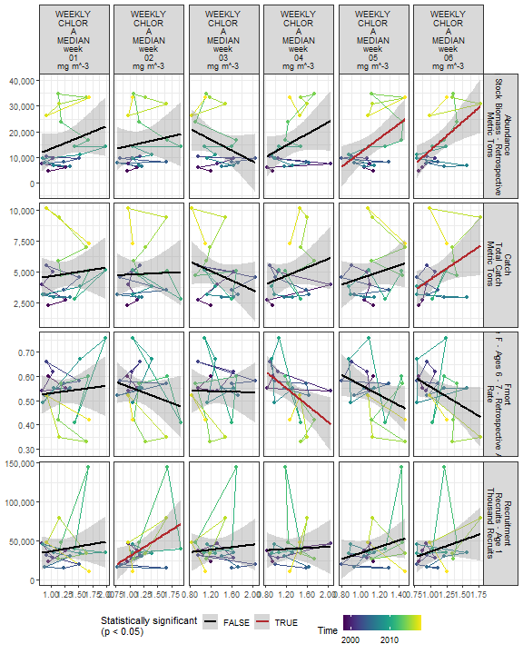

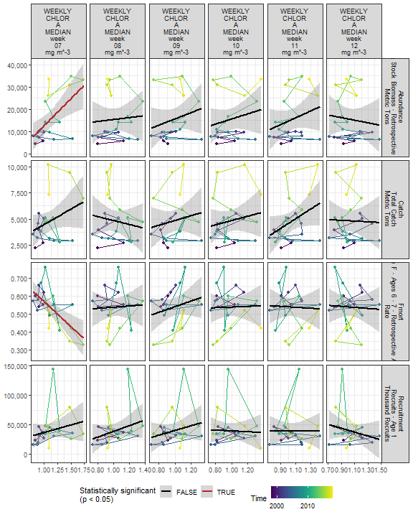

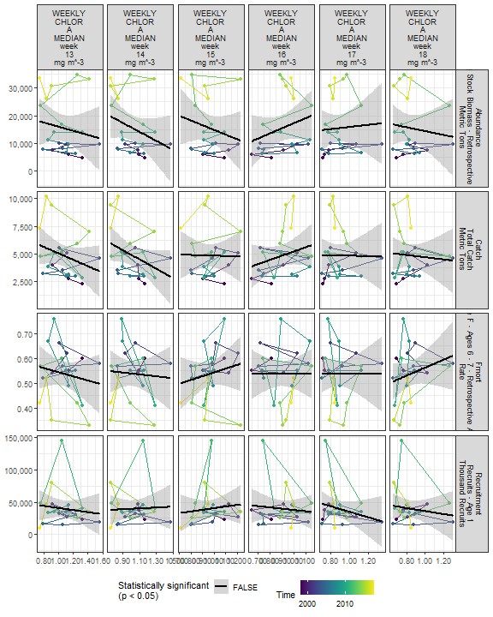

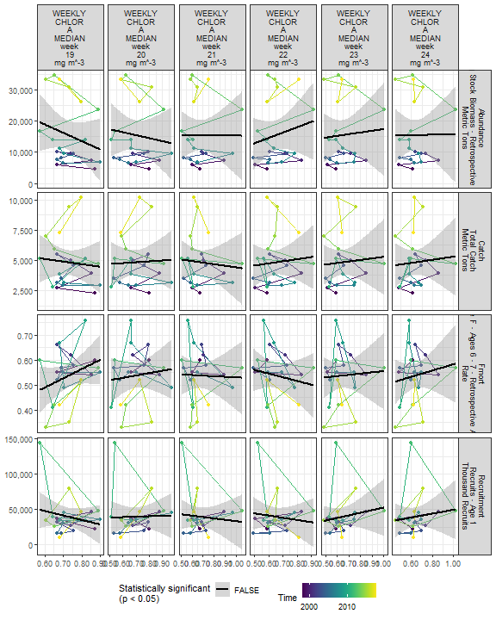

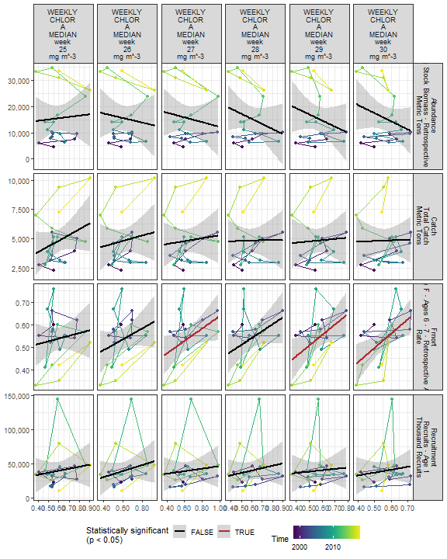

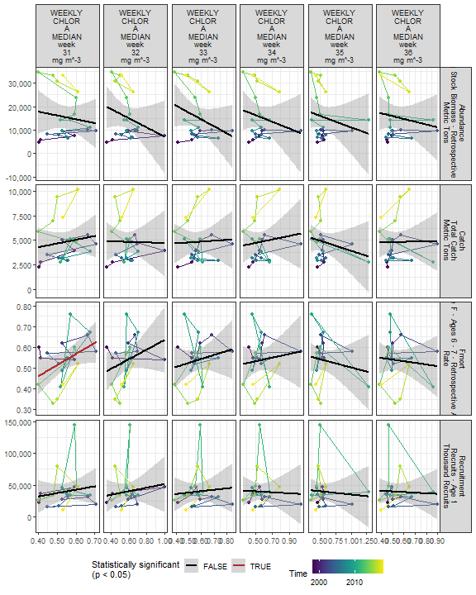

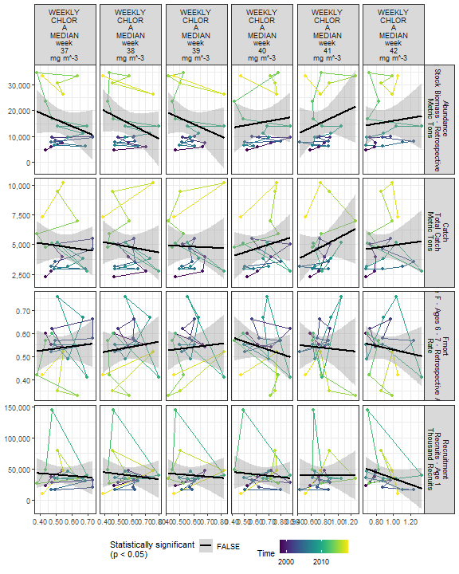

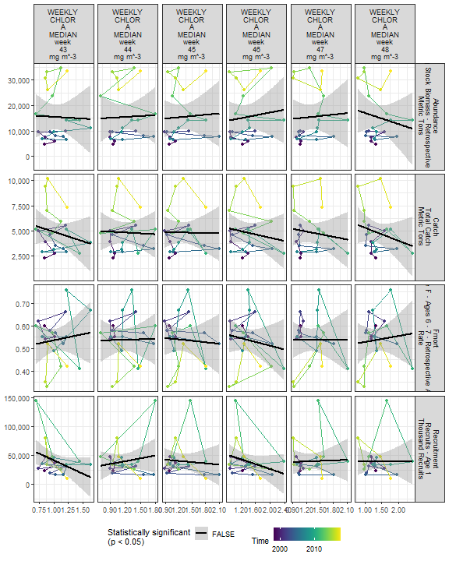

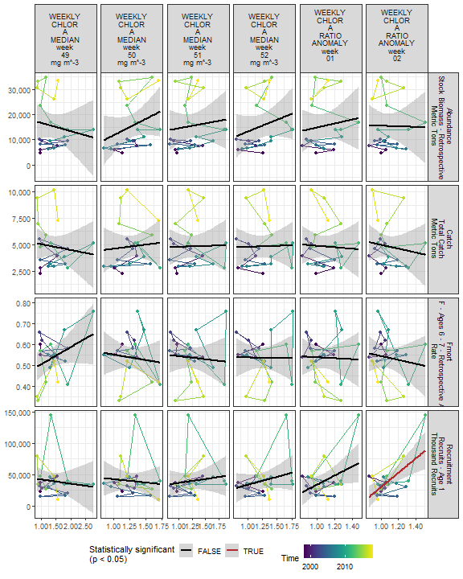

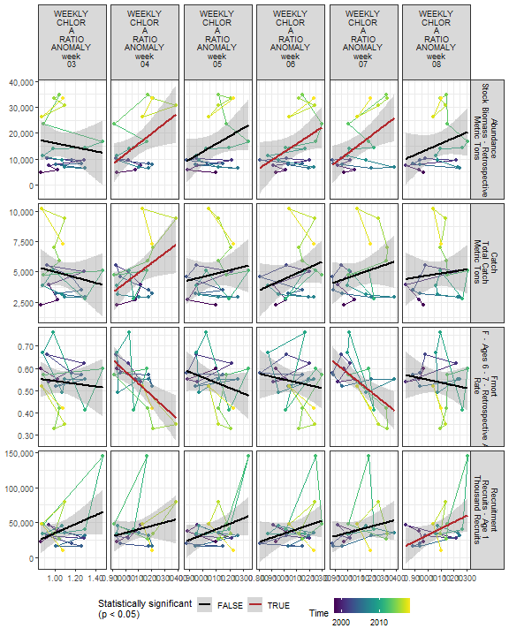

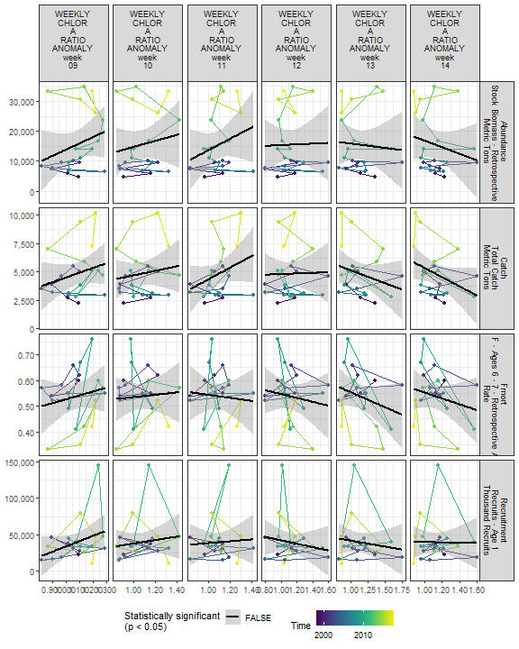

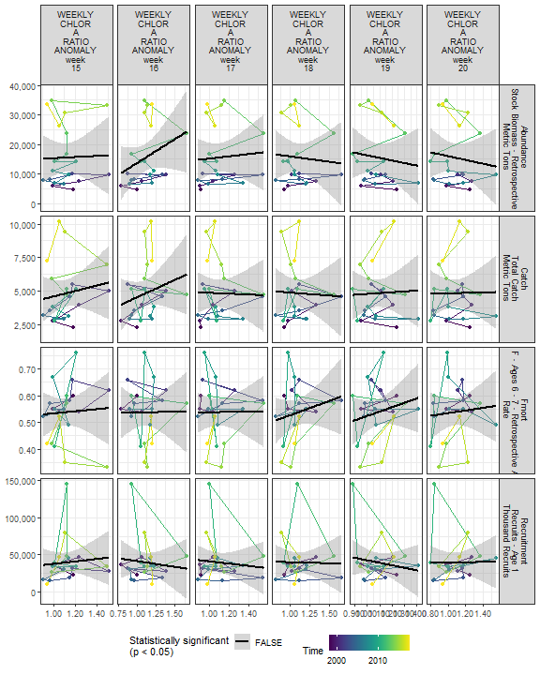

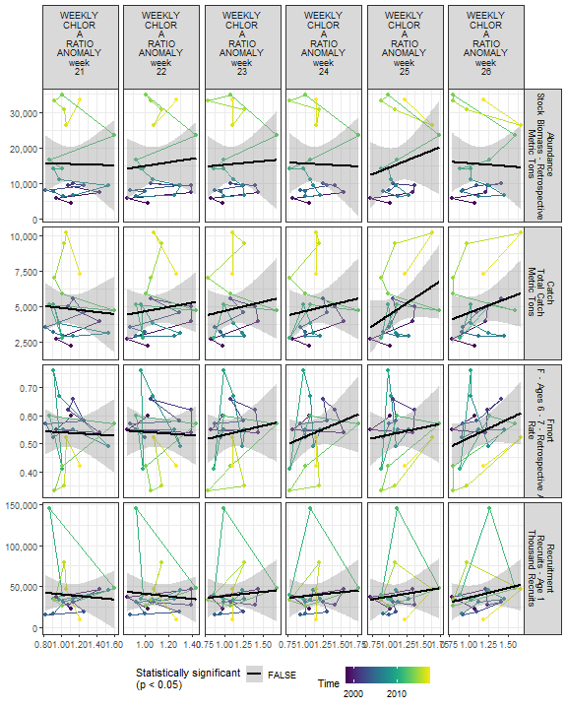

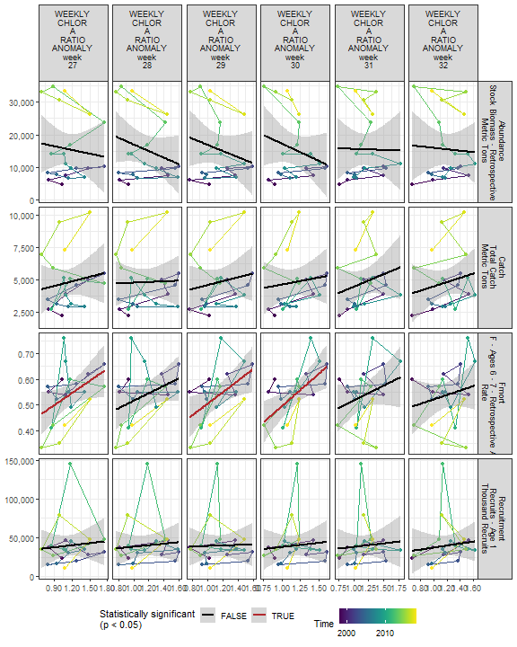

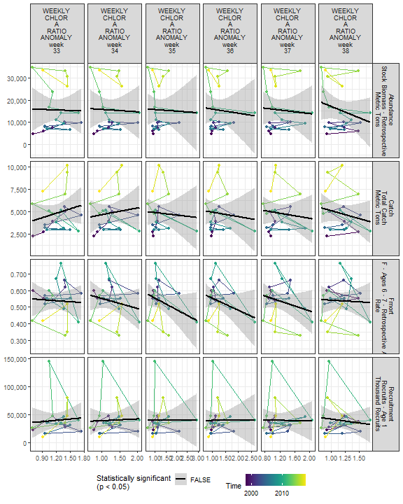

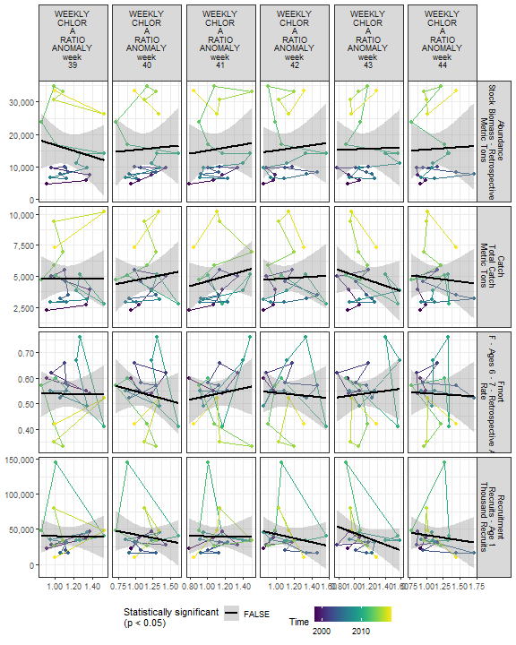

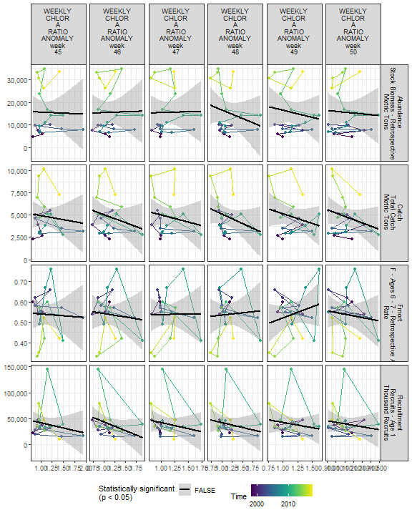

##### Regression statistics

Table 2.18: Catch vs WEEKLY CHLOR A MEDIAN week 06 mg m^-3

|  |  |  |  |  |
| --- | --- | --- | --- | --- |
|  | Estimate | Std. Error | t value | Pr(>|t|) |
| (Intercept) | 855.35 | 1891.18 | 0.45 | 0.66 |
| Val | 3540.81 | 1647.32 | 2.15 | 0.04 |

|  |  |
| --- | --- |
| Name | Value |
| F-statistic | 4.62 |
| df | 1, 19 |
| R2 | 0.2 |
| R2-adj | 0.15 |

Table 2.18: Catch vs WEEKLY CHLOR A RATIO ANOMALY week 04

|  |  |  |  |  |
| --- | --- | --- | --- | --- |
|  | Estimate | Std. Error | t value | Pr(>|t|) |
| (Intercept) | -4055.93 | 3865.68 | -1.05 | 0.31 |
| Val | 8145.43 | 3529.01 | 2.31 | 0.03 |

|  |  |
| --- | --- |
| Name | Value |
| F-statistic | 5.33 |
| df | 1, 19 |
| R2 | 0.22 |
| R2-adj | 0.18 |

Table 2.18: Fmort vs WEEKLY CHLOR A RATIO ANOMALY week 04

|  |  |  |  |  |
| --- | --- | --- | --- | --- |
|  | Estimate | Std. Error | t value | Pr(>|t|) |
| (Intercept) | 1.13 | 0.17 | 6.76 | 0 |
| Val | -0.54 | 0.15 | -3.56 | 0 |

|  |  |
| --- | --- |
| Name | Value |
| F-statistic | 12.68 |
| df | 1, 19 |
| R2 | 0.4 |
| R2-adj | 0.37 |

Table 2.18: Fmort vs WEEKLY CHLOR A MEDIAN week 04 mg m^-3

|  |  |  |  |  |
| --- | --- | --- | --- | --- |
|  | Estimate | Std. Error | t value | Pr(>|t|) |
| (Intercept) | 0.76 | 0.08 | 9.14 | 0.00 |
| Val | -0.17 | 0.06 | -2.77 | 0.01 |

|  |  |
| --- | --- |
| Name | Value |
| F-statistic | 7.69 |
| df | 1, 19 |
| R2 | 0.29 |
| R2-adj | 0.25 |

Table 2.18: Fmort vs WEEKLY CHLOR A MEDIAN week 07 mg m^-3

|  |  |  |  |  |
| --- | --- | --- | --- | --- |
|  | Estimate | Std. Error | t value | Pr(>|t|) |
| (Intercept) | 0.84 | 0.08 | 10.56 | 0 |
| Val | -0.28 | 0.07 | -3.94 | 0 |

|  |  |
| --- | --- |
| Name | Value |
| F-statistic | 15.5 |
| df | 1, 19 |
| R2 | 0.45 |
| R2-adj | 0.42 |

Table 2.18: Fmort vs WEEKLY CHLOR A MEDIAN week 27 mg m^-3

|  |  |  |  |  |
| --- | --- | --- | --- | --- |
|  | Estimate | Std. Error | t value | Pr(>|t|) |
| (Intercept) | 0.36 | 0.08 | 4.27 | 0.00 |
| Val | 0.28 | 0.13 | 2.15 | 0.04 |

|  |  |
| --- | --- |
| Name | Value |
| F-statistic | 4.64 |
| df | 1, 19 |
| R2 | 0.2 |
| R2-adj | 0.15 |

Table 2.18: Fmort vs WEEKLY CHLOR A MEDIAN week 29 mg m^-3

|  |  |  |  |  |
| --- | --- | --- | --- | --- |
|  | Estimate | Std. Error | t value | Pr(>|t|) |
| (Intercept) | 0.27 | 0.11 | 2.38 | 0.03 |
| Val | 0.47 | 0.20 | 2.40 | 0.03 |

|  |  |
| --- | --- |
| Name | Value |
| F-statistic | 5.75 |
| df | 1, 19 |
| R2 | 0.23 |
| R2-adj | 0.19 |

Table 2.18: Fmort vs WEEKLY CHLOR A MEDIAN week 30 mg m^-3

|  |  |  |  |  |
| --- | --- | --- | --- | --- |
|  | Estimate | Std. Error | t value | Pr(>|t|) |
| (Intercept) | 0.18 | 0.12 | 1.50 | 0.15 |
| Val | 0.63 | 0.21 | 3.02 | 0.01 |

|  |  |
| --- | --- |
| Name | Value |
| F-statistic | 9.13 |
| df | 1, 19 |
| R2 | 0.32 |
| R2-adj | 0.29 |

Table 2.18: Fmort vs WEEKLY CHLOR A MEDIAN week 31 mg m^-3

|  |  |  |  |  |
| --- | --- | --- | --- | --- |
|  | Estimate | Std. Error | t value | Pr(>|t|) |
| (Intercept) | 0.24 | 0.14 | 1.74 | 0.10 |
| Val | 0.54 | 0.26 | 2.09 | 0.05 |

|  |  |
| --- | --- |
| Name | Value |
| F-statistic | 4.39 |
| df | 1, 19 |
| R2 | 0.19 |
| R2-adj | 0.14 |

Table 2.18: Fmort vs WEEKLY CHLOR A RATIO ANOMALY week 07

|  |  |  |  |  |
| --- | --- | --- | --- | --- |
|  | Estimate | Std. Error | t value | Pr(>|t|) |
| (Intercept) | 1.01 | 0.14 | 7.39 | 0 |
| Val | -0.43 | 0.12 | -3.49 | 0 |

|  |  |
| --- | --- |
| Name | Value |
| F-statistic | 12.21 |
| df | 1, 19 |
| R2 | 0.39 |
| R2-adj | 0.36 |

Table 2.18: Fmort vs WEEKLY CHLOR A RATIO ANOMALY week 27

|  |  |  |  |  |
| --- | --- | --- | --- | --- |
|  | Estimate | Std. Error | t value | Pr(>|t|) |
| (Intercept) | 0.36 | 0.09 | 4.12 | 0.00 |
| Val | 0.16 | 0.07 | 2.16 | 0.04 |

|  |  |
| --- | --- |
| Name | Value |
| F-statistic | 4.65 |
| df | 1, 19 |
| R2 | 0.2 |
| R2-adj | 0.15 |

Table 2.18: Fmort vs WEEKLY CHLOR A RATIO ANOMALY week 29

|  |  |  |  |  |
| --- | --- | --- | --- | --- |
|  | Estimate | Std. Error | t value | Pr(>|t|) |
| (Intercept) | 0.28 | 0.10 | 2.81 | 0.01 |
| Val | 0.23 | 0.08 | 2.69 | 0.01 |

|  |  |
| --- | --- |
| Name | Value |
| F-statistic | 7.21 |
| df | 1, 19 |
| R2 | 0.28 |
| R2-adj | 0.24 |

Table 2.18: Fmort vs WEEKLY CHLOR A RATIO ANOMALY week 30

|  |  |  |  |  |
| --- | --- | --- | --- | --- |
|  | Estimate | Std. Error | t value | Pr(>|t|) |
| (Intercept) | 0.24 | 0.10 | 2.50 | 0.02 |
| Val | 0.25 | 0.08 | 3.11 | 0.01 |

|  |  |
| --- | --- |
| Name | Value |
| F-statistic | 9.7 |
| df | 1, 19 |
| R2 | 0.34 |
| R2-adj | 0.3 |

Table 2.18: Recruitment vs WEEKLY CHLOR A MEDIAN week 02 mg m^-3

|  |  |  |  |  |
| --- | --- | --- | --- | --- |
|  | Estimate | Std. Error | t value | Pr(>|t|) |
| (Intercept) | -14639.49 | 23585.21 | -0.62 | 0.54 |
| Val | 44997.15 | 19077.91 | 2.36 | 0.03 |

|  |  |
| --- | --- |
| Name | Value |
| F-statistic | 5.56 |
| df | 1, 19 |
| R2 | 0.23 |
| R2-adj | 0.19 |

Table 2.18: Recruitment vs WEEKLY CHLOR A RATIO ANOMALY week 02

|  |  |  |  |  |
| --- | --- | --- | --- | --- |
|  | Estimate | Std. Error | t value | Pr(>|t|) |
| (Intercept) | -84581.32 | 34504.29 | -2.45 | 0.02 |
| Val | 114681.17 | 31593.47 | 3.63 | 0.00 |

|  |  |
| --- | --- |
| Name | Value |
| F-statistic | 13.18 |
| df | 1, 19 |
| R2 | 0.41 |
| R2-adj | 0.38 |

Table 2.18: Recruitment vs WEEKLY CHLOR A RATIO ANOMALY week 08

|  |  |  |  |  |
| --- | --- | --- | --- | --- |
|  | Estimate | Std. Error | t value | Pr(>|t|) |
| (Intercept) | -58492.99 | 47038.09 | -1.24 | 0.23 |
| Val | 90726.60 | 43267.27 | 2.10 | 0.05 |

|  |  |
| --- | --- |
| Name | Value |
| F-statistic | 4.4 |
| df | 1, 19 |
| R2 | 0.19 |
| R2-adj | 0.15 |

Table 2.18: Abundance vs WEEKLY CHLOR A MEDIAN week 06 mg m^-3

|  |  |  |  |  |
| --- | --- | --- | --- | --- |
|  | Estimate | Std. Error | t value | Pr(>|t|) |
| (Intercept) | -9291.65 | 8189.95 | -1.13 | 0.27 |
| Val | 22120.47 | 7133.92 | 3.10 | 0.01 |

|  |  |
| --- | --- |
| Name | Value |
| F-statistic | 9.61 |
| df | 1, 19 |
| R2 | 0.34 |
| R2-adj | 0.3 |

Table 2.18: Abundance vs WEEKLY CHLOR A RATIO ANOMALY week 04

|  |  |  |  |  |
| --- | --- | --- | --- | --- |
|  | Estimate | Std. Error | t value | Pr(>|t|) |
| (Intercept) | -27974.68 | 18285.16 | -1.53 | 0.14 |
| Val | 39865.08 | 16692.66 | 2.39 | 0.03 |

|  |  |
| --- | --- |
| Name | Value |
| F-statistic | 5.7 |
| df | 1, 19 |
| R2 | 0.23 |
| R2-adj | 0.19 |

Table 2.18: Abundance vs WEEKLY CHLOR A MEDIAN week 07 mg m^-3

|  |  |  |  |  |
| --- | --- | --- | --- | --- |
|  | Estimate | Std. Error | t value | Pr(>|t|) |
| (Intercept) | -11507.59 | 8303.46 | -1.39 | 0.18 |
| Val | 24227.21 | 7284.81 | 3.33 | 0.00 |

|  |  |
| --- | --- |
| Name | Value |
| F-statistic | 11.06 |
| df | 1, 19 |
| R2 | 0.37 |
| R2-adj | 0.33 |

Table 2.18: Abundance vs WEEKLY CHLOR A RATIO ANOMALY week 07

|  |  |  |  |  |
| --- | --- | --- | --- | --- |
|  | Estimate | Std. Error | t value | Pr(>|t|) |
| (Intercept) | -23142.94 | 14471.56 | -1.60 | 0.13 |
| Val | 35253.06 | 13105.31 | 2.69 | 0.01 |

|  |  |
| --- | --- |
| Name | Value |
| F-statistic | 7.24 |
| df | 1, 19 |
| R2 | 0.28 |
| R2-adj | 0.24 |

Table 2.18: Abundance vs WEEKLY CHLOR A MEDIAN week 05 mg m^-3

|  |  |  |  |  |
| --- | --- | --- | --- | --- |
|  | Estimate | Std. Error | t value | Pr(>|t|) |
| (Intercept) | -15981.99 | 11355.21 | -1.41 | 0.18 |
| Val | 27883.52 | 9933.03 | 2.81 | 0.01 |

|  |  |
| --- | --- |
| Name | Value |
| F-statistic | 7.88 |
| df | 1, 19 |
| R2 | 0.29 |
| R2-adj | 0.26 |

Table 2.18: Abundance vs WEEKLY CHLOR A RATIO ANOMALY week 06

|  |  |  |  |  |
| --- | --- | --- | --- | --- |
|  | Estimate | Std. Error | t value | Pr(>|t|) |
| (Intercept) | -19097.09 | 16585.31 | -1.15 | 0.26 |
| Val | 31715.77 | 15116.74 | 2.10 | 0.05 |

|  |  |
| --- | --- |
| Name | Value |
| F-statistic | 4.4 |
| df | 1, 19 |
| R2 | 0.19 |
| R2-adj | 0.15 |

### 2.3.2 Primary production

#### 2.3.2.1 Annual primary production

##### Figures

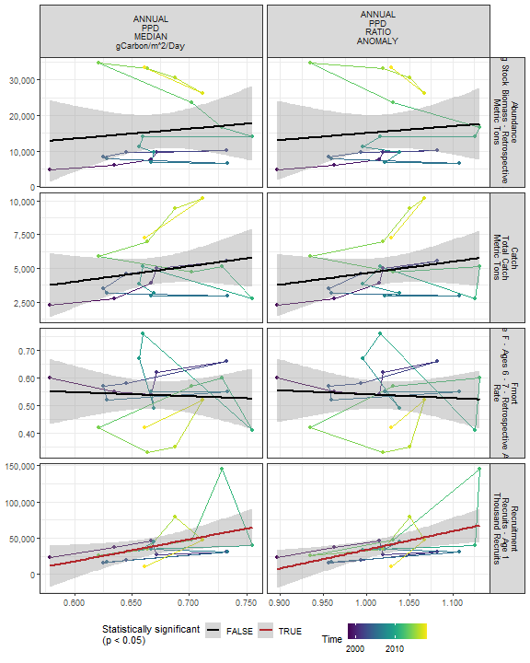

##### Regression statistics

Table 2.19: Recruitment vs ANNUAL PPD MEDIAN gCarbon/m^2/Day

|  |  |  |  |  |
| --- | --- | --- | --- | --- |
|  | Estimate | Std. Error | t value | Pr(>|t|) |
| (Intercept) | -163192.6 | 88337.88 | -1.85 | 0.08 |
| Val | 301760.6 | 131306.96 | 2.30 | 0.03 |

|  |  |
| --- | --- |
| Name | Value |
| F-statistic | 5.28 |
| df | 1, 19 |
| R2 | 0.22 |
| R2-adj | 0.18 |

Table 2.19: Recruitment vs ANNUAL PPD RATIO ANOMALY

|  |  |  |  |  |
| --- | --- | --- | --- | --- |
|  | Estimate | Std. Error | t value | Pr(>|t|) |
| (Intercept) | -222071.3 | 91655.99 | -2.42 | 0.03 |
| Val | 255939.5 | 89563.21 | 2.86 | 0.01 |

|  |  |
| --- | --- |
| Name | Value |
| F-statistic | 8.17 |
| df | 1, 19 |
| R2 | 0.3 |
| R2-adj | 0.26 |

#### 2.3.2.2 Monthly primary production

##### Figures

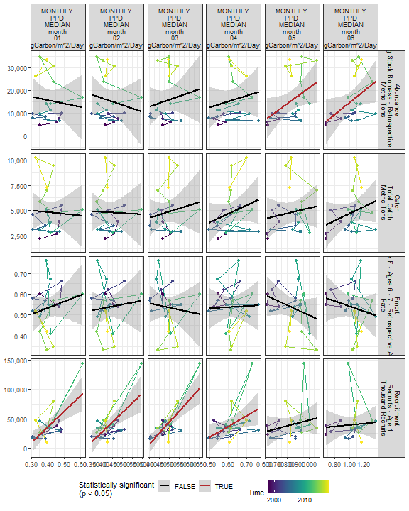

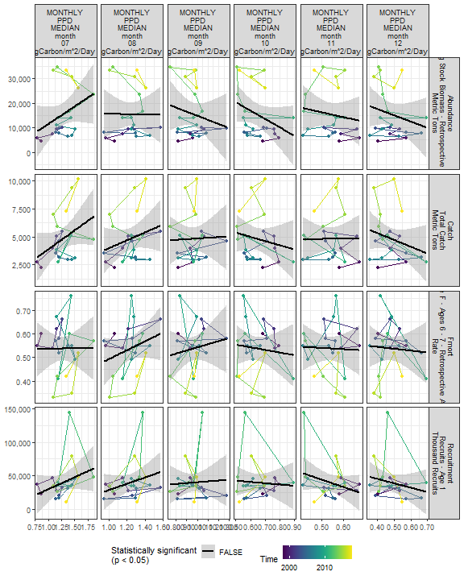

##### Regression statistics

Table 2.20: Recruitment vs MONTHLY PPD MEDIAN month 01 gCarbon/m^2/Day

|  |  |  |  |  |
| --- | --- | --- | --- | --- |
|  | Estimate | Std. Error | t value | Pr(>|t|) |
| (Intercept) | -71830.36 | 28479.34 | -2.52 | 0.02 |
| Val | 268276.96 | 67743.60 | 3.96 | 0.00 |

|  |  |
| --- | --- |
| Name | Value |
| F-statistic | 15.68 |
| df | 1, 19 |
| R2 | 0.45 |
| R2-adj | 0.42 |

Table 2.20: Recruitment vs MONTHLY PPD MEDIAN month 02 gCarbon/m^2/Day

|  |  |  |  |  |
| --- | --- | --- | --- | --- |
|  | Estimate | Std. Error | t value | Pr(>|t|) |
| (Intercept) | -105542.1 | 39423.00 | -2.68 | 0.01 |
| Val | 332766.7 | 89820.81 | 3.70 | 0.00 |

|  |  |
| --- | --- |
| Name | Value |
| F-statistic | 13.73 |
| df | 1, 19 |
| R2 | 0.42 |
| R2-adj | 0.39 |

Table 2.20: Recruitment vs MONTHLY PPD MEDIAN month 03 gCarbon/m^2/Day

|  |  |  |  |  |
| --- | --- | --- | --- | --- |
|  | Estimate | Std. Error | t value | Pr(>|t|) |
| (Intercept) | -145143.8 | 35665.73 | -4.07 | 0 |
| Val | 379345.0 | 72830.84 | 5.21 | 0 |

|  |  |
| --- | --- |
| Name | Value |
| F-statistic | 27.13 |
| df | 1, 19 |
| R2 | 0.59 |
| R2-adj | 0.57 |

Table 2.20: Recruitment vs MONTHLY PPD MEDIAN month 04 gCarbon/m^2/Day

|  |  |  |  |  |
| --- | --- | --- | --- | --- |
|  | Estimate | Std. Error | t value | Pr(>|t|) |
| (Intercept) | -72635.14 | 50598.23 | -1.44 | 0.17 |
| Val | 182336.39 | 81826.62 | 2.23 | 0.04 |

|  |  |
| --- | --- |
| Name | Value |
| F-statistic | 4.97 |
| df | 1, 19 |
| R2 | 0.21 |
| R2-adj | 0.17 |

Table 2.20: Abundance vs MONTHLY PPD MEDIAN month 05 gCarbon/m^2/Day

|  |  |  |  |  |
| --- | --- | --- | --- | --- |
|  | Estimate | Std. Error | t value | Pr(>|t|) |
| (Intercept) | -13820.44 | 14015.78 | -0.99 | 0.34 |
| Val | 34890.22 | 16536.26 | 2.11 | 0.05 |

|  |  |
| --- | --- |
| Name | Value |
| F-statistic | 4.45 |
| df | 1, 19 |
| R2 | 0.19 |
| R2-adj | 0.15 |

Table 2.20: Abundance vs MONTHLY PPD MEDIAN month 06 gCarbon/m^2/Day

|  |  |  |  |  |
| --- | --- | --- | --- | --- |
|  | Estimate | Std. Error | t value | Pr(>|t|) |
| (Intercept) | -11380.06 | 12660.42 | -0.90 | 0.38 |
| Val | 25910.14 | 12072.92 | 2.15 | 0.04 |

|  |  |
| --- | --- |
| Name | Value |
| F-statistic | 4.61 |
| df | 1, 19 |
| R2 | 0.2 |
| R2-adj | 0.15 |

#### 2.3.2.3 Weekly primary production

##### Figures

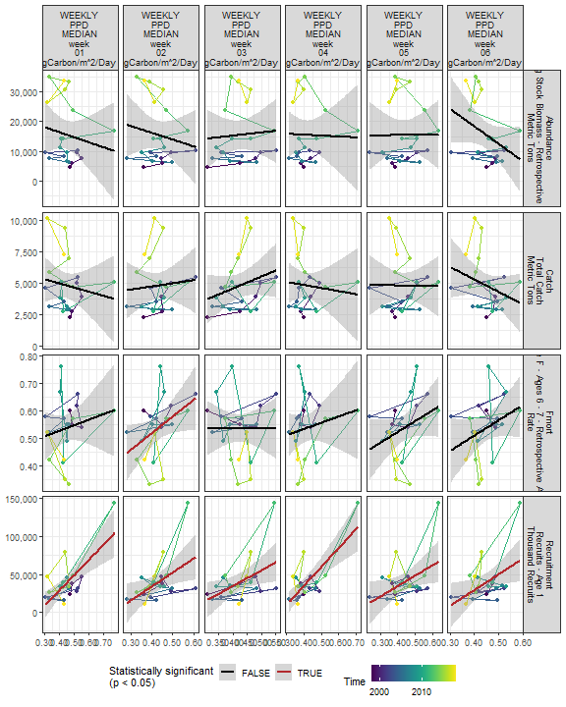

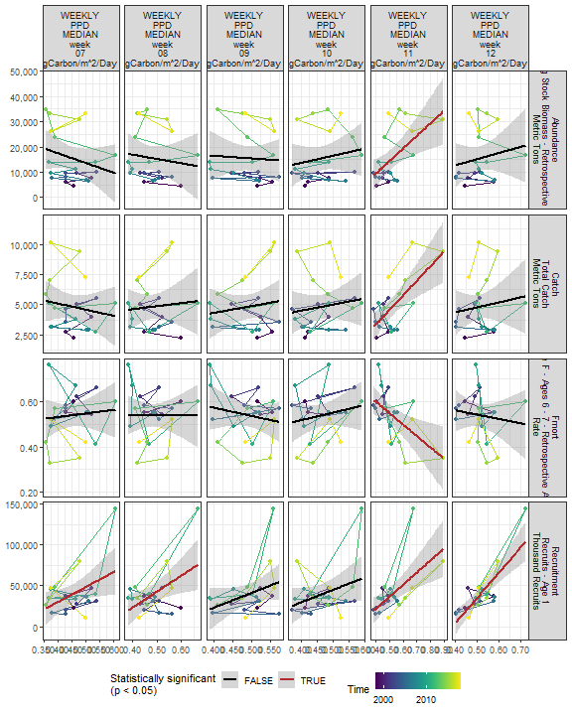

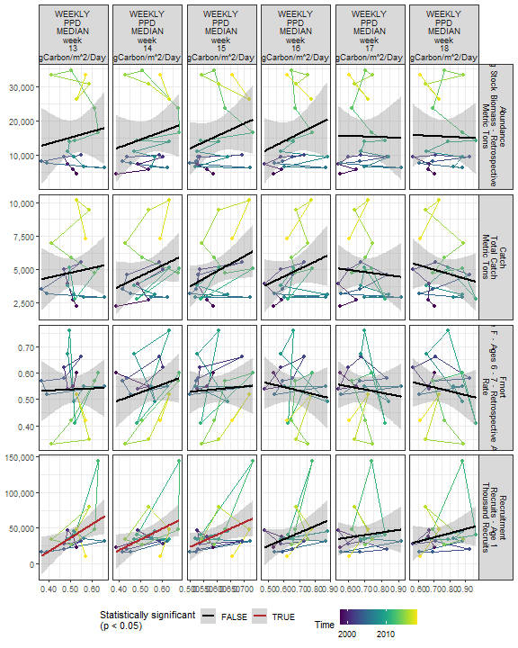

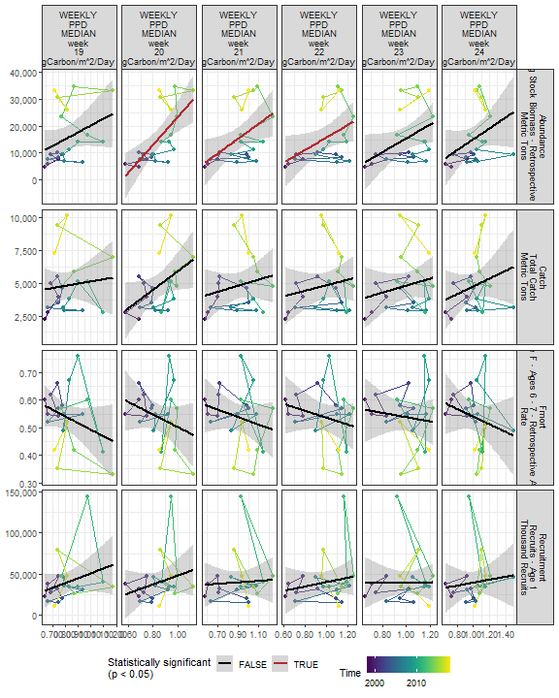

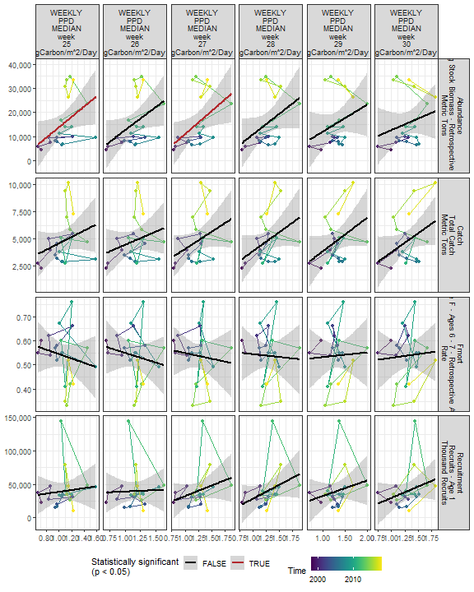

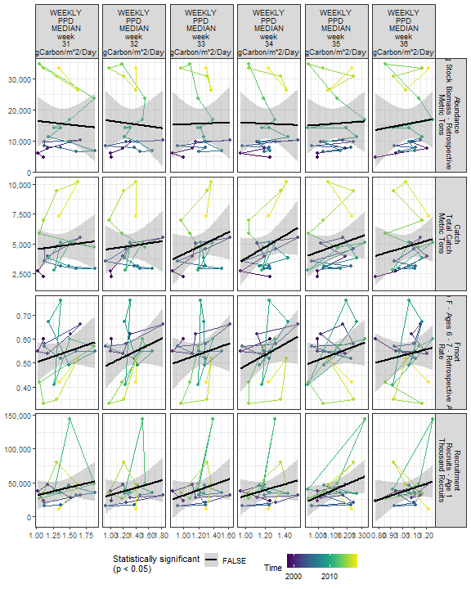

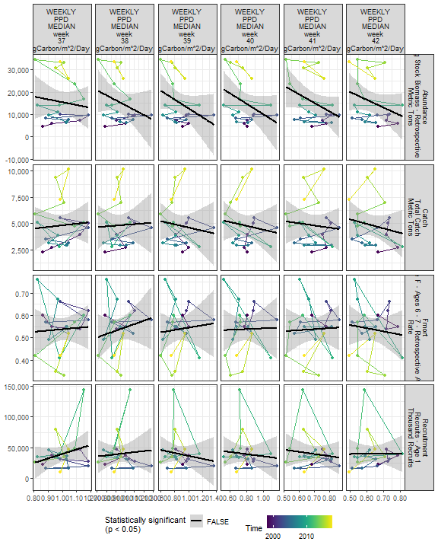

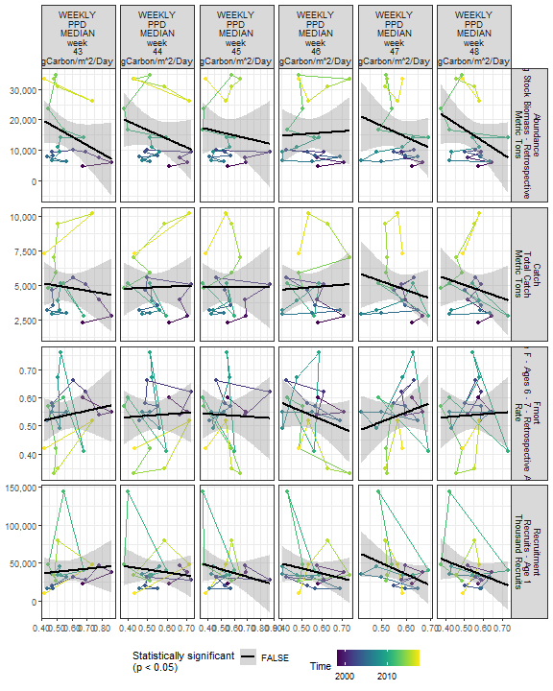

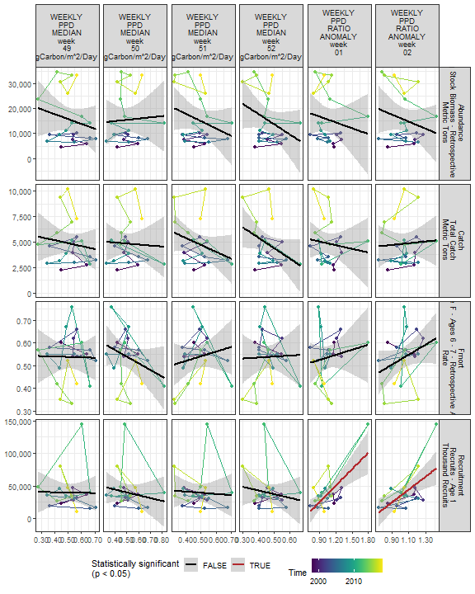

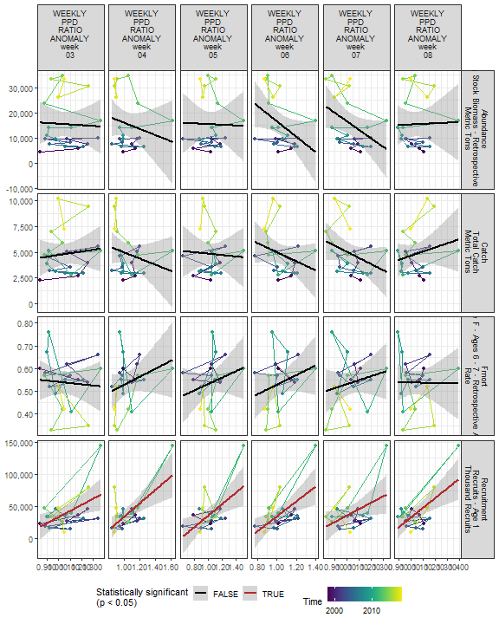

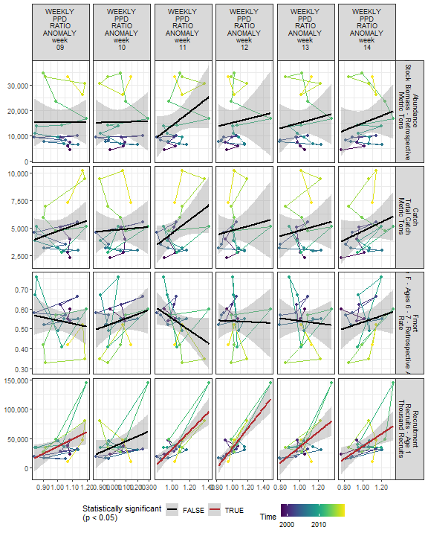

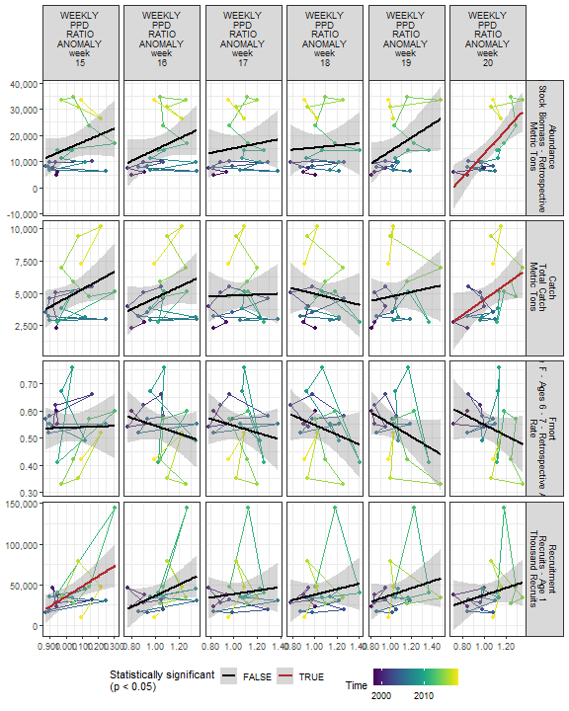

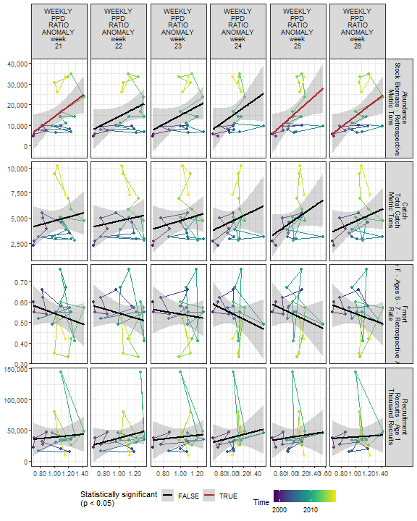

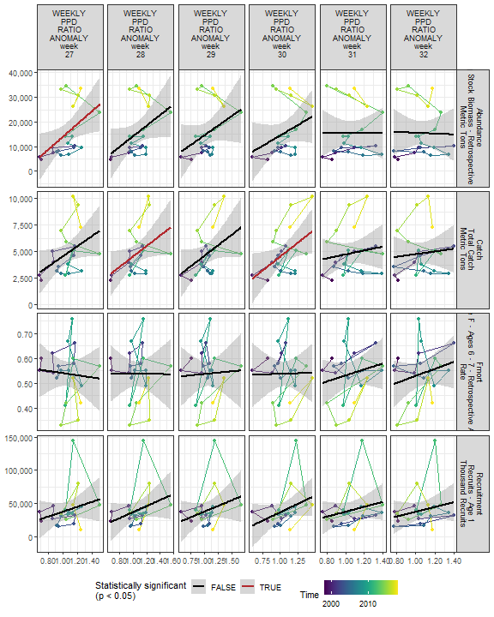

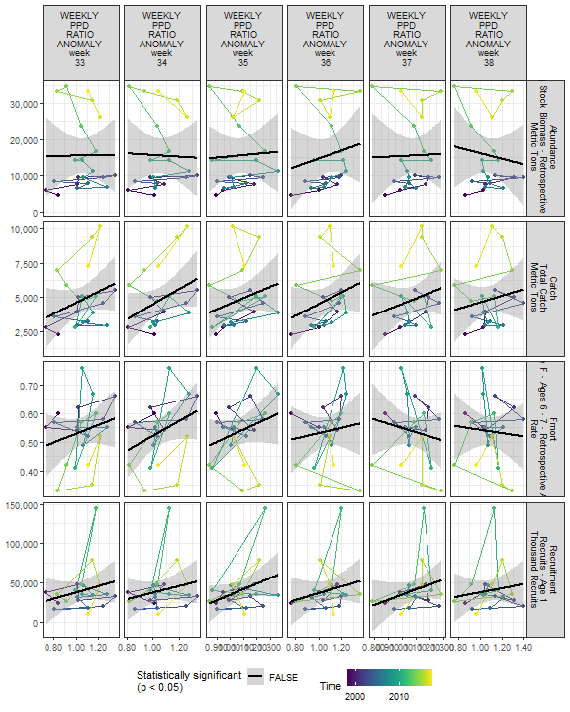

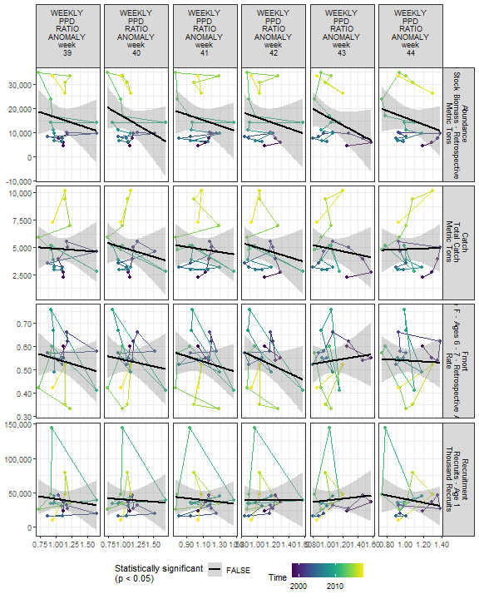

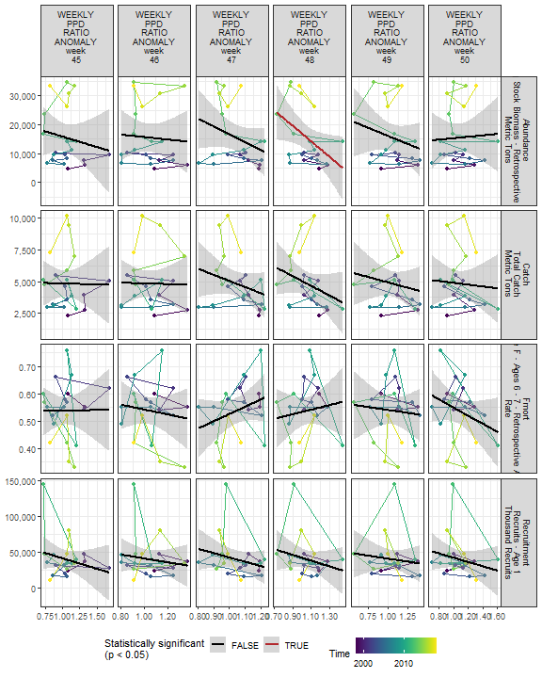

##### Regression statistics

Table 2.21: Catch vs WEEKLY PPD MEDIAN week 11 gCarbon/m^2/Day

|  |  |  |  |  |
| --- | --- | --- | --- | --- |
|  | Estimate | Std. Error | t value | Pr(>|t|) |
| (Intercept) | -1470.56 | 1658.31 | -0.89 | 0.39 |
| Val | 12075.20 | 3110.80 | 3.88 | 0.00 |

|  |  |
| --- | --- |
| Name | Value |
| F-statistic | 15.07 |
| df | 1, 19 |
| R2 | 0.44 |
| R2-adj | 0.41 |

Table 2.21: Catch vs WEEKLY PPD RATIO ANOMALY week 20

|  |  |  |  |  |
| --- | --- | --- | --- | --- |
|  | Estimate | Std. Error | t value | Pr(>|t|) |
| (Intercept) | -1475.14 | 3002.26 | -0.49 | 0.63 |
| Val | 6000.21 | 2835.05 | 2.12 | 0.05 |

|  |  |
| --- | --- |
| Name | Value |
| F-statistic | 4.48 |
| df | 1, 19 |
| R2 | 0.19 |
| R2-adj | 0.15 |

Table 2.21: Catch vs WEEKLY PPD RATIO ANOMALY week 28

|  |  |  |  |  |
| --- | --- | --- | --- | --- |
|  | Estimate | Std. Error | t value | Pr(>|t|) |
| (Intercept) | -371.36 | 2482.56 | -0.15 | 0.88 |
| Val | 4911.67 | 2316.10 | 2.12 | 0.05 |

|  |  |
| --- | --- |
| Name | Value |
| F-statistic | 4.5 |
| df | 1, 19 |
| R2 | 0.19 |
| R2-adj | 0.15 |

Table 2.21: Catch vs WEEKLY PPD RATIO ANOMALY week 30

|  |  |  |  |  |
| --- | --- | --- | --- | --- |
|  | Estimate | Std. Error | t value | Pr(>|t|) |
| (Intercept) | -764.25 | 2470.74 | -0.31 | 0.76 |
| Val | 5294.95 | 2310.66 | 2.29 | 0.03 |

|  |  |
| --- | --- |
| Name | Value |
| F-statistic | 5.25 |
| df | 1, 19 |
| R2 | 0.22 |
| R2-adj | 0.18 |

Table 2.21: Fmort vs WEEKLY PPD MEDIAN week 11 gCarbon/m^2/Day

|  |  |  |  |  |
| --- | --- | --- | --- | --- |
|  | Estimate | Std. Error | t value | Pr(>|t|) |
| (Intercept) | 0.8 | 0.09 | 8.84 | 0.00 |
| Val | -0.5 | 0.17 | -2.96 | 0.01 |

|  |  |
| --- | --- |
| Name | Value |
| F-statistic | 8.79 |
| df | 1, 19 |
| R2 | 0.32 |
| R2-adj | 0.28 |

Table 2.21: Fmort vs WEEKLY PPD MEDIAN week 02 gCarbon/m^2/Day

|  |  |  |  |  |
| --- | --- | --- | --- | --- |
|  | Estimate | Std. Error | t value | Pr(>|t|) |
| (Intercept) | 0.28 | 0.12 | 2.22 | 0.04 |
| Val | 0.61 | 0.29 | 2.12 | 0.05 |

|  |  |
| --- | --- |
| Name | Value |
| F-statistic | 4.5 |
| df | 1, 19 |
| R2 | 0.19 |
| R2-adj | 0.15 |

Table 2.21: Recruitment vs WEEKLY PPD MEDIAN week 11 gCarbon/m^2/Day

|  |  |  |  |  |
| --- | --- | --- | --- | --- |
|  | Estimate | Std. Error | t value | Pr(>|t|) |
| (Intercept) | -37877.61 | 22748.29 | -1.67 | 0.11 |
| Val | 148551.58 | 42673.11 | 3.48 | 0.00 |

|  |  |
| --- | --- |
| Name | Value |
| F-statistic | 12.12 |
| df | 1, 19 |
| R2 | 0.39 |
| R2-adj | 0.36 |

Table 2.21: Recruitment vs WEEKLY PPD MEDIAN week 02 gCarbon/m^2/Day

|  |  |  |  |  |
| --- | --- | --- | --- | --- |
|  | Estimate | Std. Error | t value | Pr(>|t|) |
| (Intercept) | -39787.55 | 32012.85 | -1.24 | 0.23 |
| Val | 184362.12 | 73415.58 | 2.51 | 0.02 |

|  |  |
| --- | --- |
| Name | Value |
| F-statistic | 6.31 |
| df | 1, 19 |
| R2 | 0.25 |
| R2-adj | 0.21 |

Table 2.21: Recruitment vs WEEKLY PPD MEDIAN week 01 gCarbon/m^2/Day

|  |  |  |  |  |
| --- | --- | --- | --- | --- |
|  | Estimate | Std. Error | t value | Pr(>|t|) |
| (Intercept) | -51493.18 | 21090.17 | -2.44 | 0.02 |
| Val | 201835.51 | 45768.55 | 4.41 | 0.00 |

|  |  |
| --- | --- |
| Name | Value |
| F-statistic | 19.45 |
| df | 1, 19 |
| R2 | 0.51 |
| R2-adj | 0.48 |

Table 2.21: Recruitment vs WEEKLY PPD MEDIAN week 03 gCarbon/m^2/Day

|  |  |  |  |  |
| --- | --- | --- | --- | --- |
|  | Estimate | Std. Error | t value | Pr(>|t|) |
| (Intercept) | -48233.73 | 36634.82 | -1.32 | 0.20 |
| Val | 206699.27 | 85404.29 | 2.42 | 0.03 |

|  |  |
| --- | --- |
| Name | Value |
| F-statistic | 5.86 |
| df | 1, 19 |
| R2 | 0.24 |
| R2-adj | 0.2 |

Table 2.21: Recruitment vs WEEKLY PPD MEDIAN week 04 gCarbon/m^2/Day

|  |  |  |  |  |
| --- | --- | --- | --- | --- |
|  | Estimate | Std. Error | t value | Pr(>|t|) |
| (Intercept) | -64535.66 | 21506.67 | -3.00 | 0.01 |
| Val | 249212.46 | 50568.78 | 4.93 | 0.00 |

|  |  |
| --- | --- |
| Name | Value |
| F-statistic | 24.29 |
| df | 1, 19 |
| R2 | 0.56 |
| R2-adj | 0.54 |

Table 2.21: Recruitment vs WEEKLY PPD MEDIAN week 05 gCarbon/m^2/Day

|  |  |  |  |  |
| --- | --- | --- | --- | --- |
|  | Estimate | Std. Error | t value | Pr(>|t|) |
| (Intercept) | -21166.62 | 27335.18 | -0.77 | 0.45 |
| Val | 138936.46 | 61351.56 | 2.26 | 0.04 |

|  |  |
| --- | --- |
| Name | Value |
| F-statistic | 5.13 |
| df | 1, 19 |
| R2 | 0.21 |
| R2-adj | 0.17 |

Table 2.21: Recruitment vs WEEKLY PPD MEDIAN week 06 gCarbon/m^2/Day

|  |  |  |  |  |
| --- | --- | --- | --- | --- |
|  | Estimate | Std. Error | t value | Pr(>|t|) |
| (Intercept) | -53516.24 | 39532.97 | -1.35 | 0.19 |
| Val | 206796.48 | 87098.57 | 2.37 | 0.03 |

|  |  |
| --- | --- |
| Name | Value |
| F-statistic | 5.64 |
| df | 1, 19 |
| R2 | 0.23 |
| R2-adj | 0.19 |

Table 2.21: Recruitment vs WEEKLY PPD MEDIAN week 07 gCarbon/m^2/Day

|  |  |  |  |  |
| --- | --- | --- | --- | --- |
|  | Estimate | Std. Error | t value | Pr(>|t|) |
| (Intercept) | -43945.9 | 37894.51 | -1.16 | 0.26 |
| Val | 184094.3 | 82756.15 | 2.22 | 0.04 |

|  |  |
| --- | --- |
| Name | Value |
| F-statistic | 4.95 |
| df | 1, 19 |
| R2 | 0.21 |
| R2-adj | 0.16 |

Table 2.21: Recruitment vs WEEKLY PPD MEDIAN week 08 gCarbon/m^2/Day

|  |  |  |  |  |
| --- | --- | --- | --- | --- |
|  | Estimate | Std. Error | t value | Pr(>|t|) |
| (Intercept) | -54890.4 | 36742.45 | -1.49 | 0.15 |
| Val | 195449.9 | 75311.22 | 2.60 | 0.02 |

|  |  |
| --- | --- |
| Name | Value |
| F-statistic | 6.74 |
| df | 1, 19 |
| R2 | 0.26 |
| R2-adj | 0.22 |

Table 2.21: Recruitment vs WEEKLY PPD MEDIAN week 12 gCarbon/m^2/Day

|  |  |  |  |  |
| --- | --- | --- | --- | --- |
|  | Estimate | Std. Error | t value | Pr(>|t|) |
| (Intercept) | -120035.7 | 27160.46 | -4.42 | 0 |
| Val | 310948.6 | 52458.52 | 5.93 | 0 |

|  |  |
| --- | --- |
| Name | Value |
| F-statistic | 35.14 |
| df | 1, 19 |
| R2 | 0.65 |
| R2-adj | 0.63 |

Table 2.21: Recruitment vs WEEKLY PPD MEDIAN week 13 gCarbon/m^2/Day

|  |  |  |  |  |
| --- | --- | --- | --- | --- |
|  | Estimate | Std. Error | t value | Pr(>|t|) |
| (Intercept) | -60165.38 | 40050.31 | -1.50 | 0.15 |
| Val | 191742.69 | 76391.40 | 2.51 | 0.02 |

|  |  |
| --- | --- |
| Name | Value |
| F-statistic | 6.3 |
| df | 1, 19 |
| R2 | 0.25 |
| R2-adj | 0.21 |

Table 2.21: Recruitment vs WEEKLY PPD MEDIAN week 14 gCarbon/m^2/Day

|  |  |  |  |  |
| --- | --- | --- | --- | --- |
|  | Estimate | Std. Error | t value | Pr(>|t|) |
| (Intercept) | -41603.6 | 35655.40 | -1.17 | 0.26 |
| Val | 150539.6 | 65430.02 | 2.30 | 0.03 |

|  |  |
| --- | --- |
| Name | Value |
| F-statistic | 5.29 |
| df | 1, 19 |
| R2 | 0.22 |
| R2-adj | 0.18 |

Table 2.21: Recruitment vs WEEKLY PPD MEDIAN week 15 gCarbon/m^2/Day

|  |  |  |  |  |
| --- | --- | --- | --- | --- |
|  | Estimate | Std. Error | t value | Pr(>|t|) |
| (Intercept) | -62482.46 | 45808.53 | -1.36 | 0.19 |
| Val | 171374.67 | 76460.00 | 2.24 | 0.04 |

|  |  |
| --- | --- |
| Name | Value |
| F-statistic | 5.02 |
| df | 1, 19 |
| R2 | 0.21 |
| R2-adj | 0.17 |

Table 2.21: Recruitment vs WEEKLY PPD RATIO ANOMALY week 01

|  |  |  |  |  |
| --- | --- | --- | --- | --- |
|  | Estimate | Std. Error | t value | Pr(>|t|) |
| (Intercept) | -49420.86 | 22252.82 | -2.22 | 0.04 |
| Val | 83547.45 | 20471.16 | 4.08 | 0.00 |

|  |  |
| --- | --- |
| Name | Value |
| F-statistic | 16.66 |
| df | 1, 19 |
| R2 | 0.47 |
| R2-adj | 0.44 |

Table 2.21: Recruitment vs WEEKLY PPD RATIO ANOMALY week 02

|  |  |  |  |  |
| --- | --- | --- | --- | --- |
|  | Estimate | Std. Error | t value | Pr(>|t|) |
| (Intercept) | -66770.17 | 32064.54 | -2.08 | 0.05 |
| Val | 101146.56 | 30166.69 | 3.35 | 0.00 |

|  |  |
| --- | --- |
| Name | Value |
| F-statistic | 11.24 |
| df | 1, 19 |
| R2 | 0.37 |
| R2-adj | 0.34 |

Table 2.21: Recruitment vs WEEKLY PPD RATIO ANOMALY week 03

|  |  |  |  |  |
| --- | --- | --- | --- | --- |
|  | Estimate | Std. Error | t value | Pr(>|t|) |
| (Intercept) | -62200.82 | 37615.69 | -1.65 | 0.11 |
| Val | 95786.21 | 35095.51 | 2.73 | 0.01 |

|  |  |
| --- | --- |
| Name | Value |
| F-statistic | 7.45 |
| df | 1, 19 |
| R2 | 0.28 |
| R2-adj | 0.24 |

Table 2.21: Recruitment vs WEEKLY PPD RATIO ANOMALY week 04

|  |  |  |  |  |
| --- | --- | --- | --- | --- |
|  | Estimate | Std. Error | t value | Pr(>|t|) |
| (Intercept) | -71184.28 | 30253.04 | -2.35 | 0.03 |
| Val | 105074.42 | 28373.79 | 3.70 | 0.00 |

|  |  |
| --- | --- |
| Name | Value |
| F-statistic | 13.71 |
| df | 1, 19 |
| R2 | 0.42 |
| R2-adj | 0.39 |

Table 2.21: Recruitment vs WEEKLY PPD RATIO ANOMALY week 05

|  |  |  |  |  |
| --- | --- | --- | --- | --- |
|  | Estimate | Std. Error | t value | Pr(>|t|) |
| (Intercept) | -54135.34 | 31255.84 | -1.73 | 0.10 |
| Val | 90045.13 | 29666.20 | 3.04 | 0.01 |

|  |  |
| --- | --- |
| Name | Value |
| F-statistic | 9.21 |
| df | 1, 19 |
| R2 | 0.33 |
| R2-adj | 0.29 |

Table 2.21: Recruitment vs WEEKLY PPD RATIO ANOMALY week 06

|  |  |  |  |  |
| --- | --- | --- | --- | --- |
|  | Estimate | Std. Error | t value | Pr(>|t|) |
| (Intercept) | -81442.61 | 37621.55 | -2.16 | 0.04 |
| Val | 116288.99 | 35868.15 | 3.24 | 0.00 |

|  |  |
| --- | --- |
| Name | Value |
| F-statistic | 10.51 |
| df | 1, 19 |
| R2 | 0.36 |
| R2-adj | 0.32 |

Table 2.21: Recruitment vs WEEKLY PPD RATIO ANOMALY week 07

|  |  |  |  |  |
| --- | --- | --- | --- | --- |
|  | Estimate | Std. Error | t value | Pr(>|t|) |
| (Intercept) | -64482.46 | 47891.56 | -1.35 | 0.19 |
| Val | 100222.93 | 45875.16 | 2.18 | 0.04 |

|  |  |
| --- | --- |
| Name | Value |
| F-statistic | 4.77 |
| df | 1, 19 |
| R2 | 0.2 |
| R2-adj | 0.16 |

Table 2.21: Recruitment vs WEEKLY PPD RATIO ANOMALY week 08

|  |  |  |  |  |
| --- | --- | --- | --- | --- |
|  | Estimate | Std. Error | t value | Pr(>|t|) |
| (Intercept) | -116856.9 | 43531.85 | -2.68 | 0.01 |
| Val | 150254.4 | 41592.74 | 3.61 | 0.00 |

|  |  |
| --- | --- |
| Name | Value |
| F-statistic | 13.05 |
| df | 1, 19 |
| R2 | 0.41 |
| R2-adj | 0.38 |

Table 2.21: Recruitment vs WEEKLY PPD RATIO ANOMALY week 09

|  |  |  |  |  |
| --- | --- | --- | --- | --- |
|  | Estimate | Std. Error | t value | Pr(>|t|) |
| (Intercept) | -88554.89 | 52159.34 | -1.70 | 0.11 |
| Val | 124749.51 | 50563.31 | 2.47 | 0.02 |

|  |  |
| --- | --- |
| Name | Value |
| F-statistic | 6.09 |
| df | 1, 19 |
| R2 | 0.24 |
| R2-adj | 0.2 |

Table 2.21: Recruitment vs WEEKLY PPD RATIO ANOMALY week 11

|  |  |  |  |  |
| --- | --- | --- | --- | --- |
|  | Estimate | Std. Error | t value | Pr(>|t|) |
| (Intercept) | -123811.2 | 29920.60 | -4.14 | 0 |
| Val | 155619.2 | 28278.85 | 5.50 | 0 |

|  |  |
| --- | --- |
| Name | Value |
| F-statistic | 30.28 |
| df | 1, 19 |
| R2 | 0.61 |
| R2-adj | 0.59 |

Table 2.21: Recruitment vs WEEKLY PPD RATIO ANOMALY week 12

|  |  |  |  |  |
| --- | --- | --- | --- | --- |
|  | Estimate | Std. Error | t value | Pr(>|t|) |
| (Intercept) | -137439.2 | 25459.16 | -5.40 | 0 |
| Val | 171130.7 | 24421.68 | 7.01 | 0 |

|  |  |
| --- | --- |
| Name | Value |
| F-statistic | 49.1 |
| df | 1, 19 |
| R2 | 0.72 |
| R2-adj | 0.71 |

Table 2.21: Recruitment vs WEEKLY PPD RATIO ANOMALY week 13

|  |  |  |  |  |
| --- | --- | --- | --- | --- |
|  | Estimate | Std. Error | t value | Pr(>|t|) |
| (Intercept) | -96884.2 | 38491.63 | -2.52 | 0.02 |
| Val | 132214.9 | 37034.92 | 3.57 | 0.00 |

|  |  |
| --- | --- |
| Name | Value |
| F-statistic | 12.74 |
| df | 1, 19 |
| R2 | 0.4 |
| R2-adj | 0.37 |

Table 2.21: Recruitment vs WEEKLY PPD RATIO ANOMALY week 14

|  |  |  |  |  |
| --- | --- | --- | --- | --- |
|  | Estimate | Std. Error | t value | Pr(>|t|) |
| (Intercept) | -68333.9 | 36981.62 | -1.85 | 0.08 |
| Val | 105132.3 | 35718.87 | 2.94 | 0.01 |

|  |  |
| --- | --- |
| Name | Value |
| F-statistic | 8.66 |
| df | 1, 19 |
| R2 | 0.31 |
| R2-adj | 0.28 |

Table 2.21: Recruitment vs WEEKLY PPD RATIO ANOMALY week 15

|  |  |  |  |  |
| --- | --- | --- | --- | --- |
|  | Estimate | Std. Error | t value | Pr(>|t|) |
| (Intercept) | -88291.54 | 43096.33 | -2.05 | 0.05 |
| Val | 123973.84 | 41528.78 | 2.99 | 0.01 |

|  |  |
| --- | --- |
| Name | Value |
| F-statistic | 8.91 |
| df | 1, 19 |
| R2 | 0.32 |
| R2-adj | 0.28 |

Table 2.21: Abundance vs WEEKLY PPD MEDIAN week 11 gCarbon/m^2/Day

|  |  |  |  |  |
| --- | --- | --- | --- | --- |
|  | Estimate | Std. Error | t value | Pr(>|t|) |
| (Intercept) | -10535.82 | 8647.89 | -1.22 | 0.24 |
| Val | 49899.74 | 16222.42 | 3.08 | 0.01 |

|  |  |
| --- | --- |
| Name | Value |
| F-statistic | 9.46 |
| df | 1, 19 |
| R2 | 0.33 |
| R2-adj | 0.3 |

Table 2.21: Abundance vs WEEKLY PPD RATIO ANOMALY week 20

|  |  |  |  |  |
| --- | --- | --- | --- | --- |
|  | Estimate | Std. Error | t value | Pr(>|t|) |
| (Intercept) | -32038.18 | 11486.97 | -2.79 | 0.01 |
| Val | 45298.95 | 10847.21 | 4.18 | 0.00 |

|  |  |
| --- | --- |
| Name | Value |
| F-statistic | 17.44 |
| df | 1, 19 |
| R2 | 0.48 |
| R2-adj | 0.45 |

Table 2.21: Abundance vs WEEKLY PPD MEDIAN week 20 gCarbon/m^2/Day

|  |  |  |  |  |
| --- | --- | --- | --- | --- |
|  | Estimate | Std. Error | t value | Pr(>|t|) |
| (Intercept) | -28369.41 | 11533.36 | -2.46 | 0.02 |
| Val | 51845.15 | 13498.79 | 3.84 | 0.00 |

|  |  |
| --- | --- |
| Name | Value |
| F-statistic | 14.75 |
| df | 1, 19 |
| R2 | 0.44 |
| R2-adj | 0.41 |

Table 2.21: Abundance vs WEEKLY PPD MEDIAN week 21 gCarbon/m^2/Day

|  |  |  |  |  |
| --- | --- | --- | --- | --- |
|  | Estimate | Std. Error | t value | Pr(>|t|) |
| (Intercept) | -9840.94 | 10110.45 | -0.97 | 0.34 |
| Val | 27989.74 | 10980.83 | 2.55 | 0.02 |

|  |  |
| --- | --- |
| Name | Value |
| F-statistic | 6.5 |
| df | 1, 19 |
| R2 | 0.25 |
| R2-adj | 0.22 |

Table 2.21: Abundance vs WEEKLY PPD MEDIAN week 22 gCarbon/m^2/Day

|  |  |  |  |  |
| --- | --- | --- | --- | --- |
|  | Estimate | Std. Error | t value | Pr(>|t|) |
| (Intercept) | -7449.05 | 10878.84 | -0.68 | 0.50 |
| Val | 23117.56 | 10793.50 | 2.14 | 0.05 |

|  |  |
| --- | --- |
| Name | Value |
| F-statistic | 4.59 |
| df | 1, 19 |
| R2 | 0.19 |
| R2-adj | 0.15 |

Table 2.21: Abundance vs WEEKLY PPD MEDIAN week 25 gCarbon/m^2/Day

|  |  |  |  |  |
| --- | --- | --- | --- | --- |
|  | Estimate | Std. Error | t value | Pr(>|t|) |
| (Intercept) | -7313.63 | 10682.41 | -0.68 | 0.50 |
| Val | 21199.95 | 9771.48 | 2.17 | 0.04 |

|  |  |
| --- | --- |
| Name | Value |
| F-statistic | 4.71 |
| df | 1, 19 |
| R2 | 0.2 |
| R2-adj | 0.16 |

Table 2.21: Abundance vs WEEKLY PPD MEDIAN week 27 gCarbon/m^2/Day

|  |  |  |  |  |
| --- | --- | --- | --- | --- |
|  | Estimate | Std. Error | t value | Pr(>|t|) |
| (Intercept) | -8142.54 | 10516.2 | -0.77 | 0.45 |
| Val | 19219.81 | 8412.6 | 2.28 | 0.03 |

|  |  |
| --- | --- |
| Name | Value |
| F-statistic | 5.22 |
| df | 1, 19 |
| R2 | 0.22 |
| R2-adj | 0.17 |

Table 2.21: Abundance vs WEEKLY PPD RATIO ANOMALY week 21

|  |  |  |  |  |
| --- | --- | --- | --- | --- |
|  | Estimate | Std. Error | t value | Pr(>|t|) |
| (Intercept) | -11034.64 | 10928.17 | -1.01 | 0.33 |
| Val | 25200.94 | 10230.87 | 2.46 | 0.02 |

|  |  |
| --- | --- |
| Name | Value |
| F-statistic | 6.07 |
| df | 1, 19 |
| R2 | 0.24 |
| R2-adj | 0.2 |

Table 2.21: Abundance vs WEEKLY PPD RATIO ANOMALY week 25

|  |  |  |  |  |
| --- | --- | --- | --- | --- |
|  | Estimate | Std. Error | t value | Pr(>|t|) |
| (Intercept) | -9713.46 | 10994.96 | -0.88 | 0.39 |
| Val | 24142.46 | 10376.71 | 2.33 | 0.03 |

|  |  |
| --- | --- |
| Name | Value |
| F-statistic | 5.41 |
| df | 1, 19 |
| R2 | 0.22 |
| R2-adj | 0.18 |

Table 2.21: Abundance vs WEEKLY PPD RATIO ANOMALY week 26

|  |  |  |  |  |
| --- | --- | --- | --- | --- |
|  | Estimate | Std. Error | t value | Pr(>|t|) |
| (Intercept) | -10677.67 | 11124.21 | -0.96 | 0.35 |
| Val | 24953.16 | 10456.74 | 2.39 | 0.03 |

|  |  |
| --- | --- |
| Name | Value |
| F-statistic | 5.69 |
| df | 1, 19 |
| R2 | 0.23 |
| R2-adj | 0.19 |

Table 2.21: Abundance vs WEEKLY PPD RATIO ANOMALY week 27

|  |  |  |  |  |
| --- | --- | --- | --- | --- |
|  | Estimate | Std. Error | t value | Pr(>|t|) |
| (Intercept) | -12222.80 | 11659.41 | -1.05 | 0.31 |
| Val | 26224.01 | 10891.69 | 2.41 | 0.03 |

|  |  |
| --- | --- |
| Name | Value |
| F-statistic | 5.8 |
| df | 1, 19 |
| R2 | 0.23 |
| R2-adj | 0.19 |

Table 2.21: Abundance vs WEEKLY PPD RATIO ANOMALY week 48

|  |  |  |  |  |
| --- | --- | --- | --- | --- |
|  | Estimate | Std. Error | t value | Pr(>|t|) |
| (Intercept) | 43875.69 | 13187.64 | 3.33 | 0.00 |
| Val | -26959.35 | 12342.87 | -2.18 | 0.04 |

|  |  |
| --- | --- |
| Name | Value |
| F-statistic | 4.77 |
| df | 1, 19 |
| R2 | 0.2 |
| R2-adj | 0.16 |

### 2.3.3 Zooplankton

#### 2.3.3.1 Spring zooplankton abundance by species

##### Figures

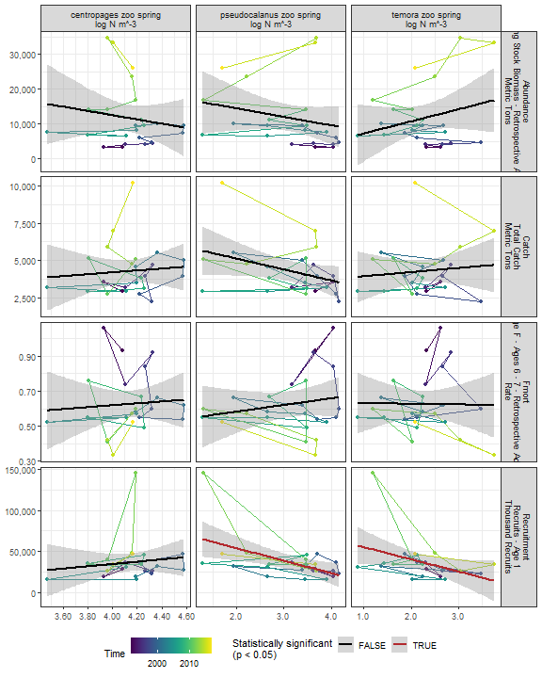

##### Regression statistics

Table 2.22: Recruitment vs pseudocalanus zoo spring log N m^-3

|  |  |  |  |  |
| --- | --- | --- | --- | --- |
|  | Estimate | Std. Error | t value | Pr(>|t|) |
| (Intercept) | 84209.86 | 16502.62 | 5.10 | 0.00 |
| Val | -15156.51 | 5061.63 | -2.99 | 0.01 |

|  |  |
| --- | --- |
| Name | Value |
| F-statistic | 8.97 |
| df | 1, 22 |
| R2 | 0.29 |
| R2-adj | 0.26 |

Table 2.22: Recruitment vs temora zoo spring log N m^-3

|  |  |  |  |  |
| --- | --- | --- | --- | --- |
|  | Estimate | Std. Error | t value | Pr(>|t|) |
| (Intercept) | 69879.30 | 16729.56 | 4.18 | 0.00 |
| Val | -14733.65 | 7094.35 | -2.08 | 0.05 |

|  |  |
| --- | --- |
| Name | Value |
| F-statistic | 4.31 |
| df | 1, 22 |
| R2 | 0.16 |
| R2-adj | 0.13 |

#### 2.3.3.2 Fall zooplankton abundance by species

##### Figures

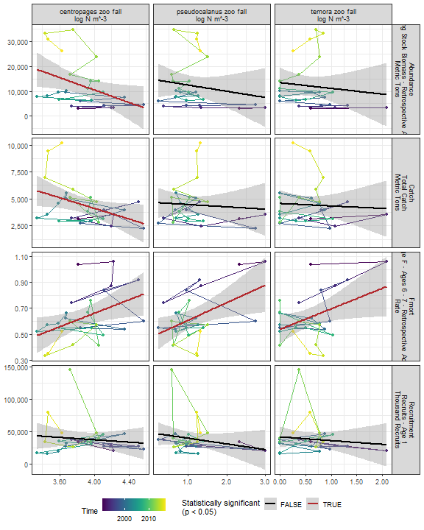

##### Regression statistics

Table 2.23: Catch vs centropages zoo fall log N m^-3

|  |  |  |  |  |
| --- | --- | --- | --- | --- |
|  | Estimate | Std. Error | t value | Pr(>|t|) |
| (Intercept) | 13953.55 | 4305.78 | 3.24 | 0.00 |
| Val | -2463.09 | 1108.03 | -2.22 | 0.04 |

|  |  |
| --- | --- |
| Name | Value |
| F-statistic | 4.94 |
| df | 1, 24 |
| R2 | 0.17 |
| R2-adj | 0.14 |

Table 2.23: Fmort vs centropages zoo fall log N m^-3

|  |  |  |  |  |
| --- | --- | --- | --- | --- |
|  | Estimate | Std. Error | t value | Pr(>|t|) |
| (Intercept) | -0.38 | 0.41 | -0.92 | 0.37 |
| Val | 0.26 | 0.11 | 2.46 | 0.02 |

|  |  |
| --- | --- |
| Name | Value |
| F-statistic | 6.03 |
| df | 1, 24 |
| R2 | 0.2 |
| R2-adj | 0.17 |

Table 2.23: Fmort vs pseudocalanus zoo fall log N m^-3

|  |  |  |  |  |
| --- | --- | --- | --- | --- |
|  | Estimate | Std. Error | t value | Pr(>|t|) |
| (Intercept) | 0.47 | 0.07 | 6.85 | 0.00 |
| Val | 0.14 | 0.05 | 2.61 | 0.02 |

|  |  |
| --- | --- |
| Name | Value |
| F-statistic | 6.81 |
| df | 1, 24 |
| R2 | 0.22 |
| R2-adj | 0.19 |

Table 2.23: Fmort vs temora zoo fall log N m^-3

|  |  |  |  |  |
| --- | --- | --- | --- | --- |
|  | Estimate | Std. Error | t value | Pr(>|t|) |
| (Intercept) | 0.54 | 0.05 | 10.08 | 0.00 |
| Val | 0.16 | 0.07 | 2.25 | 0.03 |

|  |  |
| --- | --- |
| Name | Value |
| F-statistic | 5.08 |
| df | 1, 24 |
| R2 | 0.17 |
| R2-adj | 0.14 |

Table 2.23: Abundance vs centropages zoo fall log N m^-3

|  |  |  |  |  |
| --- | --- | --- | --- | --- |
|  | Estimate | Std. Error | t value | Pr(>|t|) |
| (Intercept) | 60170.68 | 20963.85 | 2.87 | 0.01 |
| Val | -12428.16 | 5394.77 | -2.30 | 0.03 |

|  |  |
| --- | --- |
| Name | Value |
| F-statistic | 5.31 |
| df | 1, 24 |
| R2 | 0.18 |
| R2-adj | 0.15 |

#### 2.3.3.3 Zooplankton abundance by group

##### Figures

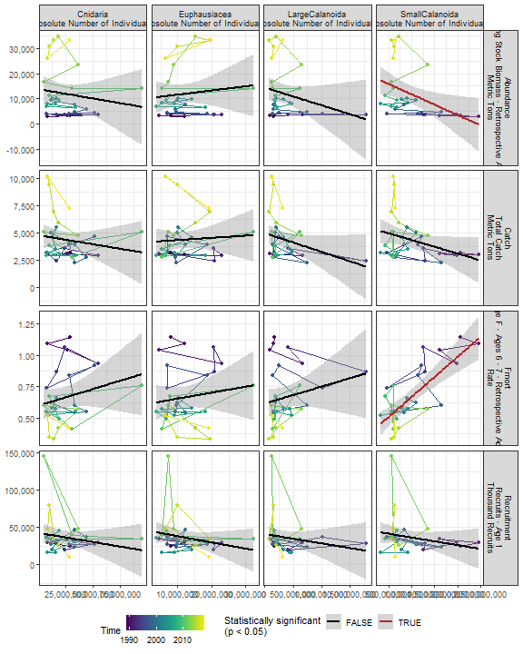

##### Regression statistics

Table 2.24: Fmort vs SmallCalanoida Absolute Number of Individuals

|  |  |  |  |  |
| --- | --- | --- | --- | --- |
|  | Estimate | Std. Error | t value | Pr(>|t|) |
| (Intercept) | 0.35 | 0.06 | 5.95 | 0 |
| Val | 0.00 | 0.00 | 5.99 | 0 |

|  |  |
| --- | --- |
| Name | Value |
| F-statistic | 35.87 |
| df | 1, 28 |
| R2 | 0.56 |
| R2-adj | 0.55 |

Table 2.24: Abundance vs SmallCalanoida Absolute Number of Individuals

|  |  |  |  |  |
| --- | --- | --- | --- | --- |
|  | Estimate | Std. Error | t value | Pr(>|t|) |
| (Intercept) | 19954.29 | 3623.31 | 5.51 | 0.00 |
| Val | 0.00 | 0.00 | -2.53 | 0.02 |

|  |  |
| --- | --- |
| Name | Value |
| F-statistic | 6.4 |
| df | 1, 28 |
| R2 | 0.19 |
| R2-adj | 0.16 |

#### 2.3.3.4 Abundance of Calanus CV and adults

##### Figures

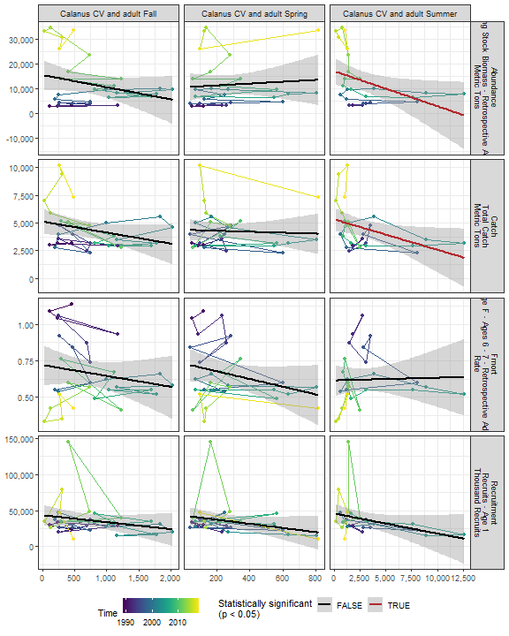

##### Regression statistics

Table 2.25: Catch vs Calanus CV and adult Summer

|  |  |  |  |  |
| --- | --- | --- | --- | --- |
|  | Estimate | Std. Error | t value | Pr(>|t|) |
| (Intercept) | 5309.07 | 523.20 | 10.15 | 0.00 |
| Val | -0.27 | 0.13 | -2.19 | 0.04 |

|  |  |
| --- | --- |
| Name | Value |
| F-statistic | 4.8 |
| df | 1, 24 |
| R2 | 0.17 |
| R2-adj | 0.13 |

Table 2.25: Abundance vs Calanus CV and adult Summer

|  |  |  |  |  |
| --- | --- | --- | --- | --- |
|  | Estimate | Std. Error | t value | Pr(>|t|) |
| (Intercept) | 17076.37 | 2668.33 | 6.40 | 0.00 |
| Val | -1.41 | 0.64 | -2.21 | 0.04 |

|  |  |
| --- | --- |
| Name | Value |
| F-statistic | 4.86 |
| df | 1, 24 |
| R2 | 0.17 |
| R2-adj | 0.13 |

#### 2.3.3.5 Zooplankton abundance anomaly

##### Figures

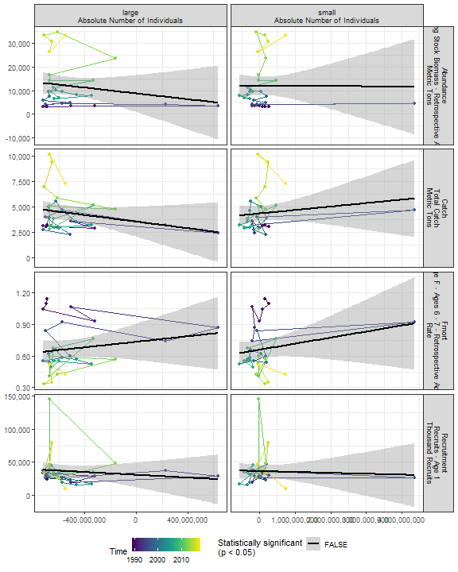

##### Regression statistics

[1] “No statistically significant data”

#### 2.3.3.6 Zooplankton diversity index

##### Figures

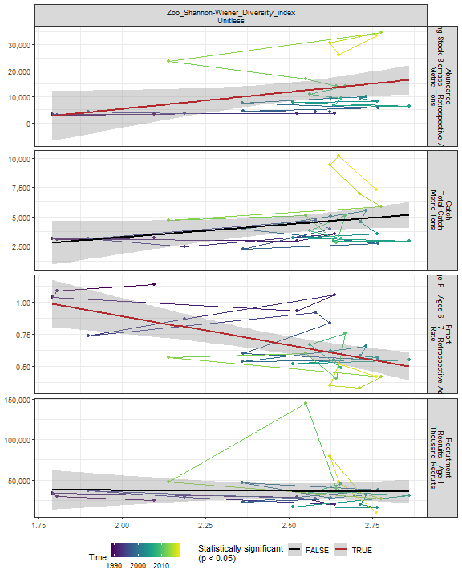

##### Regression statistics

Table 2.26: Fmort vs Zoo_Shannon-Wiener_Diversity_index Unitless

|  |  |  |  |  |
| --- | --- | --- | --- | --- |
|  | Estimate | Std. Error | t value | Pr(>|t|) |
| (Intercept) | 1.81 | 0.29 | 6.15 | 0 |
| Val | -0.46 | 0.12 | -3.92 | 0 |

|  |  |
| --- | --- |
| Name | Value |
| F-statistic | 15.35 |
| df | 1, 28 |
| R2 | 0.35 |
| R2-adj | 0.33 |

Table 2.26: Abundance vs Zoo_Shannon-Wiener_Diversity_index Unitless

|  |  |  |  |  |
| --- | --- | --- | --- | --- |
|  | Estimate | Std. Error | t value | Pr(>|t|) |
| (Intercept) | -20519.33 | 15262.63 | -1.34 | 0.19 |
| Val | 12921.78 | 6048.18 | 2.14 | 0.04 |

|  |  |
| --- | --- |
| Name | Value |
| F-statistic | 4.56 |
| df | 1, 28 |
| R2 | 0.14 |
| R2-adj | 0.11 |

#### 2.3.3.7 Small/large copepod anomaly

##### Figures

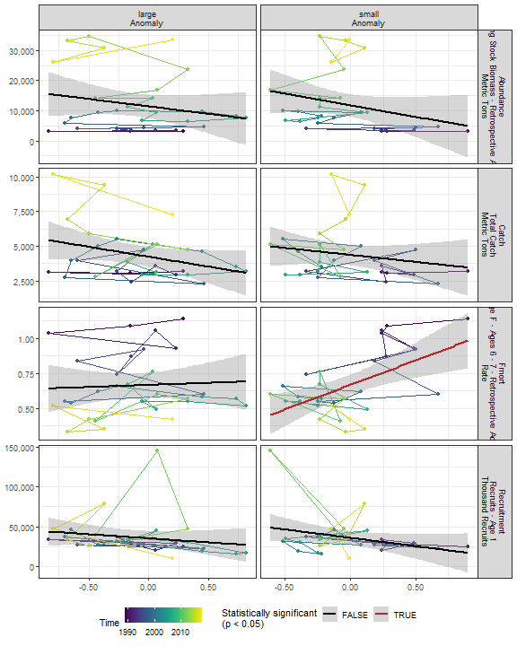

##### Regression statistics

Table 2.27: Fmort vs small Anomaly

|  |  |  |  |  |
| --- | --- | --- | --- | --- |
|  | Estimate | Std. Error | t value | Pr(>|t|) |
| (Intercept) | 0.67 | 0.03 | 19.16 | 0 |
| Val | 0.35 | 0.10 | 3.55 | 0 |

|  |  |
| --- | --- |
| Name | Value |
| F-statistic | 12.63 |
| df | 1, 28 |
| R2 | 0.31 |
| R2-adj | 0.29 |

#### 2.3.3.8 Ichthyoplankton diversity

##### Figures

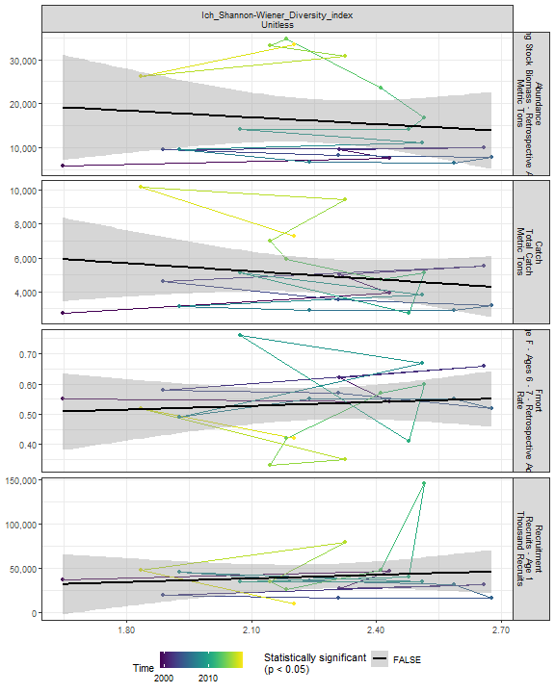

##### Regression statistics

[1] “No statistically significant data”

### 2.3.4 Forage fish abundance

##### Figures

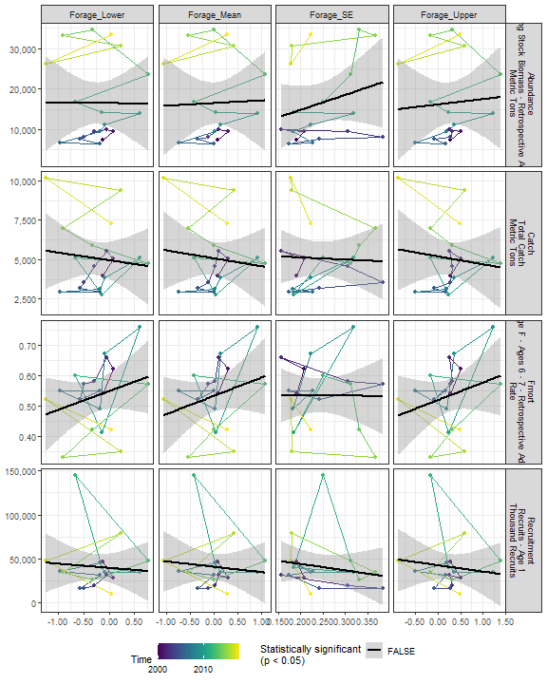

##### Regression statistics

[1] “No statistically significant data”

## 2.4 Trophic indicators in the stock region

### 2.4.1 Chlorophyll in stock region

##### Figures

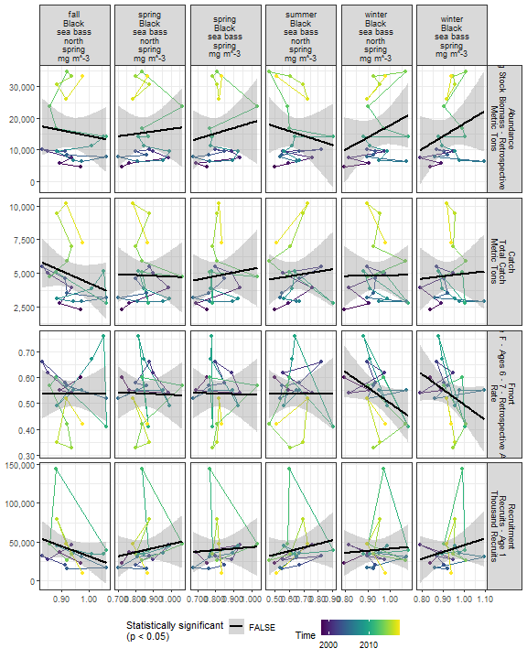

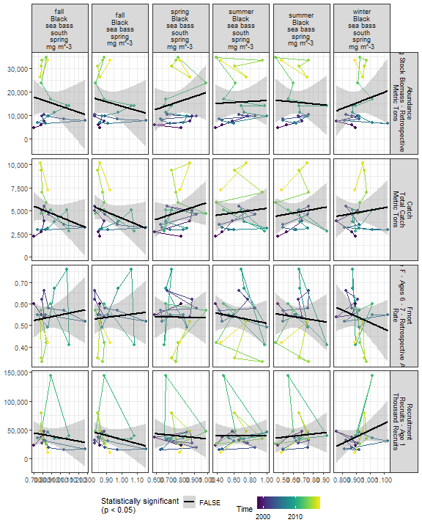

##### Regression statistics

[1] “No statistically significant data”

### 2.4.2 Primary production in stock region

##### Figures

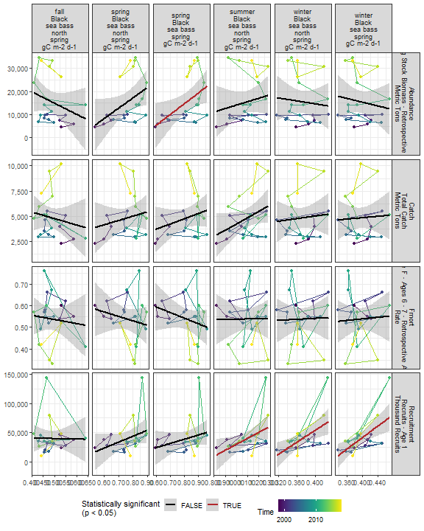

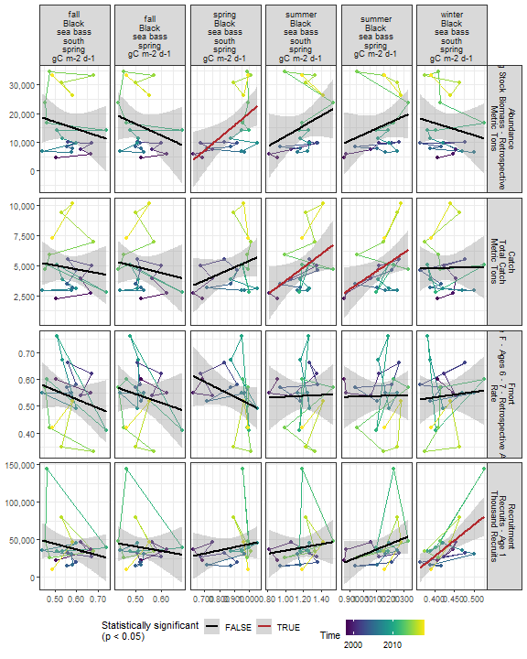

##### Regression statistics

Table 2.28: Catch vs summer Black sea bass spring gC m-2 d-1

|  |  |  |  |  |
| --- | --- | --- | --- | --- |
|  | Estimate | Std. Error | t value | Pr(>|t|) |
| (Intercept) | -3737.76 | 3773.84 | -0.99 | 0.33 |
| Val | 7537.48 | 3305.55 | 2.28 | 0.03 |

|  |  |
| --- | --- |
| Name | Value |
| F-statistic | 5.2 |
| df | 1, 19 |
| R2 | 0.21 |
| R2-adj | 0.17 |

Table 2.28: Catch vs summer Black sea bass south spring gC m-2 d-1

|  |  |  |  |  |
| --- | --- | --- | --- | --- |
|  | Estimate | Std. Error | t value | Pr(>|t|) |
| (Intercept) | -1912.50 | 3091.35 | -0.62 | 0.54 |
| Val | 5657.88 | 2575.54 | 2.20 | 0.04 |

|  |  |
| --- | --- |
| Name | Value |
| F-statistic | 4.83 |
| df | 1, 19 |
| R2 | 0.2 |
| R2-adj | 0.16 |

Table 2.28: Recruitment vs winter Black sea bass north spring gC m-2 d-1

|  |  |  |  |  |
| --- | --- | --- | --- | --- |
|  | Estimate | Std. Error | t value | Pr(>|t|) |
| (Intercept) | -151495.7 | 61575.77 | -2.46 | 0.02 |
| Val | 512875.8 | 164843.57 | 3.11 | 0.01 |

|  |  |
| --- | --- |
| Name | Value |
| F-statistic | 9.68 |
| df | 1, 19 |
| R2 | 0.34 |
| R2-adj | 0.3 |

Table 2.28: Recruitment vs summer Black sea bass north spring gC m-2 d-1

|  |  |  |  |  |
| --- | --- | --- | --- | --- |
|  | Estimate | Std. Error | t value | Pr(>|t|) |
| (Intercept) | -73614.5 | 47979.48 | -1.53 | 0.14 |
| Val | 103349.9 | 43575.90 | 2.37 | 0.03 |

|  |  |
| --- | --- |
| Name | Value |
| F-statistic | 5.63 |
| df | 1, 19 |
| R2 | 0.23 |
| R2-adj | 0.19 |

Table 2.28: Recruitment vs winter Black sea bass spring gC m-2 d-1

|  |  |  |  |  |
| --- | --- | --- | --- | --- |
|  | Estimate | Std. Error | t value | Pr(>|t|) |
| (Intercept) | -159017.1 | 57005.81 | -2.79 | 0.01 |
| Val | 501499.8 | 143531.31 | 3.49 | 0.00 |

|  |  |
| --- | --- |
| Name | Value |
| F-statistic | 12.21 |
| df | 1, 19 |
| R2 | 0.39 |
| R2-adj | 0.36 |

Table 2.28: Recruitment vs winter Black sea bass south spring gC m-2 d-1

|  |  |  |  |  |
| --- | --- | --- | --- | --- |
|  | Estimate | Std. Error | t value | Pr(>|t|) |
| (Intercept) | -143339.3 | 51208.42 | -2.80 | 0.01 |
| Val | 428072.1 | 119400.71 | 3.59 | 0.00 |

|  |  |
| --- | --- |
| Name | Value |
| F-statistic | 12.85 |
| df | 1, 19 |
| R2 | 0.4 |
| R2-adj | 0.37 |

Table 2.28: Abundance vs spring Black sea bass spring gC m-2 d-1

|  |  |  |  |  |
| --- | --- | --- | --- | --- |
|  | Estimate | Std. Error | t value | Pr(>|t|) |
| (Intercept) | -22891.02 | 15703.82 | -1.46 | 0.16 |
| Val | 46924.99 | 19073.96 | 2.46 | 0.02 |

|  |  |
| --- | --- |
| Name | Value |
| F-statistic | 6.05 |
| df | 1, 19 |
| R2 | 0.24 |
| R2-adj | 0.2 |

Table 2.28: Abundance vs spring Black sea bass south spring gC m-2 d-1

|  |  |  |  |  |
| --- | --- | --- | --- | --- |
|  | Estimate | Std. Error | t value | Pr(>|t|) |
| (Intercept) | -23201.68 | 14110.66 | -1.64 | 0.12 |
| Val | 43356.71 | 15686.71 | 2.76 | 0.01 |

|  |  |
| --- | --- |
| Name | Value |
| F-statistic | 7.64 |
| df | 1, 19 |
| R2 | 0.29 |
| R2-adj | 0.25 |

### 2.4.3 Zooplankton in the stock region

#### 2.4.3.1 Annual zooplankton abundance in the stock region

#### Ctyp 100m3 Annual

##### Figures

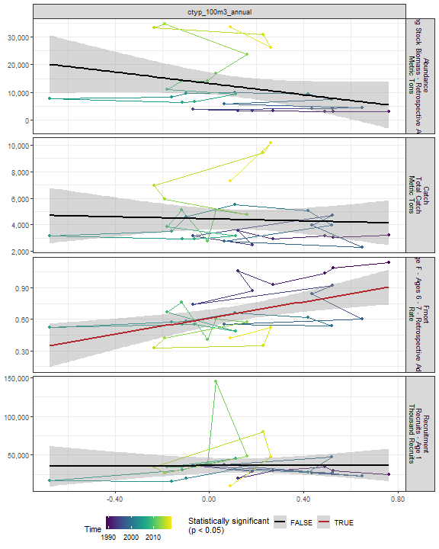

##### Regression statistics

Table 2.29: Fmort vs ctyp_100m3_annual

|  |  |  |  |  |
| --- | --- | --- | --- | --- |
|  | Estimate | Std. Error | t value | Pr(>|t|) |
| (Intercept) | 0.61 | 0.04 | 15.74 | 0 |
| Val | 0.38 | 0.12 | 3.31 | 0 |

|  |  |
| --- | --- |
| Name | Value |
| F-statistic | 10.99 |
| df | 1, 28 |
| R2 | 0.28 |
| R2-adj | 0.26 |

#### Calfin 100m3 Annual

##### Figures

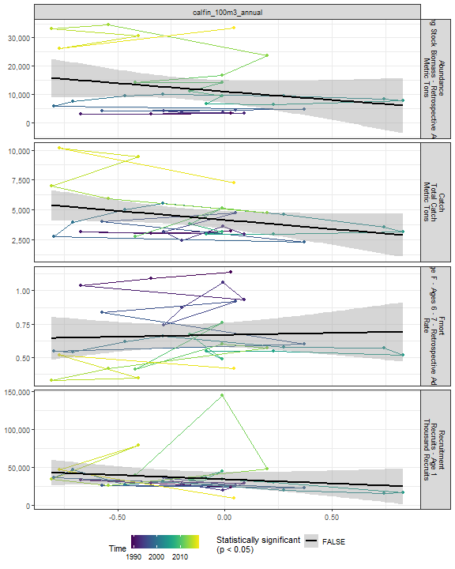

##### Regression statistics

[1] “No statistically significant data”

#### Pseudo 100m3 Annual

##### Figures

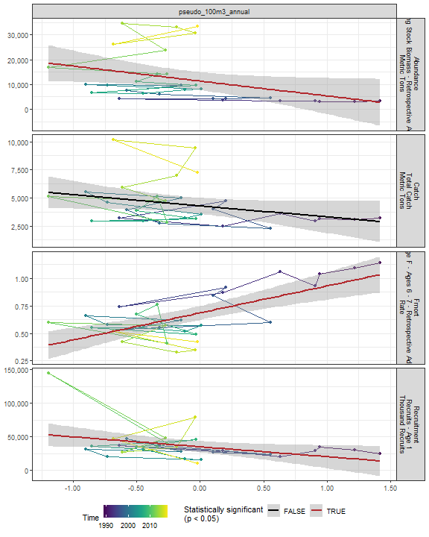

##### Regression statistics

Table 2.30: Fmort vs pseudo_100m3_annual

|  |  |  |  |  |
| --- | --- | --- | --- | --- |
|  | Estimate | Std. Error | t value | Pr(>|t|) |
| (Intercept) | 0.69 | 0.03 | 22.24 | 0 |
| Val | 0.24 | 0.05 | 5.02 | 0 |

|  |  |
| --- | --- |
| Name | Value |
| F-statistic | 25.19 |
| df | 1, 28 |
| R2 | 0.47 |
| R2-adj | 0.45 |

Table 2.30: Recruitment vs pseudo_100m3_annual

|  |  |  |  |  |
| --- | --- | --- | --- | --- |
|  | Estimate | Std. Error | t value | Pr(>|t|) |
| (Intercept) | 34793.10 | 4188.93 | 8.31 | 0.00 |
| Val | -14810.24 | 6629.52 | -2.23 | 0.03 |

|  |  |
| --- | --- |
| Name | Value |
| F-statistic | 4.99 |
| df | 1, 28 |
| R2 | 0.15 |
| R2-adj | 0.12 |

Table 2.30: Abundance vs pseudo_100m3_annual

|  |  |  |  |  |
| --- | --- | --- | --- | --- |
|  | Estimate | Std. Error | t value | Pr(>|t|) |
| (Intercept) | 11331.04 | 1772.05 | 6.39 | 0.00 |
| Val | -6011.89 | 2804.50 | -2.14 | 0.04 |

|  |  |
| --- | --- |
| Name | Value |
| F-statistic | 4.6 |
| df | 1, 28 |
| R2 | 0.14 |
| R2-adj | 0.11 |

#### Penilia 100m3 Annual

##### Figures

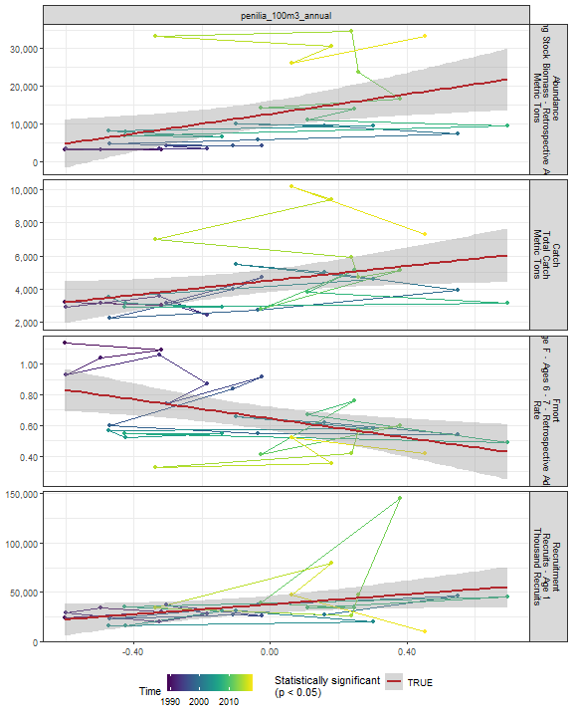

##### Regression statistics

Table 2.31: Catch vs penilia_100m3_annual

|  |  |  |  |  |
| --- | --- | --- | --- | --- |
|  | Estimate | Std. Error | t value | Pr(>|t|) |
| (Intercept) | 4503.51 | 337.22 | 13.35 | 0.00 |
| Val | 2190.68 | 953.06 | 2.30 | 0.03 |

|  |  |
| --- | --- |
| Name | Value |
| F-statistic | 5.28 |
| df | 1, 28 |
| R2 | 0.16 |
| R2-adj | 0.13 |

Table 2.31: Fmort vs penilia_100m3_annual

|  |  |  |  |  |
| --- | --- | --- | --- | --- |
|  | Estimate | Std. Error | t value | Pr(>|t|) |
| (Intercept) | 0.65 | 0.04 | 17.34 | 0.00 |
| Val | -0.31 | 0.11 | -2.97 | 0.01 |

|  |  |
| --- | --- |
| Name | Value |
| F-statistic | 8.81 |
| df | 1, 28 |
| R2 | 0.24 |
| R2-adj | 0.21 |

Table 2.31: Recruitment vs penilia_100m3_annual

|  |  |  |  |  |
| --- | --- | --- | --- | --- |
|  | Estimate | Std. Error | t value | Pr(>|t|) |
| (Intercept) | 37620.63 | 4240.30 | 8.87 | 0.00 |
| Val | 25270.39 | 11983.91 | 2.11 | 0.04 |

|  |  |
| --- | --- |
| Name | Value |
| F-statistic | 4.45 |
| df | 1, 28 |
| R2 | 0.14 |
| R2-adj | 0.11 |

Table 2.31: Abundance vs penilia_100m3_annual

|  |  |  |  |  |
| --- | --- | --- | --- | --- |
|  | Estimate | Std. Error | t value | Pr(>|t|) |
| (Intercept) | 12646.72 | 1707.83 | 7.41 | 0.00 |
| Val | 13099.54 | 4826.65 | 2.71 | 0.01 |

|  |  |
| --- | --- |
| Name | Value |
| F-statistic | 7.37 |
| df | 1, 28 |
| R2 | 0.21 |
| R2-adj | 0.18 |

#### Tlong 100m3 Annual

##### Figures

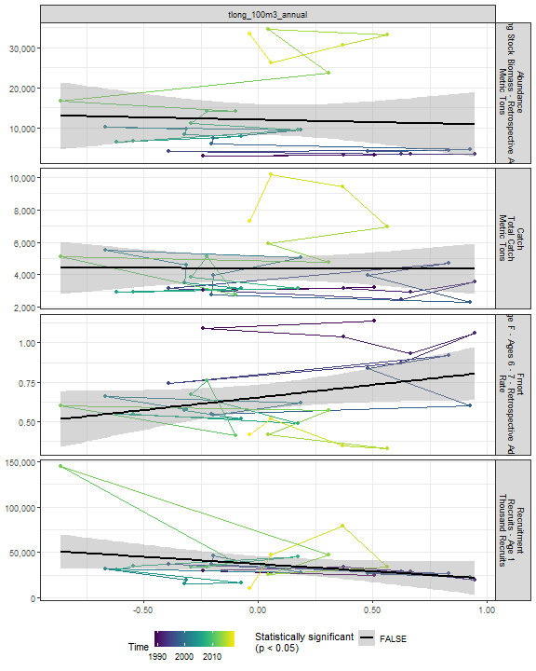

##### Regression statistics

[1] “No statistically significant data”

#### Cham 100m3 Annual

##### Figures

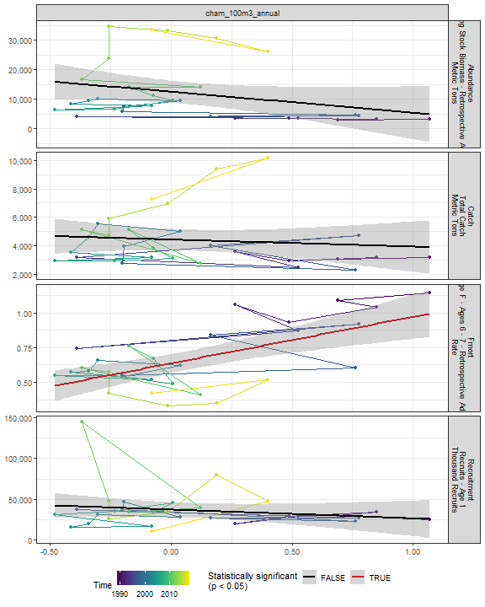

##### Regression statistics

Table 2.32: Fmort vs cham_100m3_annual

|  |  |  |  |  |
| --- | --- | --- | --- | --- |
|  | Estimate | Std. Error | t value | Pr(>|t|) |
| (Intercept) | 0.64 | 0.03 | 19.22 | 0 |
| Val | 0.33 | 0.08 | 4.35 | 0 |

|  |  |
| --- | --- |
| Name | Value |
| F-statistic | 18.94 |
| df | 1, 28 |
| R2 | 0.4 |
| R2-adj | 0.38 |

#### Echino 100m3 Annual

##### Figures

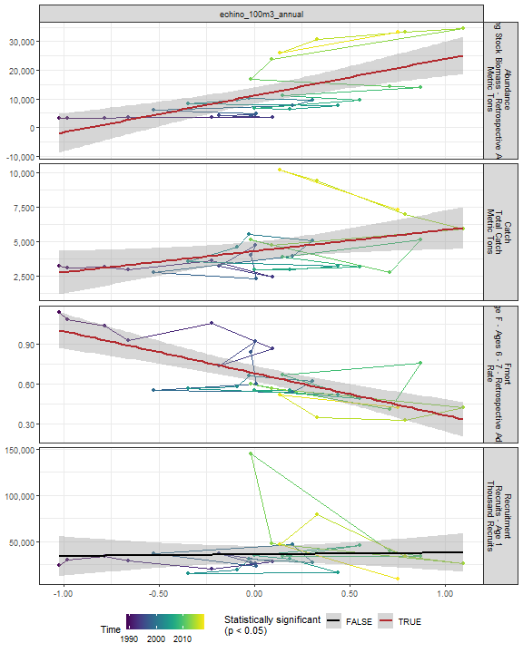

##### Regression statistics

Table 2.33: Catch vs echino_100m3_annual

|  |  |  |  |  |
| --- | --- | --- | --- | --- |
|  | Estimate | Std. Error | t value | Pr(>|t|) |
| (Intercept) | 4280.65 | 332.62 | 12.87 | 0.00 |
| Val | 1538.23 | 643.04 | 2.39 | 0.02 |

|  |  |
| --- | --- |
| Name | Value |
| F-statistic | 5.72 |
| df | 1, 28 |
| R2 | 0.17 |
| R2-adj | 0.14 |

Table 2.33: Fmort vs echino_100m3_annual

|  |  |  |  |  |
| --- | --- | --- | --- | --- |
|  | Estimate | Std. Error | t value | Pr(>|t|) |
| (Intercept) | 0.68 | 0.03 | 23.73 | 0 |
| Val | -0.32 | 0.06 | -5.71 | 0 |

|  |  |
| --- | --- |
| Name | Value |
| F-statistic | 32.64 |
| df | 1, 28 |
| R2 | 0.54 |
| R2-adj | 0.52 |

Table 2.33: Abundance vs echino_100m3_annual

|  |  |  |  |  |
| --- | --- | --- | --- | --- |
|  | Estimate | Std. Error | t value | Pr(>|t|) |
| (Intercept) | 11090.01 | 1429.70 | 7.76 | 0 |
| Val | 12888.02 | 2763.99 | 4.66 | 0 |

|  |  |
| --- | --- |
| Name | Value |
| F-statistic | 21.74 |
| df | 1, 28 |
| R2 | 0.44 |
| R2-adj | 0.42 |

#### Larvaceans 100m3 Annual

##### Figures

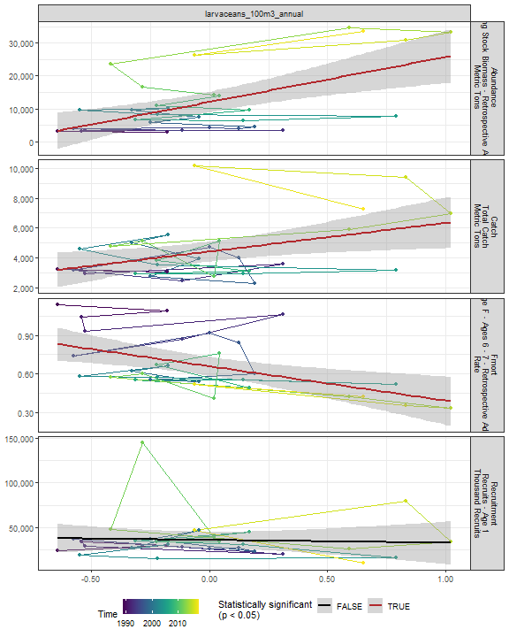

##### Regression statistics

Table 2.34: Catch vs larvaceans_100m3_annual

|  |  |  |  |  |
| --- | --- | --- | --- | --- |
|  | Estimate | Std. Error | t value | Pr(>|t|) |
| (Intercept) | 4409.93 | 326.78 | 13.50 | 0.00 |
| Val | 1919.97 | 751.92 | 2.55 | 0.02 |

|  |  |
| --- | --- |
| Name | Value |
| F-statistic | 6.52 |
| df | 1, 28 |
| R2 | 0.19 |
| R2-adj | 0.16 |

Table 2.34: Fmort vs larvaceans_100m3_annual

|  |  |  |  |  |
| --- | --- | --- | --- | --- |
|  | Estimate | Std. Error | t value | Pr(>|t|) |
| (Intercept) | 0.66 | 0.04 | 18.34 | 0 |
| Val | -0.27 | 0.08 | -3.23 | 0 |

|  |  |
| --- | --- |
| Name | Value |
| F-statistic | 10.46 |
| df | 1, 28 |
| R2 | 0.27 |
| R2-adj | 0.25 |

Table 2.34: Abundance vs larvaceans_100m3_annual

|  |  |  |  |  |
| --- | --- | --- | --- | --- |
|  | Estimate | Std. Error | t value | Pr(>|t|) |
| (Intercept) | 12127.29 | 1527.92 | 7.94 | 0 |
| Val | 13630.84 | 3515.75 | 3.88 | 0 |

|  |  |
| --- | --- |
| Name | Value |
| F-statistic | 15.03 |
| df | 1, 28 |
| R2 | 0.35 |
| R2-adj | 0.33 |

#### Para 100m3 Annual

##### Figures

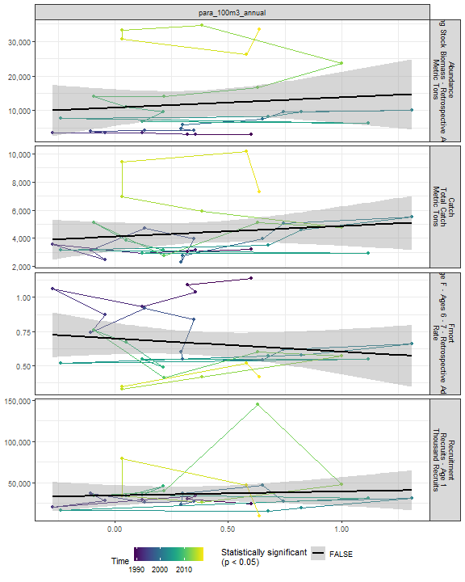

##### Regression statistics

[1] “No statistically significant data”

#### Gas 100m3 Annual

##### Figures

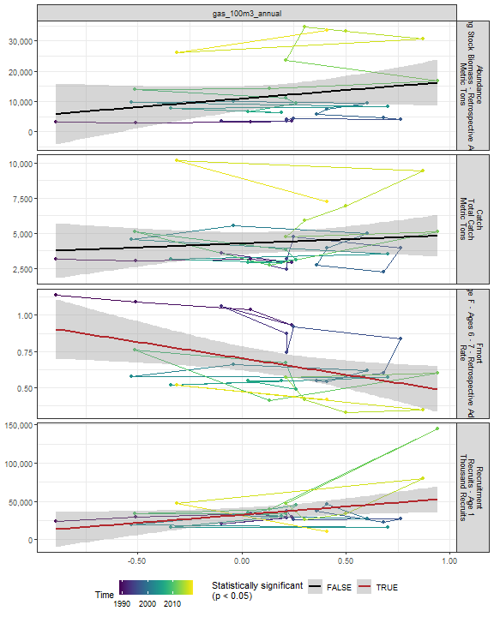

##### Regression statistics

Table 2.35: Fmort vs gas_100m3_annual

|  |  |  |  |  |
| --- | --- | --- | --- | --- |
|  | Estimate | Std. Error | t value | Pr(>|t|) |
| (Intercept) | 0.70 | 0.04 | 17.25 | 0.00 |
| Val | -0.23 | 0.09 | -2.59 | 0.02 |

|  |  |
| --- | --- |
| Name | Value |
| F-statistic | 6.7 |
| df | 1, 28 |
| R2 | 0.19 |
| R2-adj | 0.16 |

Table 2.35: Recruitment vs gas_100m3_annual

|  |  |  |  |  |
| --- | --- | --- | --- | --- |
|  | Estimate | Std. Error | t value | Pr(>|t|) |
| (Intercept) | 32355.99 | 4474.76 | 7.23 | 0.00 |
| Val | 21342.69 | 9538.80 | 2.24 | 0.03 |

|  |  |
| --- | --- |
| Name | Value |
| F-statistic | 5.01 |
| df | 1, 28 |
| R2 | 0.15 |
| R2-adj | 0.12 |

#### Acarspp 100m3 Annual

##### Figures

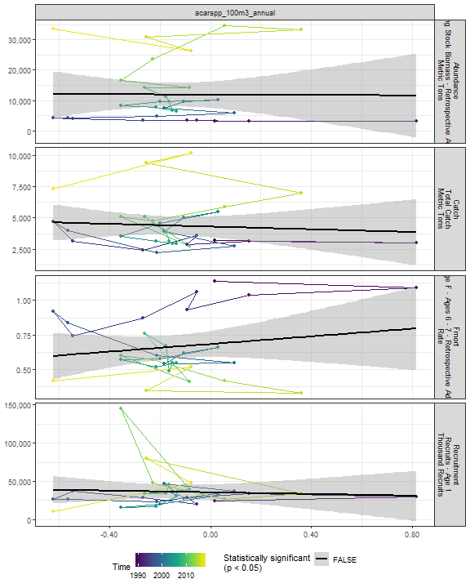

##### Regression statistics

[1] “No statistically significant data”

#### Mlucens 100m3 Annual

##### Figures

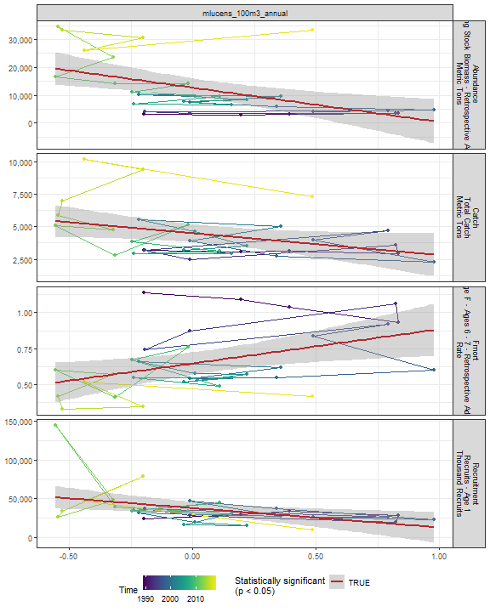

##### Regression statistics

Table 2.36: Catch vs mlucens_100m3_annual

|  |  |  |  |  |
| --- | --- | --- | --- | --- |
|  | Estimate | Std. Error | t value | Pr(>|t|) |
| (Intercept) | 4493.42 | 340.84 | 13.18 | 0.00 |
| Val | -1694.78 | 794.51 | -2.13 | 0.04 |

|  |  |
| --- | --- |
| Name | Value |
| F-statistic | 4.55 |
| df | 1, 28 |
| R2 | 0.14 |
| R2-adj | 0.11 |

Table 2.36: Fmort vs mlucens_100m3_annual

|  |  |  |  |  |
| --- | --- | --- | --- | --- |
|  | Estimate | Std. Error | t value | Pr(>|t|) |
| (Intercept) | 0.65 | 0.04 | 17.01 | 0.00 |
| Val | 0.24 | 0.09 | 2.68 | 0.01 |

|  |  |
| --- | --- |
| Name | Value |
| F-statistic | 7.18 |
| df | 1, 28 |
| R2 | 0.2 |
| R2-adj | 0.18 |

Table 2.36: Recruitment vs mlucens_100m3_annual

|  |  |  |  |  |
| --- | --- | --- | --- | --- |
|  | Estimate | Std. Error | t value | Pr(>|t|) |
| (Intercept) | 37885.32 | 4089.02 | 9.27 | 0.00 |
| Val | -24961.81 | 9531.78 | -2.62 | 0.01 |

|  |  |
| --- | --- |
| Name | Value |
| F-statistic | 6.86 |
| df | 1, 28 |
| R2 | 0.2 |
| R2-adj | 0.17 |

Table 2.36: Abundance vs mlucens_100m3_annual

|  |  |  |  |  |
| --- | --- | --- | --- | --- |
|  | Estimate | Std. Error | t value | Pr(>|t|) |
| (Intercept) | 12738.98 | 1638.85 | 7.77 | 0 |
| Val | -12301.24 | 3820.27 | -3.22 | 0 |

|  |  |
| --- | --- |
| Name | Value |
| F-statistic | 10.37 |
| df | 1, 28 |
| R2 | 0.27 |
| R2-adj | 0.24 |

#### Evadnespp 100m3 Annual

##### Figures

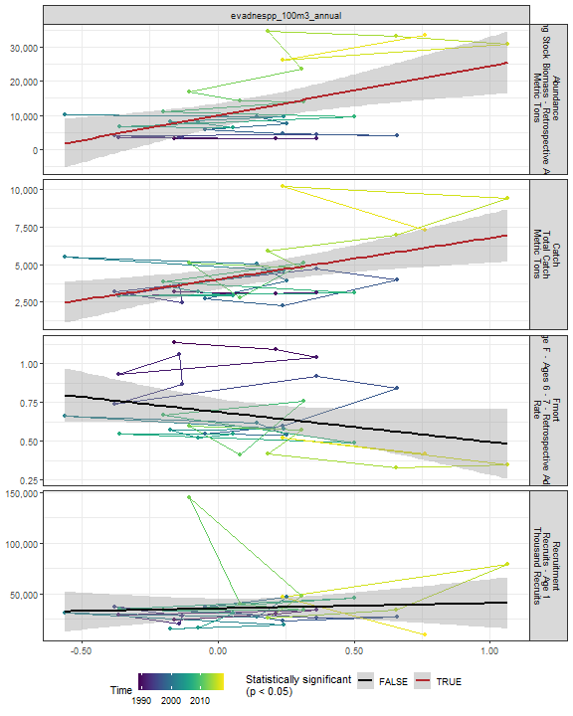

##### Regression statistics

Table 2.37: Catch vs evadnespp_100m3_annual

|  |  |  |  |  |
| --- | --- | --- | --- | --- |
|  | Estimate | Std. Error | t value | Pr(>|t|) |
| (Intercept) | 4015.31 | 329.45 | 12.19 | 0 |
| Val | 2731.85 | 850.95 | 3.21 | 0 |

|  |  |
| --- | --- |
| Name | Value |
| F-statistic | 10.31 |
| df | 1, 28 |
| R2 | 0.27 |
| R2-adj | 0.24 |

Table 2.37: Abundance vs evadnespp_100m3_annual

|  |  |  |  |  |
| --- | --- | --- | --- | --- |
|  | Estimate | Std. Error | t value | Pr(>|t|) |
| (Intercept) | 9963.62 | 1707.48 | 5.84 | 0 |
| Val | 14537.16 | 4410.28 | 3.30 | 0 |

|  |  |
| --- | --- |
| Name | Value |
| F-statistic | 10.86 |
| df | 1, 28 |
| R2 | 0.28 |
| R2-adj | 0.25 |

#### Salps 100m3 Annual

##### Figures

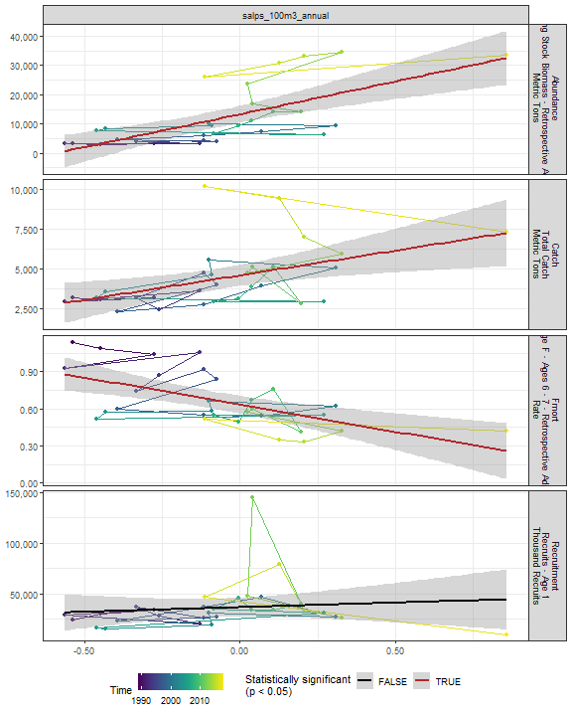

##### Regression statistics

Table 2.38: Catch vs salps_100m3_annual

|  |  |  |  |  |
| --- | --- | --- | --- | --- |
|  | Estimate | Std. Error | t value | Pr(>|t|) |
| (Intercept) | 4576.44 | 324.17 | 14.12 | 0.00 |
| Val | 3102.06 | 1053.99 | 2.94 | 0.01 |

|  |  |
| --- | --- |
| Name | Value |
| F-statistic | 8.66 |
| df | 1, 28 |
| R2 | 0.24 |
| R2-adj | 0.21 |

Table 2.38: Fmort vs salps_100m3_annual

|  |  |  |  |  |
| --- | --- | --- | --- | --- |
|  | Estimate | Std. Error | t value | Pr(>|t|) |
| (Intercept) | 0.64 | 0.03 | 18.33 | 0 |
| Val | -0.44 | 0.11 | -3.90 | 0 |

|  |  |
| --- | --- |
| Name | Value |
| F-statistic | 15.19 |
| df | 1, 28 |
| R2 | 0.35 |
| R2-adj | 0.33 |

Table 2.38: Abundance vs salps_100m3_annual

|  |  |  |  |  |
| --- | --- | --- | --- | --- |
|  | Estimate | Std. Error | t value | Pr(>|t|) |
| (Intercept) | 13336.46 | 1431.47 | 9.32 | 0 |
| Val | 22437.15 | 4654.18 | 4.82 | 0 |

|  |  |
| --- | --- |
| Name | Value |
| F-statistic | 23.24 |
| df | 1, 28 |
| R2 | 0.45 |
| R2-adj | 0.43 |

#### Oithspp 100m3 Annual

##### Figures

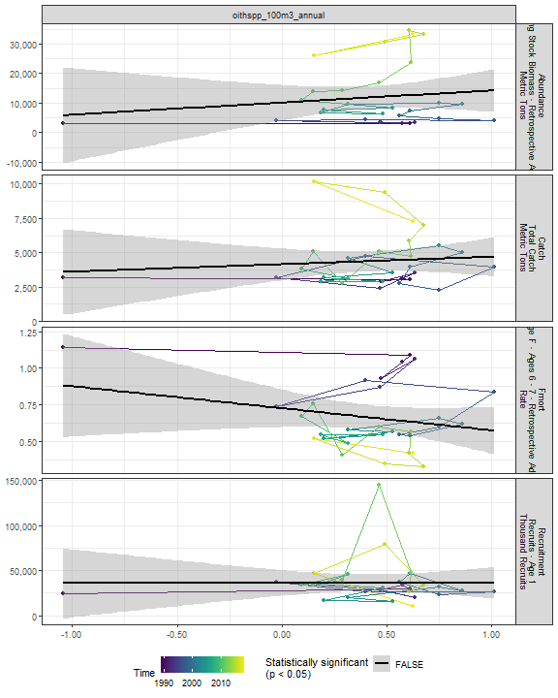

##### Regression statistics

[1] “No statistically significant data”

#### Chaeto 100m3 Annual

##### Figures

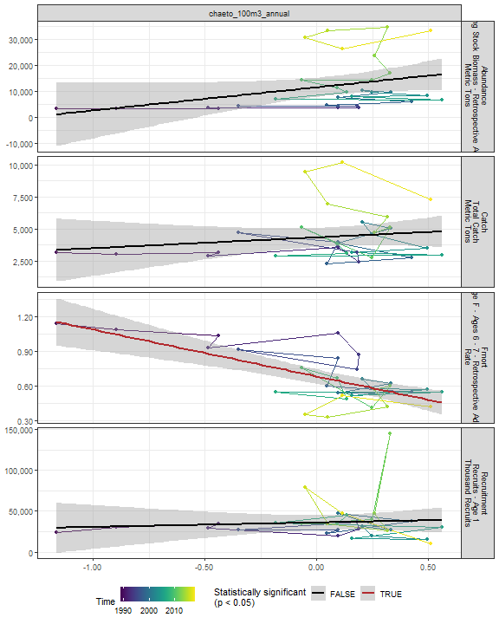

##### Regression statistics

Table 2.39: Fmort vs chaeto_100m3_annual

|  |  |  |  |  |
| --- | --- | --- | --- | --- |
|  | Estimate | Std. Error | t value | Pr(>|t|) |
| (Intercept) | 0.68 | 0.03 | 22.51 | 0 |
| Val | -0.41 | 0.08 | -5.15 | 0 |

|  |  |
| --- | --- |
| Name | Value |
| F-statistic | 26.52 |
| df | 1, 28 |
| R2 | 0.49 |
| R2-adj | 0.47 |

#### Hyper 100m3 Annual

##### Figures

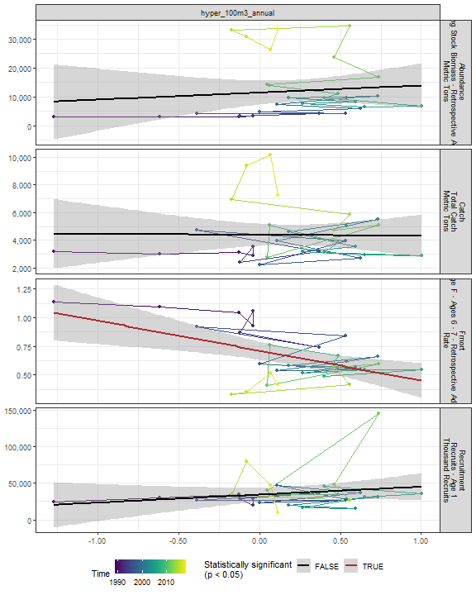

##### Regression statistics

Table 2.40: Fmort vs hyper_100m3_annual

|  |  |  |  |  |
| --- | --- | --- | --- | --- |
|  | Estimate | Std. Error | t value | Pr(>|t|) |
| (Intercept) | 0.71 | 0.04 | 18.46 | 0 |
| Val | -0.26 | 0.08 | -3.32 | 0 |

|  |  |
| --- | --- |
| Name | Value |
| F-statistic | 11 |
| df | 1, 28 |
| R2 | 0.28 |
| R2-adj | 0.26 |

#### Calminor 100m3 Annual

##### Figures

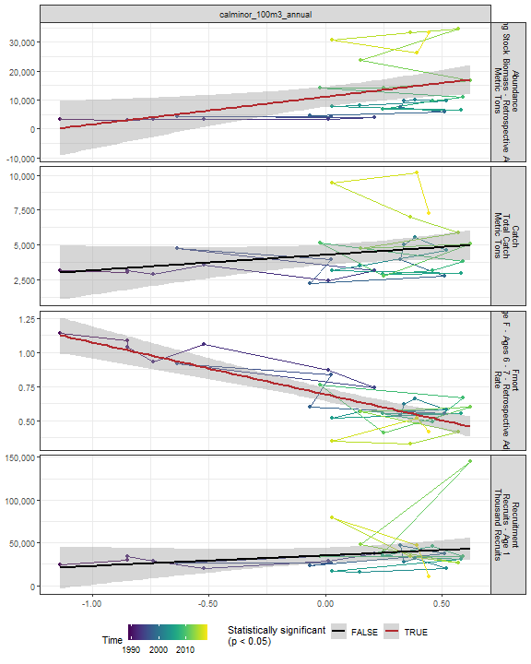

##### Regression statistics

Table 2.41: Fmort vs calminor_100m3_annual

|  |  |  |  |  |
| --- | --- | --- | --- | --- |
|  | Estimate | Std. Error | t value | Pr(>|t|) |
| (Intercept) | 0.69 | 0.02 | 28.92 | 0 |
| Val | -0.38 | 0.05 | -7.76 | 0 |

|  |  |
| --- | --- |
| Name | Value |
| F-statistic | 60.29 |
| df | 1, 28 |
| R2 | 0.68 |
| R2-adj | 0.67 |

Table 2.41: Abundance vs calminor_100m3_annual

|  |  |  |  |  |
| --- | --- | --- | --- | --- |
|  | Estimate | Std. Error | t value | Pr(>|t|) |
| (Intercept) | 11105.76 | 1701.45 | 6.53 | 0.00 |
| Val | 9556.64 | 3468.77 | 2.76 | 0.01 |

|  |  |
| --- | --- |
| Name | Value |
| F-statistic | 7.59 |
| df | 1, 28 |
| R2 | 0.21 |
| R2-adj | 0.19 |

#### Clauso Annual

##### Figures

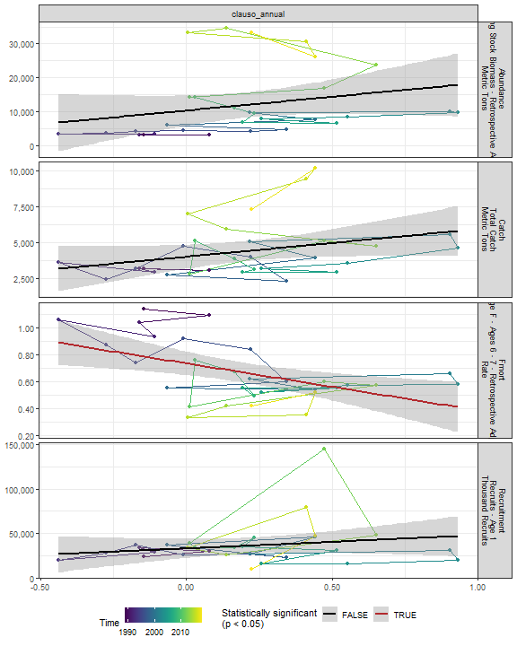

##### Regression statistics

Table 2.42: Fmort vs clauso_annual

|  |  |  |  |  |
| --- | --- | --- | --- | --- |
|  | Estimate | Std. Error | t value | Pr(>|t|) |
| (Intercept) | 0.73 | 0.04 | 17.07 | 0 |
| Val | -0.35 | 0.11 | -3.07 | 0 |

|  |  |
| --- | --- |
| Name | Value |
| F-statistic | 9.44 |
| df | 1, 28 |
| R2 | 0.25 |
| R2-adj | 0.23 |

#### Dec 100m3 Annual

##### Figures

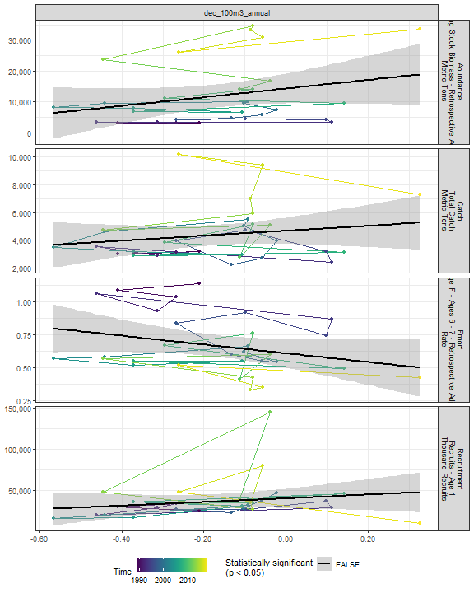

##### Regression statistics

[1] “No statistically significant data”

#### Euph 100m3 Annual

##### Figures

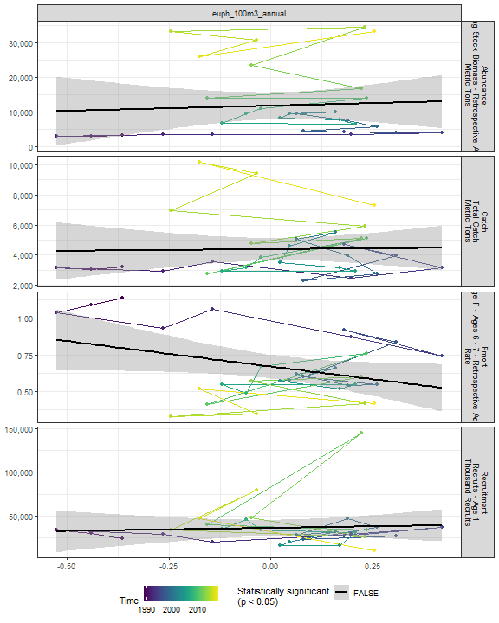

##### Regression statistics

[1] “No statistically significant data”

#### Prot 100m3 Annual

##### Figures

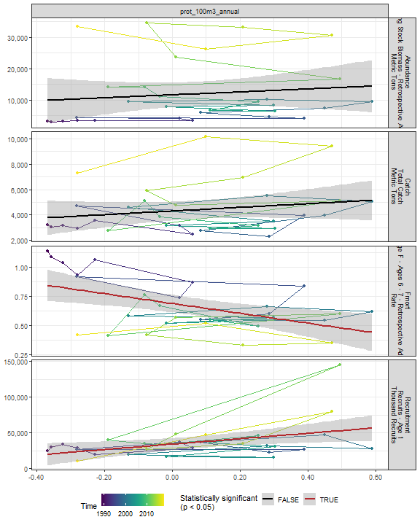

##### Regression statistics

Table 2.43: Fmort vs prot_100m3_annual

|  |  |  |  |  |
| --- | --- | --- | --- | --- |
|  | Estimate | Std. Error | t value | Pr(>|t|) |
| (Intercept) | 0.69 | 0.04 | 18.75 | 0 |
| Val | -0.42 | 0.13 | -3.23 | 0 |

|  |  |
| --- | --- |
| Name | Value |
| F-statistic | 10.43 |
| df | 1, 28 |
| R2 | 0.27 |
| R2-adj | 0.25 |

Table 2.43: Recruitment vs prot_100m3_annual

|  |  |  |  |  |
| --- | --- | --- | --- | --- |
|  | Estimate | Std. Error | t value | Pr(>|t|) |
| (Intercept) | 33904.97 | 4139.27 | 8.19 | 0.00 |
| Val | 37821.90 | 14711.34 | 2.57 | 0.02 |

|  |  |
| --- | --- |
| Name | Value |
| F-statistic | 6.61 |
| df | 1, 28 |
| R2 | 0.19 |
| R2-adj | 0.16 |

#### Poly 100m3 Annual

##### Figures

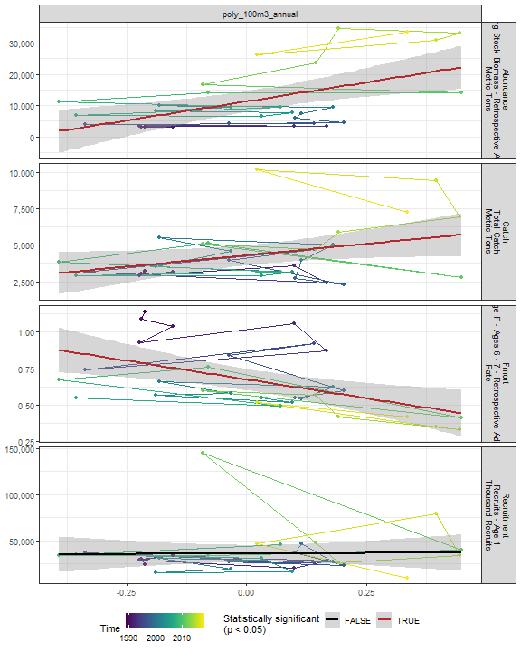

##### Regression statistics

Table 2.44: Catch vs poly_100m3_annual

|  |  |  |  |  |
| --- | --- | --- | --- | --- |
|  | Estimate | Std. Error | t value | Pr(>|t|) |
| (Intercept) | 4303.38 | 338.79 | 12.70 | 0.00 |
| Val | 3124.81 | 1493.40 | 2.09 | 0.05 |

|  |  |
| --- | --- |
| Name | Value |
| F-statistic | 4.38 |
| df | 1, 28 |
| R2 | 0.14 |
| R2-adj | 0.1 |

Table 2.44: Fmort vs poly_100m3_annual

|  |  |  |  |  |
| --- | --- | --- | --- | --- |
|  | Estimate | Std. Error | t value | Pr(>|t|) |
| (Intercept) | 0.68 | 0.04 | 18.73 | 0 |
| Val | -0.51 | 0.16 | -3.24 | 0 |

|  |  |
| --- | --- |
| Name | Value |
| F-statistic | 10.47 |
| df | 1, 28 |
| R2 | 0.27 |
| R2-adj | 0.25 |

Table 2.44: Abundance vs poly_100m3_annual

|  |  |  |  |  |
| --- | --- | --- | --- | --- |
|  | Estimate | Std. Error | t value | Pr(>|t|) |
| (Intercept) | 11322.90 | 1591.10 | 7.12 | 0 |
| Val | 24302.44 | 7013.63 | 3.47 | 0 |

|  |  |
| --- | --- |
| Name | Value |
| F-statistic | 12.01 |
| df | 1, 28 |
| R2 | 0.3 |
| R2-adj | 0.28 |

#### Fish 100m3 Annual

##### Figures

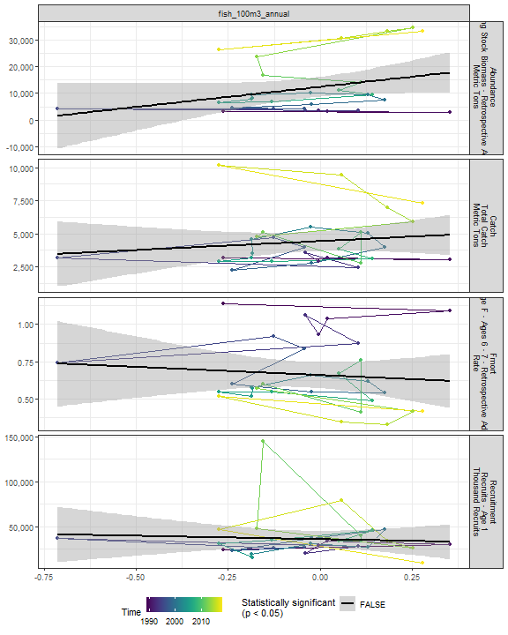

##### Regression statistics

[1] “No statistically significant data”

#### Oncaea 100m3 Annual

##### Figures

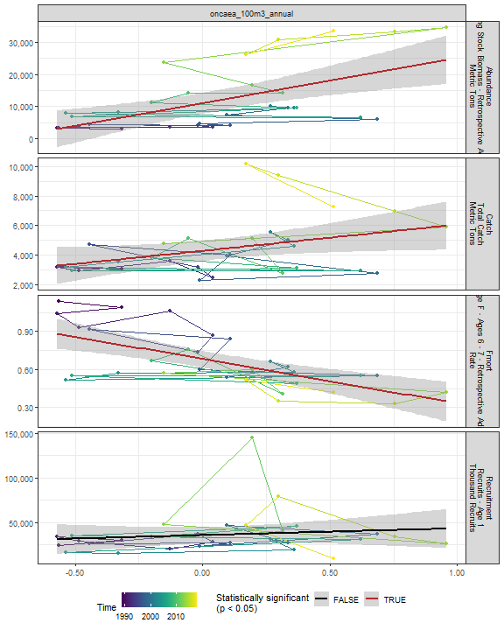

##### Regression statistics

Table 2.45: Catch vs oncaea_100m3_annual

|  |  |  |  |  |
| --- | --- | --- | --- | --- |
|  | Estimate | Std. Error | t value | Pr(>|t|) |
| (Intercept) | 4269.44 | 337.98 | 12.63 | 0.00 |
| Val | 1780.88 | 807.90 | 2.20 | 0.04 |

|  |  |
| --- | --- |
| Name | Value |
| F-statistic | 4.86 |
| df | 1, 28 |
| R2 | 0.15 |
| R2-adj | 0.12 |

Table 2.45: Fmort vs oncaea_100m3_annual

|  |  |  |  |  |
| --- | --- | --- | --- | --- |
|  | Estimate | Std. Error | t value | Pr(>|t|) |
| (Intercept) | 0.68 | 0.03 | 21.23 | 0 |
| Val | -0.35 | 0.08 | -4.54 | 0 |

|  |  |
| --- | --- |
| Name | Value |
| F-statistic | 20.63 |
| df | 1, 28 |
| R2 | 0.42 |
| R2-adj | 0.4 |

Table 2.45: Abundance vs oncaea_100m3_annual

|  |  |  |  |  |
| --- | --- | --- | --- | --- |
|  | Estimate | Std. Error | t value | Pr(>|t|) |
| (Intercept) | 11045.81 | 1554.06 | 7.11 | 0 |
| Val | 14074.69 | 3714.82 | 3.79 | 0 |

|  |  |
| --- | --- |
| Name | Value |
| F-statistic | 14.35 |
| df | 1, 28 |
| R2 | 0.34 |
| R2-adj | 0.32 |

#### Cory 100m3 Annual

##### Figures

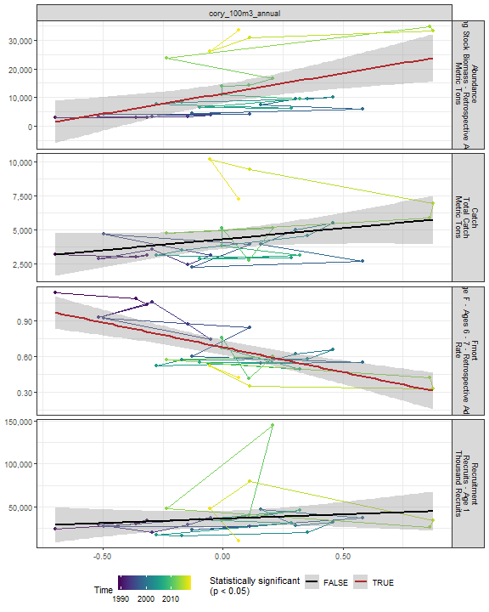

##### Regression statistics

Table 2.46: Fmort vs cory_100m3_annual

|  |  |  |  |  |
| --- | --- | --- | --- | --- |
|  | Estimate | Std. Error | t value | Pr(>|t|) |
| (Intercept) | 0.68 | 0.03 | 22.30 | 0 |
| Val | -0.42 | 0.08 | -5.11 | 0 |

|  |  |
| --- | --- |
| Name | Value |
| F-statistic | 26.13 |
| df | 1, 28 |
| R2 | 0.48 |
| R2-adj | 0.46 |

Table 2.46: Abundance vs cory_100m3_annual

|  |  |  |  |  |
| --- | --- | --- | --- | --- |
|  | Estimate | Std. Error | t value | Pr(>|t|) |
| (Intercept) | 11424.32 | 1624.50 | 7.03 | 0 |
| Val | 14091.60 | 4394.99 | 3.21 | 0 |

|  |  |
| --- | --- |
| Name | Value |
| F-statistic | 10.28 |
| df | 1, 28 |
| R2 | 0.27 |
| R2-adj | 0.24 |

#### Siph 100m3 Annual

##### Figures

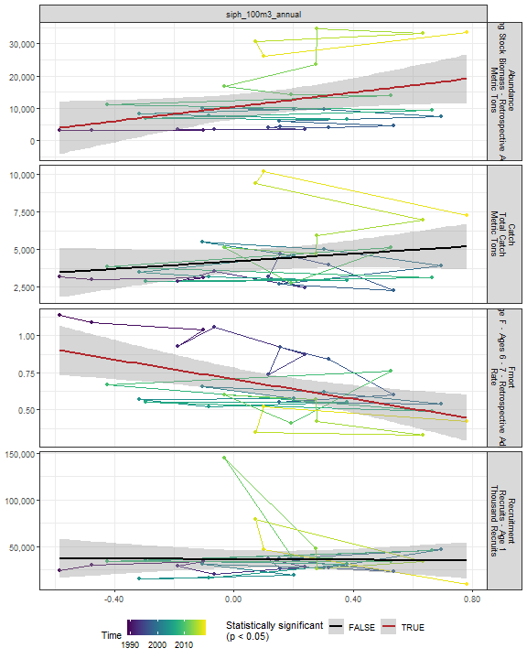

##### Regression statistics

Table 2.47: Fmort vs siph_100m3_annual

|  |  |  |  |  |
| --- | --- | --- | --- | --- |
|  | Estimate | Std. Error | t value | Pr(>|t|) |
| (Intercept) | 0.71 | 0.04 | 18.47 | 0 |
| Val | -0.33 | 0.10 | -3.24 | 0 |

|  |  |
| --- | --- |
| Name | Value |
| F-statistic | 10.53 |
| df | 1, 28 |
| R2 | 0.27 |
| R2-adj | 0.25 |

Table 2.47: Abundance vs siph_100m3_annual

|  |  |  |  |  |
| --- | --- | --- | --- | --- |
|  | Estimate | Std. Error | t value | Pr(>|t|) |
| (Intercept) | 10412.12 | 1862.54 | 5.59 | 0.00 |
| Val | 11090.28 | 4970.42 | 2.23 | 0.03 |

|  |  |
| --- | --- |
| Name | Value |
| F-statistic | 4.98 |
| df | 1, 28 |
| R2 | 0.15 |
| R2-adj | 0.12 |

#### Coel 100m3 Annual

##### Figures

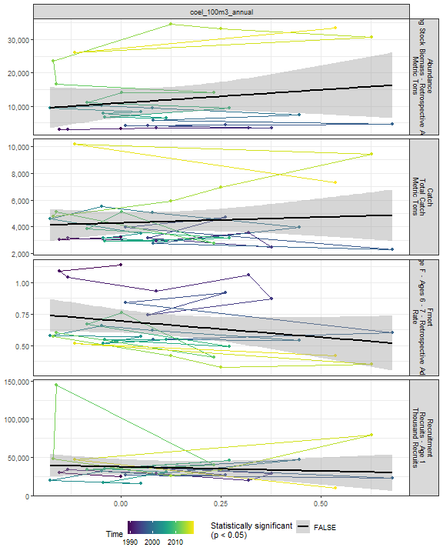

##### Regression statistics

[1] “No statistically significant data”

#### Euph1 100m3 Annual

##### Figures

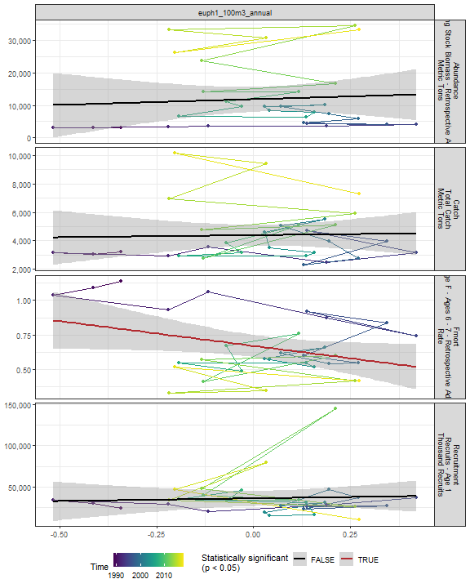

##### Regression statistics

Table 2.48: Fmort vs euph1_100m3_annual

|  |  |  |  |  |
| --- | --- | --- | --- | --- |
|  | Estimate | Std. Error | t value | Pr(>|t|) |
| (Intercept) | 0.67 | 0.04 | 17.06 | 0.00 |
| Val | -0.36 | 0.17 | -2.07 | 0.05 |

|  |  |
| --- | --- |
| Name | Value |
| F-statistic | 4.29 |
| df | 1, 28 |
| R2 | 0.13 |
| R2-adj | 0.1 |

#### Thecos 100m3 Annual

##### Figures

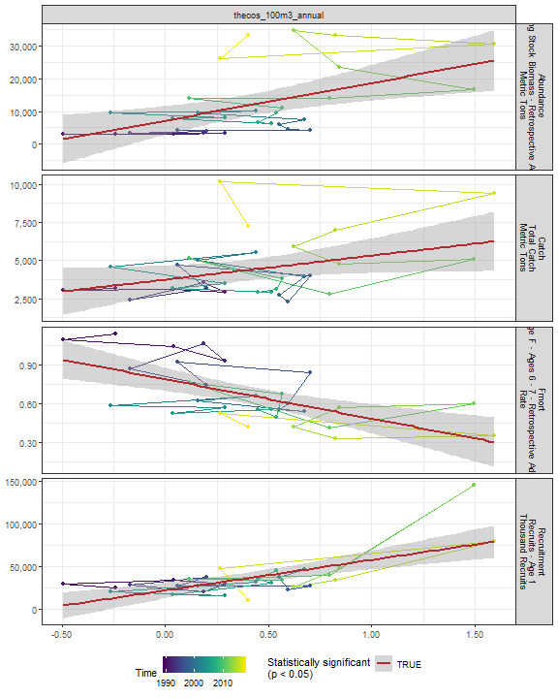

##### Regression statistics

Table 2.49: Catch vs thecos_100m3_annual

|  |  |  |  |  |
| --- | --- | --- | --- | --- |
|  | Estimate | Std. Error | t value | Pr(>|t|) |
| (Intercept) | 3740.7 | 451.19 | 8.29 | 0.00 |
| Val | 1572.3 | 745.47 | 2.11 | 0.04 |

|  |  |
| --- | --- |
| Name | Value |
| F-statistic | 4.45 |
| df | 1, 28 |
| R2 | 0.14 |
| R2-adj | 0.11 |

Table 2.49: Fmort vs thecos_100m3_annual

|  |  |  |  |  |
| --- | --- | --- | --- | --- |
|  | Estimate | Std. Error | t value | Pr(>|t|) |
| (Intercept) | 0.79 | 0.04 | 17.80 | 0 |
| Val | -0.31 | 0.07 | -4.18 | 0 |

|  |  |
| --- | --- |
| Name | Value |
| F-statistic | 17.5 |
| df | 1, 28 |
| R2 | 0.38 |
| R2-adj | 0.36 |

Table 2.49: Recruitment vs thecos_100m3_annual

|  |  |  |  |  |
| --- | --- | --- | --- | --- |
|  | Estimate | Std. Error | t value | Pr(>|t|) |
| (Intercept) | 21726.99 | 4432.09 | 4.90 | 0 |
| Val | 35748.24 | 7322.86 | 4.88 | 0 |

|  |  |
| --- | --- |
| Name | Value |
| F-statistic | 23.83 |
| df | 1, 28 |
| R2 | 0.46 |
| R2-adj | 0.44 |

Table 2.49: Abundance vs thecos_100m3_annual

|  |  |  |  |  |
| --- | --- | --- | --- | --- |
|  | Estimate | Std. Error | t value | Pr(>|t|) |
| (Intercept) | 7228.17 | 2165.67 | 3.34 | 0 |
| Val | 11529.72 | 3578.19 | 3.22 | 0 |

|  |  |
| --- | --- |
| Name | Value |
| F-statistic | 10.38 |
| df | 1, 28 |
| R2 | 0.27 |
| R2-adj | 0.24 |

#### Spirspp 100m3 Annual

##### Figures

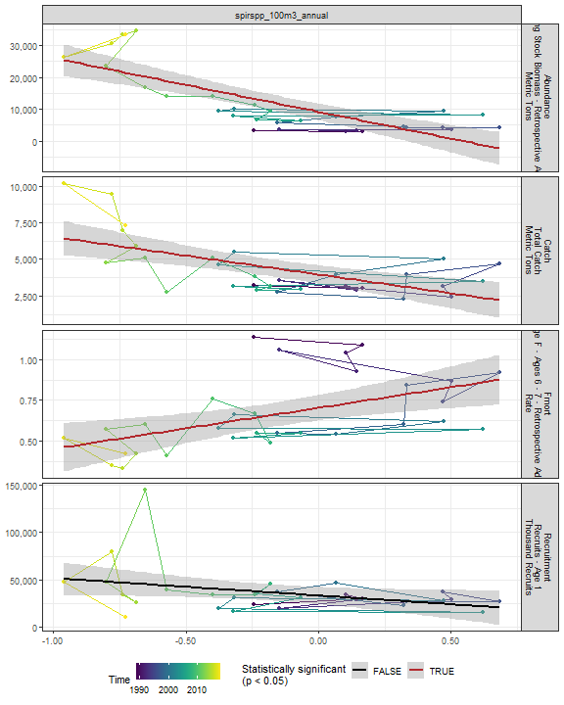

##### Regression statistics

Table 2.50: Catch vs spirspp_100m3_annual

|  |  |  |  |  |
| --- | --- | --- | --- | --- |
|  | Estimate | Std. Error | t value | Pr(>|t|) |
| (Intercept) | 3969.66 | 302.11 | 13.14 | 0 |
| Val | -2573.80 | 623.35 | -4.13 | 0 |

|  |  |
| --- | --- |
| Name | Value |
| F-statistic | 17.05 |
| df | 1, 28 |
| R2 | 0.38 |
| R2-adj | 0.36 |

Table 2.50: Fmort vs spirspp_100m3_annual

|  |  |  |  |  |
| --- | --- | --- | --- | --- |
|  | Estimate | Std. Error | t value | Pr(>|t|) |
| (Intercept) | 0.70 | 0.04 | 18.54 | 0 |
| Val | 0.25 | 0.08 | 3.23 | 0 |

|  |  |
| --- | --- |
| Name | Value |
| F-statistic | 10.43 |
| df | 1, 28 |
| R2 | 0.27 |
| R2-adj | 0.25 |

Table 2.50: Abundance vs spirspp_100m3_annual

|  |  |  |  |  |
| --- | --- | --- | --- | --- |
|  | Estimate | Std. Error | t value | Pr(>|t|) |
| (Intercept) | 9226.33 | 1273.64 | 7.24 | 0 |
| Val | -16842.44 | 2627.93 | -6.41 | 0 |

|  |  |
| --- | --- |
| Name | Value |
| F-statistic | 41.08 |
| df | 1, 28 |
| R2 | 0.59 |
| R2-adj | 0.58 |

#### Cnidar 100m3 Annual

##### Figures

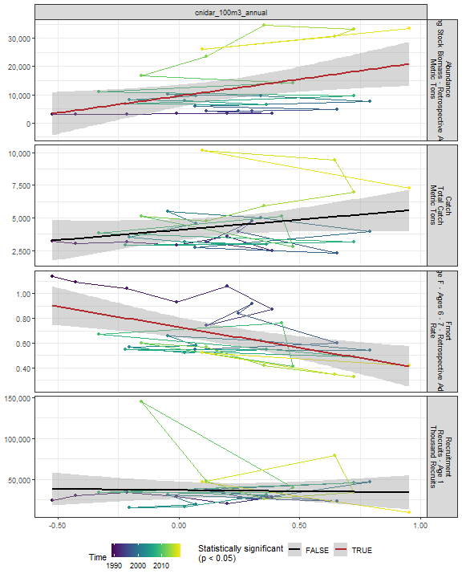

##### Regression statistics

Table 2.51: Fmort vs cnidar_100m3_annual

|  |  |  |  |  |
| --- | --- | --- | --- | --- |
|  | Estimate | Std. Error | t value | Pr(>|t|) |
| (Intercept) | 0.73 | 0.04 | 18.42 | 0 |
| Val | -0.33 | 0.09 | -3.53 | 0 |

|  |  |
| --- | --- |
| Name | Value |
| F-statistic | 12.49 |
| df | 1, 28 |
| R2 | 0.31 |
| R2-adj | 0.28 |

Table 2.51: Abundance vs cnidar_100m3_annual

|  |  |  |  |  |
| --- | --- | --- | --- | --- |
|  | Estimate | Std. Error | t value | Pr(>|t|) |
| (Intercept) | 9518.07 | 1921.41 | 4.95 | 0.00 |
| Val | 11931.90 | 4567.53 | 2.61 | 0.01 |

|  |  |
| --- | --- |
| Name | Value |
| F-statistic | 6.82 |
| df | 1, 28 |
| R2 | 0.2 |
| R2-adj | 0.17 |

#### 2.4.3.2 Spring zooplankton abundance in the stock region

#### Ctyp 100m3 Spring

##### Figures

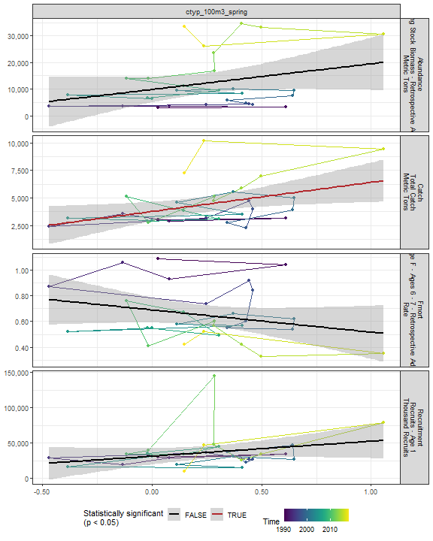

##### Regression statistics

Table 2.52: Catch vs ctyp_100m3_spring

|  |  |  |  |  |
| --- | --- | --- | --- | --- |
|  | Estimate | Std. Error | t value | Pr(>|t|) |
| (Intercept) | 3770.99 | 426.25 | 8.85 | 0.00 |
| Val | 2643.07 | 1071.71 | 2.47 | 0.02 |

|  |  |
| --- | --- |
| Name | Value |
| F-statistic | 6.08 |
| df | 1, 27 |
| R2 | 0.18 |
| R2-adj | 0.15 |

#### Calfin 100m3 Spring

##### Figures

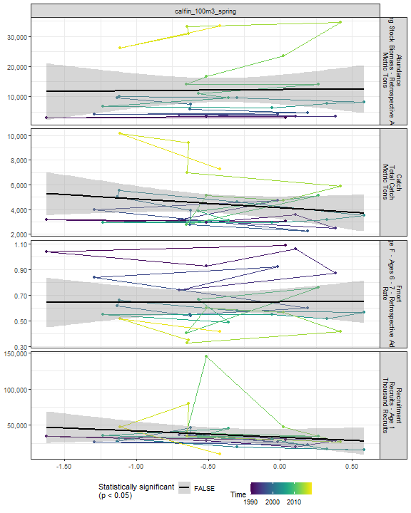

##### Regression statistics

[1] “No statistically significant data”

#### Pseudo 100m3 Spring

##### Figures

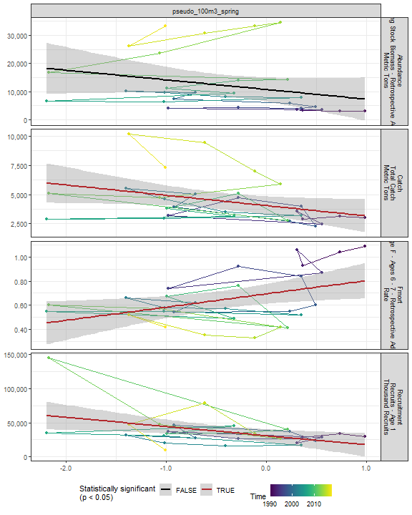

##### Regression statistics

Table 2.53: Catch vs pseudo_100m3_spring

|  |  |  |  |  |
| --- | --- | --- | --- | --- |
|  | Estimate | Std. Error | t value | Pr(>|t|) |
| (Intercept) | 4048.57 | 388.51 | 10.42 | 0.00 |
| Val | -882.74 | 424.53 | -2.08 | 0.05 |

|  |  |
| --- | --- |
| Name | Value |
| F-statistic | 4.32 |
| df | 1, 27 |
| R2 | 0.14 |
| R2-adj | 0.11 |

Table 2.53: Fmort vs pseudo_100m3_spring

|  |  |  |  |  |
| --- | --- | --- | --- | --- |
|  | Estimate | Std. Error | t value | Pr(>|t|) |
| (Intercept) | 0.69 | 0.04 | 17.13 | 0.00 |
| Val | 0.11 | 0.04 | 2.49 | 0.02 |

|  |  |
| --- | --- |
| Name | Value |
| F-statistic | 6.19 |
| df | 1, 27 |
| R2 | 0.19 |
| R2-adj | 0.16 |

Table 2.53: Recruitment vs pseudo_100m3_spring

|  |  |  |  |  |
| --- | --- | --- | --- | --- |
|  | Estimate | Std. Error | t value | Pr(>|t|) |
| (Intercept) | 30955.72 | 4638.23 | 6.67 | 0.00 |
| Val | -13442.85 | 5068.16 | -2.65 | 0.01 |

|  |  |
| --- | --- |
| Name | Value |
| F-statistic | 7.04 |
| df | 1, 27 |
| R2 | 0.21 |
| R2-adj | 0.18 |

#### Penilia 100m3 Spring

##### Figures

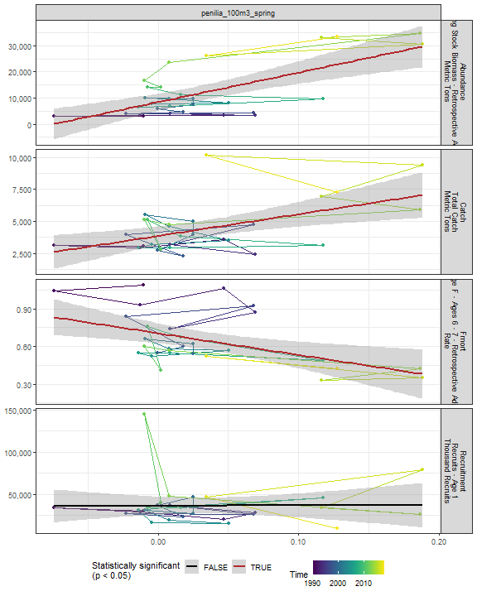

##### Regression statistics

Table 2.54: Catch vs penilia_100m3_spring

|  |  |  |  |  |
| --- | --- | --- | --- | --- |
|  | Estimate | Std. Error | t value | Pr(>|t|) |
| (Intercept) | 3855.75 | 360.22 | 10.70 | 0 |
| Val | 16926.00 | 5215.36 | 3.25 | 0 |

|  |  |
| --- | --- |
| Name | Value |
| F-statistic | 10.53 |
| df | 1, 27 |
| R2 | 0.28 |
| R2-adj | 0.25 |

Table 2.54: Fmort vs penilia_100m3_spring

|  |  |  |  |  |
| --- | --- | --- | --- | --- |
|  | Estimate | Std. Error | t value | Pr(>|t|) |
| (Intercept) | 0.70 | 0.04 | 17.89 | 0.00 |
| Val | -1.72 | 0.57 | -3.02 | 0.01 |

|  |  |
| --- | --- |
| Name | Value |
| F-statistic | 9.12 |
| df | 1, 27 |
| R2 | 0.25 |
| R2-adj | 0.22 |

Table 2.54: Abundance vs penilia_100m3_spring

|  |  |  |  |  |
| --- | --- | --- | --- | --- |
|  | Estimate | Std. Error | t value | Pr(>|t|) |
| (Intercept) | 8439.31 | 1610.57 | 5.24 | 0 |
| Val | 113032.58 | 23318.34 | 4.85 | 0 |

|  |  |
| --- | --- |
| Name | Value |
| F-statistic | 23.5 |
| df | 1, 27 |
| R2 | 0.47 |
| R2-adj | 0.45 |

#### Tlong 100m3 Spring

##### Figures

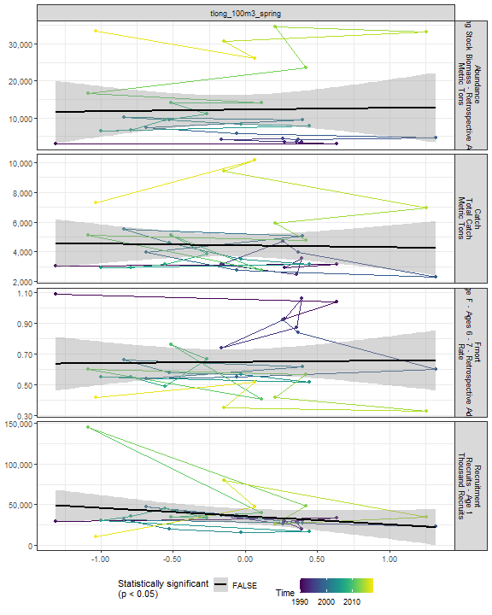

##### Regression statistics

[1] “No statistically significant data”

#### Cham 100m3 Spring

##### Figures

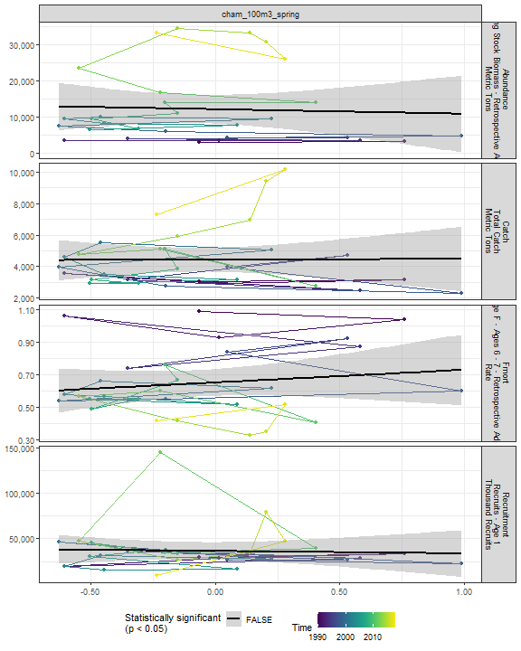

##### Regression statistics

[1] “No statistically significant data”

#### Echino 100m3 Spring

##### Figures

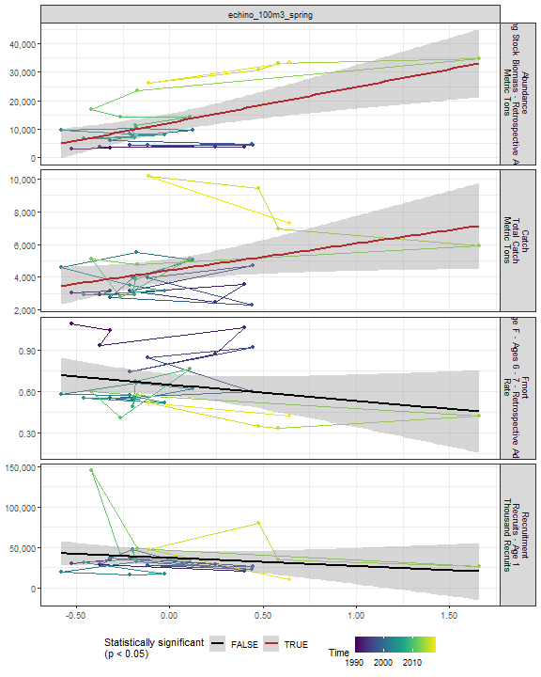

##### Regression statistics

Table 2.55: Catch vs echino_100m3_spring

|  |  |  |  |  |
| --- | --- | --- | --- | --- |
|  | Estimate | Std. Error | t value | Pr(>|t|) |
| (Intercept) | 4412.19 | 343.73 | 12.84 | 0.00 |
| Val | 1636.72 | 747.33 | 2.19 | 0.04 |

|  |  |
| --- | --- |
| Name | Value |
| F-statistic | 4.8 |
| df | 1, 27 |
| R2 | 0.15 |
| R2-adj | 0.12 |

Table 2.55: Abundance vs echino_100m3_spring

|  |  |  |  |  |
| --- | --- | --- | --- | --- |
|  | Estimate | Std. Error | t value | Pr(>|t|) |
| (Intercept) | 12152.55 | 1578.03 | 7.70 | 0 |
| Val | 12640.82 | 3430.95 | 3.68 | 0 |

|  |  |
| --- | --- |
| Name | Value |
| F-statistic | 13.57 |
| df | 1, 27 |
| R2 | 0.33 |
| R2-adj | 0.31 |

#### Larvaceans 100m3 Spring

##### Figures

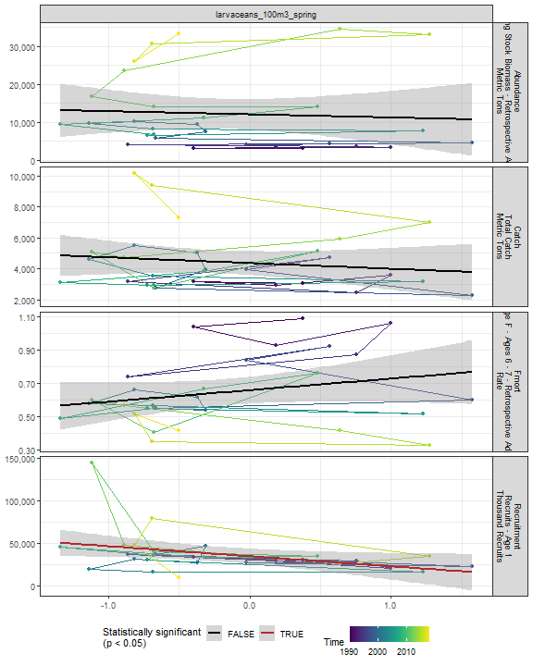

##### Regression statistics

Table 2.56: Recruitment vs larvaceans_100m3_spring

|  |  |  |  |  |
| --- | --- | --- | --- | --- |
|  | Estimate | Std. Error | t value | Pr(>|t|) |
| (Intercept) | 34528.32 | 4376.30 | 7.89 | 0.00 |
| Val | -11802.14 | 5402.65 | -2.18 | 0.04 |

|  |  |
| --- | --- |
| Name | Value |
| F-statistic | 4.77 |
| df | 1, 27 |
| R2 | 0.15 |
| R2-adj | 0.12 |

#### Para 100m3 Spring

##### Figures

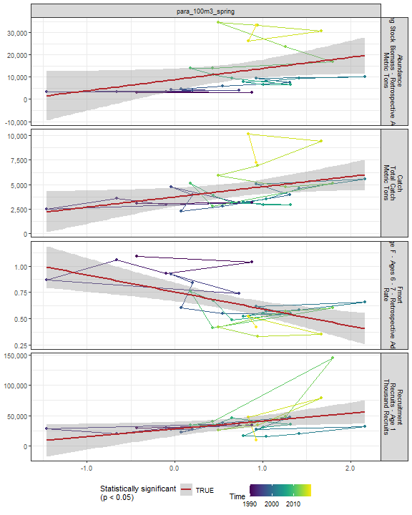

##### Regression statistics

Table 2.57: Catch vs para_100m3_spring

|  |  |  |  |  |
| --- | --- | --- | --- | --- |
|  | Estimate | Std. Error | t value | Pr(>|t|) |
| (Intercept) | 3717.18 | 456.07 | 8.15 | 0.00 |
| Val | 1046.01 | 454.12 | 2.30 | 0.03 |

|  |  |
| --- | --- |
| Name | Value |
| F-statistic | 5.31 |
| df | 1, 27 |
| R2 | 0.16 |
| R2-adj | 0.13 |

Table 2.57: Fmort vs para_100m3_spring

|  |  |  |  |  |
| --- | --- | --- | --- | --- |
|  | Estimate | Std. Error | t value | Pr(>|t|) |
| (Intercept) | 0.76 | 0.04 | 17.44 | 0 |
| Val | -0.16 | 0.04 | -3.76 | 0 |

|  |  |
| --- | --- |
| Name | Value |
| F-statistic | 14.11 |
| df | 1, 27 |
| R2 | 0.34 |
| R2-adj | 0.32 |

Table 2.57: Recruitment vs para_100m3_spring

|  |  |  |  |  |
| --- | --- | --- | --- | --- |
|  | Estimate | Std. Error | t value | Pr(>|t|) |
| (Intercept) | 27931.08 | 5685.76 | 4.91 | 0.00 |
| Val | 12897.27 | 5661.39 | 2.28 | 0.03 |

|  |  |
| --- | --- |
| Name | Value |
| F-statistic | 5.19 |
| df | 1, 27 |
| R2 | 0.16 |
| R2-adj | 0.13 |

Table 2.57: Abundance vs para_100m3_spring

|  |  |  |  |  |
| --- | --- | --- | --- | --- |
|  | Estimate | Std. Error | t value | Pr(>|t|) |
| (Intercept) | 8835.92 | 2399.72 | 3.68 | 0.00 |
| Val | 5002.95 | 2389.43 | 2.09 | 0.05 |

|  |  |
| --- | --- |
| Name | Value |
| F-statistic | 4.38 |
| df | 1, 27 |
| R2 | 0.14 |
| R2-adj | 0.11 |

#### Gas 100m3 Spring

##### Figures

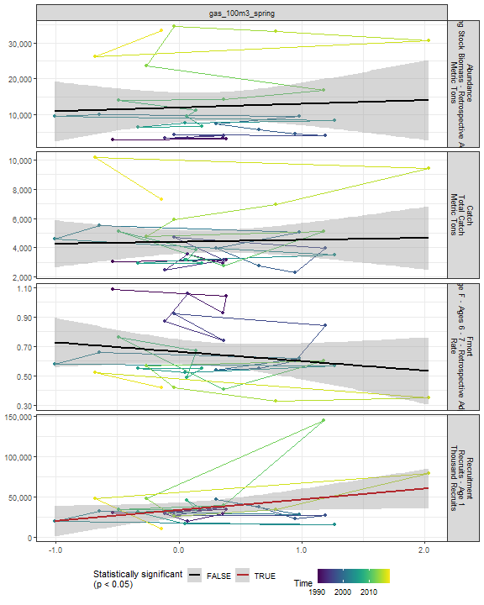

##### Regression statistics

Table 2.58: Recruitment vs gas_100m3_spring

|  |  |  |  |  |
| --- | --- | --- | --- | --- |
|  | Estimate | Std. Error | t value | Pr(>|t|) |
| (Intercept) | 33302.29 | 4584.50 | 7.26 | 0.00 |
| Val | 13291.06 | 6412.59 | 2.07 | 0.05 |

|  |  |
| --- | --- |
| Name | Value |
| F-statistic | 4.3 |
| df | 1, 27 |
| R2 | 0.14 |
| R2-adj | 0.11 |

#### Acarspp 100m3 Spring

##### Figures

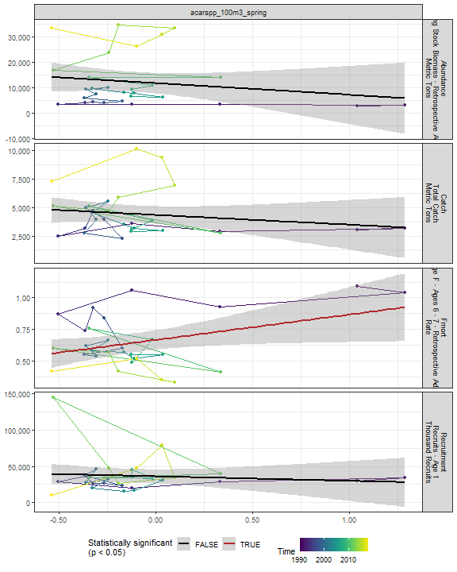

##### Regression statistics

Table 2.59: Fmort vs acarspp_100m3_spring

|  |  |  |  |  |
| --- | --- | --- | --- | --- |
|  | Estimate | Std. Error | t value | Pr(>|t|) |
| (Intercept) | 0.67 | 0.04 | 17.63 | 0.00 |
| Val | 0.20 | 0.09 | 2.20 | 0.04 |

|  |  |
| --- | --- |
| Name | Value |
| F-statistic | 4.83 |
| df | 1, 27 |
| R2 | 0.15 |
| R2-adj | 0.12 |

#### Mlucens 100m3 Spring

##### Figures

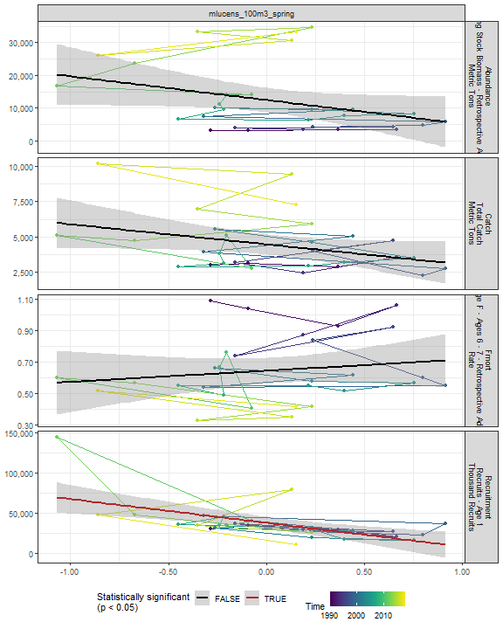

##### Regression statistics

Table 2.60: Recruitment vs mlucens_100m3_spring

|  |  |  |  |  |
| --- | --- | --- | --- | --- |
|  | Estimate | Std. Error | t value | Pr(>|t|) |
| (Intercept) | 37691.22 | 3748.08 | 10.06 | 0 |
| Val | -29735.14 | 7759.83 | -3.83 | 0 |

|  |  |
| --- | --- |
| Name | Value |
| F-statistic | 14.68 |
| df | 1, 27 |
| R2 | 0.35 |
| R2-adj | 0.33 |

#### Evadnespp 100m3 Spring

##### Figures

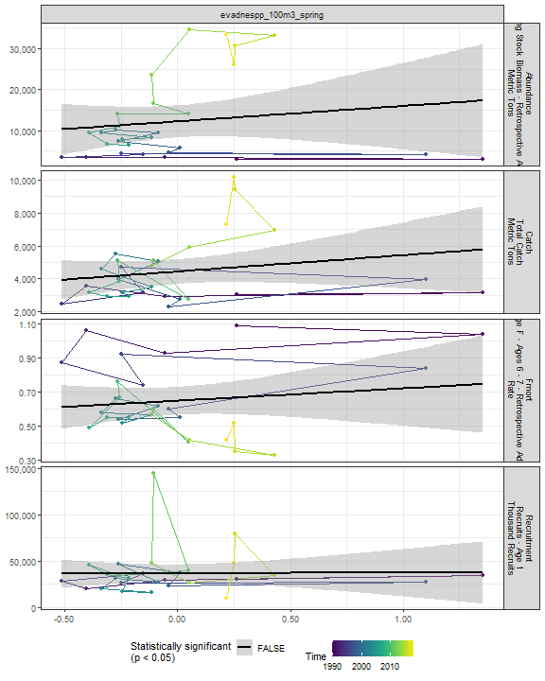

##### Regression statistics

[1] “No statistically significant data”

#### Salps 100m3 Spring

##### Figures

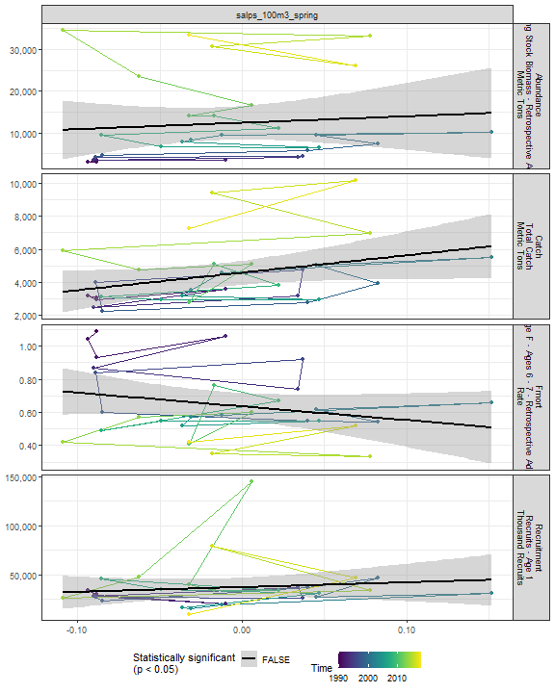

##### Regression statistics

[1] “No statistically significant data”

#### Oithspp 100m3 Spring

##### Figures

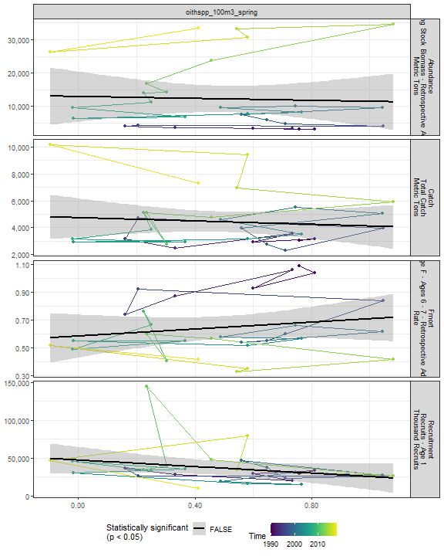

##### Regression statistics

[1] “No statistically significant data”

#### Chaeto 100m3 Spring

##### Figures

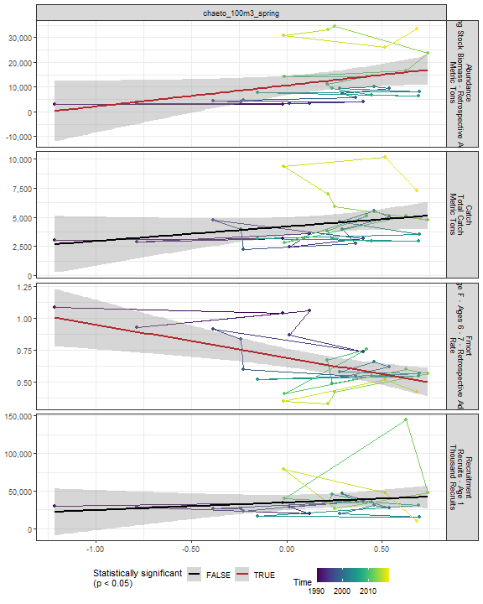

##### Regression statistics

Table 2.61: Fmort vs chaeto_100m3_spring

|  |  |  |  |  |
| --- | --- | --- | --- | --- |
|  | Estimate | Std. Error | t value | Pr(>|t|) |
| (Intercept) | 0.69 | 0.04 | 19.32 | 0 |
| Val | -0.26 | 0.08 | -3.45 | 0 |

|  |  |
| --- | --- |
| Name | Value |
| F-statistic | 11.87 |
| df | 1, 27 |
| R2 | 0.31 |
| R2-adj | 0.28 |

Table 2.61: Abundance vs chaeto_100m3_spring

|  |  |  |  |  |
| --- | --- | --- | --- | --- |
|  | Estimate | Std. Error | t value | Pr(>|t|) |
| (Intercept) | 10661.77 | 1932.56 | 5.52 | 0.00 |
| Val | 8532.01 | 4064.19 | 2.10 | 0.05 |

|  |  |
| --- | --- |
| Name | Value |
| F-statistic | 4.41 |
| df | 1, 27 |
| R2 | 0.14 |
| R2-adj | 0.11 |

#### Hyper 100m3 Spring

##### Figures

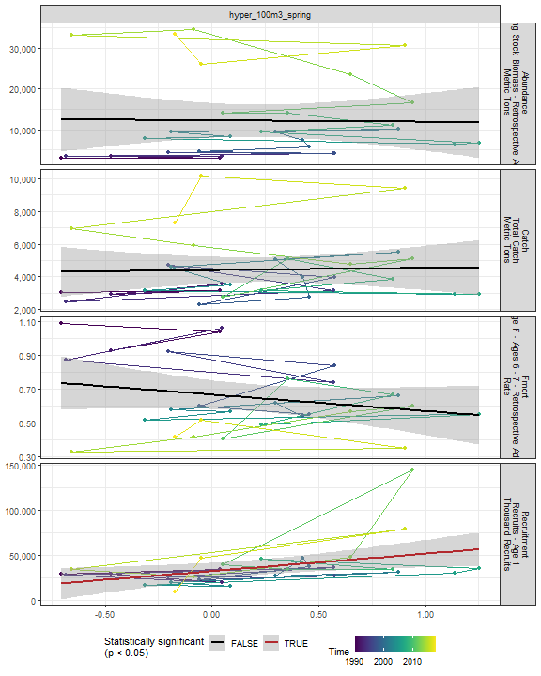

##### Regression statistics

Table 2.62: Recruitment vs hyper_100m3_spring

|  |  |  |  |  |
| --- | --- | --- | --- | --- |
|  | Estimate | Std. Error | t value | Pr(>|t|) |
| (Intercept) | 32420.30 | 4507.24 | 7.19 | 0.00 |
| Val | 19378.38 | 7824.85 | 2.48 | 0.02 |

|  |  |
| --- | --- |
| Name | Value |
| F-statistic | 6.13 |
| df | 1, 27 |
| R2 | 0.19 |
| R2-adj | 0.15 |

#### Calminor 100m3 Spring

##### Figures

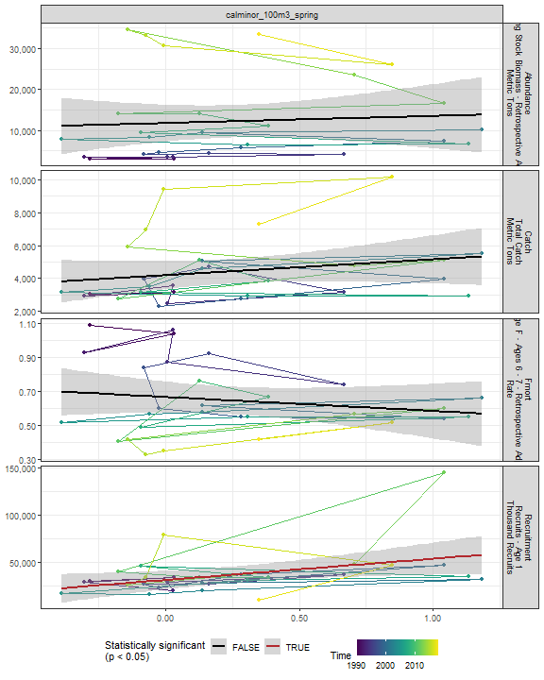

##### Regression statistics

Table 2.63: Recruitment vs calminor_100m3_spring

|  |  |  |  |  |
| --- | --- | --- | --- | --- |
|  | Estimate | Std. Error | t value | Pr(>|t|) |
| (Intercept) | 31158.14 | 4789.29 | 6.51 | 0.00 |
| Val | 22453.22 | 9450.45 | 2.38 | 0.02 |

|  |  |
| --- | --- |
| Name | Value |
| F-statistic | 5.64 |
| df | 1, 27 |
| R2 | 0.17 |
| R2-adj | 0.14 |

#### Clauso Spring

##### Figures

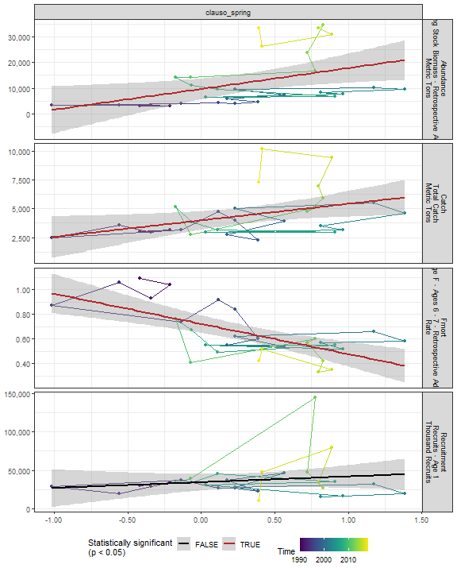

##### Regression statistics

Table 2.64: Catch vs clauso_spring

|  |  |  |  |  |
| --- | --- | --- | --- | --- |
|  | Estimate | Std. Error | t value | Pr(>|t|) |
| (Intercept) | 3975.68 | 388.74 | 10.23 | 0.00 |
| Val | 1432.14 | 613.32 | 2.34 | 0.03 |

|  |  |
| --- | --- |
| Name | Value |
| F-statistic | 5.45 |
| df | 1, 27 |
| R2 | 0.17 |
| R2-adj | 0.14 |

Table 2.64: Fmort vs clauso_spring

|  |  |  |  |  |
| --- | --- | --- | --- | --- |
|  | Estimate | Std. Error | t value | Pr(>|t|) |
| (Intercept) | 0.72 | 0.03 | 20.86 | 0 |
| Val | -0.24 | 0.05 | -4.47 | 0 |

|  |  |
| --- | --- |
| Name | Value |
| F-statistic | 20 |
| df | 1, 27 |
| R2 | 0.43 |
| R2-adj | 0.4 |

Table 2.64: Abundance vs clauso_spring

|  |  |  |  |  |
| --- | --- | --- | --- | --- |
|  | Estimate | Std. Error | t value | Pr(>|t|) |
| (Intercept) | 9691.30 | 1977.55 | 4.90 | 0.00 |
| Val | 8092.56 | 3120.04 | 2.59 | 0.02 |

|  |  |
| --- | --- |
| Name | Value |
| F-statistic | 6.73 |
| df | 1, 27 |
| R2 | 0.2 |
| R2-adj | 0.17 |

#### Dec 100m3 Spring

##### Figures

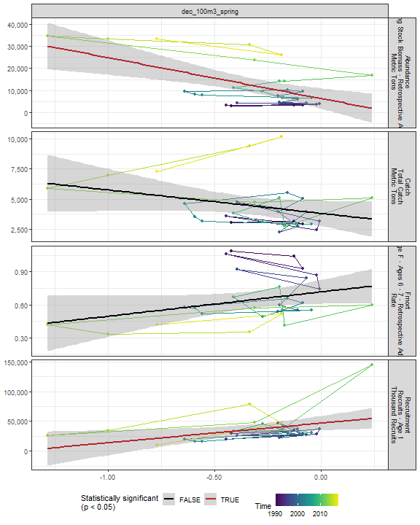

##### Regression statistics

Table 2.65: Recruitment vs dec_100m3_spring

|  |  |  |  |  |
| --- | --- | --- | --- | --- |
|  | Estimate | Std. Error | t value | Pr(>|t|) |
| (Intercept) | 46740.89 | 5925.62 | 7.89 | 0.00 |
| Val | 32807.61 | 13430.86 | 2.44 | 0.02 |

|  |  |
| --- | --- |
| Name | Value |
| F-statistic | 5.97 |
| df | 1, 27 |
| R2 | 0.18 |
| R2-adj | 0.15 |

Table 2.65: Abundance vs dec_100m3_spring

|  |  |  |  |  |
| --- | --- | --- | --- | --- |
|  | Estimate | Std. Error | t value | Pr(>|t|) |
| (Intercept) | 6416.07 | 2231.3 | 2.88 | 0.01 |
| Val | -18499.10 | 5057.4 | -3.66 | 0.00 |

|  |  |
| --- | --- |
| Name | Value |
| F-statistic | 13.38 |
| df | 1, 27 |
| R2 | 0.33 |
| R2-adj | 0.31 |

#### Euph 100m3 Spring

##### Figures

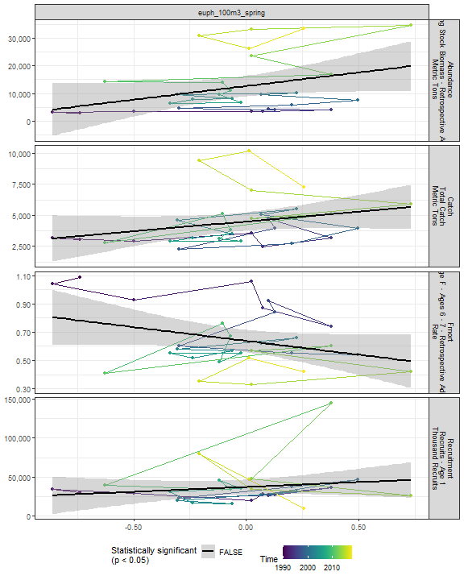

##### Regression statistics

[1] “No statistically significant data”

#### Prot 100m3 Spring

##### Figures

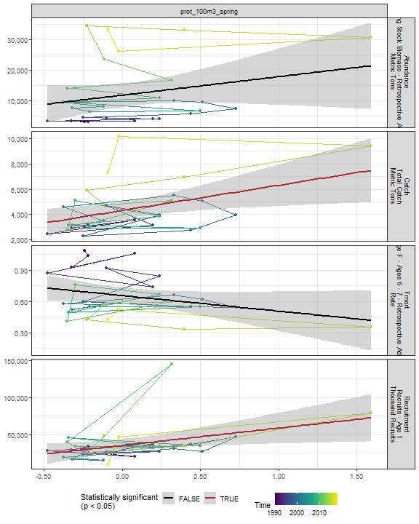

##### Regression statistics

Table 2.66: Catch vs prot_100m3_spring

|  |  |  |  |  |
| --- | --- | --- | --- | --- |
|  | Estimate | Std. Error | t value | Pr(>|t|) |
| (Intercept) | 4312.08 | 336.40 | 12.82 | 0.00 |
| Val | 1991.40 | 771.25 | 2.58 | 0.02 |

|  |  |
| --- | --- |
| Name | Value |
| F-statistic | 6.67 |
| df | 1, 27 |
| R2 | 0.2 |
| R2-adj | 0.17 |

Table 2.66: Recruitment vs prot_100m3_spring

|  |  |  |  |  |
| --- | --- | --- | --- | --- |
|  | Estimate | Std. Error | t value | Pr(>|t|) |
| (Intercept) | 35326.50 | 4242.49 | 8.33 | 0.00 |
| Val | 23385.59 | 9726.63 | 2.40 | 0.02 |

|  |  |
| --- | --- |
| Name | Value |
| F-statistic | 5.78 |
| df | 1, 27 |
| R2 | 0.18 |
| R2-adj | 0.15 |

#### Poly 100m3 Spring

##### Figures

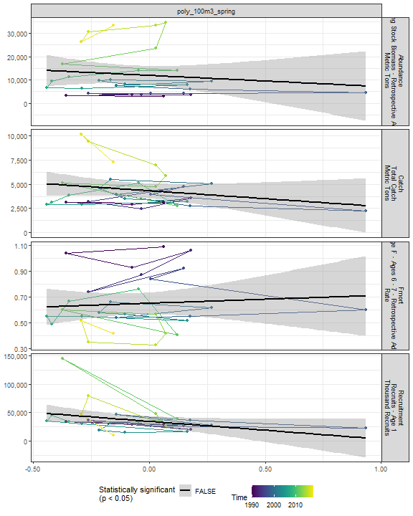

##### Regression statistics

[1] “No statistically significant data”

#### Fish 100m3 Spring

##### Figures

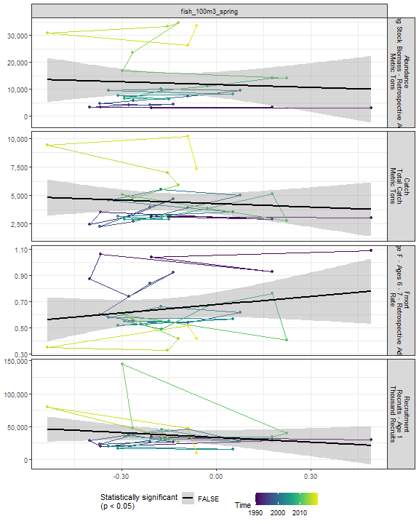

##### Regression statistics

[1] “No statistically significant data”

#### Oncaea 100m3 Spring

##### Figures

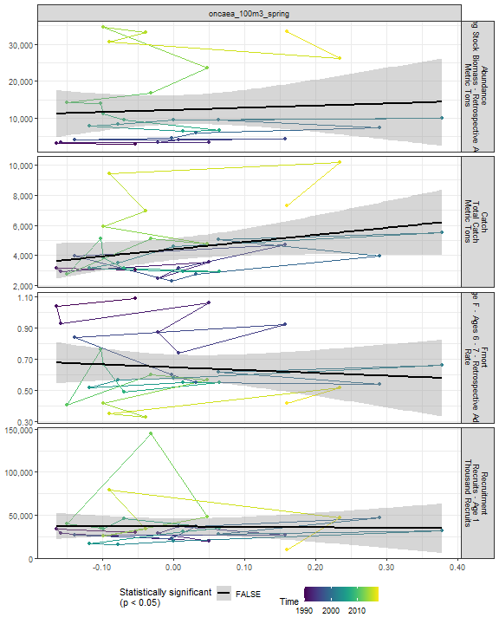

##### Regression statistics

[1] “No statistically significant data”

#### Cory 100m3 Spring

##### Figures

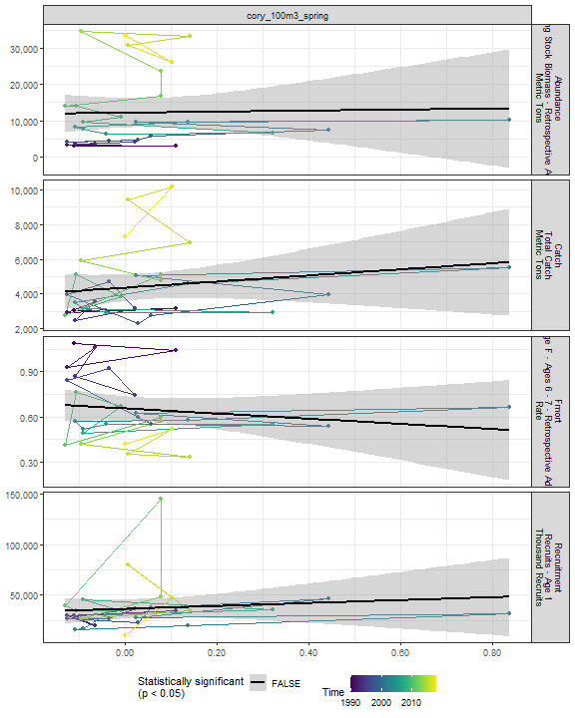

##### Regression statistics

[1] “No statistically significant data”

#### Siph 100m3 Spring

##### Figures

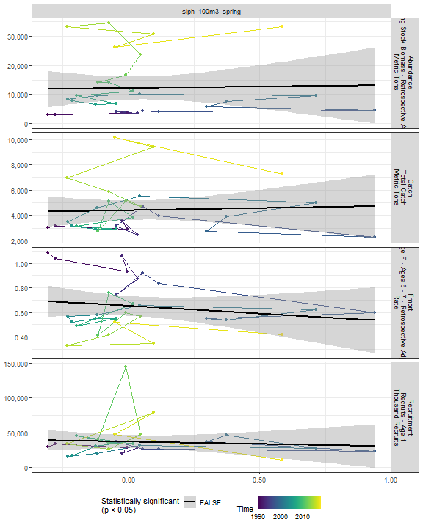

##### Regression statistics

[1] “No statistically significant data”

#### Coel 100m3 Spring

##### Figures

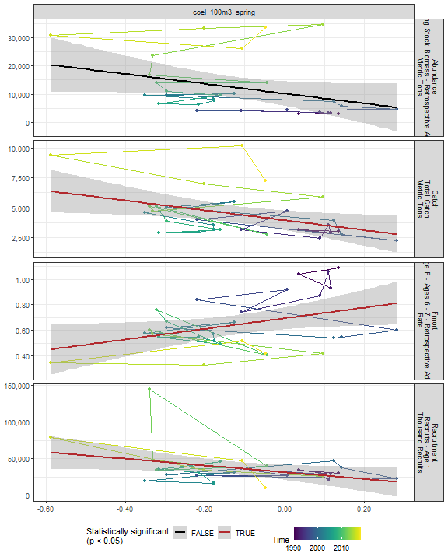

##### Regression statistics

Table 2.67: Catch vs coel_100m3_spring

|  |  |  |  |  |
| --- | --- | --- | --- | --- |
|  | Estimate | Std. Error | t value | Pr(>|t|) |
| (Intercept) | 3946.34 | 388.85 | 10.15 | 0.00 |
| Val | -4127.10 | 1696.60 | -2.43 | 0.02 |

|  |  |
| --- | --- |
| Name | Value |
| F-statistic | 5.92 |
| df | 1, 27 |
| R2 | 0.18 |
| R2-adj | 0.15 |

Table 2.67: Fmort vs coel_100m3_spring

|  |  |  |  |  |
| --- | --- | --- | --- | --- |
|  | Estimate | Std. Error | t value | Pr(>|t|) |
| (Intercept) | 0.69 | 0.04 | 16.44 | 0.00 |
| Val | 0.41 | 0.18 | 2.25 | 0.03 |

|  |  |
| --- | --- |
| Name | Value |
| F-statistic | 5.06 |
| df | 1, 27 |
| R2 | 0.16 |
| R2-adj | 0.13 |

Table 2.67: Recruitment vs coel_100m3_spring

|  |  |  |  |  |
| --- | --- | --- | --- | --- |
|  | Estimate | Std. Error | t value | Pr(>|t|) |
| (Intercept) | 31301.09 | 4941.14 | 6.33 | 0.00 |
| Val | -46089.88 | 21558.94 | -2.14 | 0.04 |

|  |  |
| --- | --- |
| Name | Value |
| F-statistic | 4.57 |
| df | 1, 27 |
| R2 | 0.14 |
| R2-adj | 0.11 |

#### Euph1 100m3 Spring

##### Figures

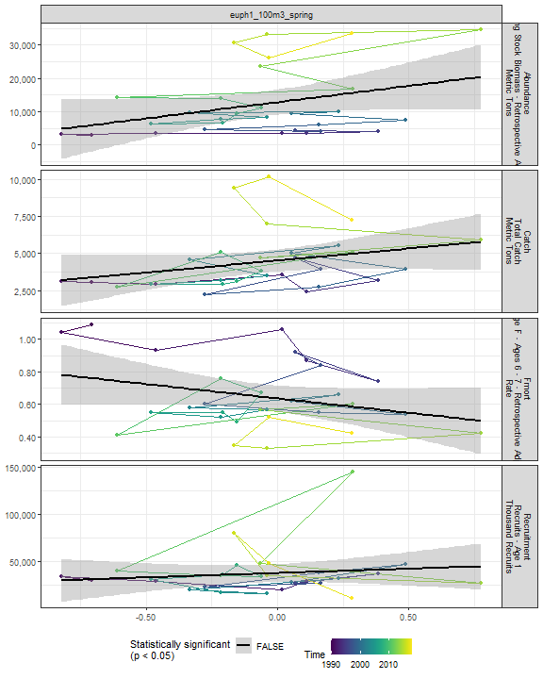

##### Regression statistics

[1] “No statistically significant data”

#### Thecos 100m3 Spring

##### Figures

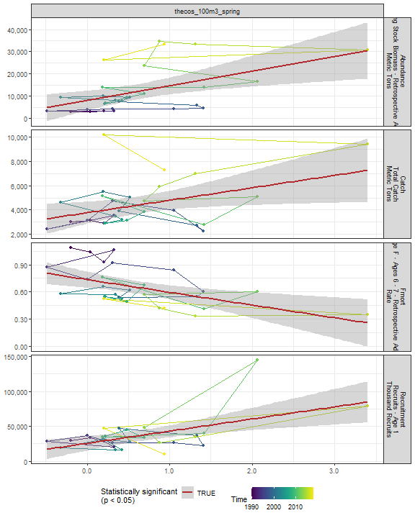

##### Regression statistics

Table 2.68: Catch vs thecos_100m3_spring

|  |  |  |  |  |
| --- | --- | --- | --- | --- |
|  | Estimate | Std. Error | t value | Pr(>|t|) |
| (Intercept) | 3770.86 | 439.22 | 8.59 | 0.00 |
| Val | 1023.50 | 440.87 | 2.32 | 0.03 |

|  |  |
| --- | --- |
| Name | Value |
| F-statistic | 5.39 |
| df | 1, 27 |
| R2 | 0.17 |
| R2-adj | 0.14 |

Table 2.68: Fmort vs thecos_100m3_spring

|  |  |  |  |  |
| --- | --- | --- | --- | --- |
|  | Estimate | Std. Error | t value | Pr(>|t|) |
| (Intercept) | 0.74 | 0.04 | 16.76 | 0 |
| Val | -0.14 | 0.04 | -3.20 | 0 |

|  |  |
| --- | --- |
| Name | Value |
| F-statistic | 10.22 |
| df | 1, 27 |
| R2 | 0.27 |
| R2-adj | 0.25 |

Table 2.68: Recruitment vs thecos_100m3_spring

|  |  |  |  |  |
| --- | --- | --- | --- | --- |
|  | Estimate | Std. Error | t value | Pr(>|t|) |
| (Intercept) | 25561.44 | 4965.89 | 5.15 | 0 |
| Val | 17438.37 | 4984.62 | 3.50 | 0 |

|  |  |
| --- | --- |
| Name | Value |
| F-statistic | 12.24 |
| df | 1, 27 |
| R2 | 0.31 |
| R2-adj | 0.29 |

Table 2.68: Abundance vs thecos_100m3_spring

|  |  |  |  |  |
| --- | --- | --- | --- | --- |
|  | Estimate | Std. Error | t value | Pr(>|t|) |
| (Intercept) | 8009.40 | 2148.17 | 3.73 | 0 |
| Val | 6617.16 | 2156.27 | 3.07 | 0 |

|  |  |
| --- | --- |
| Name | Value |
| F-statistic | 9.42 |
| df | 1, 27 |
| R2 | 0.26 |
| R2-adj | 0.23 |

#### Spirspp 100m3 Spring

##### Figures

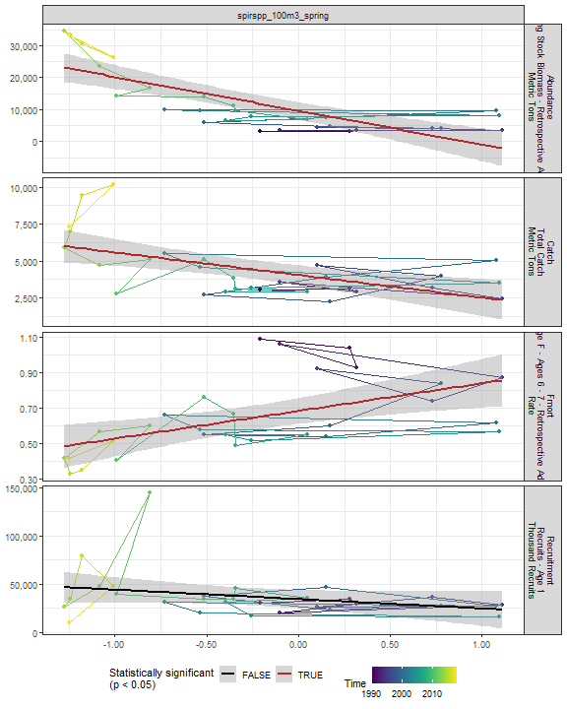

##### Regression statistics

Table 2.69: Catch vs spirspp_100m3_spring

|  |  |  |  |  |
| --- | --- | --- | --- | --- |
|  | Estimate | Std. Error | t value | Pr(>|t|) |
| (Intercept) | 4048.45 | 322.89 | 12.54 | 0 |
| Val | -1530.20 | 424.52 | -3.60 | 0 |

|  |  |
| --- | --- |
| Name | Value |
| F-statistic | 12.99 |
| df | 1, 27 |
| R2 | 0.32 |
| R2-adj | 0.3 |

Table 2.69: Fmort vs spirspp_100m3_spring

|  |  |  |  |  |
| --- | --- | --- | --- | --- |
|  | Estimate | Std. Error | t value | Pr(>|t|) |
| (Intercept) | 0.68 | 0.04 | 19.33 | 0 |
| Val | 0.16 | 0.05 | 3.34 | 0 |

|  |  |
| --- | --- |
| Name | Value |
| F-statistic | 11.17 |
| df | 1, 27 |
| R2 | 0.29 |
| R2-adj | 0.27 |

Table 2.69: Abundance vs spirspp_100m3_spring

|  |  |  |  |  |
| --- | --- | --- | --- | --- |
|  | Estimate | Std. Error | t value | Pr(>|t|) |
| (Intercept) | 9637.22 | 1323.03 | 7.28 | 0 |
| Val | -10590.30 | 1739.44 | -6.09 | 0 |

|  |  |
| --- | --- |
| Name | Value |
| F-statistic | 37.07 |
| df | 1, 27 |
| R2 | 0.58 |
| R2-adj | 0.56 |

#### Cnidar 100m3 Spring

##### Figures

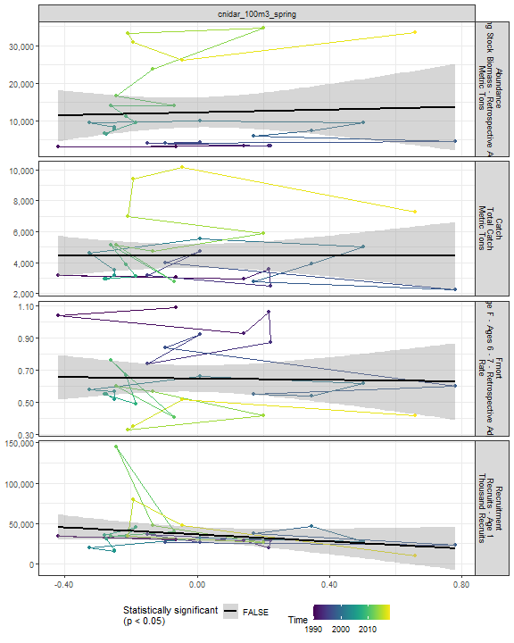

##### Regression statistics

[1] “No statistically significant data”

#### 2.4.3.3 Fall zooplankton abundance in the stock region

#### Ctyp 100m3 Fall

##### Figures

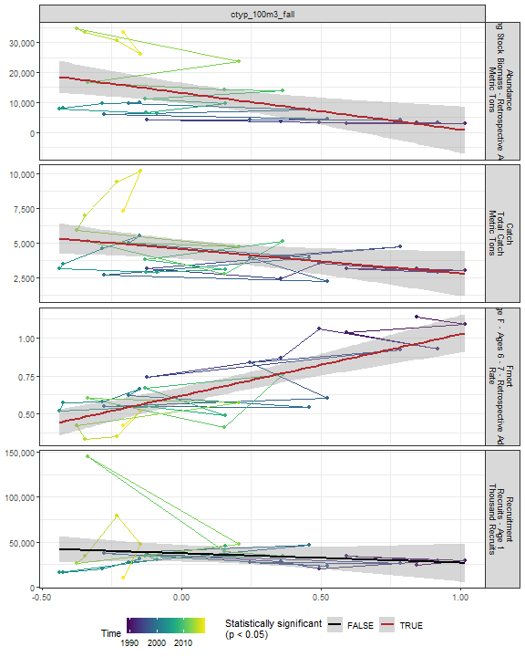

##### Regression statistics

Table 2.70: Catch vs ctyp_100m3_fall

|  |  |  |  |  |
| --- | --- | --- | --- | --- |
|  | Estimate | Std. Error | t value | Pr(>|t|) |
| (Intercept) | 4563.35 | 344.60 | 13.24 | 0.00 |
| Val | -1744.91 | 781.75 | -2.23 | 0.03 |

|  |  |
| --- | --- |
| Name | Value |
| F-statistic | 4.98 |
| df | 1, 28 |
| R2 | 0.15 |
| R2-adj | 0.12 |

Table 2.70: Fmort vs ctyp_100m3_fall

|  |  |  |  |  |
| --- | --- | --- | --- | --- |
|  | Estimate | Std. Error | t value | Pr(>|t|) |
| (Intercept) | 0.62 | 0.03 | 22.89 | 0 |
| Val | 0.41 | 0.06 | 6.63 | 0 |

|  |  |
| --- | --- |
| Name | Value |
| F-statistic | 43.98 |
| df | 1, 28 |
| R2 | 0.61 |
| R2-adj | 0.6 |

Table 2.70: Abundance vs ctyp_100m3_fall

|  |  |  |  |  |
| --- | --- | --- | --- | --- |
|  | Estimate | Std. Error | t value | Pr(>|t|) |
| (Intercept) | 13197.22 | 1666.57 | 7.92 | 0 |
| Val | -12210.08 | 3780.72 | -3.23 | 0 |

|  |  |
| --- | --- |
| Name | Value |
| F-statistic | 10.43 |
| df | 1, 28 |
| R2 | 0.27 |
| R2-adj | 0.25 |

#### Calfin 100m3 Fall

##### Figures

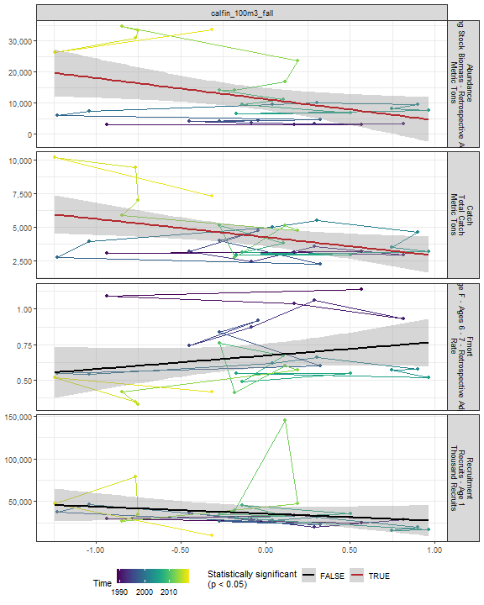

##### Regression statistics

Table 2.71: Catch vs calfin_100m3_fall

|  |  |  |  |  |
| --- | --- | --- | --- | --- |
|  | Estimate | Std. Error | t value | Pr(>|t|) |
| (Intercept) | 4252.60 | 330.82 | 12.85 | 0.00 |
| Val | -1356.31 | 538.27 | -2.52 | 0.02 |

|  |  |
| --- | --- |
| Name | Value |
| F-statistic | 6.35 |
| df | 1, 28 |
| R2 | 0.18 |
| R2-adj | 0.16 |

Table 2.71: Abundance vs calfin_100m3_fall

|  |  |  |  |  |
| --- | --- | --- | --- | --- |
|  | Estimate | Std. Error | t value | Pr(>|t|) |
| (Intercept) | 11269.57 | 1745.6 | 6.46 | 0.00 |
| Val | -6734.22 | 2840.2 | -2.37 | 0.02 |

|  |  |
| --- | --- |
| Name | Value |
| F-statistic | 5.62 |
| df | 1, 28 |
| R2 | 0.17 |
| R2-adj | 0.14 |

#### Pseudo 100m3 Fall

##### Figures

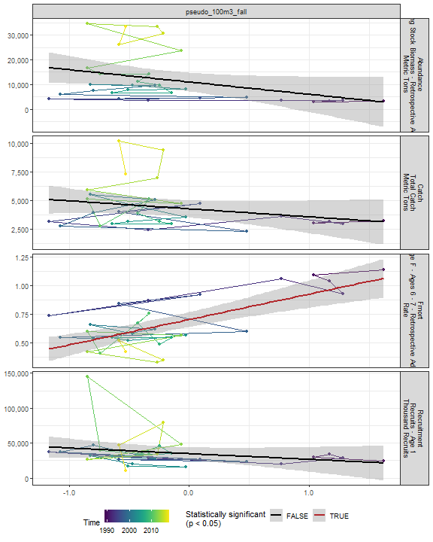

##### Regression statistics

Table 2.72: Fmort vs pseudo_100m3_fall

|  |  |  |  |  |
| --- | --- | --- | --- | --- |
|  | Estimate | Std. Error | t value | Pr(>|t|) |
| (Intercept) | 0.70 | 0.03 | 22.77 | 0 |
| Val | 0.22 | 0.04 | 5.22 | 0 |

|  |  |
| --- | --- |
| Name | Value |
| F-statistic | 27.27 |
| df | 1, 28 |
| R2 | 0.49 |
| R2-adj | 0.48 |

#### Penilia 100m3 Fall

##### Figures

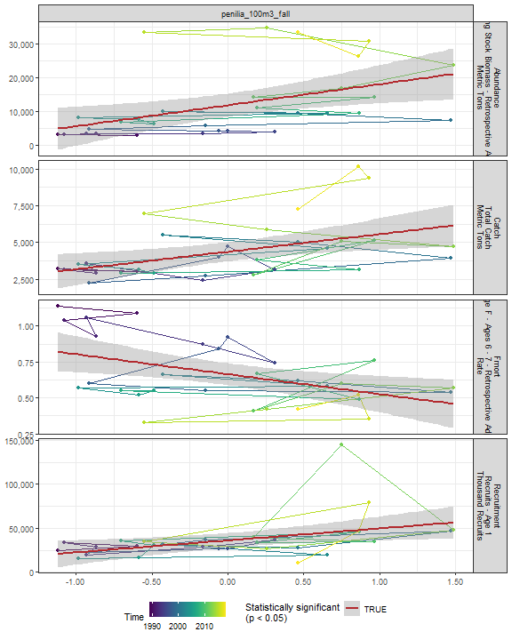

##### Regression statistics

Table 2.73: Catch vs penilia_100m3_fall

|  |  |  |  |  |
| --- | --- | --- | --- | --- |
|  | Estimate | Std. Error | t value | Pr(>|t|) |
| (Intercept) | 4365.34 | 319.56 | 13.66 | 0.00 |
| Val | 1198.57 | 422.86 | 2.83 | 0.01 |

|  |  |
| --- | --- |
| Name | Value |
| F-statistic | 8.03 |
| df | 1, 28 |
| R2 | 0.22 |
| R2-adj | 0.2 |

Table 2.73: Fmort vs penilia_100m3_fall

|  |  |  |  |  |
| --- | --- | --- | --- | --- |
|  | Estimate | Std. Error | t value | Pr(>|t|) |
| (Intercept) | 0.66 | 0.04 | 17.91 | 0.00 |
| Val | -0.14 | 0.05 | -2.82 | 0.01 |

|  |  |
| --- | --- |
| Name | Value |
| F-statistic | 7.97 |
| df | 1, 28 |
| R2 | 0.22 |
| R2-adj | 0.19 |

Table 2.73: Recruitment vs penilia_100m3_fall

|  |  |  |  |  |
| --- | --- | --- | --- | --- |
|  | Estimate | Std. Error | t value | Pr(>|t|) |
| (Intercept) | 36028.2 | 4058.78 | 8.88 | 0.00 |
| Val | 13618.1 | 5370.75 | 2.54 | 0.02 |

|  |  |
| --- | --- |
| Name | Value |
| F-statistic | 6.43 |
| df | 1, 28 |
| R2 | 0.19 |
| R2-adj | 0.16 |

Table 2.73: Abundance vs penilia_100m3_fall

|  |  |  |  |  |
| --- | --- | --- | --- | --- |
|  | Estimate | Std. Error | t value | Pr(>|t|) |
| (Intercept) | 11827.64 | 1674.02 | 7.07 | 0.00 |
| Val | 6180.78 | 2215.14 | 2.79 | 0.01 |

|  |  |
| --- | --- |
| Name | Value |
| F-statistic | 7.79 |
| df | 1, 28 |
| R2 | 0.22 |
| R2-adj | 0.19 |

#### Tlong 100m3 Fall

##### Figures

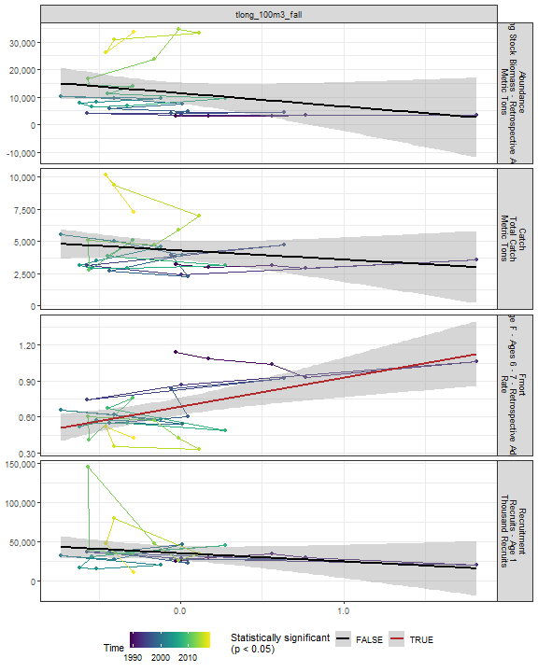

##### Regression statistics

Table 2.74: Fmort vs tlong_100m3_fall

|  |  |  |  |  |
| --- | --- | --- | --- | --- |
|  | Estimate | Std. Error | t value | Pr(>|t|) |
| (Intercept) | 0.69 | 0.04 | 19.47 | 0 |
| Val | 0.24 | 0.07 | 3.63 | 0 |

|  |  |
| --- | --- |
| Name | Value |
| F-statistic | 13.16 |
| df | 1, 28 |
| R2 | 0.32 |
| R2-adj | 0.3 |

#### Cham 100m3 Fall

##### Figures

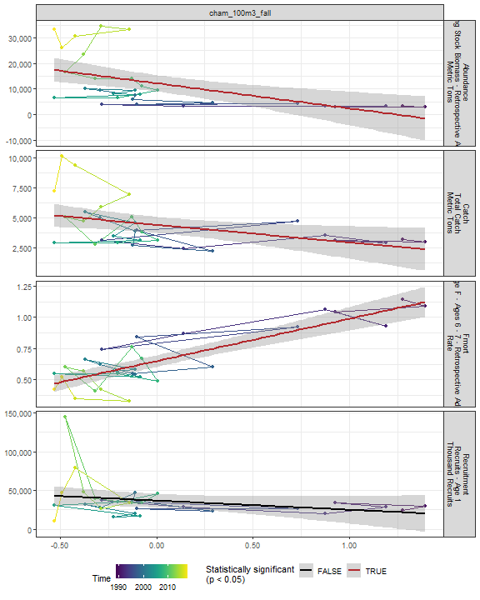

##### Regression statistics

Table 2.75: Catch vs cham_100m3_fall

|  |  |  |  |  |
| --- | --- | --- | --- | --- |
|  | Estimate | Std. Error | t value | Pr(>|t|) |
| (Intercept) | 4430.49 | 328.92 | 13.47 | 0.00 |
| Val | -1468.61 | 591.15 | -2.48 | 0.02 |

|  |  |
| --- | --- |
| Name | Value |
| F-statistic | 6.17 |
| df | 1, 28 |
| R2 | 0.18 |
| R2-adj | 0.15 |

Table 2.75: Fmort vs cham_100m3_fall

|  |  |  |  |  |
| --- | --- | --- | --- | --- |
|  | Estimate | Std. Error | t value | Pr(>|t|) |
| (Intercept) | 0.65 | 0.02 | 28.68 | 0 |
| Val | 0.34 | 0.04 | 8.29 | 0 |

|  |  |
| --- | --- |
| Name | Value |
| F-statistic | 68.69 |
| df | 1, 28 |
| R2 | 0.71 |
| R2-adj | 0.7 |

Table 2.75: Abundance vs cham_100m3_fall

|  |  |  |  |  |
| --- | --- | --- | --- | --- |
|  | Estimate | Std. Error | t value | Pr(>|t|) |
| (Intercept) | 12249.23 | 1592.52 | 7.69 | 0 |
| Val | -9801.58 | 2862.14 | -3.42 | 0 |

|  |  |
| --- | --- |
| Name | Value |
| F-statistic | 11.73 |
| df | 1, 28 |
| R2 | 0.3 |
| R2-adj | 0.27 |

#### Echino 100m3 Fall

##### Figures

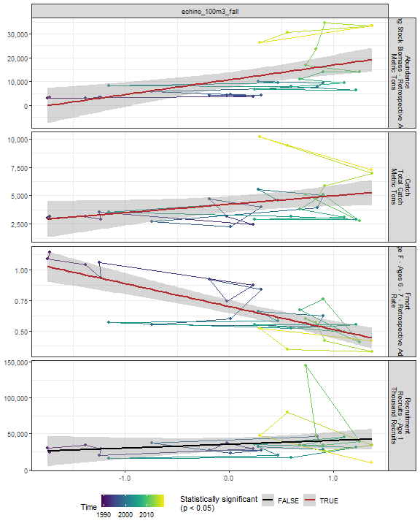

##### Regression statistics

Table 2.76: Catch vs echino_100m3_fall

|  |  |  |  |  |
| --- | --- | --- | --- | --- |
|  | Estimate | Std. Error | t value | Pr(>|t|) |
| (Intercept) | 4232.60 | 344.72 | 12.28 | 0.00 |
| Val | 746.82 | 362.55 | 2.06 | 0.05 |

|  |  |
| --- | --- |
| Name | Value |
| F-statistic | 4.24 |
| df | 1, 28 |
| R2 | 0.13 |
| R2-adj | 0.1 |

Table 2.76: Fmort vs echino_100m3_fall

|  |  |  |  |  |
| --- | --- | --- | --- | --- |
|  | Estimate | Std. Error | t value | Pr(>|t|) |
| (Intercept) | 0.70 | 0.03 | 26.23 | 0 |
| Val | -0.19 | 0.03 | -6.68 | 0 |

|  |  |
| --- | --- |
| Name | Value |
| F-statistic | 44.59 |
| df | 1, 28 |
| R2 | 0.61 |
| R2-adj | 0.6 |

Table 2.76: Abundance vs echino_100m3_fall

|  |  |  |  |  |
| --- | --- | --- | --- | --- |
|  | Estimate | Std. Error | t value | Pr(>|t|) |
| (Intercept) | 10701.30 | 1579.42 | 6.78 | 0 |
| Val | 6183.71 | 1661.10 | 3.72 | 0 |

|  |  |
| --- | --- |
| Name | Value |
| F-statistic | 13.86 |
| df | 1, 28 |
| R2 | 0.33 |
| R2-adj | 0.31 |

#### Larvaceans 100m3 Fall

##### Figures

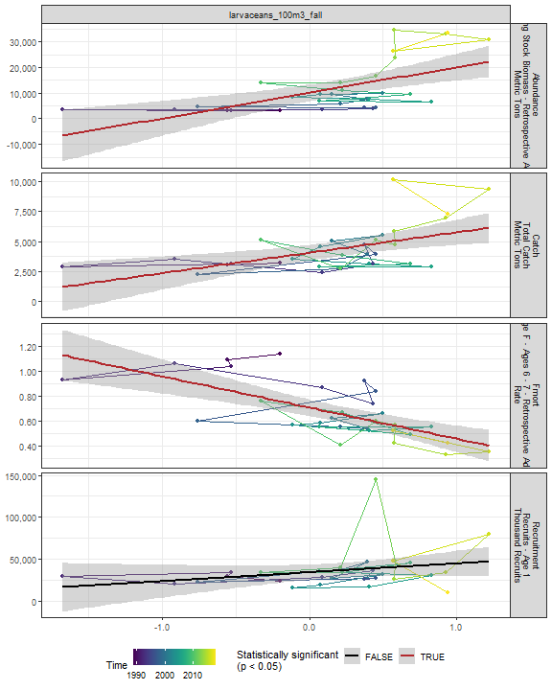

##### Regression statistics

Table 2.77: Catch vs larvaceans_100m3_fall

|  |  |  |  |  |
| --- | --- | --- | --- | --- |
|  | Estimate | Std. Error | t value | Pr(>|t|) |
| (Intercept) | 4072.85 | 319.21 | 12.76 | 0 |
| Val | 1697.25 | 506.64 | 3.35 | 0 |

|  |  |
| --- | --- |
| Name | Value |
| F-statistic | 11.22 |
| df | 1, 28 |
| R2 | 0.29 |
| R2-adj | 0.26 |

Table 2.77: Fmort vs larvaceans_100m3_fall

|  |  |  |  |  |
| --- | --- | --- | --- | --- |
|  | Estimate | Std. Error | t value | Pr(>|t|) |
| (Intercept) | 0.71 | 0.03 | 22.01 | 0 |
| Val | -0.25 | 0.05 | -4.90 | 0 |

|  |  |
| --- | --- |
| Name | Value |
| F-statistic | 23.98 |
| df | 1, 28 |
| R2 | 0.46 |
| R2-adj | 0.44 |

Table 2.77: Abundance vs larvaceans_100m3_fall

|  |  |  |  |  |
| --- | --- | --- | --- | --- |
|  | Estimate | Std. Error | t value | Pr(>|t|) |
| (Intercept) | 10103.37 | 1575.07 | 6.41 | 0 |
| Val | 9969.23 | 2499.91 | 3.99 | 0 |

|  |  |
| --- | --- |
| Name | Value |
| F-statistic | 15.9 |
| df | 1, 28 |
| R2 | 0.36 |
| R2-adj | 0.34 |

#### Para 100m3 Fall

##### Figures

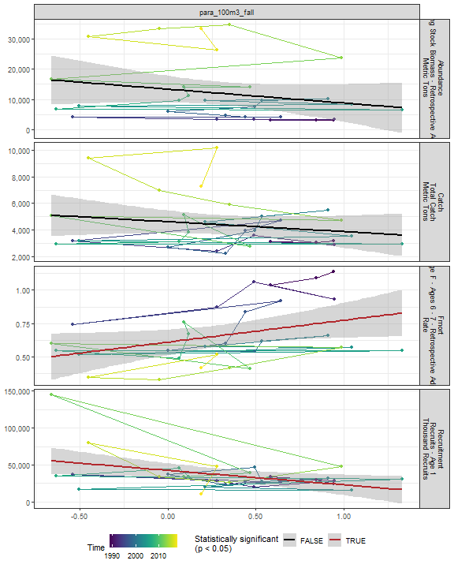

##### Regression statistics

Table 2.78: Fmort vs para_100m3_fall

|  |  |  |  |  |
| --- | --- | --- | --- | --- |
|  | Estimate | Std. Error | t value | Pr(>|t|) |
| (Intercept) | 0.61 | 0.05 | 13.32 | 0.00 |
| Val | 0.16 | 0.08 | 2.18 | 0.04 |

|  |  |
| --- | --- |
| Name | Value |
| F-statistic | 4.74 |
| df | 1, 28 |
| R2 | 0.14 |
| R2-adj | 0.11 |

Table 2.78: Recruitment vs para_100m3_fall

|  |  |  |  |  |
| --- | --- | --- | --- | --- |
|  | Estimate | Std. Error | t value | Pr(>|t|) |
| (Intercept) | 42452.70 | 4801.94 | 8.84 | 0.00 |
| Val | -19577.86 | 7872.17 | -2.49 | 0.02 |

|  |  |
| --- | --- |
| Name | Value |
| F-statistic | 6.19 |
| df | 1, 28 |
| R2 | 0.18 |
| R2-adj | 0.15 |

#### Gas 100m3 Fall

##### Figures

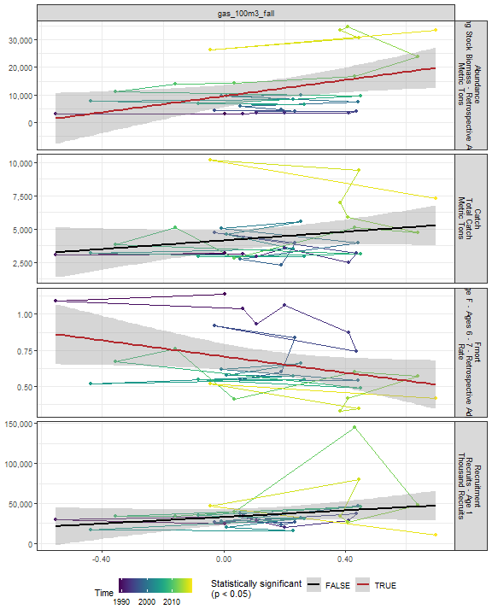

##### Regression statistics

Table 2.79: Fmort vs gas_100m3_fall

|  |  |  |  |  |
| --- | --- | --- | --- | --- |
|  | Estimate | Std. Error | t value | Pr(>|t|) |
| (Intercept) | 0.71 | 0.04 | 15.97 | 0.00 |
| Val | -0.28 | 0.13 | -2.10 | 0.05 |

|  |  |
| --- | --- |
| Name | Value |
| F-statistic | 4.4 |
| df | 1, 28 |
| R2 | 0.14 |
| R2-adj | 0.1 |

Table 2.79: Abundance vs gas_100m3_fall

|  |  |  |  |  |
| --- | --- | --- | --- | --- |
|  | Estimate | Std. Error | t value | Pr(>|t|) |
| (Intercept) | 9581.80 | 1937.13 | 4.95 | 0.00 |
| Val | 14595.95 | 5806.73 | 2.51 | 0.02 |

|  |  |
| --- | --- |
| Name | Value |
| F-statistic | 6.32 |
| df | 1, 28 |
| R2 | 0.18 |
| R2-adj | 0.15 |

#### Acarspp 100m3 Fall

##### Figures

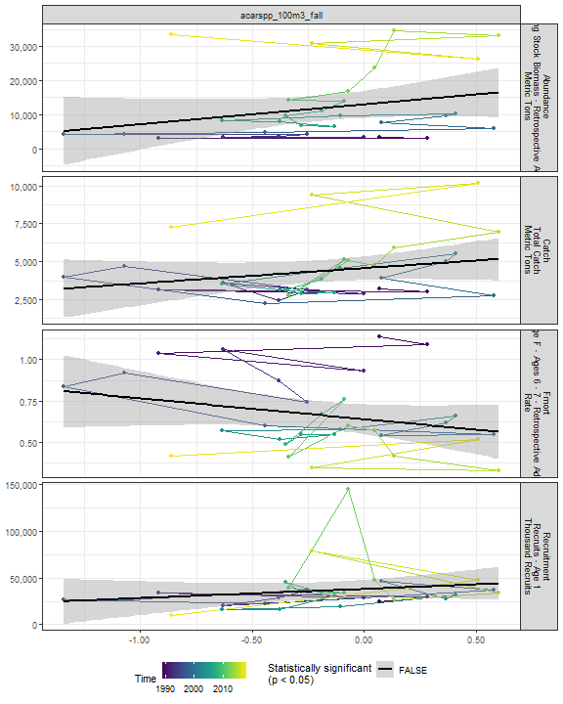

##### Regression statistics

[1] “No statistically significant data”

#### Mlucens 100m3 Fall

##### Figures

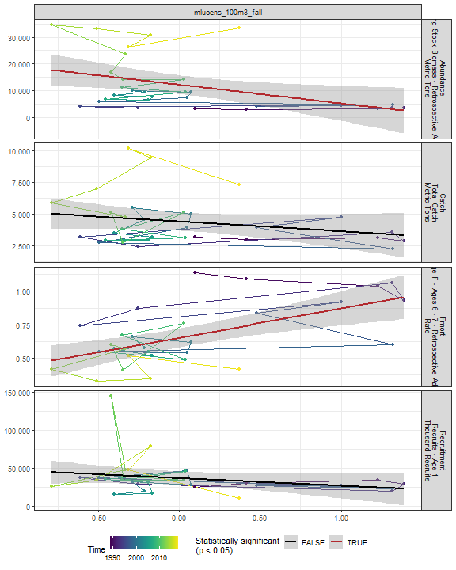

##### Regression statistics

Table 2.80: Fmort vs mlucens_100m3_fall

|  |  |  |  |  |
| --- | --- | --- | --- | --- |
|  | Estimate | Std. Error | t value | Pr(>|t|) |
| (Intercept) | 0.65 | 0.03 | 19.35 | 0 |
| Val | 0.22 | 0.06 | 3.98 | 0 |

|  |  |
| --- | --- |
| Name | Value |
| F-statistic | 15.81 |
| df | 1, 28 |
| R2 | 0.36 |
| R2-adj | 0.34 |

Table 2.80: Abundance vs mlucens_100m3_fall

|  |  |  |  |  |
| --- | --- | --- | --- | --- |
|  | Estimate | Std. Error | t value | Pr(>|t|) |
| (Intercept) | 12221.03 | 1717.73 | 7.11 | 0.00 |
| Val | -6991.86 | 2805.52 | -2.49 | 0.02 |

|  |  |
| --- | --- |
| Name | Value |
| F-statistic | 6.21 |
| df | 1, 28 |
| R2 | 0.18 |
| R2-adj | 0.15 |

#### Evadnespp 100m3 Fall

##### Figures

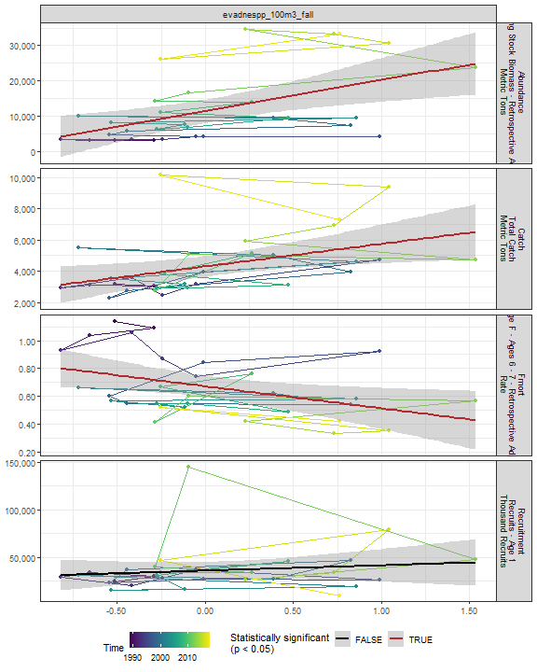

##### Regression statistics

Table 2.81: Catch vs evadnespp_100m3_fall

|  |  |  |  |  |
| --- | --- | --- | --- | --- |
|  | Estimate | Std. Error | t value | Pr(>|t|) |
| (Intercept) | 4303.20 | 325.07 | 13.24 | 0.00 |
| Val | 1442.48 | 543.08 | 2.66 | 0.01 |

|  |  |
| --- | --- |
| Name | Value |
| F-statistic | 7.05 |
| df | 1, 28 |
| R2 | 0.2 |
| R2-adj | 0.17 |

Table 2.81: Fmort vs evadnespp_100m3_fall

|  |  |  |  |  |
| --- | --- | --- | --- | --- |
|  | Estimate | Std. Error | t value | Pr(>|t|) |
| (Intercept) | 0.67 | 0.04 | 17.58 | 0.00 |
| Val | -0.16 | 0.06 | -2.49 | 0.02 |

|  |  |
| --- | --- |
| Name | Value |
| F-statistic | 6.19 |
| df | 1, 28 |
| R2 | 0.18 |
| R2-adj | 0.15 |

Table 2.81: Abundance vs evadnespp_100m3_fall

|  |  |  |  |  |
| --- | --- | --- | --- | --- |
|  | Estimate | Std. Error | t value | Pr(>|t|) |
| (Intercept) | 11440.73 | 1617.48 | 7.07 | 0 |
| Val | 8792.50 | 2702.20 | 3.25 | 0 |

|  |  |
| --- | --- |
| Name | Value |
| F-statistic | 10.59 |
| df | 1, 28 |
| R2 | 0.27 |
| R2-adj | 0.25 |

#### Salps 100m3 Fall

##### Figures

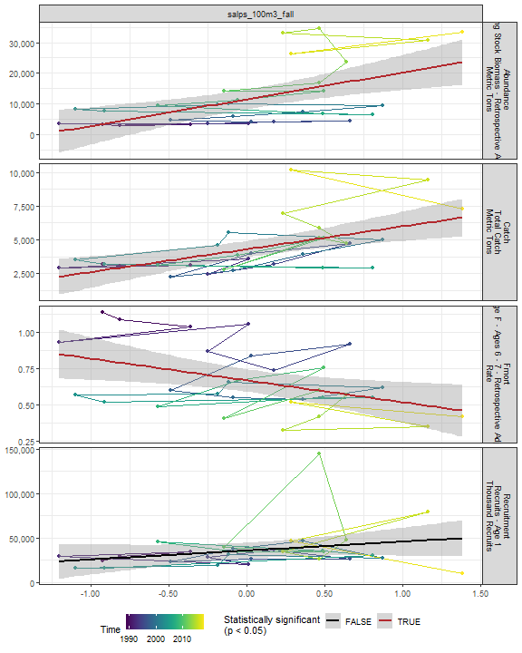

##### Regression statistics

Table 2.82: Catch vs salps_100m3_fall

|  |  |  |  |  |
| --- | --- | --- | --- | --- |
|  | Estimate | Std. Error | t value | Pr(>|t|) |
| (Intercept) | 4299.21 | 298.50 | 14.40 | 0 |
| Val | 1693.62 | 461.14 | 3.67 | 0 |

|  |  |
| --- | --- |
| Name | Value |
| F-statistic | 13.49 |
| df | 1, 28 |
| R2 | 0.33 |
| R2-adj | 0.3 |

Table 2.82: Fmort vs salps_100m3_fall

|  |  |  |  |  |
| --- | --- | --- | --- | --- |
|  | Estimate | Std. Error | t value | Pr(>|t|) |
| (Intercept) | 0.67 | 0.04 | 17.67 | 0.00 |
| Val | -0.15 | 0.06 | -2.56 | 0.02 |

|  |  |
| --- | --- |
| Name | Value |
| F-statistic | 6.58 |
| df | 1, 28 |
| R2 | 0.19 |
| R2-adj | 0.16 |

Table 2.82: Abundance vs salps_100m3_fall

|  |  |  |  |  |
| --- | --- | --- | --- | --- |
|  | Estimate | Std. Error | t value | Pr(>|t|) |
| (Intercept) | 11486.91 | 1567.79 | 7.33 | 0 |
| Val | 8728.31 | 2422.04 | 3.60 | 0 |

|  |  |
| --- | --- |
| Name | Value |
| F-statistic | 12.99 |
| df | 1, 28 |
| R2 | 0.32 |
| R2-adj | 0.29 |

#### Oithspp 100m3 Fall

##### Figures

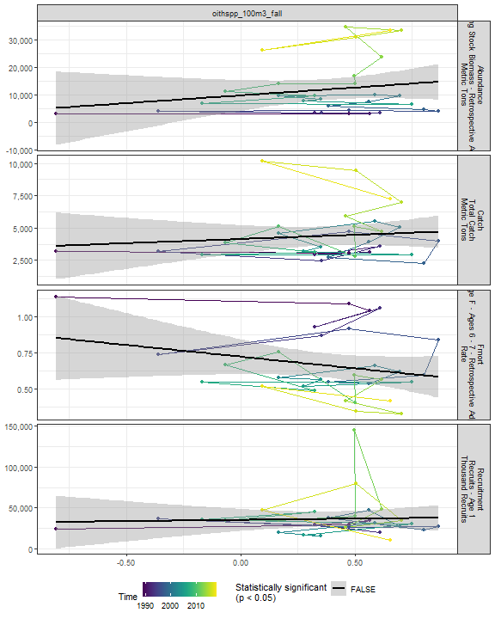

##### Regression statistics

[1] “No statistically significant data”

#### Chaeto 100m3 Fall

##### Figures

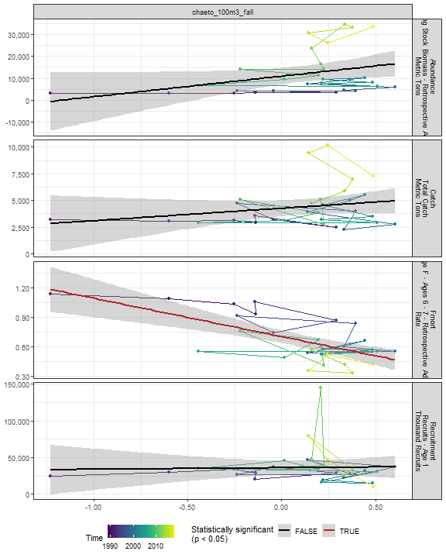

##### Regression statistics

Table 2.83: Fmort vs chaeto_100m3_fall

|  |  |  |  |  |
| --- | --- | --- | --- | --- |
|  | Estimate | Std. Error | t value | Pr(>|t|) |
| (Intercept) | 0.70 | 0.03 | 21.82 | 0 |
| Val | -0.39 | 0.08 | -4.80 | 0 |

|  |  |
| --- | --- |
| Name | Value |
| F-statistic | 23.04 |
| df | 1, 28 |
| R2 | 0.45 |
| R2-adj | 0.43 |

#### Hyper 100m3 Fall

##### Figures

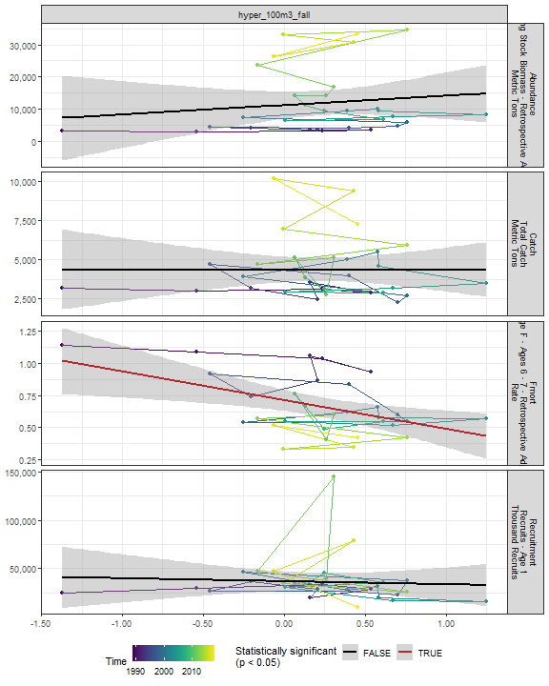

##### Regression statistics

Table 2.84: Fmort vs hyper_100m3_fall

|  |  |  |  |  |
| --- | --- | --- | --- | --- |
|  | Estimate | Std. Error | t value | Pr(>|t|) |
| (Intercept) | 0.71 | 0.04 | 17.66 | 0.00 |
| Val | -0.22 | 0.08 | -2.95 | 0.01 |

|  |  |
| --- | --- |
| Name | Value |
| F-statistic | 8.73 |
| df | 1, 28 |
| R2 | 0.24 |
| R2-adj | 0.21 |

#### Calminor 100m3 Fall

##### Figures

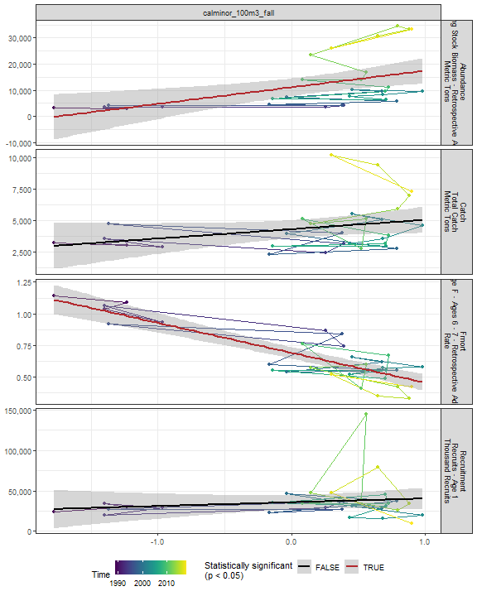

##### Regression statistics

Table 2.85: Fmort vs calminor_100m3_fall

|  |  |  |  |  |
| --- | --- | --- | --- | --- |
|  | Estimate | Std. Error | t value | Pr(>|t|) |
| (Intercept) | 0.69 | 0.02 | 30.85 | 0 |
| Val | -0.24 | 0.03 | -8.53 | 0 |

|  |  |
| --- | --- |
| Name | Value |
| F-statistic | 72.7 |
| df | 1, 28 |
| R2 | 0.72 |
| R2-adj | 0.71 |

Table 2.85: Abundance vs calminor_100m3_fall

|  |  |  |  |  |
| --- | --- | --- | --- | --- |
|  | Estimate | Std. Error | t value | Pr(>|t|) |
| (Intercept) | 11121.71 | 1648.26 | 6.75 | 0 |
| Val | 6359.06 | 2040.17 | 3.12 | 0 |

|  |  |
| --- | --- |
| Name | Value |
| F-statistic | 9.72 |
| df | 1, 28 |
| R2 | 0.26 |
| R2-adj | 0.23 |

#### Clauso Fall

##### Figures

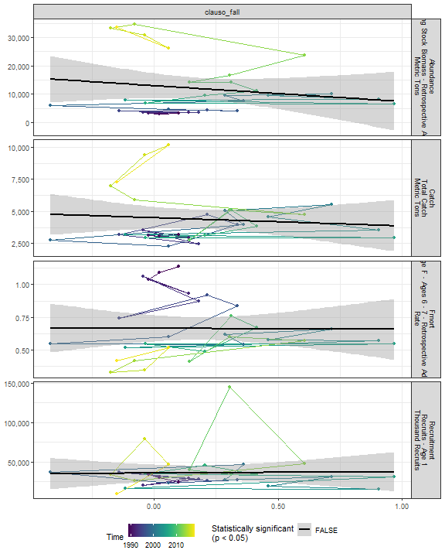

##### Regression statistics

[1] “No statistically significant data”

#### Dec 100m3 Fall

##### Figures

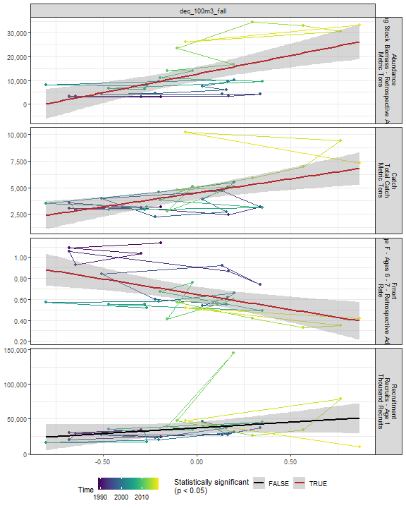

##### Regression statistics

Table 2.86: Catch vs dec_100m3_fall

|  |  |  |  |  |
| --- | --- | --- | --- | --- |
|  | Estimate | Std. Error | t value | Pr(>|t|) |
| (Intercept) | 4510.66 | 303.87 | 14.84 | 0 |
| Val | 2617.38 | 740.21 | 3.54 | 0 |

|  |  |
| --- | --- |
| Name | Value |
| F-statistic | 12.5 |
| df | 1, 28 |
| R2 | 0.31 |
| R2-adj | 0.28 |

Table 2.86: Fmort vs dec_100m3_fall

|  |  |  |  |  |
| --- | --- | --- | --- | --- |
|  | Estimate | Std. Error | t value | Pr(>|t|) |
| (Intercept) | 0.65 | 0.04 | 18.11 | 0 |
| Val | -0.29 | 0.09 | -3.36 | 0 |

|  |  |
| --- | --- |
| Name | Value |
| F-statistic | 11.26 |
| df | 1, 28 |
| R2 | 0.29 |
| R2-adj | 0.26 |

Table 2.86: Abundance vs dec_100m3_fall

|  |  |  |  |  |
| --- | --- | --- | --- | --- |
|  | Estimate | Std. Error | t value | Pr(>|t|) |
| (Intercept) | 12692.34 | 1468.05 | 8.65 | 0 |
| Val | 15706.97 | 3576.12 | 4.39 | 0 |

|  |  |
| --- | --- |
| Name | Value |
| F-statistic | 19.29 |
| df | 1, 28 |
| R2 | 0.41 |
| R2-adj | 0.39 |

#### Euph 100m3 Fall

##### Figures

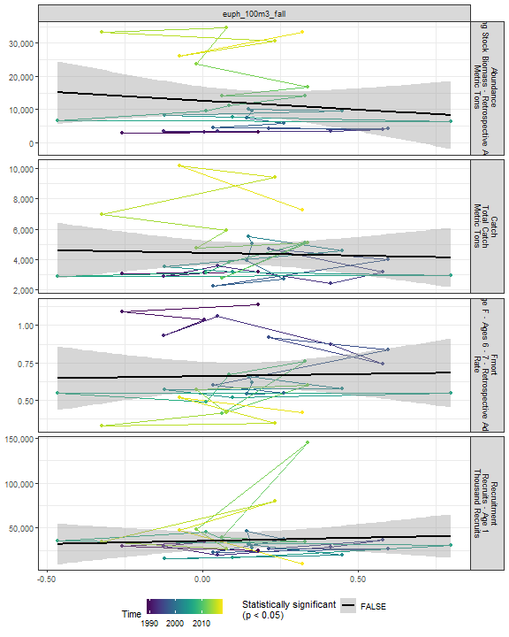

##### Regression statistics

[1] “No statistically significant data”

#### Prot 100m3 Fall

##### Figures

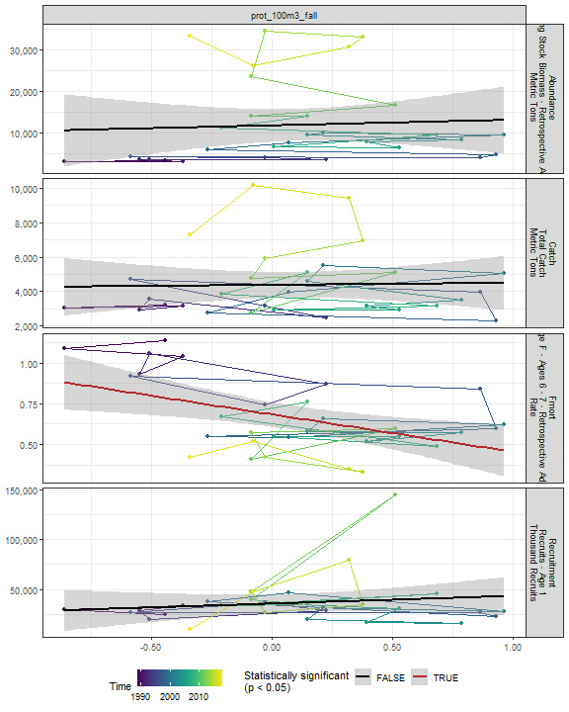

##### Regression statistics

Table 2.87: Fmort vs prot_100m3_fall

|  |  |  |  |  |
| --- | --- | --- | --- | --- |
|  | Estimate | Std. Error | t value | Pr(>|t|) |
| (Intercept) | 0.68 | 0.04 | 18.30 | 0.00 |
| Val | -0.23 | 0.08 | -2.95 | 0.01 |

|  |  |
| --- | --- |
| Name | Value |
| F-statistic | 8.7 |
| df | 1, 28 |
| R2 | 0.24 |
| R2-adj | 0.21 |

#### Poly 100m3 Fall

##### Figures

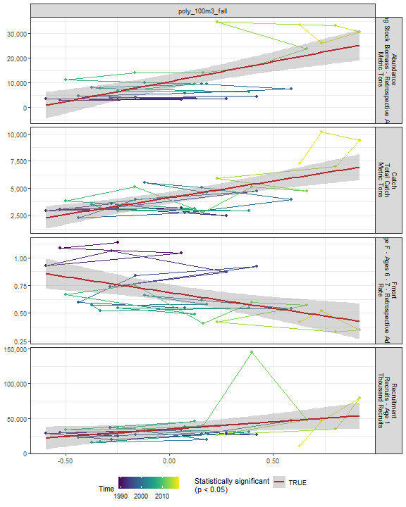

##### Regression statistics

Table 2.88: Catch vs poly_100m3_fall

|  |  |  |  |  |
| --- | --- | --- | --- | --- |
|  | Estimate | Std. Error | t value | Pr(>|t|) |
| (Intercept) | 4116.58 | 271.84 | 15.14 | 0 |
| Val | 3068.97 | 629.77 | 4.87 | 0 |

|  |  |
| --- | --- |
| Name | Value |
| F-statistic | 23.75 |
| df | 1, 28 |
| R2 | 0.46 |
| R2-adj | 0.44 |

Table 2.88: Fmort vs poly_100m3_fall

|  |  |  |  |  |
| --- | --- | --- | --- | --- |
|  | Estimate | Std. Error | t value | Pr(>|t|) |
| (Intercept) | 0.69 | 0.04 | 19.03 | 0 |
| Val | -0.28 | 0.08 | -3.38 | 0 |

|  |  |
| --- | --- |
| Name | Value |
| F-statistic | 11.44 |
| df | 1, 28 |
| R2 | 0.29 |
| R2-adj | 0.26 |

Table 2.88: Recruitment vs poly_100m3_fall

|  |  |  |  |  |
| --- | --- | --- | --- | --- |
|  | Estimate | Std. Error | t value | Pr(>|t|) |
| (Intercept) | 34370.19 | 4258.04 | 8.07 | 0.00 |
| Val | 20944.08 | 9864.74 | 2.12 | 0.04 |

|  |  |
| --- | --- |
| Name | Value |
| F-statistic | 4.51 |
| df | 1, 28 |
| R2 | 0.14 |
| R2-adj | 0.11 |

Table 2.88: Abundance vs poly_100m3_fall

|  |  |  |  |  |
| --- | --- | --- | --- | --- |
|  | Estimate | Std. Error | t value | Pr(>|t|) |
| (Intercept) | 10520.29 | 1411.73 | 7.45 | 0 |
| Val | 16118.85 | 3270.60 | 4.93 | 0 |

|  |  |
| --- | --- |
| Name | Value |
| F-statistic | 24.29 |
| df | 1, 28 |
| R2 | 0.46 |
| R2-adj | 0.45 |

#### Fish 100m3 Fall

##### Figures

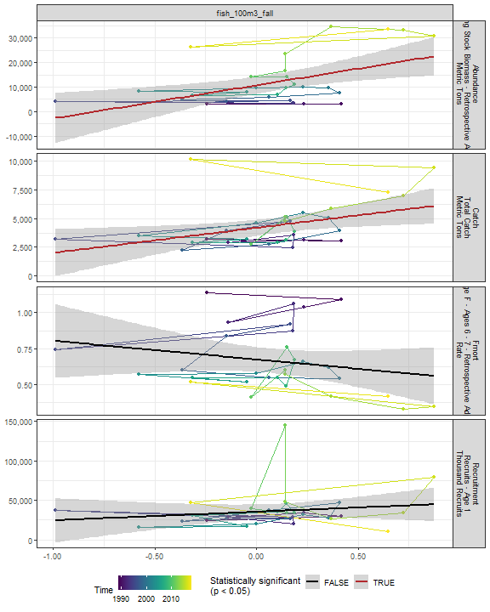

##### Regression statistics

Table 2.89: Catch vs fish_100m3_fall

|  |  |  |  |  |
| --- | --- | --- | --- | --- |
|  | Estimate | Std. Error | t value | Pr(>|t|) |
| (Intercept) | 4188.59 | 336.34 | 12.45 | 0.00 |
| Val | 2189.42 | 879.15 | 2.49 | 0.02 |

|  |  |
| --- | --- |
| Name | Value |
| F-statistic | 6.2 |
| df | 1, 28 |
| R2 | 0.18 |
| R2-adj | 0.15 |

Table 2.89: Abundance vs fish_100m3_fall

|  |  |  |  |  |
| --- | --- | --- | --- | --- |
|  | Estimate | Std. Error | t value | Pr(>|t|) |
| (Intercept) | 10727.28 | 1676.40 | 6.40 | 0 |
| Val | 13520.21 | 4381.87 | 3.09 | 0 |

|  |  |
| --- | --- |
| Name | Value |
| F-statistic | 9.52 |
| df | 1, 28 |
| R2 | 0.25 |
| R2-adj | 0.23 |

#### Oncaea 100m3 Fall

##### Figures

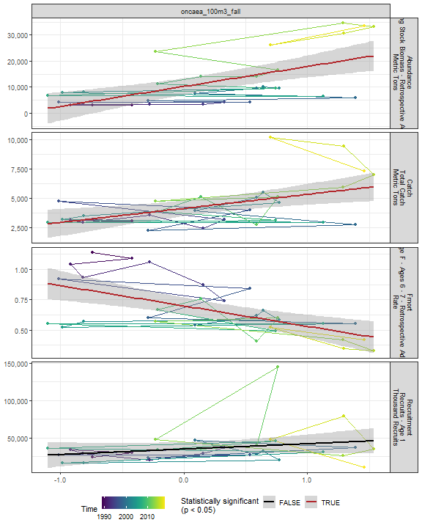

##### Regression statistics

Table 2.90: Catch vs oncaea_100m3_fall

|  |  |  |  |  |
| --- | --- | --- | --- | --- |
|  | Estimate | Std. Error | t value | Pr(>|t|) |
| (Intercept) | 4122.58 | 322.58 | 12.78 | 0 |
| Val | 1196.32 | 383.74 | 3.12 | 0 |

|  |  |
| --- | --- |
| Name | Value |
| F-statistic | 9.72 |
| df | 1, 28 |
| R2 | 0.26 |
| R2-adj | 0.23 |

Table 2.90: Fmort vs oncaea_100m3_fall

|  |  |  |  |  |
| --- | --- | --- | --- | --- |
|  | Estimate | Std. Error | t value | Pr(>|t|) |
| (Intercept) | 0.70 | 0.03 | 20.36 | 0 |
| Val | -0.17 | 0.04 | -4.10 | 0 |

|  |  |
| --- | --- |
| Name | Value |
| F-statistic | 16.82 |
| df | 1, 28 |
| R2 | 0.38 |
| R2-adj | 0.35 |

Table 2.90: Abundance vs oncaea_100m3_fall

|  |  |  |  |  |
| --- | --- | --- | --- | --- |
|  | Estimate | Std. Error | t value | Pr(>|t|) |
| (Intercept) | 10264.32 | 1530.64 | 6.71 | 0 |
| Val | 7650.96 | 1820.87 | 4.20 | 0 |

|  |  |
| --- | --- |
| Name | Value |
| F-statistic | 17.66 |
| df | 1, 28 |
| R2 | 0.39 |
| R2-adj | 0.36 |

#### Cory 100m3 Fall

##### Figures

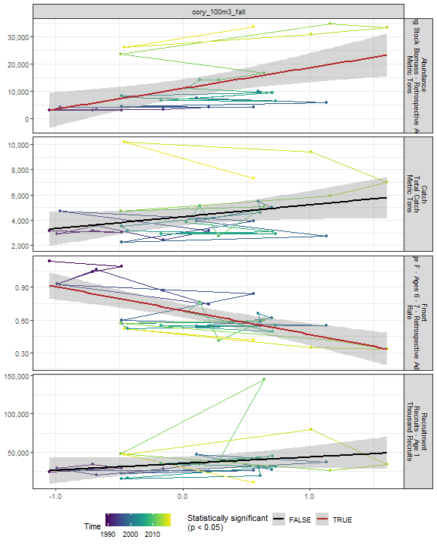

##### Regression statistics

Table 2.91: Fmort vs cory_100m3_fall

|  |  |  |  |  |
| --- | --- | --- | --- | --- |
|  | Estimate | Std. Error | t value | Pr(>|t|) |
| (Intercept) | 0.69 | 0.03 | 22.20 | 0 |
| Val | -0.22 | 0.04 | -4.99 | 0 |

|  |  |
| --- | --- |
| Name | Value |
| F-statistic | 24.94 |
| df | 1, 28 |
| R2 | 0.47 |
| R2-adj | 0.45 |

Table 2.91: Abundance vs cory_100m3_fall

|  |  |  |  |  |
| --- | --- | --- | --- | --- |
|  | Estimate | Std. Error | t value | Pr(>|t|) |
| (Intercept) | 11074.80 | 1625.06 | 6.82 | 0 |
| Val | 7560.56 | 2296.92 | 3.29 | 0 |

|  |  |
| --- | --- |
| Name | Value |
| F-statistic | 10.83 |
| df | 1, 28 |
| R2 | 0.28 |
| R2-adj | 0.25 |

#### Siph 100m3 Fall

##### Figures

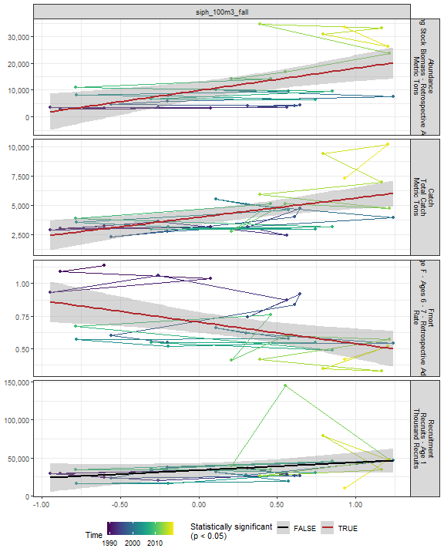

##### Regression statistics

Table 2.92: Catch vs siph_100m3_fall

|  |  |  |  |  |
| --- | --- | --- | --- | --- |
|  | Estimate | Std. Error | t value | Pr(>|t|) |
| (Intercept) | 3968.91 | 321.41 | 12.35 | 0 |
| Val | 1632.58 | 457.99 | 3.56 | 0 |

|  |  |
| --- | --- |
| Name | Value |
| F-statistic | 12.71 |
| df | 1, 28 |
| R2 | 0.31 |
| R2-adj | 0.29 |

Table 2.92: Fmort vs siph_100m3_fall

|  |  |  |  |  |
| --- | --- | --- | --- | --- |
|  | Estimate | Std. Error | t value | Pr(>|t|) |
| (Intercept) | 0.70 | 0.04 | 17.92 | 0.00 |
| Val | -0.16 | 0.06 | -2.93 | 0.01 |

|  |  |
| --- | --- |
| Name | Value |
| F-statistic | 8.61 |
| df | 1, 28 |
| R2 | 0.24 |
| R2-adj | 0.21 |

Table 2.92: Abundance vs siph_100m3_fall

|  |  |  |  |  |
| --- | --- | --- | --- | --- |
|  | Estimate | Std. Error | t value | Pr(>|t|) |
| (Intercept) | 9805.76 | 1694.97 | 5.79 | 0 |
| Val | 8328.53 | 2415.20 | 3.45 | 0 |

|  |  |
| --- | --- |
| Name | Value |
| F-statistic | 11.89 |
| df | 1, 28 |
| R2 | 0.3 |
| R2-adj | 0.27 |

#### Coel 100m3 Fall

##### Figures

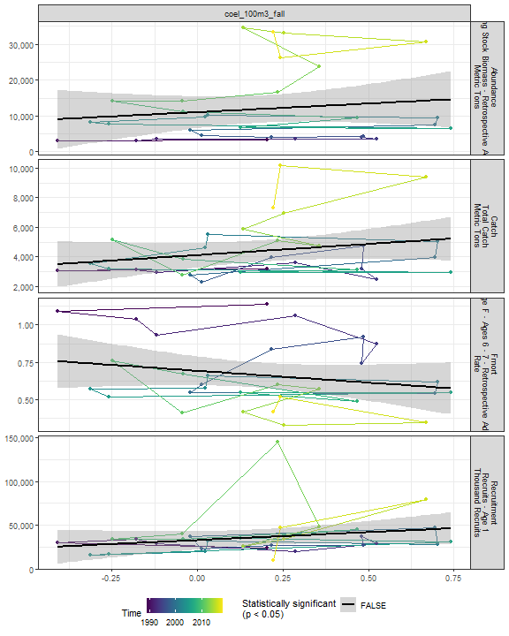

##### Regression statistics

[1] “No statistically significant data”

#### Euph1 100m3 Fall

##### Figures

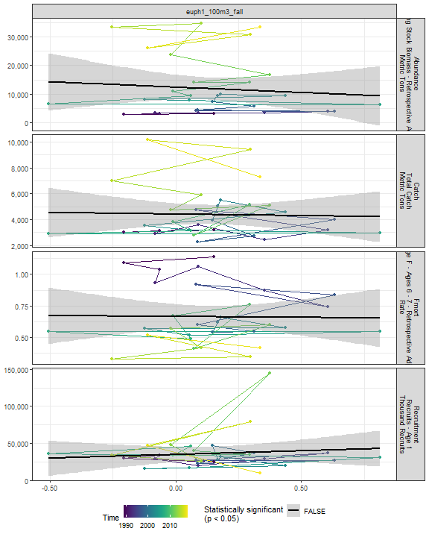

##### Regression statistics

[1] “No statistically significant data”

#### Thecos 100m3 Fall

##### Figures

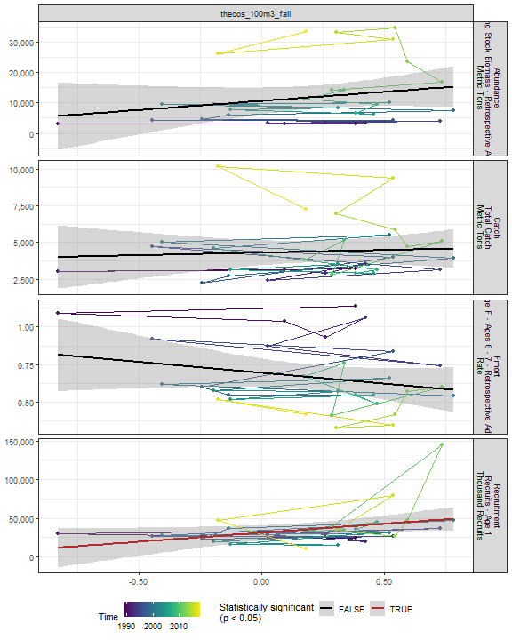

##### Regression statistics

Table 2.93: Recruitment vs thecos_100m3_fall

|  |  |  |  |  |
| --- | --- | --- | --- | --- |
|  | Estimate | Std. Error | t value | Pr(>|t|) |
| (Intercept) | 31096.15 | 4797.43 | 6.48 | 0.00 |
| Val | 23185.54 | 10889.11 | 2.13 | 0.04 |

|  |  |
| --- | --- |
| Name | Value |
| F-statistic | 4.53 |
| df | 1, 28 |
| R2 | 0.14 |
| R2-adj | 0.11 |

#### Spirspp 100m3 Fall

##### Figures

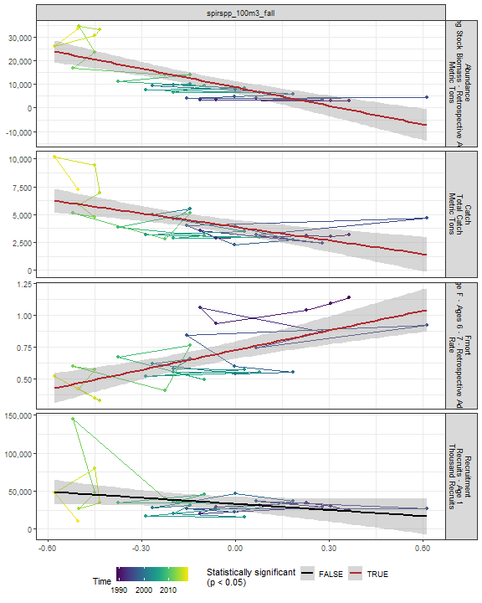

##### Regression statistics

Table 2.94: Catch vs spirspp_100m3_fall

|  |  |  |  |  |
| --- | --- | --- | --- | --- |
|  | Estimate | Std. Error | t value | Pr(>|t|) |
| (Intercept) | 3893.96 | 307.74 | 12.65 | 0 |
| Val | -4040.45 | 973.16 | -4.15 | 0 |

|  |  |
| --- | --- |
| Name | Value |
| F-statistic | 17.24 |
| df | 1, 28 |
| R2 | 0.38 |
| R2-adj | 0.36 |

Table 2.94: Fmort vs spirspp_100m3_fall

|  |  |  |  |  |
| --- | --- | --- | --- | --- |
|  | Estimate | Std. Error | t value | Pr(>|t|) |
| (Intercept) | 0.72 | 0.03 | 21.74 | 0 |
| Val | 0.52 | 0.11 | 4.89 | 0 |

|  |  |
| --- | --- |
| Name | Value |
| F-statistic | 23.88 |
| df | 1, 28 |
| R2 | 0.46 |
| R2-adj | 0.44 |

Table 2.94: Abundance vs spirspp_100m3_fall

|  |  |  |  |  |
| --- | --- | --- | --- | --- |
|  | Estimate | Std. Error | t value | Pr(>|t|) |
| (Intercept) | 8769.59 | 1316.92 | 6.66 | 0 |
| Val | -26114.74 | 4164.44 | -6.27 | 0 |

|  |  |
| --- | --- |
| Name | Value |
| F-statistic | 39.32 |
| df | 1, 28 |
| R2 | 0.58 |
| R2-adj | 0.57 |

#### Cnidar 100m3 Fall

##### Figures

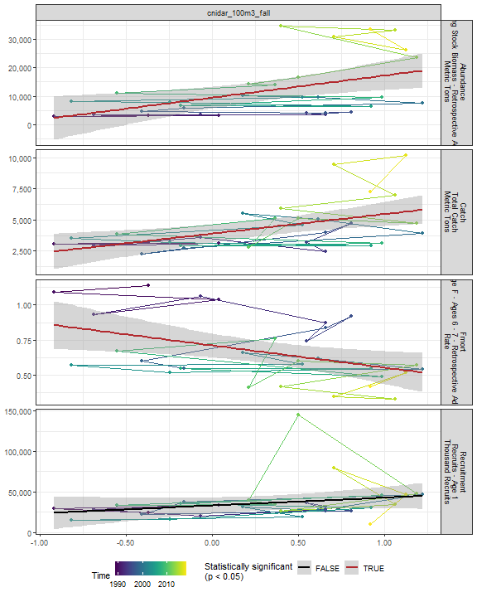

##### Regression statistics

Table 2.95: Catch vs cnidar_100m3_fall

|  |  |  |  |  |
| --- | --- | --- | --- | --- |
|  | Estimate | Std. Error | t value | Pr(>|t|) |
| (Intercept) | 3891.88 | 349.83 | 11.13 | 0 |
| Val | 1564.15 | 506.39 | 3.09 | 0 |

|  |  |
| --- | --- |
| Name | Value |
| F-statistic | 9.54 |
| df | 1, 28 |
| R2 | 0.25 |
| R2-adj | 0.23 |

Table 2.95: Fmort vs cnidar_100m3_fall

|  |  |  |  |  |
| --- | --- | --- | --- | --- |
|  | Estimate | Std. Error | t value | Pr(>|t|) |
| (Intercept) | 0.71 | 0.04 | 16.86 | 0.00 |
| Val | -0.16 | 0.06 | -2.58 | 0.02 |

|  |  |
| --- | --- |
| Name | Value |
| F-statistic | 6.64 |
| df | 1, 28 |
| R2 | 0.19 |
| R2-adj | 0.16 |

Table 2.95: Abundance vs cnidar_100m3_fall

|  |  |  |  |  |
| --- | --- | --- | --- | --- |
|  | Estimate | Std. Error | t value | Pr(>|t|) |
| (Intercept) | 9486.49 | 1857.53 | 5.11 | 0.00 |
| Val | 7740.47 | 2688.85 | 2.88 | 0.01 |

|  |  |
| --- | --- |
| Name | Value |
| F-statistic | 8.29 |
| df | 1, 28 |
| R2 | 0.23 |
| R2-adj | 0.2 |

## 2.5 Larvae and YOY indicators

### 2.5.1 Recruitment

##### Figures

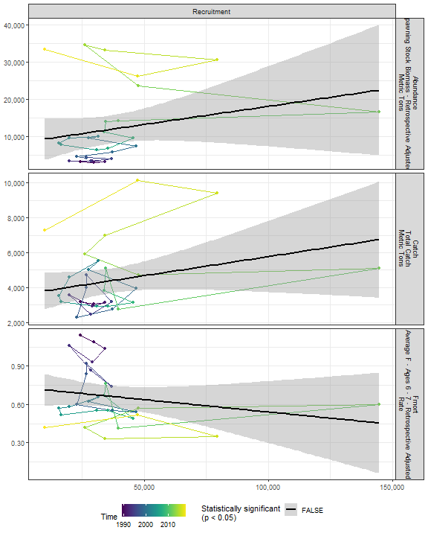

##### Regression statistics

[1] “No statistically significant data”

### 2.5.2 Larval growth

## 2.6 Juvenile indicators

### 2.6.1 Length-age curves

### 2.6.2 Condition

### 2.6.3 CPUE

## 2.7 Adult indicators

### 2.7.1 Abundance

##### Figures

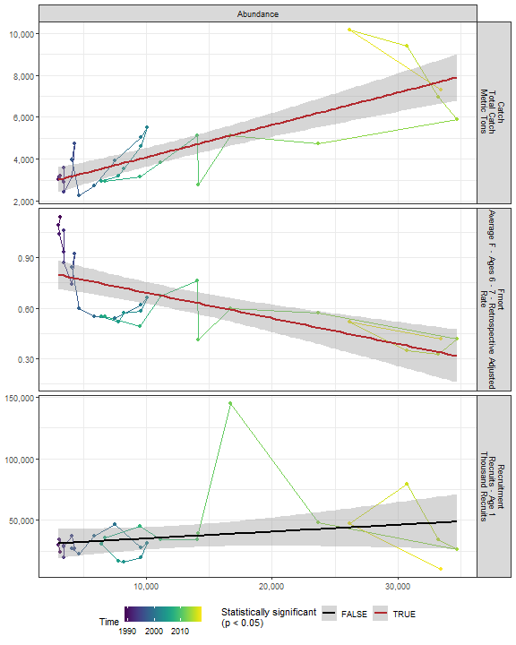

##### Regression statistics

Table 2.96: Catch vs Abundance

|  |  |  |  |  |
| --- | --- | --- | --- | --- |
|  | Estimate | Std. Error | t value | Pr(>|t|) |
| (Intercept) | 2543.26 | 333.57 | 7.62 | 0 |
| Val | 0.15 | 0.02 | 7.18 | 0 |

|  |  |
| --- | --- |
| Name | Value |
| F-statistic | 51.55 |
| df | 1, 28 |
| R2 | 0.65 |
| R2-adj | 0.64 |

Table 2.96: Fmort vs Abundance

|  |  |  |  |  |
| --- | --- | --- | --- | --- |
|  | Estimate | Std. Error | t value | Pr(>|t|) |
| (Intercept) | 0.84 | 0.05 | 17.68 | 0 |
| Val | 0.00 | 0.00 | -4.93 | 0 |

|  |  |
| --- | --- |
| Name | Value |
| F-statistic | 24.33 |
| df | 1, 28 |
| R2 | 0.46 |
| R2-adj | 0.45 |

### 2.7.2 Mean age of spawning stock

### 2.7.3 Age distribution

### 2.7.4 Length-age curves

### 2.7.5 Condition

##### Figures

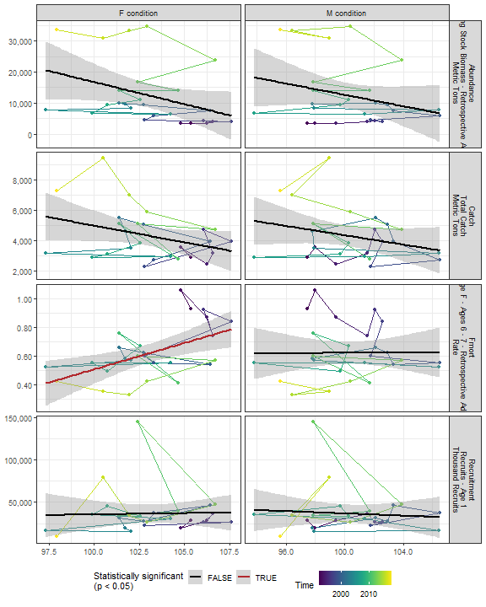

##### Regression statistics

Table 2.97: Fmort vs F condition

|  |  |  |  |  |
| --- | --- | --- | --- | --- |
|  | Estimate | Std. Error | t value | Pr(>|t|) |
| (Intercept) | -3.18 | 1.23 | -2.58 | 0.02 |
| Val | 0.04 | 0.01 | 3.08 | 0.01 |

|  |  |
| --- | --- |
| Name | Value |
| F-statistic | 9.5 |
| df | 1, 24 |
| R2 | 0.28 |
| R2-adj | 0.25 |

### 2.7.6 Stomach fullness

##### Figures

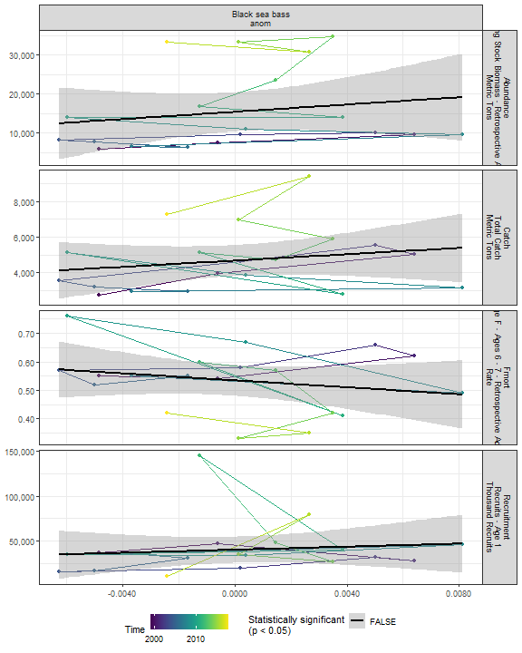

##### Regression statistics

[1] “No statistically significant data”

### 2.7.7 Center of gravity and area occupied

## 2.8 Socioeconomic indicators

### 2.8.1 CPUE by catch strategy

### 2.8.2 Recreational CPUE

##### Figures

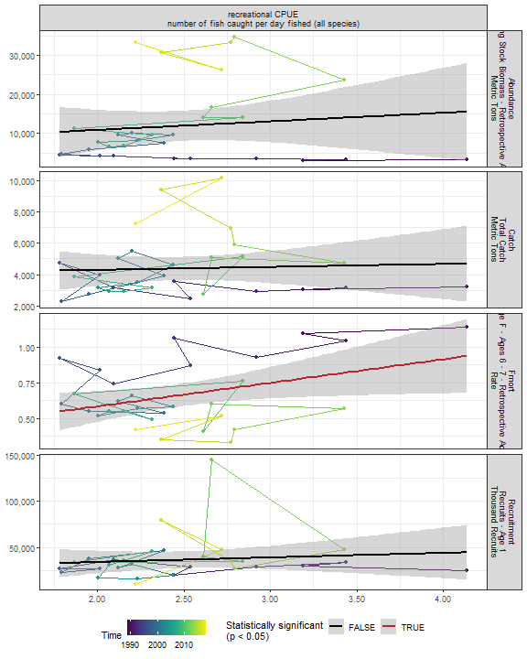

##### Regression statistics

Table 2.98: Fmort vs recreational CPUE number of fish caught per day fished (all species)

|  |  |  |  |  |
| --- | --- | --- | --- | --- |
|  | Estimate | Std. Error | t value | Pr(>|t|) |
| (Intercept) | 0.26 | 0.18 | 1.39 | 0.17 |
| Val | 0.16 | 0.07 | 2.27 | 0.03 |

|  |  |
| --- | --- |
| Name | Value |
| F-statistic | 5.14 |
| df | 1, 28 |
| R2 | 0.16 |
| R2-adj | 0.13 |

# 3 Summary of statistically significant indicators

## 3.1 Abundance

|  |  |  |  |  |
| --- | --- | --- | --- | --- |
| Indicator | Number of data points | Slope | P-value | R2_adj |
| Time | 30 | 1000 | 9.3e-10 | 0.73 |
| cumulative intensity |  |  |  |  |

degrees C (annual mean) |26 |51 |0.0016 |0.32 | |maximum intensity degrees C (annual mean) |26 |12000 |0.012 |0.2 | |cumulative intensity Black sea bass north spring degrees C (annual mean) |25 |48 |0.0011 |0.35 | |cumulative intensity Black sea bass spring degrees C (annual mean) |26 |47 |0.0046 |0.26 | |maximum intensity Black sea bass spring degrees C (annual mean) |26 |17000 |0.00015 |0.44 | |maximum intensity Black sea bass north spring degrees C (annual mean) |25 |10000 |0.0077 |0.24 | |cumulative intensity Black sea bass south spring degrees C (annual mean) |27 |44 |0.03 |0.14 | |GLORYS bottom temp anomaly degreesC |26 |5500 |0.011 |0.21 | |long-term sst degreesC |30 |10000 |2.6e-05 |0.46 | |summer OI SST Anomaly degreesC |30 |8900 |3.6e-05 |0.44 | |fall OI SST Anomaly degreesC |30 |8600 |0.00035 |0.35 | |spring OI SST Anomaly degreesC |30 |5700 |0.015 |0.16 | |winter OI SST Anomaly Black sea bass north spring degreesC |30 |4400 |0.04 |0.11 | |summer OI SST Anomaly Black sea bass north spring degreesC |30 |8100 |3.8e-05 |0.44 | |fall OI SST Anomaly Black sea bass north spring degreesC |30 |7400 |9.7e-05 |0.4 | |summer OI SST Anomaly Black sea bass spring degreesC |30 |8800 |5.3e-05 |0.43 | |fall OI SST Anomaly Black sea bass spring degreesC |30 |8000 |0.00024 |0.36 | |summer OI SST Anomaly Black sea bass south spring degreesC |30 |8200 |0.00062 |0.32 | |fall OI SST Anomaly Black sea bass south spring degreesC |30 |7100 |0.0042 |0.23 | |spring OI SST Anomaly Black sea bass north spring degreesC |30 |6500 |0.015 |0.17 | |spring OI SST Anomaly Black sea bass spring degreesC |30 |5000 |0.05 |0.1 | |tke winter J/kg |30 |67000 |0.0038 |0.24 | |hcly summer m2/sec2 |30 |-630 |0.015 |0.16 | |Latitude degreesN |30 |41000 |2.8e-05 |0.45 | |Longitude degreesW |30 |36000 |5.9e-05 |0.42 | |along-shelf distance km |30 |290 |1.6e-05 |0.47 | |depth m |30 |900 |0.01 |0.19 | |northern_latitude |30 |11000 |0.00043 |0.34 | |MONTHLY CHLOR A MEDIAN month 02 mg m^-3 |21 |35000 |0.045 |0.15 | |WEEKLY CHLOR A MEDIAN week 06 mg m^-3 |21 |22000 |0.0059 |0.3 | |WEEKLY CHLOR A RATIO ANOMALY week 04 |21 |40000 |0.027 |0.19 | |WEEKLY CHLOR A MEDIAN week 07 mg m^-3 |21 |24000 |0.0036 |0.33 | |WEEKLY CHLOR A RATIO ANOMALY week 07 |21 |35000 |0.014 |0.24 | |WEEKLY CHLOR A MEDIAN week 05 mg m^-3 |21 |28000 |0.011 |0.26 | |WEEKLY CHLOR A RATIO ANOMALY week 06 |21 |32000 |0.05 |0.15 | |MONTHLY PPD MEDIAN month 05 gCarbon/m^2/Day |21 |35000 |0.048 |0.15 | |MONTHLY PPD MEDIAN month 06 gCarbon/m^2/Day |21 |26000 |0.045 |0.15 | |WEEKLY PPD MEDIAN week 11 gCarbon/m^2/Day |21 |50000 |0.0062 |0.3 | |WEEKLY PPD RATIO ANOMALY week 20 |21 |45000 |0.00051 |0.45 | |WEEKLY PPD MEDIAN week 20 gCarbon/m^2/Day |21 |52000 |0.0011 |0.41 | |WEEKLY PPD MEDIAN week 21 gCarbon/m^2/Day |21 |28000 |0.02 |0.22 | |WEEKLY PPD MEDIAN week 22 gCarbon/m^2/Day |21 |23000 |0.045 |0.15 | |WEEKLY PPD MEDIAN week 25 gCarbon/m^2/Day |21 |21000 |0.043 |0.16 | |WEEKLY PPD MEDIAN week 27 gCarbon/m^2/Day |21 |19000 |0.034 |0.17 | |WEEKLY PPD RATIO ANOMALY week 21 |21 |25000 |0.023 |0.2 | |WEEKLY PPD RATIO ANOMALY week 25 |21 |24000 |0.031 |0.18 | |WEEKLY PPD RATIO ANOMALY week 26 |21 |25000 |0.028 |0.19 | |WEEKLY PPD RATIO ANOMALY week 27 |21 |26000 |0.026 |0.19 | |WEEKLY PPD RATIO ANOMALY week 48 |21 |-27000 |0.042 |0.16 | |centropages zoo fall log N m^-3 |26 |-12000 |0.03 |0.15 | |SmallCalanoida Absolute Number of Individuals |30 |-8.3e-06 |0.017 |0.16 | |Calanus CV and adult Summer |26 |-1.4 |0.037 |0.13 | |Zoo_Shannon-Wiener_Diversity_index Unitless |30 |13000 |0.042 |0.11 | |spring Black sea bass spring gC m-2 d-1 |21 |47000 |0.024 |0.2 | |spring Black sea bass south spring gC m-2 d-1 |21 |43000 |0.012 |0.25 | |pseudo_100m3_annual |30 |-6000 |0.041 |0.11 | |penilia_100m3_annual |30 |13000 |0.011 |0.18 | |echino_100m3_annual |30 |13000 |7e-05 |0.42 | |larvaceans_100m3_annual |30 |14000 |0.00058 |0.33 | |mlucens_100m3_annual |30 |-12000 |0.0032 |0.24 | |evadnespp_100m3_annual |30 |15000 |0.0027 |0.25 | |salps_100m3_annual |30 |22000 |4.5e-05 |0.43 | |calminor_100m3_annual |30 |9600 |0.01 |0.19 | |poly_100m3_annual |30 |24000 |0.0017 |0.28 | |oncaea_100m3_annual |30 |14000 |0.00074 |0.32 | |cory_100m3_annual |30 |14000 |0.0034 |0.24 | |siph_100m3_annual |30 |11000 |0.034 |0.12 | |thecos_100m3_annual |30 |12000 |0.0032 |0.24 | |spirspp_100m3_annual |30 |-17000 |6.1e-07 |0.58 | |cnidar_100m3_annual |30 |12000 |0.014 |0.17 | |penilia_100m3_spring |29 |110000 |4.6e-05 |0.45 | |echino_100m3_spring |29 |13000 |0.001 |0.31 | |para_100m3_spring |29 |5000 |0.046 |0.11 | |chaeto_100m3_spring |29 |8500 |0.045 |0.11 | |clauso_spring |29 |8100 |0.015 |0.17 | |dec_100m3_spring |29 |-18000 |0.0011 |0.31 | |thecos_100m3_spring |29 |6600 |0.0049 |0.23 | |spirspp_100m3_spring |29 |-11000 |1.7e-06 |0.56 | |ctyp_100m3_fall |30 |-12000 |0.0032 |0.25 | |calfin_100m3_fall |30 |-6700 |0.025 |0.14 | |penilia_100m3_fall |30 |6200 |0.0094 |0.19 | |cham_100m3_fall |30 |-9800 |0.0019 |0.27 | |echino_100m3_fall |30 |6200 |0.00088 |0.31 | |larvaceans_100m3_fall |30 |10000 |0.00043 |0.34 | |gas_100m3_fall |30 |15000 |0.018 |0.15 | |mlucens_100m3_fall |30 |-7000 |0.019 |0.15 | |evadnespp_100m3_fall |30 |8800 |0.003 |0.25 | |salps_100m3_fall |30 |8700 |0.0012 |0.29 | |calminor_100m3_fall |30 |6400 |0.0042 |0.23 | |dec_100m3_fall |30 |16000 |0.00015 |0.39 | |poly_100m3_fall |30 |16000 |3.4e-05 |0.45 | |fish_100m3_fall |30 |14000 |0.0045 |0.23 | |oncaea_100m3_fall |30 |7700 |0.00024 |0.36 | |cory_100m3_fall |30 |7600 |0.0027 |0.25 | |siph_100m3_fall |30 |8300 |0.0018 |0.27 | |spirspp_100m3_fall |30 |-26000 |8.9e-07 |0.57 | |cnidar_100m3_fall |30 |7700 |0.0076 |0.2 |

### 3.1.1 Generalized linear model

This is an exploratory fit of a poisson GLM. Initial covariates were included based on statistical significance at a Bonferroni-corrected alpha in the linear correlations shown in this report. Final covariates were chosen by forward stepwise AIC selection of additive GLMs.

|  |  |  |  |  |
| --- | --- | --- | --- | --- |
| rnames | Estimate | Std. Error | z value | Pr(>|z|) |
| (Intercept) | 96.6 | 16.8 | 5.75 | 8.91e-09 |
| spirspp 100m3 annual | 0.875 | 0.0345 | 25.3 | 1.24e-141 |
| penilia 100m3 spring | 0.37 | 0.049 | 7.55 | 4.23e-14 |
| spirspp 100m3 fall | -1.53 | 0.0281 | -54.3 | 0 |
| echino 100m3 annual | 0.179 | 0.00762 | 23.5 | 6.48e-122 |
| poly 100m3 fall | 0.402 | 0.00883 | 45.5 | 0 |
| spirspp 100m3 spring | -0.543 | 0.0165 | -32.9 | 6.68e-237 |
| long term sstdegreesC | 0.054 | 0.0125 | 4.31 | 1.65e-05 |
| Longitude degreesW | 2.33 | 0.616 | 3.79 | 0.000151 |
| along shelf distancekm | -0.0316 | 0.0107 | -2.96 | 0.00312 |
| fall OI SST AnomalyBlack sea bass northspring degreesC | -0.00969 | 0.00457 | -2.12 | 0.0341 |
| summer OI SSTAnomaly Black seabass spring degreesC | -3.45 | 0.076 | -45.4 | 0 |
| summer OI SSTAnomaly Black seabass north springdegreesC | 1.31 | 0.0299 | 43.9 | 0 |
| summer OI SSTAnomaly degreesC | 2.2 | 0.0509 | 43.2 | 0 |
| Latitude degreesN | 2.53 | 0.897 | 2.82 | 0.0048 |

Dropped coefficients: salps_100m3_annual

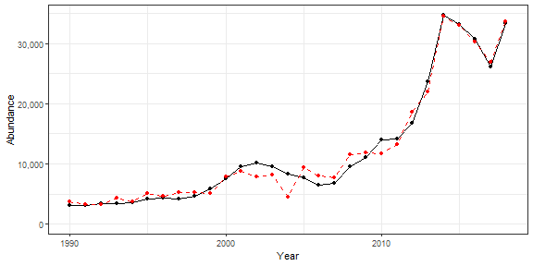

## 3.2 Recruitment

|  |  |  |  |  |
| --- | --- | --- | --- | --- |
| Indicator | Number of data points | Slope | P-value | R2_adj |
| T_mean | 26 | 44000 | 3.4e-05 | 0.5 |
| T_min | 26 | 21000 | 0.00018 | 0.43 |
| T_peak | 26 | 31000 | 5e-05 | 0.48 |
| V_max | 26 | -410000 | 0.019 | 0.17 |
| cumulative intensity |  |  |  |  |

degrees C (annual mean) |26 |150 |7.5e-05 |0.46 | |cumulative intensity Black sea bass spring degrees C (annual mean) |26 |160 |2.9e-05 |0.5 | |cumulative intensity Black sea bass south spring degrees C (annual mean) |27 |150 |0.0018 |0.3 | |GLORYS bottom temp anomaly degreesC |26 |17000 |0.00085 |0.35 | |long-term sst degreesC |30 |22000 |0.00017 |0.38 | |summer OI SST Anomaly degreesC |30 |13000 |0.023 |0.14 | |winter OI SST Anomaly degreesC |30 |18000 |2.8e-05 |0.45 | |spring OI SST Anomaly degreesC |30 |18000 |0.00089 |0.31 | |winter OI SST Anomaly Black sea bass north spring degreesC |30 |20000 |6.5e-06 |0.5 | |summer OI SST Anomaly Black sea bass north spring degreesC |30 |12000 |0.021 |0.15 | |fall OI SST Anomaly Black sea bass north spring degreesC |30 |12000 |0.012 |0.18 | |summer OI SST Anomaly Black sea bass spring degreesC |30 |13000 |0.019 |0.15 | |fall OI SST Anomaly Black sea bass spring degreesC |30 |11000 |0.047 |0.1 | |summer OI SST Anomaly Black sea bass south spring degreesC |30 |13000 |0.032 |0.12 | |spring OI SST Anomaly Black sea bass north spring degreesC |30 |22000 |0.00023 |0.37 | |winter OI SST Anomaly Black sea bass spring degreesC |30 |19000 |3.9e-05 |0.44 | |spring OI SST Anomaly Black sea bass spring degreesC |30 |19000 |0.0012 |0.29 | |winter OI SST Anomaly Black sea bass south spring degreesC |30 |15000 |0.00084 |0.31 | |spring OI SST Anomaly Black sea bass south spring degreesC |30 |11000 |0.02 |0.15 | |Latitude degreesN |30 |66000 |0.0091 |0.19 | |along-shelf distance km |30 |370 |0.041 |0.11 | |northern_latitude |30 |16000 |0.049 |0.1 | |MONTHLY CHLOR A MEDIAN month 01 mg m^-3 |21 |80000 |0.03 |0.18 | |MONTHLY CHLOR A RATIO ANOMALY month 01 |21 |120000 |0.024 |0.2 | |WEEKLY CHLOR A MEDIAN week 02 mg m^-3 |21 |45000 |0.029 |0.19 | |WEEKLY CHLOR A RATIO ANOMALY week 02 |21 |110000 |0.0018 |0.38 | |WEEKLY CHLOR A RATIO ANOMALY week 08 |21 |91000 |0.05 |0.15 | |ANNUAL PPD MEDIAN gCarbon/m^2/Day |21 |3e+05 |0.033 |0.18 | |ANNUAL PPD RATIO ANOMALY |21 |260000 |0.01 |0.26 | |MONTHLY PPD MEDIAN month 01 gCarbon/m^2/Day |21 |270000 |0.00084 |0.42 | |MONTHLY PPD MEDIAN month 02 gCarbon/m^2/Day |21 |330000 |0.0015 |0.39 | |MONTHLY PPD MEDIAN month 03 gCarbon/m^2/Day |21 |380000 |5e-05 |0.57 | |MONTHLY PPD MEDIAN month 04 gCarbon/m^2/Day |21 |180000 |0.038 |0.17 | |WEEKLY PPD MEDIAN week 11 gCarbon/m^2/Day |21 |150000 |0.0025 |0.36 | |WEEKLY PPD MEDIAN week 02 gCarbon/m^2/Day |21 |180000 |0.021 |0.21 | |WEEKLY PPD MEDIAN week 01 gCarbon/m^2/Day |21 |2e+05 |3e-04 |0.48 | |WEEKLY PPD MEDIAN week 03 gCarbon/m^2/Day |21 |210000 |0.026 |0.2 | |WEEKLY PPD MEDIAN week 04 gCarbon/m^2/Day |21 |250000 |9.3e-05 |0.54 | |WEEKLY PPD MEDIAN week 05 gCarbon/m^2/Day |21 |140000 |0.035 |0.17 | |WEEKLY PPD MEDIAN week 06 gCarbon/m^2/Day |21 |210000 |0.028 |0.19 | |WEEKLY PPD MEDIAN week 07 gCarbon/m^2/Day |21 |180000 |0.038 |0.16 | |WEEKLY PPD MEDIAN week 08 gCarbon/m^2/Day |21 |2e+05 |0.018 |0.22 | |WEEKLY PPD MEDIAN week 12 gCarbon/m^2/Day |21 |310000 |1e-05 |0.63 | |WEEKLY PPD MEDIAN week 13 gCarbon/m^2/Day |21 |190000 |0.021 |0.21 | |WEEKLY PPD MEDIAN week 14 gCarbon/m^2/Day |21 |150000 |0.033 |0.18 | |WEEKLY PPD MEDIAN week 15 gCarbon/m^2/Day |21 |170000 |0.037 |0.17 | |WEEKLY PPD RATIO ANOMALY week 01 |21 |84000 |0.00064 |0.44 | |WEEKLY PPD RATIO ANOMALY week 02 |21 |1e+05 |0.0033 |0.34 | |WEEKLY PPD RATIO ANOMALY week 03 |21 |96000 |0.013 |0.24 | |WEEKLY PPD RATIO ANOMALY week 04 |21 |110000 |0.0015 |0.39 | |WEEKLY PPD RATIO ANOMALY week 05 |21 |90000 |0.0068 |0.29 | |WEEKLY PPD RATIO ANOMALY week 06 |21 |120000 |0.0043 |0.32 | |WEEKLY PPD RATIO ANOMALY week 07 |21 |1e+05 |0.042 |0.16 | |WEEKLY PPD RATIO ANOMALY week 08 |21 |150000 |0.0019 |0.38 | |WEEKLY PPD RATIO ANOMALY week 09 |21 |120000 |0.023 |0.2 | |WEEKLY PPD RATIO ANOMALY week 11 |21 |160000 |2.6e-05 |0.59 | |WEEKLY PPD RATIO ANOMALY week 12 |21 |170000 |1.1e-06 |0.71 | |WEEKLY PPD RATIO ANOMALY week 13 |21 |130000 |0.002 |0.37 | |WEEKLY PPD RATIO ANOMALY week 14 |21 |110000 |0.0083 |0.28 | |WEEKLY PPD RATIO ANOMALY week 15 |21 |120000 |0.0076 |0.28 | |pseudocalanus zoo spring log N m^-3 |24 |-15000 |0.0067 |0.26 | |temora zoo spring log N m^-3 |24 |-15000 |0.05 |0.13 | |winter Black sea bass north spring gC m-2 d-1 |21 |510000 |0.0057 |0.3 | |summer Black sea bass north spring gC m-2 d-1 |21 |1e+05 |0.028 |0.19 | |winter Black sea bass spring gC m-2 d-1 |21 |5e+05 |0.0024 |0.36 | |winter Black sea bass south spring gC m-2 d-1 |21 |430000 |0.002 |0.37 | |pseudo_100m3_annual |30 |-15000 |0.034 |0.12 | |penilia_100m3_annual |30 |25000 |0.044 |0.11 | |gas_100m3_annual |30 |21000 |0.033 |0.12 | |mlucens_100m3_annual |30 |-25000 |0.014 |0.17 | |prot_100m3_annual |30 |38000 |0.016 |0.16 | |thecos_100m3_annual |30 |36000 |3.8e-05 |0.44 | |pseudo_100m3_spring |29 |-13000 |0.013 |0.18 | |larvaceans_100m3_spring |29 |-12000 |0.038 |0.12 | |para_100m3_spring |29 |13000 |0.031 |0.13 | |gas_100m3_spring |29 |13000 |0.048 |0.11 | |mlucens_100m3_spring |29 |-30000 |0.00069 |0.33 | |hyper_100m3_spring |29 |19000 |0.02 |0.15 | |calminor_100m3_spring |29 |22000 |0.025 |0.14 | |dec_100m3_spring |29 |33000 |0.021 |0.15 | |prot_100m3_spring |29 |23000 |0.023 |0.15 | |coel_100m3_spring |29 |-46000 |0.042 |0.11 | |thecos_100m3_spring |29 |17000 |0.0016 |0.29 | |penilia_100m3_fall |30 |14000 |0.017 |0.16 | |para_100m3_fall |30 |-20000 |0.019 |0.15 | |poly_100m3_fall |30 |21000 |0.043 |0.11 | |thecos_100m3_fall |30 |23000 |0.042 |0.11 |

### 3.2.1 Generalized linear model

This is an exploratory fit of a poisson GLM. Initial covariates were included based on statistical significance at a Bonferroni-corrected alpha in the linear correlations shown in this report. Final covariates were chosen by forward stepwise AIC selection of additive GLMs.

|  |  |  |  |  |
| --- | --- | --- | --- | --- |
| rnames | Estimate | Std. Error | z value | Pr(>|z|) |
| (Intercept) | 12.3 | 0.0868 | 142 | 0 |
| WEEKLY PPD MEDIANweek 12 gCarbon m 2Day | 4.85 | 0.0864 | 56.2 | 0 |
| winter OI SSTAnomaly Black seabass north springdegreesC | -0.222 | 0.0119 | -18.6 | 2.82e-77 |
| T peak | 0.539 | 0.00649 | 83.1 | 0 |
| MONTHLY PPD MEDIANmonth 03 gCarbon m 2Day | 0.379 | 0.142 | 2.67 | 0.00747 |
| WEEKLY PPD MEDIANweek 04 gCarbon m 2Day | -2.97 | 0.0681 | -43.6 | 0 |
| thecos 100m3 annual | 0.657 | 0.0102 | 64.6 | 0 |
| WEEKLY PPD RATIOANOMALY week 12 | 0.619 | 0.0518 | 12 | 6.29e-33 |
| cumulative intensitydegrees C annualmean | -0.0207 | 0.000245 | -84.5 | 0 |
| cumulative intensityBlack sea bassspring degrees Cannual mean | 0.0218 | 0.000269 | 81.1 | 0 |
| T mean | -0.802 | 0.0149 | -53.7 | 0 |
| WEEKLY PPD RATIOANOMALY week 11 | -2.16 | 0.0546 | -39.7 | 0 |
| winter OI SSTAnomaly Black seabass spring degreesC | 0.404 | 0.0111 | 36.3 | 1.68e-288 |

Dropped coefficients: winter_OI_SST_Anomaly_degreesC

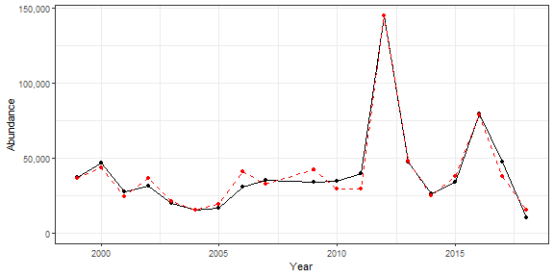

## 3.3 Catch

|  |  |  |  |  |
| --- | --- | --- | --- | --- |
| Indicator | Number of data points | Slope | P-value | R2_adj |
| Time | 30 | 150 | 5.2e-05 | 0.43 |
| cumulative intensity |  |  |  |  |

degrees C (annual mean) |26 |7.8 |0.015 |0.19 | |cumulative intensity Black sea bass north spring degrees C (annual mean) |25 |6.1 |0.048 |0.12 | |cumulative intensity Black sea bass spring degrees C (annual mean) |26 |8.1 |0.014 |0.2 | |maximum intensity Black sea bass spring degrees C (annual mean) |26 |2300 |0.019 |0.17 | |long-term sst degreesC |30 |1600 |0.00096 |0.3 | |summer OI SST Anomaly degreesC |30 |1200 |0.0099 |0.19 | |fall OI SST Anomaly degreesC |30 |1300 |0.0093 |0.19 | |winter OI SST Anomaly Black sea bass north spring degreesC |30 |970 |0.018 |0.16 | |summer OI SST Anomaly Black sea bass north spring degreesC |30 |1000 |0.016 |0.16 | |fall OI SST Anomaly Black sea bass north spring degreesC |30 |1000 |0.0074 |0.2 | |summer OI SST Anomaly Black sea bass spring degreesC |30 |1100 |0.015 |0.17 | |fall OI SST Anomaly Black sea bass spring degreesC |30 |1200 |0.0092 |0.19 | |summer OI SST Anomaly Black sea bass south spring degreesC |30 |1100 |0.027 |0.13 | |fall OI SST Anomaly Black sea bass south spring degreesC |30 |1100 |0.029 |0.13 | |stratification (0-50 m) kg m^-3 |27 |-130000 |0.033 |0.14 | |tke winter J/kg |30 |10000 |0.025 |0.14 | |gulf stream index latitude anomaly (annual mean) |26 |1100 |0.049 |0.12 | |Latitude degreesN |30 |6100 |0.0023 |0.26 | |Longitude degreesW |30 |5400 |0.003 |0.25 | |along-shelf distance km |30 |44 |0.0017 |0.28 | |northern_latitude |30 |1400 |0.03 |0.13 | |southern_latitude |30 |2100 |0.046 |0.1 | |WEEKLY CHLOR A MEDIAN week 06 mg m^-3 |21 |3500 |0.045 |0.15 | |WEEKLY CHLOR A RATIO ANOMALY week 04 |21 |8100 |0.032 |0.18 | |WEEKLY PPD MEDIAN week 11 gCarbon/m^2/Day |21 |12000 |0.001 |0.41 | |WEEKLY PPD RATIO ANOMALY week 20 |21 |6000 |0.048 |0.15 | |WEEKLY PPD RATIO ANOMALY week 28 |21 |4900 |0.047 |0.15 | |WEEKLY PPD RATIO ANOMALY week 30 |21 |5300 |0.034 |0.18 | |centropages zoo fall log N m^-3 |26 |-2500 |0.036 |0.14 | |Calanus CV and adult Summer |26 |-0.27 |0.038 |0.13 | |summer Black sea bass spring gC m-2 d-1 |21 |7500 |0.034 |0.17 | |summer Black sea bass south spring gC m-2 d-1 |21 |5700 |0.041 |0.16 | |penilia_100m3_annual |30 |2200 |0.029 |0.13 | |echino_100m3_annual |30 |1500 |0.024 |0.14 | |larvaceans_100m3_annual |30 |1900 |0.016 |0.16 | |mlucens_100m3_annual |30 |-1700 |0.042 |0.11 | |evadnespp_100m3_annual |30 |2700 |0.0033 |0.24 | |salps_100m3_annual |30 |3100 |0.0065 |0.21 | |poly_100m3_annual |30 |3100 |0.046 |0.1 | |oncaea_100m3_annual |30 |1800 |0.036 |0.12 | |thecos_100m3_annual |30 |1600 |0.044 |0.11 | |spirspp_100m3_annual |30 |-2600 |3e-04 |0.36 | |ctyp_100m3_spring |29 |2600 |0.02 |0.15 | |pseudo_100m3_spring |29 |-880 |0.047 |0.11 | |penilia_100m3_spring |29 |17000 |0.0031 |0.25 | |echino_100m3_spring |29 |1600 |0.037 |0.12 | |para_100m3_spring |29 |1000 |0.029 |0.13 | |clauso_spring |29 |1400 |0.027 |0.14 | |prot_100m3_spring |29 |2000 |0.016 |0.17 | |coel_100m3_spring |29 |-4100 |0.022 |0.15 | |thecos_100m3_spring |29 |1000 |0.028 |0.14 | |spirspp_100m3_spring |29 |-1500 |0.0012 |0.3 | |ctyp_100m3_fall |30 |-1700 |0.034 |0.12 | |calfin_100m3_fall |30 |-1400 |0.018 |0.16 | |penilia_100m3_fall |30 |1200 |0.0084 |0.2 | |cham_100m3_fall |30 |-1500 |0.019 |0.15 | |echino_100m3_fall |30 |750 |0.049 |0.1 | |larvaceans_100m3_fall |30 |1700 |0.0023 |0.26 | |evadnespp_100m3_fall |30 |1400 |0.013 |0.17 | |salps_100m3_fall |30 |1700 |0.001 |0.3 | |dec_100m3_fall |30 |2600 |0.0014 |0.28 | |poly_100m3_fall |30 |3100 |3.9e-05 |0.44 | |fish_100m3_fall |30 |2200 |0.019 |0.15 | |oncaea_100m3_fall |30 |1200 |0.0042 |0.23 | |siph_100m3_fall |30 |1600 |0.0013 |0.29 | |spirspp_100m3_fall |30 |-4000 |0.00028 |0.36 | |cnidar_100m3_fall |30 |1600 |0.0045 |0.23 | |Abundance |30 |0.15 |8.2e-08 |0.64 |

## 3.4 Fmort

|  |  |  |  |  |
| --- | --- | --- | --- | --- |
| Indicator | Number of data points | Slope | P-value | R2_adj |
| Time | 30 | -0.022 | 3.3e-09 | 0.71 |
| Warm Core Rings |  |  |  |  |
| n | 30 | -0.016 | 0.00045 | 0.34 |
| cumulative intensity |  |  |  |  |

degrees C (annual mean) |26 |-0.00096 |0.0088 |0.22 | |maximum intensity degrees C (annual mean) |26 |-0.23 |0.024 |0.16 | |cumulative intensity Black sea bass north spring degrees C (annual mean) |25 |-0.00094 |0.005 |0.26 | |cumulative intensity Black sea bass spring degrees C (annual mean) |26 |-8e-04 |0.032 |0.14 | |maximum intensity Black sea bass spring degrees C (annual mean) |26 |-0.24 |0.027 |0.15 | |maximum intensity Black sea bass north spring degrees C (annual mean) |25 |-0.23 |0.0079 |0.24 | |GLORYS bottom temp anomaly degreesC |26 |-0.091 |0.013 |0.2 | |long-term sst degreesC |30 |-0.2 |6e-04 |0.33 | |summer OI SST Anomaly degreesC |30 |-0.17 |0.00072 |0.32 | |fall OI SST Anomaly degreesC |30 |-0.2 |0.00023 |0.37 | |summer OI SST Anomaly Black sea bass north spring degreesC |30 |-0.15 |0.00087 |0.31 | |fall OI SST Anomaly Black sea bass north spring degreesC |30 |-0.15 |0.00042 |0.34 | |summer OI SST Anomaly Black sea bass spring degreesC |30 |-0.17 |0.00078 |0.31 | |fall OI SST Anomaly Black sea bass spring degreesC |30 |-0.17 |0.00034 |0.35 | |summer OI SST Anomaly Black sea bass south spring degreesC |30 |-0.16 |0.0026 |0.26 | |fall OI SST Anomaly Black sea bass south spring degreesC |30 |-0.17 |0.0013 |0.29 | |tke winter J/kg |30 |-1.6 |0.0022 |0.26 | |total wind speed winter J/kg |30 |-0.16 |0.029 |0.13 | |hcly summer m2/sec2 |30 |0.017 |0.0025 |0.26 | |tke summer J/kg |30 |-3.7 |0.032 |0.12 | |Latitude degreesN |30 |-0.89 |4.5e-05 |0.43 | |Longitude degreesW |30 |-0.86 |7.1e-06 |0.5 | |along-shelf distance km |30 |-0.0066 |7.8e-06 |0.5 | |depth m |30 |-0.021 |0.0076 |0.2 | |distance to coast km |30 |-0.017 |0.04 |0.11 | |northern_latitude |30 |-0.22 |0.0023 |0.26 | |southern_latitude |30 |-0.3 |0.014 |0.17 | |MONTHLY CHLOR A MEDIAN month 07 mg m^-3 |21 |0.45 |0.018 |0.22 | |MONTHLY CHLOR A RATIO ANOMALY month 07 |21 |0.24 |0.021 |0.21 | |WEEKLY CHLOR A RATIO ANOMALY week 04 |21 |-0.54 |0.0021 |0.37 | |WEEKLY CHLOR A MEDIAN week 04 mg m^-3 |21 |-0.17 |0.012 |0.25 | |WEEKLY CHLOR A MEDIAN week 07 mg m^-3 |21 |-0.28 |0.00088 |0.42 | |WEEKLY CHLOR A MEDIAN week 27 mg m^-3 |21 |0.28 |0.044 |0.15 | |WEEKLY CHLOR A MEDIAN week 29 mg m^-3 |21 |0.47 |0.027 |0.19 | |WEEKLY CHLOR A MEDIAN week 30 mg m^-3 |21 |0.63 |0.007 |0.29 | |WEEKLY CHLOR A MEDIAN week 31 mg m^-3 |21 |0.54 |0.05 |0.14 | |WEEKLY CHLOR A RATIO ANOMALY week 07 |21 |-0.43 |0.0024 |0.36 | |WEEKLY CHLOR A RATIO ANOMALY week 27 |21 |0.16 |0.044 |0.15 | |WEEKLY CHLOR A RATIO ANOMALY week 29 |21 |0.23 |0.015 |0.24 | |WEEKLY CHLOR A RATIO ANOMALY week 30 |21 |0.25 |0.0057 |0.3 | |WEEKLY PPD MEDIAN week 11 gCarbon/m^2/Day |21 |-0.5 |0.008 |0.28 | |WEEKLY PPD MEDIAN week 02 gCarbon/m^2/Day |21 |0.61 |0.047 |0.15 | |centropages zoo fall log N m^-3 |26 |0.26 |0.022 |0.17 | |pseudocalanus zoo fall log N m^-3 |26 |0.14 |0.015 |0.19 | |temora zoo fall log N m^-3 |26 |0.16 |0.034 |0.14 | |SmallCalanoida Absolute Number of Individuals |30 |3.2e-10 |1.9e-06 |0.55 | |Zoo_Shannon-Wiener_Diversity_index Unitless |30 |-0.46 |0.00052 |0.33 | |small Anomaly |30 |0.35 |0.0014 |0.29 | |ctyp_100m3_annual |30 |0.38 |0.0025 |0.26 | |pseudo_100m3_annual |30 |0.24 |2.6e-05 |0.45 | |penilia_100m3_annual |30 |-0.31 |0.0061 |0.21 | |cham_100m3_annual |30 |0.33 |0.00016 |0.38 | |echino_100m3_annual |30 |-0.32 |4e-06 |0.52 | |larvaceans_100m3_annual |30 |-0.27 |0.0031 |0.25 | |gas_100m3_annual |30 |-0.23 |0.015 |0.16 | |mlucens_100m3_annual |30 |0.24 |0.012 |0.18 | |salps_100m3_annual |30 |-0.44 |0.00055 |0.33 | |chaeto_100m3_annual |30 |-0.41 |1.8e-05 |0.47 | |hyper_100m3_annual |30 |-0.26 |0.0025 |0.26 | |calminor_100m3_annual |30 |-0.38 |1.9e-08 |0.67 | |clauso_annual |30 |-0.35 |0.0047 |0.23 | |prot_100m3_annual |30 |-0.42 |0.0032 |0.25 | |poly_100m3_annual |30 |-0.51 |0.0031 |0.25 | |oncaea_100m3_annual |30 |-0.35 |9.7e-05 |0.4 | |cory_100m3_annual |30 |-0.42 |2e-05 |0.46 | |siph_100m3_annual |30 |-0.33 |0.003 |0.25 | |euph1_100m3_annual |30 |-0.36 |0.048 |0.1 | |thecos_100m3_annual |30 |-0.31 |0.00026 |0.36 | |spirspp_100m3_annual |30 |0.25 |0.0032 |0.25 | |cnidar_100m3_annual |30 |-0.33 |0.0014 |0.28 | |pseudo_100m3_spring |29 |0.11 |0.019 |0.16 | |penilia_100m3_spring |29 |-1.7 |0.0055 |0.22 | |para_100m3_spring |29 |-0.16 |0.00084 |0.32 | |acarspp_100m3_spring |29 |0.2 |0.037 |0.12 | |chaeto_100m3_spring |29 |-0.26 |0.0019 |0.28 | |clauso_spring |29 |-0.24 |0.00013 |0.4 | |coel_100m3_spring |29 |0.41 |0.033 |0.13 | |thecos_100m3_spring |29 |-0.14 |0.0035 |0.25 | |spirspp_100m3_spring |29 |0.16 |0.0024 |0.27 | |ctyp_100m3_fall |30 |0.41 |3.4e-07 |0.6 | |pseudo_100m3_fall |30 |0.22 |1.5e-05 |0.48 | |penilia_100m3_fall |30 |-0.14 |0.0087 |0.19 | |tlong_100m3_fall |30 |0.24 |0.0011 |0.3 | |cham_100m3_fall |30 |0.34 |5.1e-09 |0.7 | |echino_100m3_fall |30 |-0.19 |3e-07 |0.6 | |larvaceans_100m3_fall |30 |-0.25 |3.7e-05 |0.44 | |para_100m3_fall |30 |0.16 |0.038 |0.11 | |gas_100m3_fall |30 |-0.28 |0.045 |0.1 | |mlucens_100m3_fall |30 |0.22 |0.00045 |0.34 | |evadnespp_100m3_fall |30 |-0.16 |0.019 |0.15 | |salps_100m3_fall |30 |-0.15 |0.016 |0.16 | |chaeto_100m3_fall |30 |-0.39 |4.8e-05 |0.43 | |hyper_100m3_fall |30 |-0.22 |0.0063 |0.21 | |calminor_100m3_fall |30 |-0.24 |2.9e-09 |0.71 | |dec_100m3_fall |30 |-0.29 |0.0023 |0.26 | |prot_100m3_fall |30 |-0.23 |0.0064 |0.21 | |poly_100m3_fall |30 |-0.28 |0.0021 |0.26 | |oncaea_100m3_fall |30 |-0.17 |0.00032 |0.35 | |cory_100m3_fall |30 |-0.22 |2.8e-05 |0.45 | |siph_100m3_fall |30 |-0.16 |0.0066 |0.21 | |spirspp_100m3_fall |30 |0.52 |3.8e-05 |0.44 | |cnidar_100m3_fall |30 |-0.16 |0.015 |0.16 | |Abundance |30 |-1.5e-05 |3.3e-05 |0.45 | |F condition |26 |0.037 |0.0051 |0.25 | |recreational CPUE number of fish caught per day fished (all species) |30 |0.16 |0.031 |0.13 |

# 4 Appendix

## 4.1 R session information

## R version 4.0.3 (2020-10-10)  
## Platform: x86_64-w64-mingw32/x64 (64-bit)  
## Running under: Windows 10 x64 (build 19042)  
##   
## Matrix products: default  
##   
## locale:  
## [1] LC_COLLATE=English_United States.1252 LC_CTYPE=English_United States.1252 LC_MONETARY=English_United States.1252 LC_NUMERIC=C   
## [5] LC_TIME=English_United States.1252   
##   
## attached base packages:  
## [1] stats graphics grDevices utils datasets methods base   
##   
## other attached packages:  
## [1] NEespShiny_0.1.1 shiny_1.6.0   
##   
## loaded via a namespace (and not attached):  
## [1] nlme_3.1-149 fs_1.5.0 assessmentdata_0.0.0.9000 ecodata_0.1.0 xts_0.12.1 usethis_2.0.1   
## [7] lubridate_1.7.10 devtools_2.3.2 httr_1.4.2 rprojroot_2.0.2 tools_4.0.3 bslib_0.2.4   
## [13] utf8_1.1.4 R6_2.5.0 DT_0.17 mgcv_1.8-33 DBI_1.1.1 colorspace_2.0-0   
## [19] withr_2.4.1 tidyselect_1.1.0 gridExtra_2.3 prettyunits_1.1.1 processx_3.4.5 curl_4.3   
## [25] compiler_4.0.3 cli_2.3.1 priceR_0.1.5 desc_1.3.0 labeling_0.4.2 bookdown_0.21   
## [31] sass_0.3.1 scales_1.1.1 tidyquant_1.0.3 quadprog_1.5-8 callr_3.5.1 stringr_1.4.0   
## [37] digest_0.6.27 rmarkdown_2.7 pkgconfig_2.0.3 htmltools_0.5.1.1 sessioninfo_1.1.1 highr_0.8   
## [43] fastmap_1.1.0 NEesp_0.1.1 htmlwidgets_1.5.3 rlang_0.4.10 TTR_0.24.2 rstudioapi_0.13   
## [49] quantmod_0.4.18 farver_2.1.0 jquerylib_0.1.3 generics_0.1.0 zoo_1.8-9 jsonlite_1.7.2   
## [55] crosstalk_1.1.1 dplyr_1.0.5 magrittr_2.0.1 Matrix_1.2-18 Rcpp_1.0.6 Quandl_2.10.0   
## [61] munsell_0.5.0 fansi_0.4.1 ggnewscale_0.4.5 proto_1.0.0 viridis_0.5.1 lifecycle_1.0.0   
## [67] stringi_1.5.3 yaml_2.2.1 MASS_7.3-53 PerformanceAnalytics_2.0.4 pkgbuild_1.2.0 grid_4.0.3   
## [73] promises_1.2.0.1 crayon_1.4.1 lattice_0.20-41 splines_4.0.3 knitr_1.31.6 ps_1.5.0   
## [79] pillar_1.5.1 pkgload_1.2.0 glue_1.4.2 evaluate_0.14 remotes_2.2.0 vctrs_0.3.6   
## [85] httpuv_1.5.5 testthat_3.0.2 gtable_0.3.0 purrr_0.3.4 tidyr_1.1.3 assertthat_0.2.1   
## [91] gsubfn_0.7 cachem_1.0.4 ggplot2_3.3.3 xfun_0.19 mime_0.10 xtable_1.8-4   
## [97] later_1.1.0.1 viridisLite_0.3.0 tibble_3.0.4 memoise_2.0.0 ellipsis_0.3.1

## 4.2 NEesp information

## Package: NEesp  
## Title: Generate Preliminary ESP Reports for the Northeast  
## Version: 0.1.1  
## Description: Generates preliminary Ecosystem and Socioeconomic Profiles for Northeast and Mid-Atlantic USA fishery stocks.  
## License: file LICENSE  
## Authors@R: c(person("Abigail", "Tyrell", email = "abigail.tyrell@noaa.gov", role = c("aut", "cre"), comment = c(ORCID = "0000-0002-6656-8470")),  
## person("Ricky", "Tabandera", email = "ricky.tabandera@noaa.gov", role = "aut"))  
## Maintainer: Abigail Tyrell <abigail.tyrell@noaa.gov>  
## URL: https://noaa-edab.github.io/NEesp/  
## BugReports: https://github.com/NOAA-EDAB/NEesp/issues  
## Imports: assessmentdata, bookdown, DT, ecodata, FSA, ggpubr, ggrepel, ggridges, ggthemes, here, nmfspalette, papeR, priceR, rgeos, rnaturalearth,  
## rnaturalearthhires, tidyquant, viridis  
## Remotes: ropensci/rnaturalearthhires, nmfs-general-modeling-tools/nmfspalette, NOAA-EDAB/ecodata, NOAA-EDAB/assessmentdata  
## Encoding: UTF-8  
## LazyData: true  
## Roxygen: list(markdown = TRUE)  
## RoxygenNote: 7.1.1  
## Depends: R (>= 3.5.0)  
## Suggests: testthat (>= 3.0.0)  
## Config/testthat/edition: 3  
## RemoteType: github  
## RemoteHost: api.github.com  
## RemoteRepo: NEesp  
## RemoteUsername: NOAA-EDAB  
## RemoteRef: dev  
## RemoteSha: b97a213df4b12e9eb34559612778edd93d0d02dc  
## GithubRepo: NEesp  
## GithubUsername: NOAA-EDAB  
## GithubRef: dev  
## GithubSHA1: b97a213df4b12e9eb34559612778edd93d0d02dc  
## NeedsCompilation: no  
## Packaged: 2021-07-13 20:45:00 UTC; abigail.tyrell  
## Author: Abigail Tyrell [aut, cre] (<https://orcid.org/0000-0002-6656-8470>), Ricky Tabandera [aut]  
## Built: R 4.0.3; ; 2021-07-13 20:45:08 UTC; windows  
##   
## -- File: C:/Users/abigail.tyrell/Documents/R/win-library/4.0/NEesp/Meta/package.rds